### *Day8*

#### *思维*

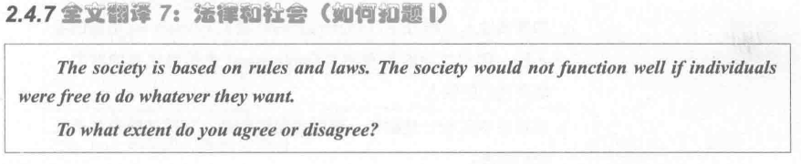

*[ positive ]*

A. 公民遵守法律可以维护社会稳定(ensure social stability) and促进经济发展 (boost economic growth) *[ topic sentences, 拓展名词 ]*

B. 因为法律在规范人的行为上发挥着重要作用(play a crucial role)。 *[ supporting sentences 解释论证，教育类是修饰词]* 这个解决并不好，拓展下，你写作业不要用红色字体，不然你可能不太好看到我的修正。我教的时候会有支持段1和支持段2.这两个东西是要有区分度的。你看看范文，范文支持段1针对的是经济方面，支持段2是社会稳定方面。你这一个段落写的社会稳定，你这写完了后你会发现你支持段2到时候没有话写了

C. For instance, 人人遵守交通规则，会让公路变得更加有序(orderly)。*[ supporting sentences 举例论证 ]*

D. 如果社会缺少法律约束(without the rule of law)将会导致公民产生(aggressive and violenct behaviours)。 *[ concluding sentences 使用without反面论证]*

*[ negative ]*

1. 有时候，过度的法律不可避免地(inevitably)会抑制(restrain)公民的自由 *[ topic sentences ]*

B. 因为人们害怕违法(fear of breaking the law) and 过多的惩罚(excessive punishment)*[ supporting sentences 解释论证 ]*

C. If 国家强迫公民过量纳税，那么这会对低收入人群造成巨大压力(put pressure on people’s survival) and 甚至出现反社会行为(anti-social behaviours ) *[ supporting sentences 对比论证 ]*

D. 政府应该放松(reduce)限制 to 鼓励创新，这样才能促进社会良性发展(promote the sound development of society)。 *[ concluding sentences 对比论证 ]*

#### *翻译*

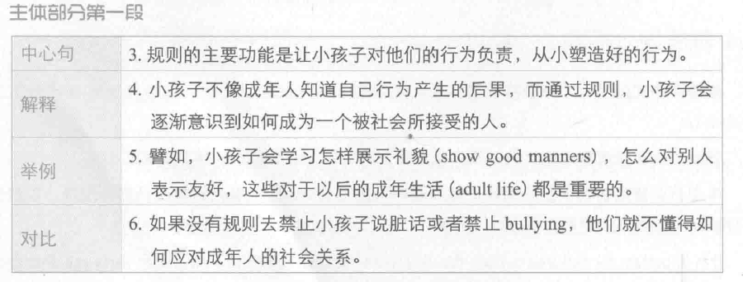

1. The main function of rules is to hold children accountable for their behaviour and to help them develop good behaviour patterns from a young age.
2. Unlike adults, children are normally not aware of the consequences of bad behaviour, and setting rules can help them realise how to behave in a socially acceptable way.
3. For example, children can learn how to show good manners and get along with others, which would be important skills in adult life.
4. If no rules forbid them to use bad language or bully others, they will not know how to deal with social relationships in adulthood.

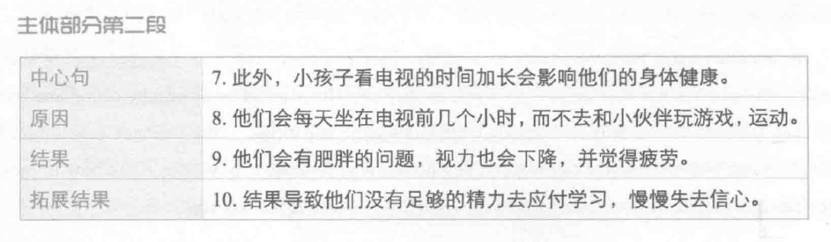

1. Another problem is that *excessive* （过多的）screen time will affect children's health.
2. They sit in front of a *screen* / television for many hours every day, *instead of* playing games and doing sports with *peers* / friends.
3. They also *suffer obesity,poor eyesight and fatigue*. 患肥胖症，视力降低，乏力
4. As a result / Because of this, they do not have energy to cope with the demands of schooling and lose self-confidence over time [ 我用的slowly ].

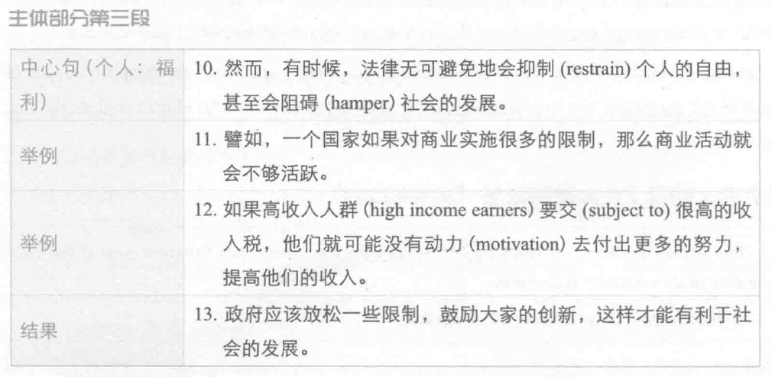

1. Nevertheless, laws sometimes inevitable(不可避免) restrain individual freedom and even hamper social progress(阻碍).
2. For instance，if one country has many restrictions on business, the bussiness activities will not thrive.
3. If high income earners have to pay a large amount of income tax, they unlikely to(我用的might don’t ) have motivation to work hard (我用的devote themselves to) and raise income.
4. The government should relax regulations to forst(我用的encourage) innovations, which can contribute to social progress.

*作业：*

*1. 每天一个思维 （一正，一反 顾2.3.7.8.9）*

*2.每天做一个段落的翻译*

*顾家北第一篇*

*Day 1----主体段1 -----90% -----没有就重新翻译（修改的范文）*

*Day2 ----重翻译主1 + 主2*

*Day 3 ---- 重翻 主1.2 + 主3*

*Day 4------ 1.2.3*

*Day 5----- 1.2.3*

*3.下节课上课前一晚 把顾家北第九篇用英文写出来*