### *Day9*

#### *思维*

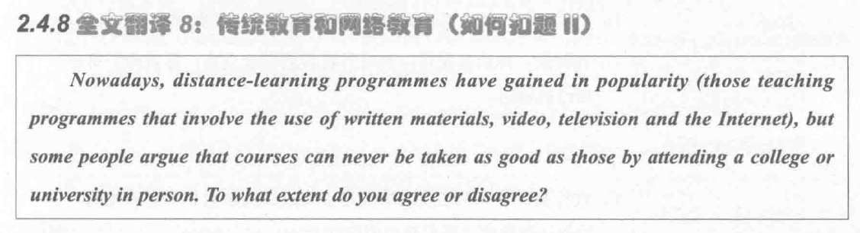

*[ positive ]*

A. 与传统教育相比，在线学习更加灵活和丰富，让更多的人快速学到知识成为可能。 *[ topic sentences] 不要与什么相比，直接说明中心*

B. 学生可以通过阅读电子书，看视频（watch videos），参加会议（attend lectures）随时随地查找知识完成学习任务。*[ supporting sentences，解释论证]*

C. For instance例如，在疫情期间（during the epidemic），中国的绝大多数高校利用网络进行远程授课（distance teaching），高效完成教学。*[ supporting sentences 举例论证 ]*

D. 远程授课超越了时间和空间限制（overcome time restriction and geographical barrier），国外线上线下一个价格，不要乱写，你这个段强调的是灵活性，跟成本价格没有关系

*[ negative ]*

A. 远程教育的一个主要缺点是难以培养社交技能（nurture interpersonal and communicative skills）。 *[ topic sentences]*

B. 因为在远程学习中，学生独立完成作业没有相互交流，很难拓展人脉（build up a network of contacts）。*[ supporting sentences，解释论证]*

C. If 体育课采用线上形式进行，老师看不到学生的肢体动作（nonverbals），上课效果会很差 and 进度也很慢。*[ supporting sentences 举例论证 ]*

D. 在远程授课过程中，学生应该积极地和同学讨论问题，这样才能促进自己全面发展（comprehensive development）。*[ concluding sentences inducing words]*

#### *翻译*

#### 2.4.1

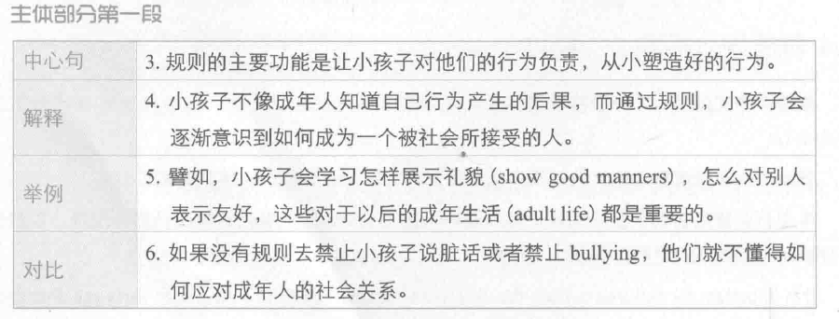

1. The main function of rules is to hold children accountable for their behaviour and to help them develop good behaviour patterns from a young age.
2. Unlike adults, children are normally not aware of the consequences of bad behaviour, and setting rules can help them realise how to behave in a socially acceptable way.
3. For example, children can learn how to show good manners and get along with others, which would be important skills in adult life.
4. If no rules forbid them to use bad language or bully others, they will not know how to deal with social relationships in adulthood.

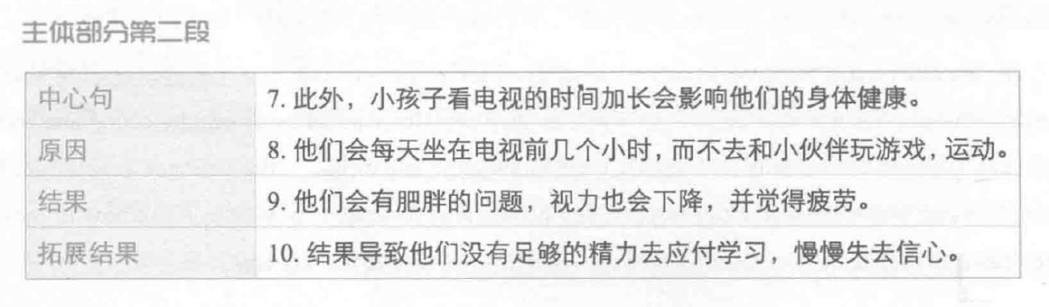

1. Another problem is that *excessive* （过多的）screen time will affect children's health.
2. They sit in front of a *screen* / television for many hours every day, *instead of* playing games and doing sports with *peers* / friends.
3. They also *suffer obesity,poor eyesight and fatigue*. 患肥胖症，视力降低，乏力
4. As a result / Because of this, they do not have energy to cope with the demands of schooling and lose self-confidence over time [ 我用的slowly ].

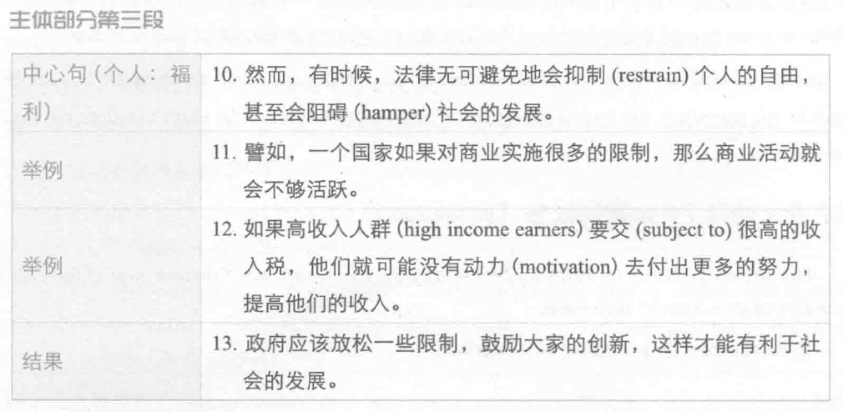

1. Nevertheless, laws sometimes inevitable(不可避免) restrain individual freedom and even hamper social progress(阻碍).
2. For instance，if one country has many restrictions on business, the bussiness activities will not thrive.
3. If high income earners have to pay a large amount of income tax, they unlikely to(我用的might don’t ) have motivation to work hard (我用的devote themselves to) and raise income.
4. The government should relax regulations to forst(我用的encourage) innovations, which can contribute to social progress.

*作业：*

*1. 每天一个思维 （一正，一反 顾2.3.7.8.9）*

*2.每天做一个段落的翻译*

*顾家北第一篇*

*Day 1----主体段1 -----90% -----没有就重新翻译（修改的范文）*

*Day2 ----重翻译主1 + 主2*

*Day 3 ---- 重翻 主1.2 + 主3*

*Day 4------ 1.2.3*

*Day 5----- 1.2.3*

*3.下节课上课前一晚 把顾家北第九篇用英文写出来*