#### *思维*

*09.01.15 08.10.23 : Students at schoots and universities learn far more from lessons with teachers than from other sources (such as the Internet and television). To what extent do you agree or disagree?*

The proportion of out-of-class learning is steadily growing possibly because of improvements in technology and needs in career. Although students acquire fundamental knowledge from traditional class, I personally believe that they should be encouraged to obtain extra skills from other sources such as the internet.

First and foremost, a student learns academic knowledge instead of comprehensive skills such as career skills, because the book and courseware that students learn are based on their major. For instance, college students majoring in computer science mainly study programming and computer architecture. Thus, in career’s aspect, the university is inferior to vocational training which is career-oriented educational.

In addition, out-of-class learning such as online learning is flexible and makes it possible for more people to learn knowledge quickly. Students can read e-books, watch videos, attend conferences and search for knowledge overcome time restriction and geographical barrier to complete their learning tasks. During the epidemic, universities in China used Internet to teaching and completed the lectures efficiently. Not only universities, but more and more companies and individuals complete their work on the line.

However, traditional class can better stimulate learning interests and motivation, which leads students to achieve good grades. Compared with other learning methods, traditional education maintains contact between teachers and students. For example, If a student feels puzzled in math class, he or she can immediately communicate with classmates and ask the teacher for advice. Students are able to improve efficiency and focus on textbook instead of being attract by Internet.

To conclude, although traditional educationcan allows students to focus more on academic knowledge, out-of-class learning is more flexible and comprehensive which makes students adapt to cutting-throat competitions. Therefore, higher schools should encourage their students to learn from other sources and be versatile.

*11.03.05*

*Some people think governments should spend money on measures to save languages*

*with few speakers from dying out completely. Others think this is a waste of financial*

*resources. Discuss both views and give your opinion.*

Some languages has gone extinct in the context of globalization, possibly because of the lack of daptablity and the development of Internet. Although investing plenty of money to saving rare languages will protect the cultural diversity, I personally believe that it increase the financial burden of the government.

First and foremost, rare languages is weak in proportion and hard to satisfy daily communicative demand. Generally, the minority language will be assimilated by the popular one which leads to cultural assimilation. For example, English has become an international language due to it’s convenience in use. Rare language speaker might face social alienation and can’t adapt to cutting-throat competition.

In addition, it is undeniable that saving rare language is money-consuming and time consuming. Governments have to invest money in protecting and publicizing it, which achieves a slight effect. There are excessive dialects in China and saving them must lead to financial deficit. Compared with rare languages, poverty and development problems are much more significant.

However, endangered language is avaluable tangible cultural heritage and plays an import role in cultural diversity. It carries cultural identity and the wisdom through the history of China for thousands of years. A forceful ilustration of this is the dialect in Xiangxi in China, which allows more people to understand the unique local cultural and emotional communication methods. Language is a precious wealth left by ancestors to descendant and government should encourage advocate language protection.

To conclusion, although endangered language is avaluable cultural heritage, it increase the financial burden of the government and lack of daptablity. Therefore government should invest in other favourable aspects such as education and poverty rather than rare languages.

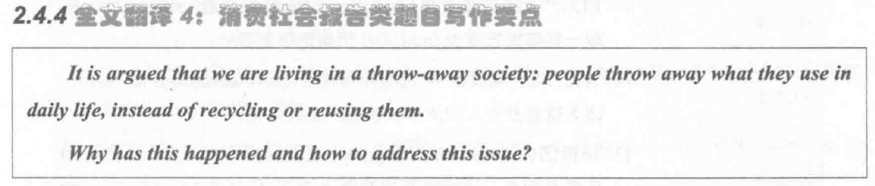

1. 今天---第四篇思维

2. 明天---第五篇

3. 写蓝色书157. 2全英文

蓝色书153. 1