#### *小作文*

<https://www.english-exam.org/IELTS/academic_writing_samples_task_1/996/>

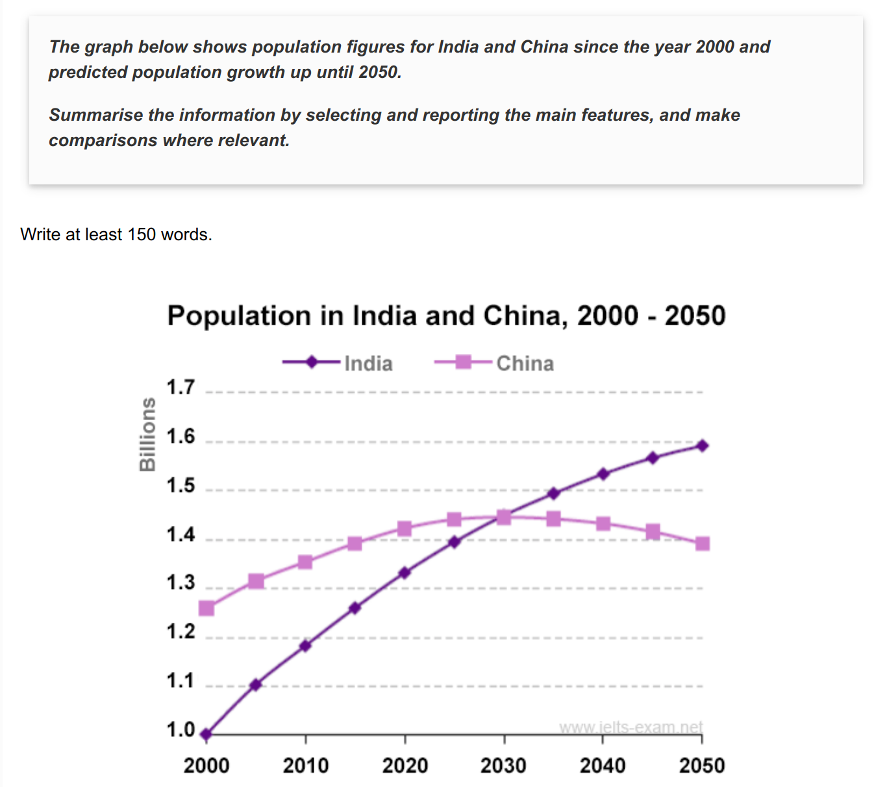

The line graph apparently demonstrates the comparisons of the population concerning India and China from 2000 to 2050.

In 2000, there were more people living in China than in India. The number of Chinese was about 1.25 billion, while India's population was about 1 billion. Between 2000 and the present, there has a 0.2 increase 这里是名词 in the number of Chinese people. Over the same period, India's population has risen by 1 billion to reach over 1.32 billion.

According to the graph, the population in India will increase more quickly than in China. By 2030, both countries will have the same population of 1.45 billion. After that, China's population is likely to fall slightly to 1.4 billion in 2050, whereas India's population will probably rise to 1.6 billion.

Overall, during the 50-year period, the population of India is going to have a steady growth and overtake Chinese. Inaddition, China's population will peak in 2030 and then begin to fall.

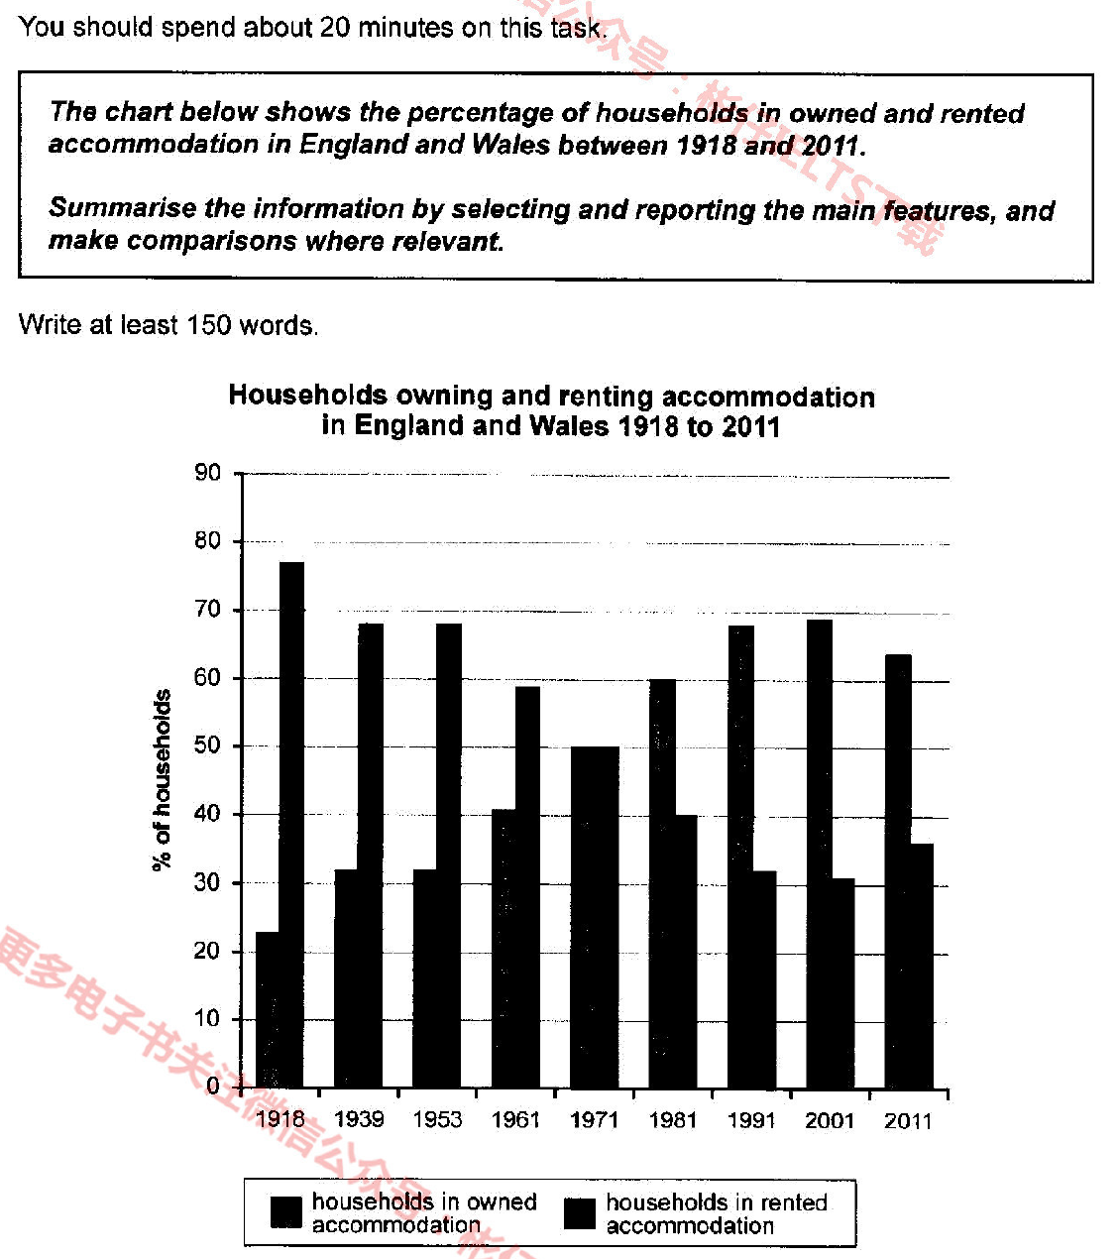

The bar chart apparently demonstrates the comparisons of the percentage concerning of households in woned and rented in England and Wales from 1918 to 2011.

In 1918, there were more families in rented than in owned. The proportion of households in rented was about 77 percent, while households in owned was 23 percent. Between 1918 and 1971, there has a 27% increase in the percent of households in rented accommodation. Over the same period, the percent of households in owned has fallen to 50 and reached the same level as the households’ in owned.

According to the chart, by 2030, the percentage of households in woned accommodation kept a significant growth to the peak at 68% and followed by a slow drop to 65%. In addition, the proportion of households in rented decreased sharply to the bottom of 31 and rose to the end at 32%. 这个段落最好对比着写

Overall, during the 9-year period, more and more people in England and Wales could afford to buy a house, instead of living in rented houses.

When A 上升的时候， there was a corresponding in B .

作业

1. 表格，开头段，连接词背完
2. 背完后练作文

Day 1 ---- 练两条线的三次 + 写剑13 P51`

Day 2-----练三条线的三次 + 写剑9 P53

Day 3 ---练四条线 + 写剑11 P77

Day 4 ---练6条线的三次

蓝色书146. 3---观点类9.1

讨论类 161.1 ---- 讨论类9,2

蓝色书157. 2----报告类9.3

蓝色书174.1 ----混合类9.4

153. 1 ------ 9.5