**The graph below shows the changes in food consumption by Chinese people between 1985 and 2010.  
Summarise the information by selecting and reporting the main features, and make comparisons where relevant.**

Write at least 150 words.

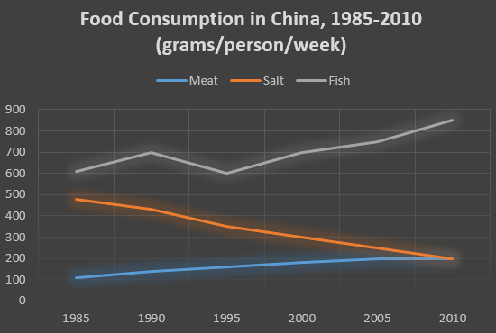

*三条线：用一段描述一条曲线，用另一段描述剩下两条变化不明显的曲线；每段开头线描述下该曲线的整体大小/走势，然后再从左端点开始写，数值前面尽量用形容词 about, almost,only等等。*

The line graph apparently demonstrates the comparisons of consumption concerning different foods in China from 1985 to 2010.

From the graph we can see that people in China consumed more fish than either meat or salt throughout the period. During the five two years, the consumption of fish increased slightly from 600 grams in 1985 to 700 grams in 1990, followed by a steady decline to the button at 590 grams before it rose steadily and ended at 850 grams in 2010.   
  
In contrast, there was a consistent drop in salt consumption. The amount consumed（可以替换the amount of避免重复） decreased steadily from about 500 grams to only 200 grams by 2010. On the contrary, the amount of meat consumed weekly started at about 100 grams and gradually increased throughout the period. By 2010, both of them ended at the same level 200.  
  
Overall, the consumption of fish rose, while the consumption of salt fell. In addition, the consumption of meat, while at a relatively low level, rose significantly during this period.

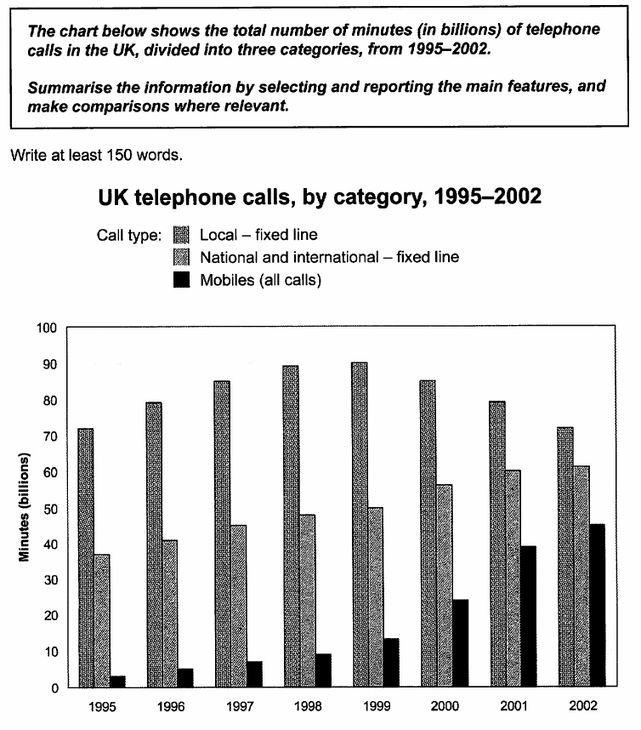

The bar chat apparently demonstrates the comparisons of telephone time concerning different call type in the UK from 1995 to 2002.

From the chart we can see that local fixed line calls were highest throughout the period. During the five eight years, the time of local fixed line calls increased significantly from 70 billion minutes in 1995 to the peak at about 90 billion minutes in 1990. After that it decreased sharply and ended at 70 billion minutes in 2002.

In contrast, there was a consistent growth in both national and international fixed line. The number of minutes increased steadily from about 37 billion minutes to almost 55 billion minutes by 2002. Similarly, the time of mobiles started at about 3 billion minutes and rose to 12 billion minutes in 1999. By 2002, it had a dramatic climb to 41 billion minutes.

Overall, the time of local fixed line calls fell, while the others rose. In addition, the time of mobiles, while at a relatively low level, rose significantly during this period.

作业

1. 表格，开头段，连接词背完
2. 背完后练作文

Day 1 ---- 练两条线的三次 + 写剑13 P51`

Day 2-----练三条线的三次 + 写剑9 P53

Day 3 ---练四条线 + 写剑11 P77

Day 4 ---练6条线的三次