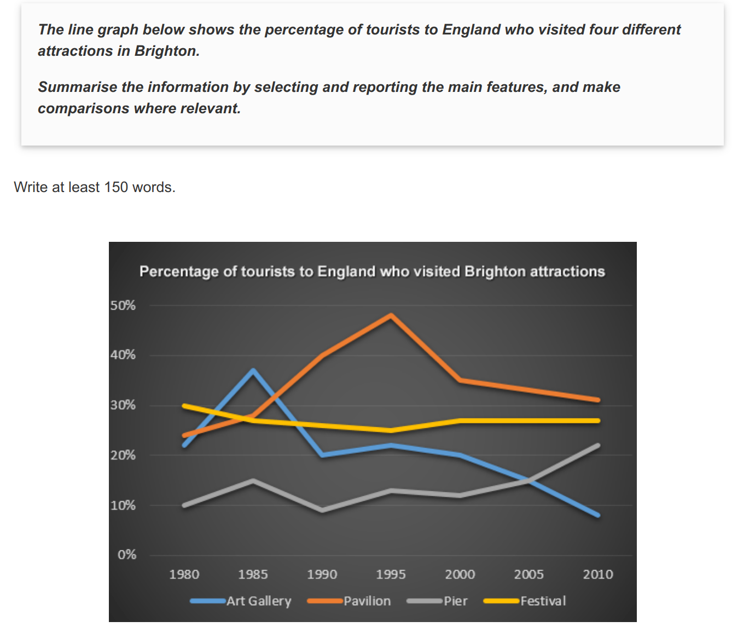

变化太复杂了，也没有太多突出的特征，怎么分段啊 .... 范文里直接第二段描述起始端点，第三段描述细节变化，绝了！

The line graph apparently demonstrates the percentage concerning tourists to England who visited four different attractions in Brighton from 1980 to 2010.

From this graph, we can see that in 1980 and in 2010 the favourite attractions were the pavilion and the festival. In 1980 the least popular attraction was the pier but in 2010 this changed and the art gallery was the least popular.

During the 1980s and 1990s there was a sharp increase in visitors to the pavilion from 28% to the peak at 48% and then the percentage gradually went down to 31% in 2010. Similarly to the pavilion, the proportion of Art Gallery rose significantly from 22% to 37% from 1980 to 1985, follow by a dramatic drop to the 20%, before it gradually decreased to less than 10% over the next twenty-five years. The number of tourists who visited the Brighton Festival fluctuated slightly and remained steady at about 25%, while visitors to the pier also fluctuated from 1980 to 2000 then rose sharply from 12% to 22% between 2000 and 2010.

Overall, the percentage of pavilion fluctuated significantly, while the number of Festival and pier change slowly. In addition, there is a drastic decline to Art Gallery during this period.

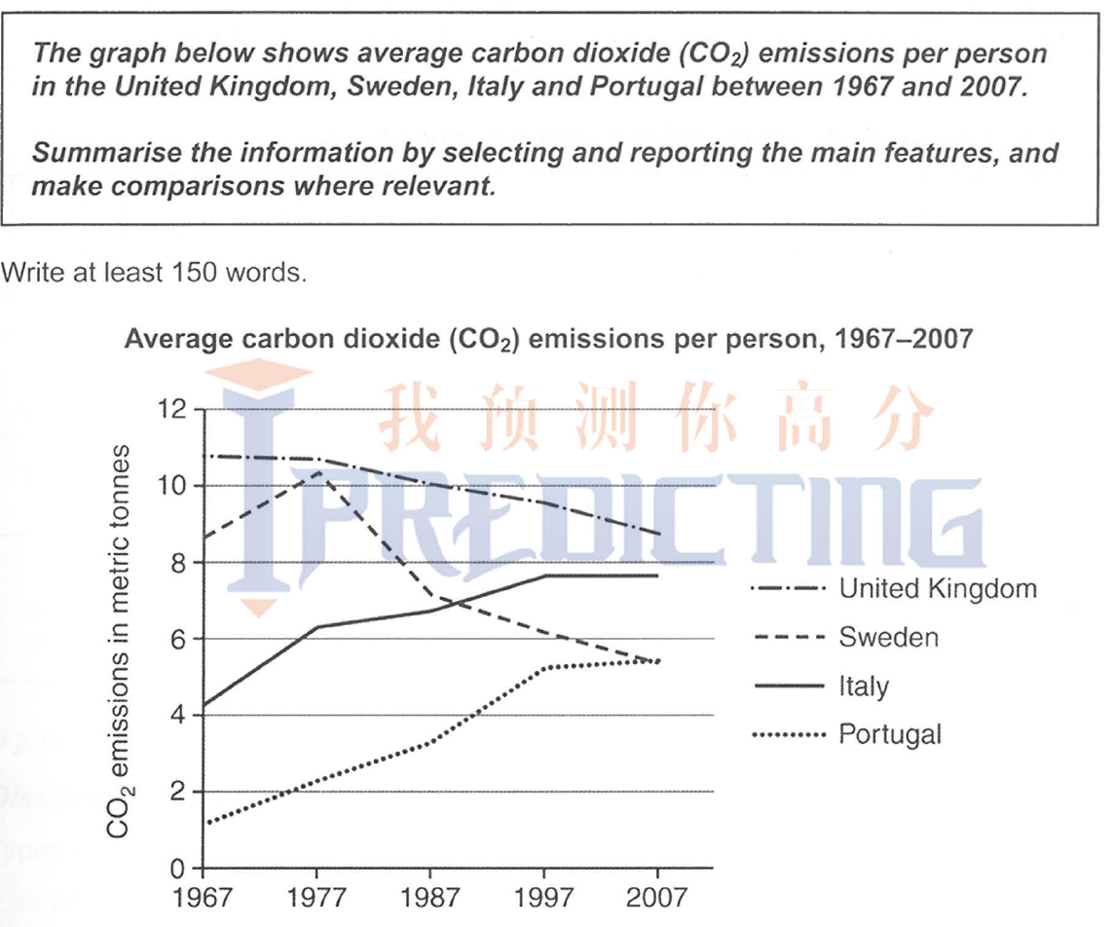

纵向分UK SW一组，IT PO一组：

The line graph apparently demonstrates the comparisons of average emissions per person concerning carbon dioxide in four different countries in Europe from 1967 to 2007.

From this graph, we can see that United Kingdom emitted the greatest amount of carbon dioxide among the four countries throughout the period. It decreased steadily from about 11 metric tonnes in 1967 to 8.8 metric tonnes in 2007. During the fifty years, the quantity for per person in Sweden increased sharply from 8.7 metric tonnes to 10.5 metric tonnes in 1980, followed by a significant decline to 7 metric tonnes before it consistently fell and ended at 8.8 metric tonnes.

In contrast, there was a steady growth in both carbon dioxide emissions of Italy and Portugal. The amount emitted of Italy started at 4.5 metric tonnes and was at the same level as the emissions of Sweden in 1990. Similarly, the quantity for per person in Sweden increased sharply from 1.2 metric tonnes and ended at the same level 5.5 metric tonnes by 2010.

Overall, the carbon dioxide emissions of the UK and Swedem rose, while the amount of Italy and Portugal fell. Although the UK stayed highest and Portugal remainded lowest during the fifty years，the gap among the four carbon dioxide emissions has narrowed by the end of this period.

作业

1. 表格，开头段，连接词背完
2. 背完后练作文

Day 1 ---- 练两条线的三次 + 写剑13 P51`

Day 2-----练三条线的三次 + 写剑9 P53

Day 3 ---练四条线 + 写剑11 P77

Day 4 ---练6条线的三次