**线图二 六条线**

**The graph below gives information from Annual Energy Outlook 2008 about consumption of energy in the USA since 1980 with projection until 2030.  
Summarise the information by selecting and reporting the main features, and make comparisons where relevant.**

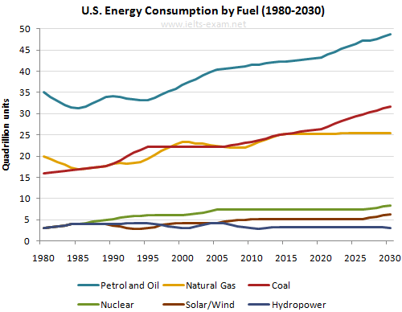



Model answer: A and B rose slightly from 100g and 80 g in 1990 to 200g and 150 g in 2000 respectively. 纵向分三段

Petrol and Oil ,Cocal, Natural Gas, Nuclear, Solar/Wind, Hydropower

The line graph apparently demonstrates the comparisons of energy consumption concerning different fuels in the U.S. from 1980 to 2030.

From the graph we can see that petrol and oil is the major sources of fuel and maintained a consistent upward trend from 35q in 1980 to 42q in 2012. During the period, the consumption fluctuated slightly between 1980 and 2005, followed by a steady climb to 40q in 2020 and is forecast to continue, reaching at 48q by 2030.

In contrast, consumption of energy from natural gas and coal followed a similar pattern throughout the period. During the first 10 years, natural gas began at 20q and showed an initial fall, while cocal remained a steady growth and equaled natural gas between 1985 and 1990. After a fluctuation, natural gas is predicted to increase to 31q in 2030, whereas cocal is expected to remain stable at 25q.

However, the consumption of solar/wind, nuclear, and hydropower were the least-used throughout the fifty years, with only 4q in 1980. Nuclear is forecast to slightly rise to 8q and solar/wind to 6q in 2030, while hydropower is predicted to remain approximately constant through the end.  
Overall, fossil fuels will remain the main energy source for the US ,with fuel oil occupying the cheif. The others including hydroelectric, nuclear, wind and solar account for a minuscule proportion.

作业

1. 表格，开头段，连接词背完
2. 背完后练作文

Day 1 ---- 练两条线的三次 + 写剑13 P51`

Day 2-----练三条线的三次 + 写剑9 P53

Day 3 ---练四条线 + 写剑11 P77

Day 4 ---练6条线的三次(讲义2)