线图一 三条线
The graph below shows the changes in food consumption by Chinese people between 1985 and 2010.
Summarise the information by selecting and reporting the main features, and make comparisons where relevant.
Write at least 150 words.
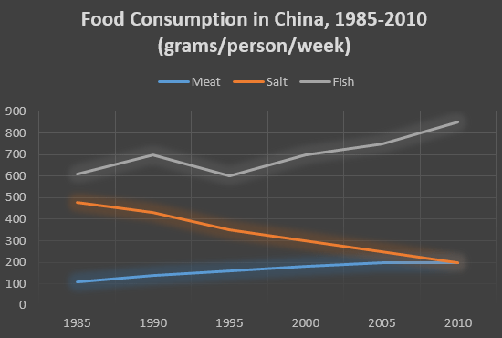
Answer: 3.
The graph shows changes in the amount of fish, salt and meat eaten per person per week in China between 1985 and 2010.
From the graph we can see that people in China consumed more fish than either meat or salt throughout the period. In 1985, the consumption of fish stood at 610 grams, then increased to 700 grams in 1990. Although it dipped in 1995, it then rose steadily and reached 850 grams in 2010.
In contrast, there was a consistent drop in salt consumption. The amount consumed decreased steadily from almost 500 grams per person to only 200 grams by 2010. The amount of meat consumed weekly started at about 100 grams. However, this gradually increased throughout the period. By 2010 it was at the same level as the consumption of salt.
Overall, the consumption of fish rose, while the consumption of salt fell. In addition, the consumption of meat, while at a relatively low level, rose significantly during this period.

线图二 六条线
The graph below gives information from Annual Energy Outlook 2008 about consumption of energy in the USA since 1980 with projection until 2030.
Summarise the information by selecting and reporting the main features, and make comparisons where relevant.
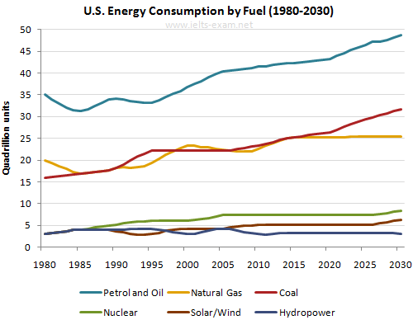
Model answer: A and B rose slightly from 100g and 80 g in 1990 to 200g and 150 g in 2000 respectively.
The graph shows consumption of energy in the U.S. since 1980 with projections through 2030.
The historical trends show Petrol and Oil as the major sources of fuel, rising from 35 quadrillion (35q) units used in 1980 to 42q in 2012. Despite some fluctuation between 1980 and 1995, there was a steady increase, which is expected to continue, reaching 47q in 2030.
Consumption of energy from natural gas and coal followed a similar pattern over the period. From 20q and 15q respectively in 1980, gas showed an initial fall and coal a gradual increase, with the two fuels equal between 1985 and 1990. Consumption has fluctuated since 1990 but both now provide 24q. Coal consumption is projected to rise to 31q in 2030, whereas after 2014, natural gas is forecast to remain stable at 25q.
In 1980, energy from solar/wind, nuclear, and hydropower was the least-used, with only 4q. Nuclear has risen by 3q, and solar/wind by 2. Since 2005, hydropower has fallen back to the 1980 figure. It is expected to remain approximately constant through 2030, while the others are projected to rise gradually after 2025.
Overall, fossil fuels will remain the chief energy source for the US, with a little bit of hydroelectric, nuclear and a smidgen of renewables like wind and solar.
(215 words)
柱图一 年份两项对比
The chart below shows the percentage of male and female teachers in six different types of educational setting in the UK in 2010.
Summarise the information by selecting and reporting the main features, and make comparisons where relevant.
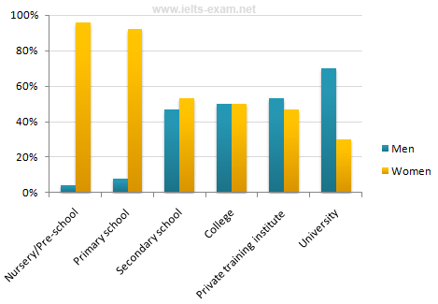
model answer:
The bar chart gives information about the gender of teachers in six types of educational institutions in the UK in 2010. It shows what percentage of teachers was male and what percentage was female.
Women dominated the teaching profession in primary education, but less so at lower and upper secondary education. It was particularly true of nursery school, where the share of female teachers was above 95%. Similarly one-sided was the situation in primary school, where over 90% of teachers were also female.
At secondary and upper secondary level this pattern was less pronounced, where there were nearly equal proportions of male and female teachers. On the other hand, male teachers outnumbered female teachers in high-level education, where the proportion of men was twice that for women.
Overall, the higher the level of education, the more male teachers dominated, and the reverse occurred with respect to female teachers.

柱图二 年份多项对比
The bar chart below shows shares of expenditures for five major categories in the United States, Canada, the United Kingdom, and Japan in the year 2009.
Write a report for a university lecturer describing the information below.
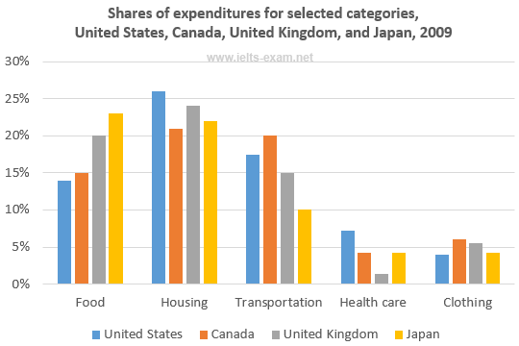
- 占比多的先写，指的value,不是x
- Model Answer：
The bar chart compares how consumers in the United States, Canada, the United Kingdom, and Japan allocated different shares of total spending to categories such as food, housing, and transportation in 2009.
We can see that the United States had the highest housing expenditure share, 26% of total expenditures in 2009. The United Kingdom and Japan followed, with 24% and 22%, respectively. Canada had the lowest housing share at 21%. Housing was the largest expenditure component in all countries except Japan.
By contrast, Canada had the largest transportation share of all four countries at 20%. The United States and the United Kingdom had the next-highest transportation shares, 17% and 15%, respectively. Japan had the lowest, at 10%.
However, in Japan, consumers spent 23% of their total expenditures on food in 2009. The United Kingdom had the second-highest share at 20%. Canada, with 15%, and the United States, with 14% had the lowest food expenditure shares among the countries studied.
Overall, the data indicates that housing and health care shares of total expenditures were higher in the United States than in Canada, the United Kingdom, and Japan in 2009, whereas Americans had the lowest clothing share. Canada had the highest clothing and transportation shares, and Japan had the highest food share, among the countries compared.

90%考双饼图

饼图一 两幅对比
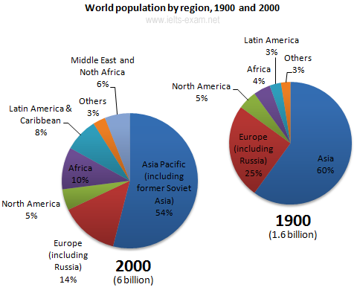
双饼图：大升，小升，大降，小降，不变，新出现
转换成表，由最大的顺时针转
population | 1900 | 2000
Asia Pacific | 60% | 54%
Europe | 25% | 14%
North America | 5% | 5%
Africa | 4% | 10%
Latin America | 3% | 8%
Others | 3% | 3%
Middle East and North Africa | 3% | 6%

The pie charts illustrate changes in the population of different areas of the world between 1900 and 2000. The major regions are represented as percentages of the total world population.
如果有倍数关系，优先倍数关系
From 1900 to 2000, the percentage of people living in Africa more than doubled from 4.5% to 10%, while Latin America’s proportion almost tripled in the same period. On the other hand, the percentage of population in Europe and Asia decreased over the last century. Europe’s percentage dropped from 25% to 14%, while Asia declined from 60% to 54%. North America’s percentage however, remained constant at 5% in 1900 and 2000. The Middle East and North Africa, a new category in 2000（插入语不影响句子）, represented 6% of world population.
Overall, this represents a huge increase in the number of humans on the planet, from 1.6 billion to 6 billion in just one century. Most of this population growth has occurred in developing countries.
饼图二 三幅对比
The three pie charts show the changes in annual spending by a particular UK school in 1981, 1991 and 2001.
Summarise the information by selecting and reporting the main features, and make comparisons where relevant.
三个时间点，分段：总量最大的先写（ teachers & other workers）
一直上升或一直下降的，给起点终点
三个波动的，给中间值top,bottom和最后值
如果是4个饼是一样

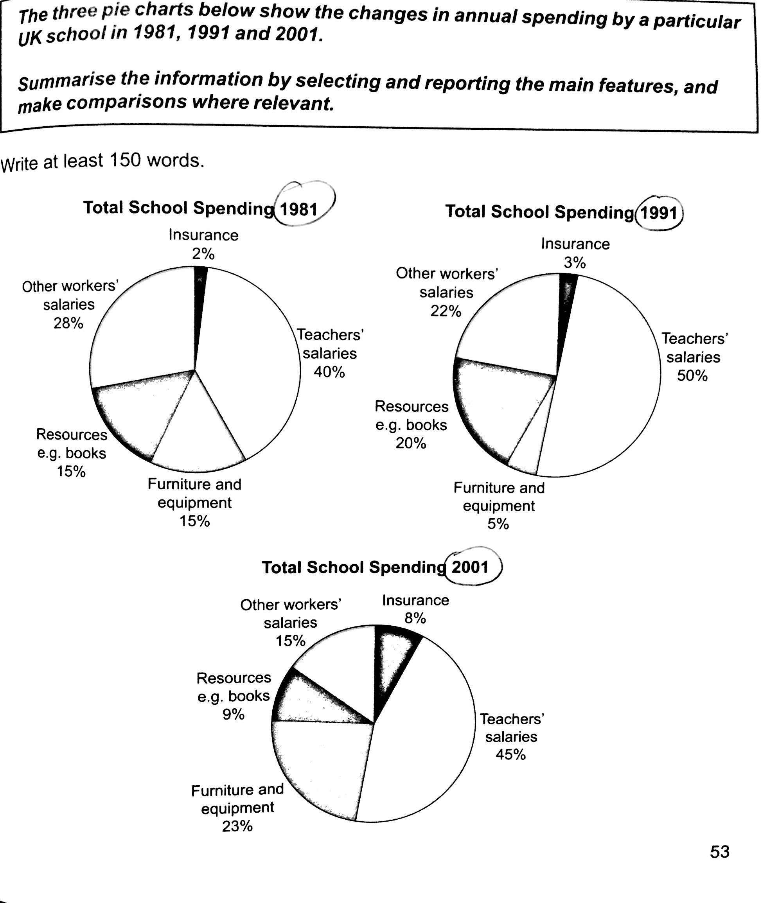
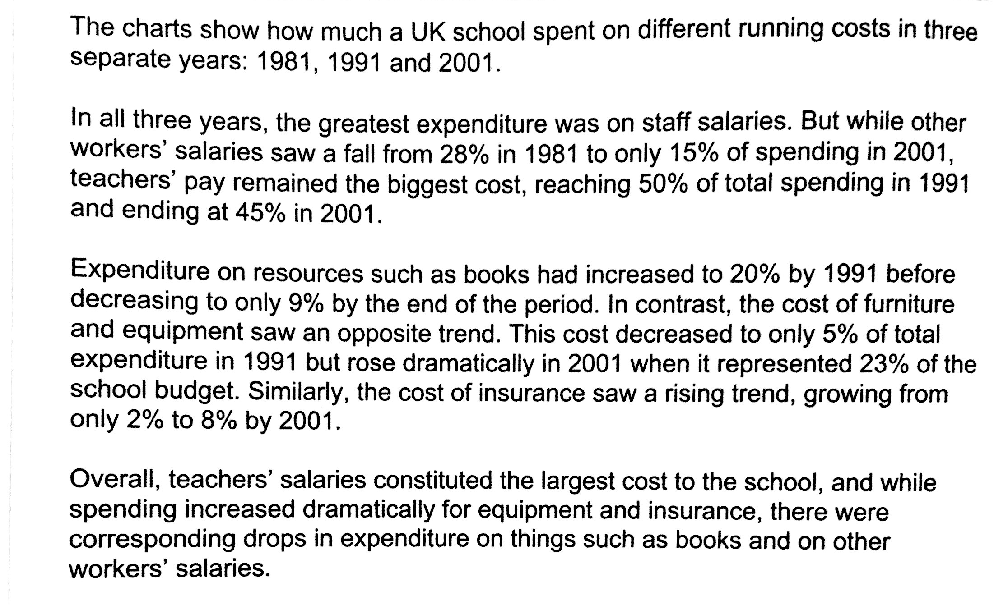
相应的 there were corresponding drops in expenditure

表图一 数据少且不能转成饼
The table below shows the monthly expenditure of an average Australian family in 1991 and 2001.
Summarise the information by selecting and reporting the main features, and make comparisons where relevant.

 | 1991 | 2001
 | Australian Dollar Per Month
Food | 155 | 160
Electricity and Water | 75 | 120
Clothing | 30 | 20
Housing | 95 | 100
Transport | 70 | 45
Other goods and services* | 250 | 270
Total | 675 | 715
*Other goods and services: non-essential goods and services

大升 -- 小升 -- 大降 --- 小降（2个，如果是3个那么就是线图）

Model answer： A and B rose slightly from — and —— in 1991 to __ and in 2001 respectively
The monthly expenditure of food and housing rose slightly from $155 and $95 in 1991 ollar to $160 and $100 in 2001 respectively.

高分句型，同义词替换，
只有表格题一定要先总再分，结尾段抓主要特征写。

Overall It seems that housing was the biggest items of expenditure. Altogether, it accounted for more than one third of the total living spending. By comparison, Australians spent little on tobacco.

Over all, it seems that housing and other goods and services were the two biggest items of expenditure. Altogether, they accounted for more than half of the total living spending. By comparison, English spent little on tobacco.

The table shows changes in the spending patterns of an average Australian household between 1991 and 2001. In general, Australian household spending was higher in 2001 than in 1991 but the difference was not significant (AUD $715 per month and AUD $675 (第一次出现时候使用) per month respectively).
The amount of monthly spending on electricity and water saw a dramatic increase over the 10-year period from $75 to $120. Yet in terms of （7分表达，然而在。。。方面）the expenditure on non-essential goods and services, the rising trend was less obvious with a minor increase of $20. At the same time, the amount of money spent on food and housing rose only slightly from $155 to $160 and $95 to $100 respectively.
However, there was a decrease in expenditure on the other two items. Australians spent one third less on clothing, which fell from $30 to $20. Similarly, expenditure on transport dropped from $70 in 1991 to $45 in 2001.
Overall It seems that food and “other goods and services” were the two biggest items of expenditure. Altogether, they accounted for more than half of the total household spending. By comparison, Australians spent little on dressing up.
(188 words)

表图二 数据多
The Table below shows the results of a survey that asked 6800 Scottish adults (aged 16 years and over) whether they had taken part in different cultural activities in the past 12 months.
Summarise the information by selecting and reporting the main features, and make comparisons where relevant.
Participation in cultural activities, by age
 | 16-24 | 25-44 | 45-74 | All aged 16 and over
 | % | % | % | %
Any performance* | 35 | 22 | 17 | 22
Undertaking any crafts | 11 | 17 | 22 | 19
Cultural purchases | 11 | 17 | 18 | 16
Any visual arts | 30 | 16 | 11 | 15
Any writing | 17 | 6 | 5 | 7
Computer based | 10 | 9 | 5 | 6
* Dancing, singing, playing musical instruments and acting

Model answer
The table shows details of participation in a variety of cultural activities over a year, according to the age of the participants.
Overall, any performance, which includes dancing, singing, playing musical instruments and acting, had the highest level of participation, with 22% of respondents participating in the previous 12 months. By contrast, computer based activities had the lowest level of participation (6 per cent).
People aged between 45 and 74 years old were most likely to undertake any activity to do with crafts (22 per cent), while performances were more likely to be participated in by those aged 16 to 24 (35 per cent). The differences between age groups were particularly marked in the case of visual arts and writing categories, where participation rates were around three times higher for younger people than for the older ones. It is clear from the evidence that age plays a significant role in the popularity of the cultural activities listed.
(157 words)

