### Hometown

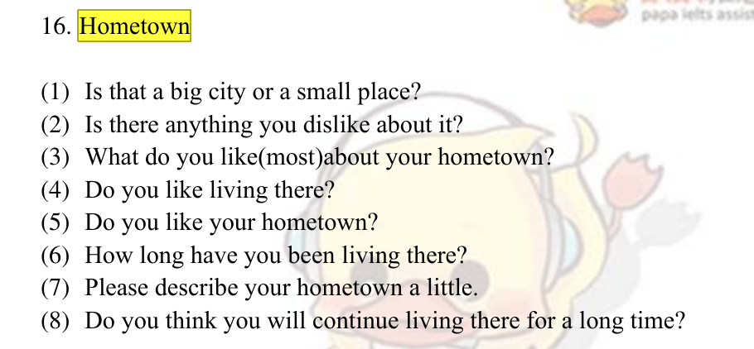

1. My hometown is Yueyang and it’s located in the eastern southern part of china.
2. Yueyang has the worldwide reputation for Yueyang Tower and Yueyang Barbecue.
3. It’s a small city with beautiful and natural landscape.
4. I personaly believe that Yueyang is less competitive and stressful than big cities. Yueyang is pretty peaceful and tranquil and it is the perfect place for young people to grow up in.

### Major

1. My major is Computer Science and technology.
2. The Intenet is promising and high demanded. I am really into and I am always a believer that i was born for CS and my dream is to be a schoolor in CS one day.

### 1. Sky

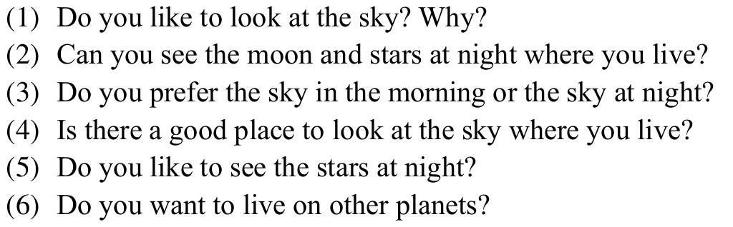

1. Yes, I like it very much. Because when I look at the sky, there are blue background, white clouds and sometimes lovely birds. Just like a picture. This frees me from my tired life and relaxes me. Especially in spring, my classmates and I fly kites on the grass. It is a very proud thing to watch our kites fly in the sky.
2. Yes, sometimes. I live in Changsha, a medium city with well-developed facilities. It is well known that Changsha is rainy all the year round, so I can only see it on a clear night. I run 6km along Hou Lake at night every two days, when I can see the moon and stars hanging on the beautiful night sky. I really like the feeling of running and sweating at night.
3. It depends on the season. In the hot summer, I prefer the night sky, because there was no hot sun during the day, and I could enjoy the cool summer night. On the contrary, I prefer the morning sky in winter, because it means the beginning of a new day, and the winter sun warms up the world.
4. Yes, I know two great places. The first is the roof of Tianma Apartment, and the other is the top of Yuelu Mountain. My friend and I often climb eight floors to enjoy the night view on the roof. On the roof, we can see the beautiful scenery of Yuelu District, such as colorful lights, bustling night market and even gorgeous fireworks. If you want to see the sky in the morning, you can go to the top of Yuelu Mountain. Last year, I climbed to the top of the mountain before 5: 00 and enjoyed the stunning sunrise, which impressed me deeply.
5. Yes, I like it. The sparkling stars are like children's eyes blinking. Stars remind me of watching the night sky with my grandfather when I was a child. We sat on the grass and counted the stars one by one. It's a touching memory.
6. Of course, What a desirable thing it is! when I was a child, my dream was to become an astronaut and travel on different planets in the universe. In order to live on other planets, I may have to learn other languages to communicate with aliens and prepare plenty of food to survive. But at present, human beings have no ability to emigrate to other planets, and I think it may be 100 years later.

### 2. Special costumes

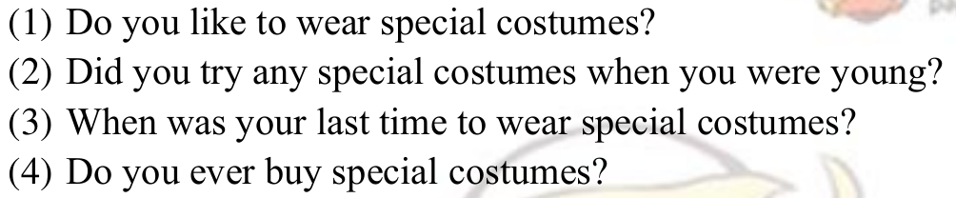

1. No, I don't like it. I'm not outgoing, and I don't like to dress up strangely. My major is computer science, and I often call myself code Monkey. Therefore, compared with special clothes, I prefer to wear plaid shirt, which is the symbol of code monkey. But I think I should try some special clothes actively, which will make me more outgoing and make more friends.
2. Of course, when I was 10 years old, I took part in a Children's Day performance.All children, including me, cosplay into their favorite cartoon characters, such as Superman, GG Bond and the Monkey King. I dressed up as my favorite Spider-Man. When I put on special clothes, I felt excited and had a good time.
3. The last time I ran for 14km at night, the clothes I wore were very special. I wore a vest with holes in my upper body and loose shorts in my lower body. This makes it easier for me to run and let the sweat run away. In fact, many marathon runners wear such special clothes, and I really like the feeling of wearing it.
4. No. As a student, I have no job, so I have no money to buy special clothes. I think I should put more energy into my study instead of shopping. So when buying clothes, I will try to choose cheap and practical clothes. I hardly ever buy special clothes.

### 3. Car trip

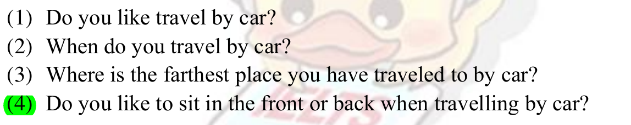

1. Of course. Actually I haven't got my driver's license yet, so I really want to own a car and drive it freely to various tourist areas. I think traveling by car is a really happy thing. I can enjoy the beautiful scenery, experience richer culture and eat all kinds of delicious food with my friends. More importantly, you can start at any time.
2. I travel by car only when necessary. For example, when I am late for class, I take a taxi to save time. Besides, I also travel by car in hot summer or when it rains heavily. In normal times, I prefer to walk to class, because the distance between classroom and dormitory is not very far, so I can relax myself by walking.
3. I guess it's Guangdong, a metropolitan city with millions of dwellers located on the southern coast of China. That driving trip was far enough for me and left a deep impression on me. Road trip is really tired! But it's worth it because of the beautiful scenery along the way.
4. I definitely love to sit in the front as that position helps me to avoid getting severe car sick.

You know, the front window allows me to have a wider vision so that I can enjoy the sceneries

outside which would divert my attention from the discomfort that a car trip brings me.

### 4. Barbecue

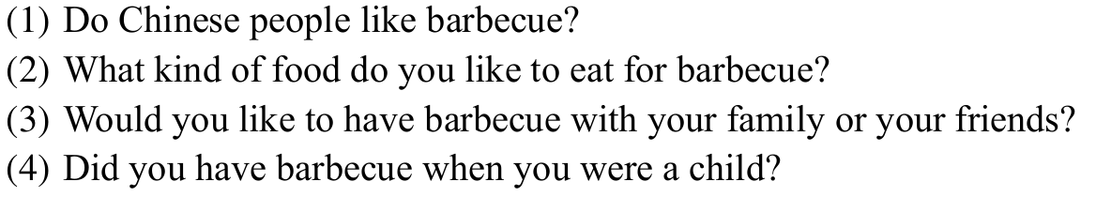

1. Yes, we like it. We like to eat barbecue, especially on summer nights. You can see a lot of barbecue restaurants in the evening, and all your friends get together and have fun drinking beer and stuttering barbecue. My hometown Yueyang is civilized by barbecue, which we call Yueyang barbecue.
2. My favorite food is chicken legs with a little spicy taste. It's not as hard as beef, and it's not very soft. It tastes very good. Sometimes I like to eat some vegetables, such as sweet peppers and tomatoes. They are rich in vitamins and good for health. Besides, I like to drink juice and beer. You know, we can't eat barbecue without beer.
3. I' d like to have it with my family. You know, I' ve had barbecue with my friends many times this year, and it seems that this is a nice social event that helps improve our friendship. However, I regret not having many opportunities to dine with my parents. So, I am more willing to grill some meats and veggies with them.
4. Of course, when I was a child, I used to eat barbecue on the street. At that time, there were many barbecue stalls on the street, which provided all kinds of food. Because the economy of the city was underdeveloped at that time, we ate more vegetables than meat. We still think the barbecue tastes delicious, so we ate it every weekend.

### 5. Flowers

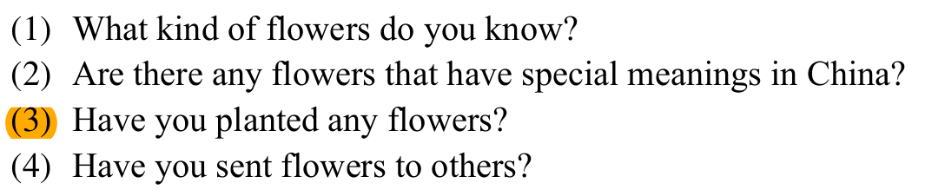

1. I know lilies and carnations. We usually send lilies to friends when they are in the hospital. We send carnations to our mothers on Mother's Day to show our love for them. Just like Mother's Day this year, I gave carnations to my mother, which made her very moved. I think this is what I should do
2. Yes, there are. As far as I know, in Chinese culture, lotus symbolizes ultimate purity of the heart and mind and perfection. You know, it grows from the mud but has an uncontaminated appearance. So, the Chinese usually use this flower to represent the good quality of a person.
3. No, I haven' t. Both my parents and I are quite busy working and studying. So, we don' t have flowers at home. My roommate planted some beautiful flowers in the dormitory. It is very beautiful. Therefore, I think planting flowers can relax us, which is very important for students under great pressure
4. Yes, I sent some mixed flowers to my girlfriend on May 20th this year, and she was very happy. That was the first time I sent flowers to her, and I hope we can be together for a long time. This is a sweet memory.

### Advertisement

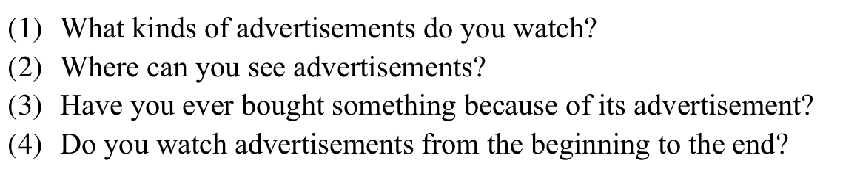

(1) I like surfing the internet, so I can see all kinds of commercial advertisements. They shot out of the web page to promote a certain product, which annoyed me. On the contrary, I like public service advertisements very much because they try to solve social problems instead of marketing.

(2) Online, on mobile apps, on websites, on the subway. There are adverts pretty much everywhere in our lives where we are in commercial places, cities, malls, transport facilities, online, everywhere. I hate commercial advertising because it forces the sale of goods. I hope there can be fewer advertisements in the environment to make the city more beautiful

(3) Of course, although I hate advertising, I bought some things because of them. After reading Nike's advertisement, I feel how excellent Nike's shoes are. He can improve my running speed and reduce the risk of injury, so I bought a pair of pegasus 37. To be honest, these shoes performed really well.

(4) Usually not. I try to ignore them or skip them. I only watch some interesting advertisements, such as sports advertisements and science advertisements. I will skip other advertisements to save my time. But on the subway, I have nothing to watch except the advertisements on the screen, so I have to watch these boring advertisements.

### 7. Relax

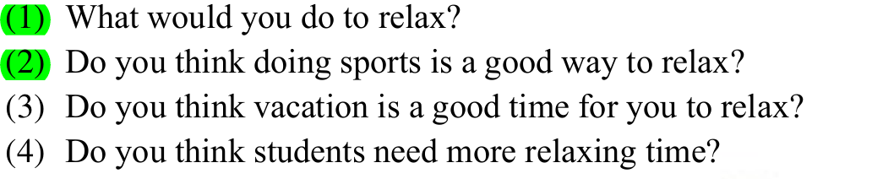

1. Usually, I relax myself by watching movies, running and doing programming problems. If the long vacation comes, I will spend a week traveling, experiencing the customs of different places, eating all kinds of delicious food and enjoying the scenery. This is the best way for me to relax.
2. Of course, I think exercise is an excellent way to relax. Nowadays, college students are under great pressure to study, usually from 8: 00 in the morning to 23:00 in the evening. Although this improves their grades, it also harms their health. Doing sports can strengthen your physique and make your body more relaxed.
3. Of course. Holidays are definitely a good time to relax! Last National Day, my friends and I traveled to Xi 'an by train. We saw all kinds of scenery and ate delicious food along the way. That trip was very relaxing, and I didn't have any study pressure.
4. I think students are under a lot of pressure and so they do need more relaxation time, yes. I think that they also need to learn better how to manage their time. Usually the more motivated students tend to manage their time better between studying, working and relaxing with friends or alone.

### 8. Environmental protection

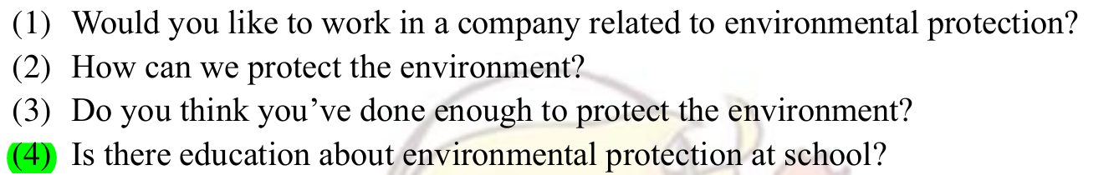

1. Yes, I’d like to. If I am qualified to work in an environmental protection company, I will be very happy, because it can not only make money but also protect the environment. My major is computer science and technology, and if I go to work, I am also engaged in Internet-related positions.
2. We can start from the little things in life. For instance, no littering is already a good start to protect our environment. When we go to school, we can choose to take bus or subway, which can reduce exhaust emissions. Besides, we can also publicize environmental protection to the students around us, so that more people can participate in it. You know, many people make great efforts.
3. No, I don’t think so. I always feel like there’s more I can do. My awareness of environmental protection is not strong enough, and sometimes I accidentally pollute the environment. For example, I often go to school by car instead of by bus. I should pay attention to it and practice it in my life.
4. Of course, as far as I know, our school regularly organizes the cleaning of apartments. Student volunteers pick up garbage and do greening together, which makes the apartment cleaner. But the propaganda of environmental protection theory is less than the practice. The school has hardly organized lectures about environmental protection.

### 9. Primary school

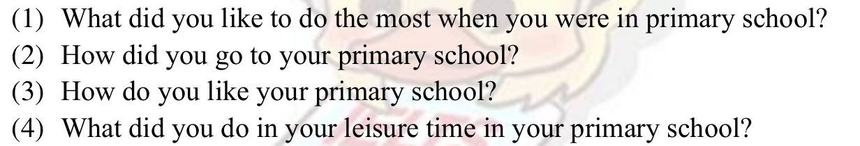

1. I enjoyed playing ping pang with my friends. When I was a child, there were no video games to play. We often rushed out of the classroom to play ping pang after class. I liked to be with my friends. There was no trouble but happiness
2. I went to school on foot. My hometown is a collection of villages with rich natural resourcesit. There was no bus to school, so we often went to school in groups. Now, with the development of economy, all the children in the village go to school by bus.
3. I quite enjoyed it, I think. Although my primary school is small, it is full of vitality. In primary school, I made many good friends and played with them happily. We don't have study pressure, so we don't have to worry about our grades. The teachers in the school were also very kind and cared about us.
4. I usually played ping pang. I was really into ping pong, so in my free time I spent a lot of time outside playing football. Besides, I read some interesting experimental books, which teach us to do some small experiments in our lives. It greatly aroused my interest.

### 10. Wild animals

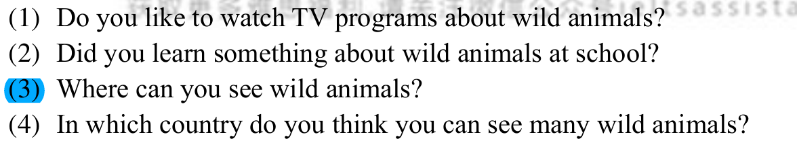

1. I love wildlife documentaries. This program made me see strange animals from all over the world, such as elephants, lions and hippos in Africa. Also let me learn a lot about animals. More importantly, it makes me very relaxed.
2. Absolutely. We studied biology in high school and introduced a lot of animal knowledge. I'm very interested in biology, I enjoyed these kind of lessons to be honest. Besides, we learned about the relationship between animals and humans in the lecture on environmental protection. Protecting animals is also a way to protect the environment
3. At the zoo, of course. Because I live in the city, there are not so many wild animals, so we can only see them in zoom. To be honest, I haven't been to the zoo once. If I have time, I will definitely go with my friends.
4. I think it's in Brazil. It is well known that there are the most diverse animals in the tropical rain forest. If we want to go to the tropical rain forest in Brazil, we should pay attention to personal safety, because it is too dangerous. It's a fantastic experience I'd love to have to be honest.

### 11. Wallet

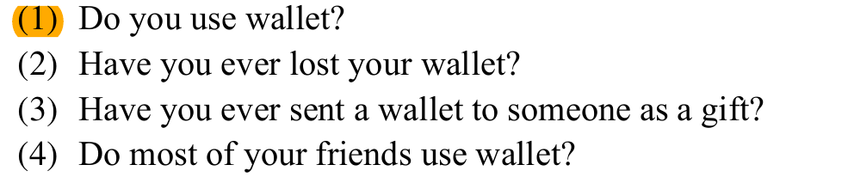

1. Hardly ever. I have a small black wallet, which I use to hold my ID card and bank card. But I usually don't take it with me but put it in my dormitory. Because we all use e-payment method in China, such as WeChat, Alipay. They are much more convenient than wallets. We can complete the payment only by mobile phone.
2. Never. I only have a small wallet, and I have never lost it. Because we all pay with mobile phones, our wallets should be mobile phones. I never lost my mobile phone as well, I protected it very well. I think we should avoid losing documents instead of money now, because we hardly need cash.
3. No, I haven’t. I didn’t even think about it when choosing present for my friends. Because no one uses a wallet, it is not appropriate to send it. I usually send books to my friends. But for older people, such as my father, I will consider giving him a wallet for his birthday. ( 精简 )
4. No, they don’t. It seems fewer friends of mine use wallets nowdays. This is because mobile payment is becominng more and more popular. They could literlly just take a phone to go shopping anywhere in the city, which is really convenient.

### 12. Holidays

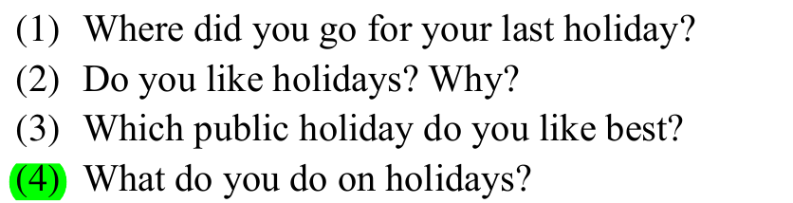

1. The last festival was Dragon Boat Festival, and I didn't go anywhere that day. Because those days were exam weeks, I had to prepare for my final exam and try my best to get good grades. I get up at 6: 30 every morning and go to the library to study until I return to the dormitory at 22: 30 in the evening.
2. Of course, I think holiday is a good time to relax. Nowadays, college students are under great pressure to study, usually from 8: 00 am in the morning to 23:00 pm. Although this improves their grades, it also harms their health. We can relax ourselves on holidays, both physically and mentally
3. My favorite holiday is National Day, which celebrates the founding of New China. I like it because I can watch the National Day military parade and these seven days to travel. Last National Day, my friends and I traveled to Xi 'an by train. We saw all kinds of scenery and ate delicious food along the way. That trip was very relaxing, and I didn't have any study pressure.
4. Well, for me, holidays are always an opportunity to relax. I usually travel to new places, to look for adventure. Sometimes, I also stay in school, play computer games with my friends. Even on holidays, I will run 6km every 2 days to exercise

### 13. Festival

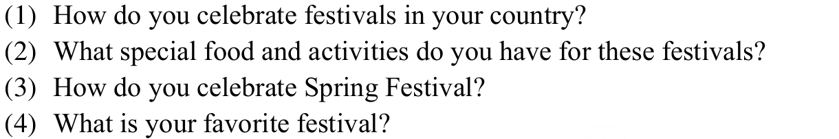

1. We usually get together with our families for a big meal. We will also eat some symbolic foods such as dumplings which represents being wealthy, zong zi , the sticky rice packed with bamboo leaves. We also watch movies and CCTV to celebrate the festival.
2. Usually my parents cook their favourite dishes at festivals. My sister and I make dumpling. I also prepare Hot pot to share the nice food with family. I go to the supermarket to buy food that my family likes.
3. Spring Festival is the biggest festival in China and a wonderful time for reunion. We will get together for a big meal, set off firecrackers with kids to kick the bad luck away. We also stay up late to watch CCTV show, which is a special program that will only be available during the Spring Festival. ( 不要讲太多，集中一点观点 )
4. My favorite holiday is National Day, which celebrates the founding of New China. I like it because I can watch the National Day military parade and these seven days to travel. Last National Day, my friends and I traveled to Xi 'an by train. We saw all kinds of scenery and ate delicious food along the way. That trip was very relaxing, and I didn't have any study pressure.

14. House(低频疑似,待确认)



1. I live in Tianma Student Apartment, and there are three roommates in my room. The decoration of the room is very simple. There are two lights on the ceiling and a supermarket outside the window. The apartment is crowded, but full of fun.
2. I hope to buy a suite in Shanghai in the future. The apartment doesn't need to be big, but it is quiet. I hope to live in harmony with my neighbors and care for each other. I also hope that the apartment is very close to the company, so that I don't have to squeeze the bus to work and get off work every day.

### Tree

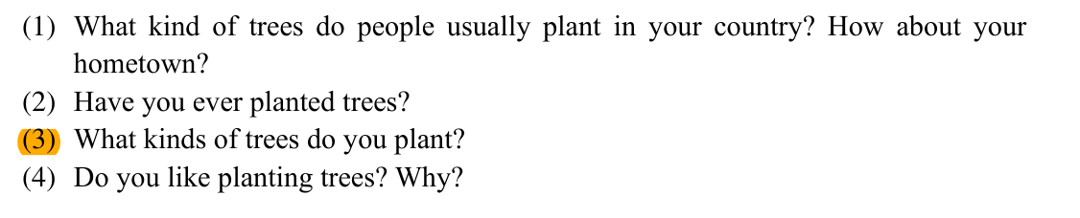

1. We often plant fruit trees in China, such as peach trees and pear trees. Orange trees will be planted in my hometown, and we will harvest a lot of fruits every autumn
2. Last year, the Arbor Day class organized group building activities, and we went to the school open space to plant trees.

（3）Yes, because it can not only harvest fruits, but also protect the environment and purify the air