## Questions

**The following questions were both used in a survey and an interview format.**

**Q1. How accurate were the responses provided by the system?**

Not at all accurate – Slightly accurate – Somewhat accurate – Moderately accurate – Extremely accurate



**Q1a. If you found the responses inaccurate, misleading, or unnecessary, please provide examples.** *(If the participant answered “Extremely accurate” to the previous question (Q1), this question will be skipped. Otherwise, this question will be asked.)*

[Open field]

**Q2. Did the response provide sufficient supporting information to justify the responses?**

Yes / No

**Q2a. Please explain what information was missing in the responses.** *(If the participant answered “Yes” to the previous question (Q2), this question will also be asked.)*

[Open field]

**Q3. How likely are you to use this system to find answers related to the questions?**

Extremely unlikely – Unlikely – Neutral – Likely- Extremely likely

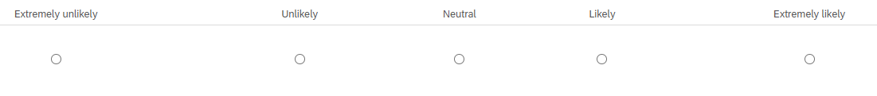

**Q4: How easy was it to interact with the system compared to acquiring the required information from other tools (e.g., Azure DevOps, Jira, GitHub Issues)?**

Very difficult – Difficult – Neither difficult nor easy – Easy – Very easy



**Q5. Which tasks would you use this system for? Please select all that apply.**

* Understand context by identifying dependencies between work items (e.g., epics, features, user stories, tasks, and bugs)
* Perform impact analysis to assess changes and risks
* Track progress and status of work across different sprints or iterations
* Troubleshooting and issue resolution
* Optimize resource allocation
* Onboarding new team members and knowledge sharing
* Trace link recovery

**Q5a. Are there any other tasks that you would use this system for? Please specify.**

[Open field]

**Q6: What aspects of the system could be improved?**

[Open field]

**Q7: Do you have any additional comments or suggestions?**

[Open field]