1. Password Reset after clicking Forgot Password

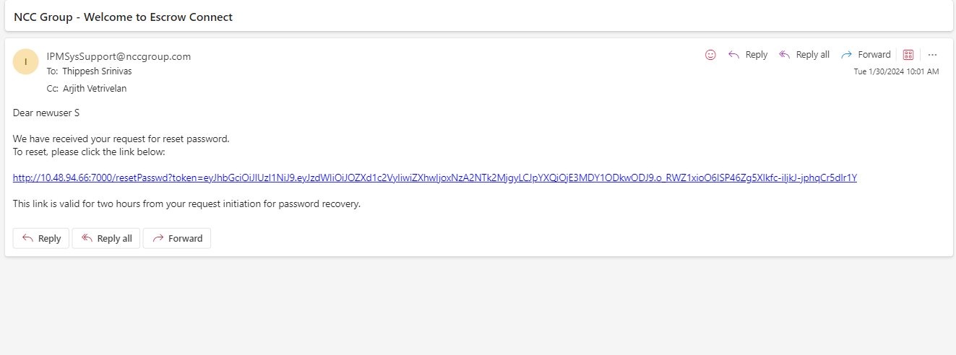

1. After Changing the Password in the Application

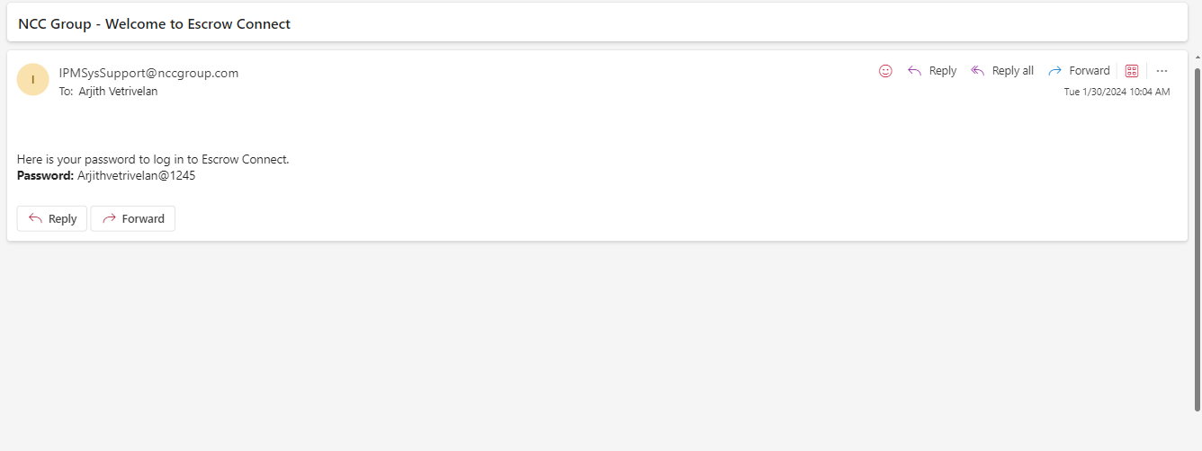

1. Add SFTP Account Request

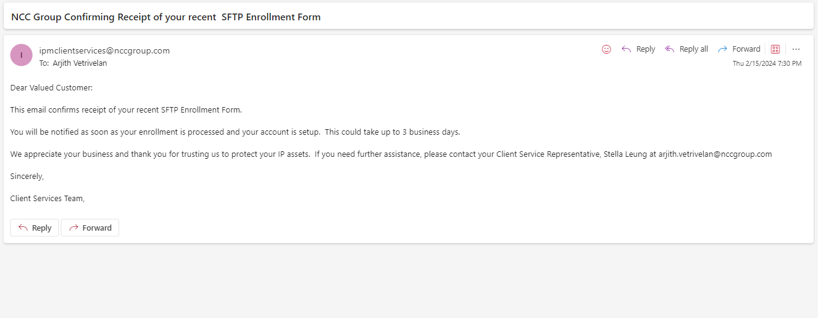

1. Add GitHub Account Request

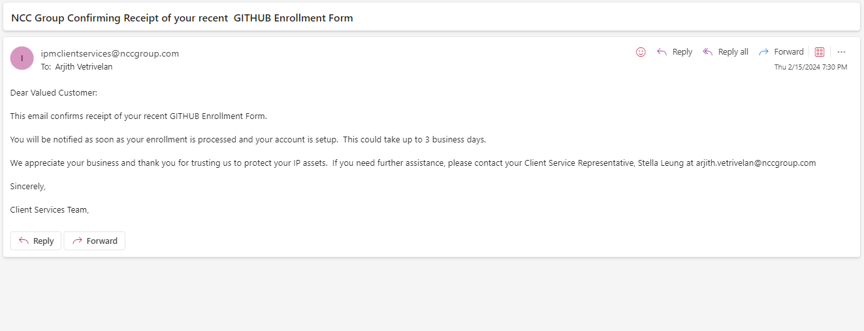

1. When the User Account gets blocked

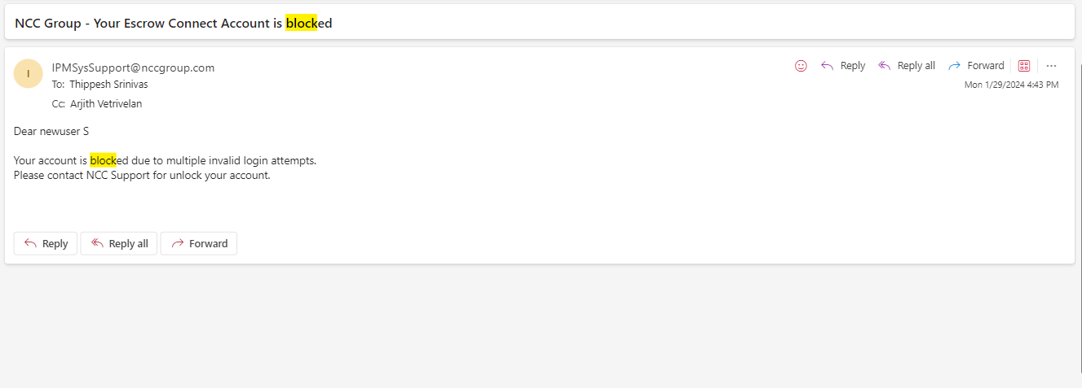

1. Add Electronic Deposit (Failure)

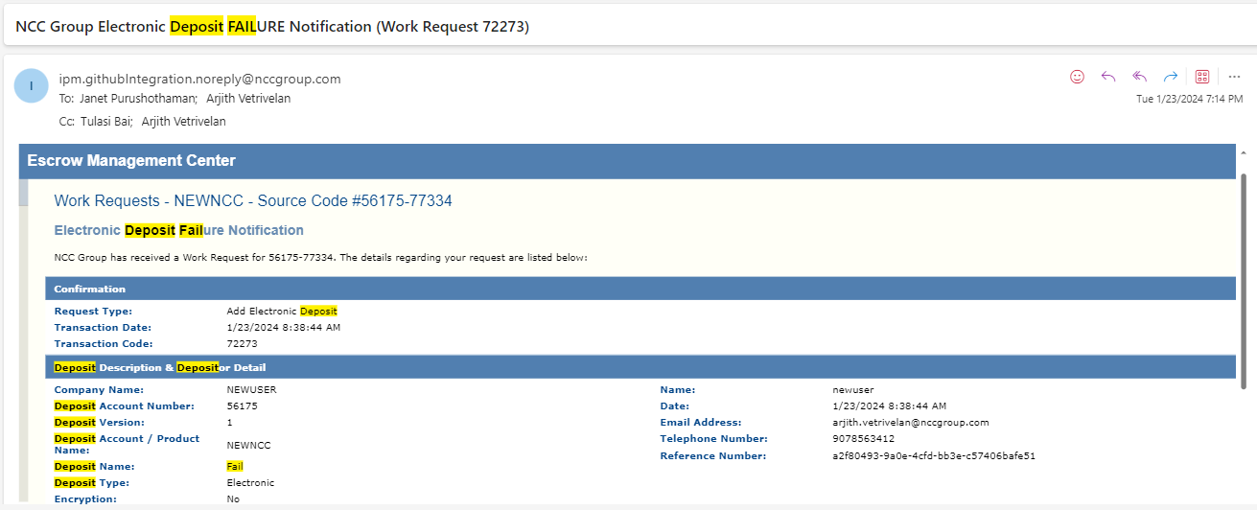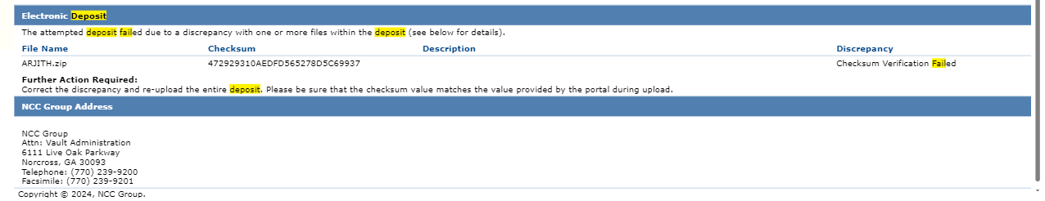

1. Alerts Setup

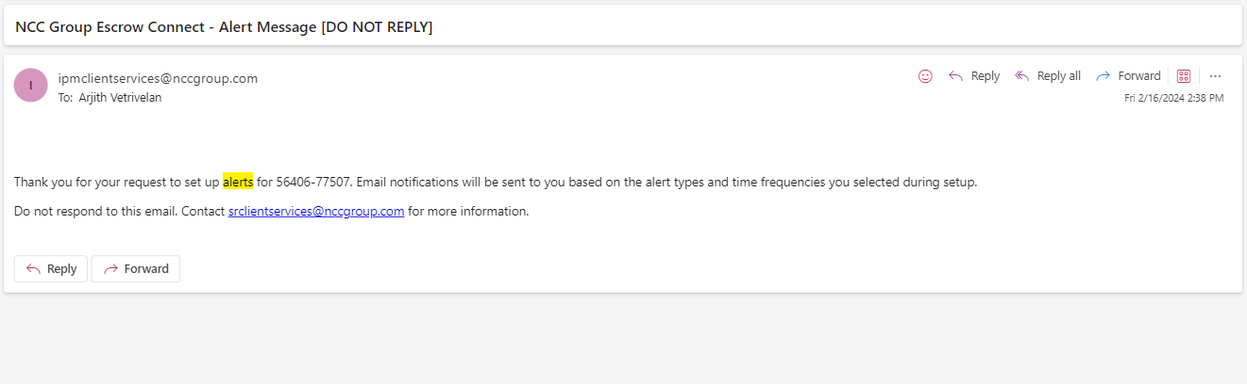

1. Alerts – No Deposits added.

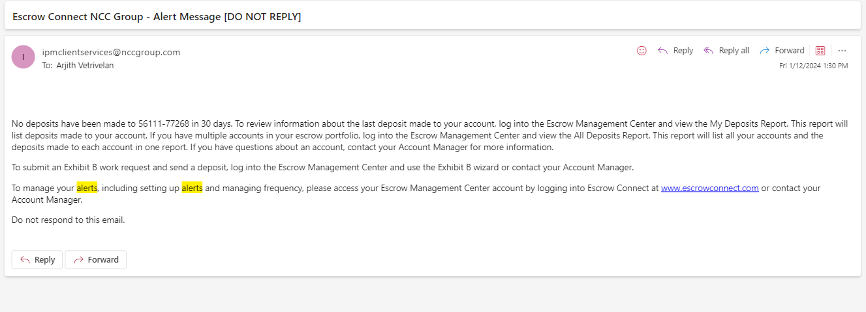

1. Alerts – No Beneficiaries added.

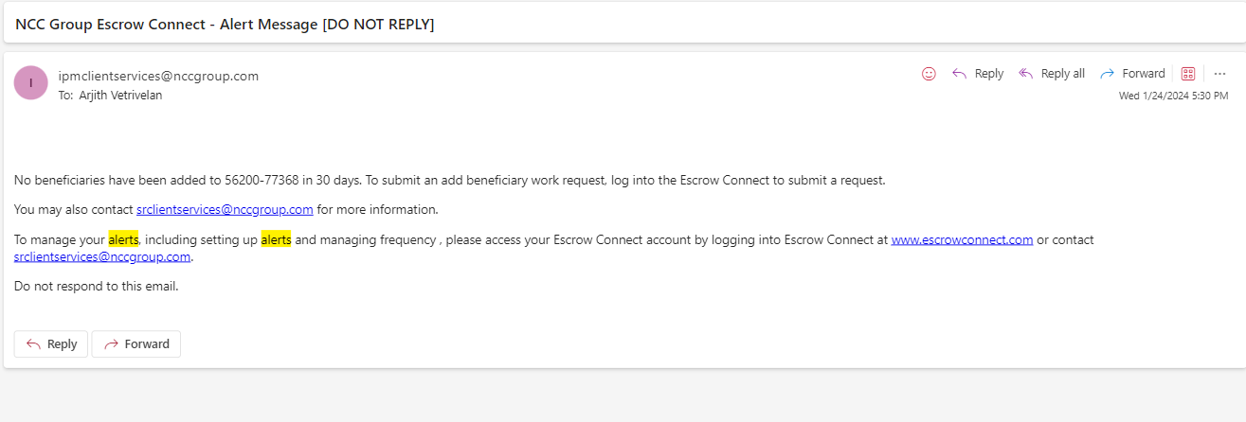

1. Alerts – Deposit Account due for renewal

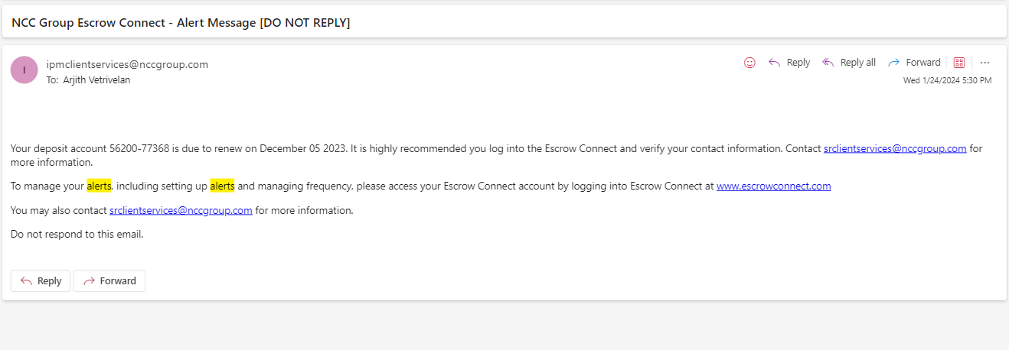

1. GitHub – Deposit Retrieval Success

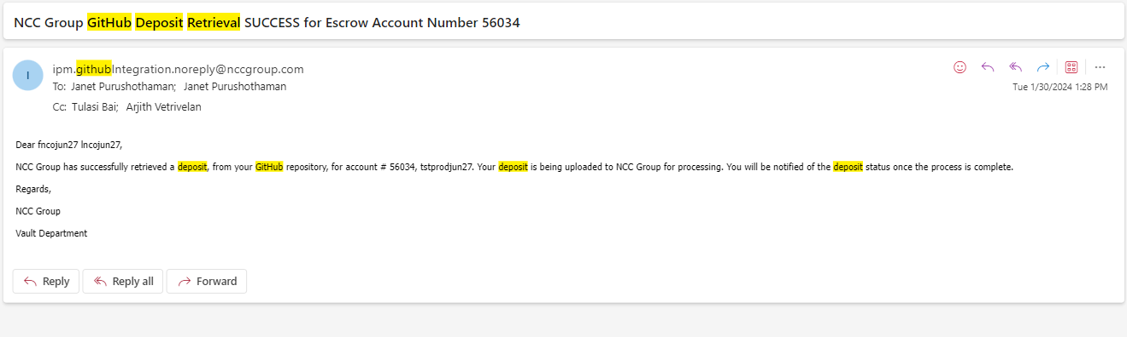

1. GitHub – Deposit Receipt Success (Exhibit B Generated)

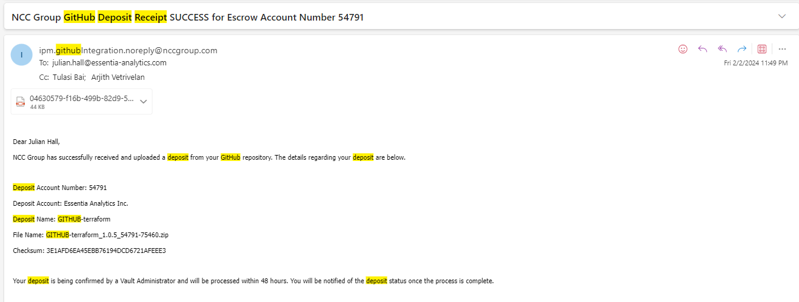

1. GitHub – License Plate generated

