Scheduler

Requirements Document

Authors: | Terrance Perry  Victor Akinla  Sebastian Perez
Date: | Aug 26, 2019
Version Number: | 1
Status: | In progress

Table of Contents

1 Document Control 3
1.2 Associated Documents 3
1.3 Glossary of Terms 5
2 Purpose of this Document 6
3 Introduction 7
3.1 Background 7
3.2 Objectives of this Project 7
3.4 Scope of this Project 7
3.5 Exclusions from Scope 7
4 Business Requirements 8
4.1 Business Process Overview 8
4.2 Detailed Business Requirements 8
4.3 Data Requirements 9
5 Non-Functional Requirements 9
5.1 Customer Experience 9
5.1 Search Engine Optimisation 9

Document Control

Associated Documents
It is recommended that the following documents are read as they provide support and context for the contents of this document.

Title/Version | Date  Issued | Location/  hyperlink
Interview Questions Document | 08/30
Analysis Document | 09/
Object Document | 09/

1.3 Glossary of Terms

Abbreviation/  Terminology | Interpretation/Description

Purpose of this Document

This document is designed to
- define all agreed requirements to ensure customer satisfaction and quality of the service
- define quality measurements for the testing process through various chapters of the project
- be an agreement document between Dr. Sonal Dekhane (client), and Cyber Atlanta as supplier to the requirements that will be fulfilled
- be a detailed and descriptive text that allow the developing team to take the most appropriate technological approaches

This document will not
- assume or discuss any particular technical solution
- include any UML diagrams
- discuss any specific technology for developing process or testing process
- define any type of pricing for the product
- record any requirements that are not demand by the client or ambiguous questions about the product and its functionality

Introduction

Background

The faculty members of Georgia Gwinnet College are searching for an efficient way to make easier the courses registration. Due to incompatible hours, availability or space, the process is not entirely pleasant, therefore, the purpose of the project is to develop a scheduling application for professors to help them search, add, compare and/or drop sections, at the same time, a scheduler or administrator will have to create said courses and sections, likewise, he or she will have the benefits of setting a day, time and location.

Objectives of this Project

Develop a software application to facilitate the course registration process that consequently:

- Speed up course’s registration
- Improve quality and clarity when it’s used
- Improve user experience

Business Requirements

Business Process Overview

Documentation | Developing | Testing
- Client Interview  - Definition of technologies | - Requirements Distribution | - Distribution of items to test

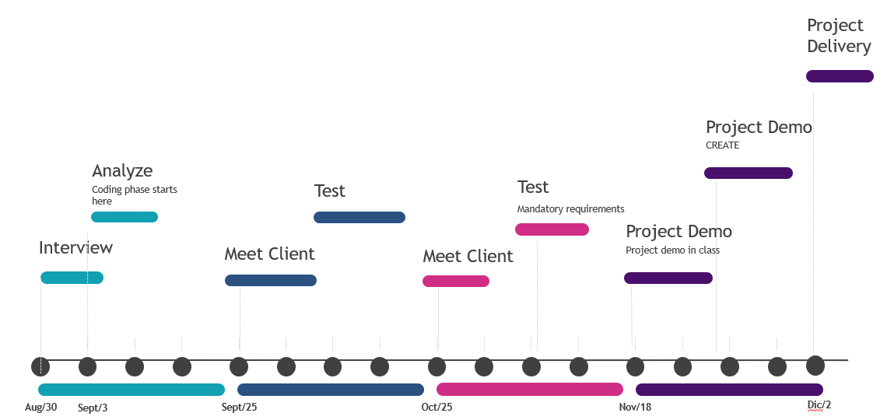

Detailed Business Requirements

the requirements that deliver the biggest benefit will be delivered as soon as possible and less important priorities will wait until the end of the project or be removed altogether.

Number | Description | Type | Raised by
 | The system will allow user to authenticate | M
 | The system will be able to differentiate between a professor or an administrator
 | Professors will be able to search for courses | M
 | Professors will be able to enrol courses
 | Professors will be able to drop courses
 | The system will prevent any hour incompatibility  between classes already enrolled | M
 | Administrator can create courses
 | Administrator can create sections
 | The system will display a schedule form where professor can clearly see what classes they have signed up
 | The system will allow the professors to send a section opening request on the professor’s perspective | R
 | The system will create a list of professors interested on the section
 | The system will count the number of credit hours a professor has enrolled
 | The system will provide a view of overall schedule replacing the actual google form
 | The system will keep track of the credits that a professor is teaching
 | Administrator can override any schedule changes and supersede the overall schedule

Type Key

M - Mandatory
D - Desirable
O - Optional
R - Removed

Non-Functional Requirements
Number | Category | Requirements | Type | Raised by
 | Archiving | The users will be have any schedules/classes that are assigned stored into a database to keep record and will be kept for 3 years. | M
 | Availability | The system will always be available for use.  Software maintenance availability to be discussed. | D
 | Performance | The system will guarantee optimal performance and will be able to handle multiple users at once without crashing | M

Customer Experience
No requirements for page download times, however, the page should be completely adapted in less than 5 seconds. The application will provide a login page to start in which it will accordingly execute the professors or administrator’s perspective. Both roles will have access to the professor’s page where the interactive schedule model will be available. As discussed at the meeting on Friday, August 30th, for the administrator angle the following features were requested:

- View of the overall schedule
- Easy access to verify number of professors trying to sign up for the same class
- be able to see the cumulative credits registered by each professor

