Courselist User Guide

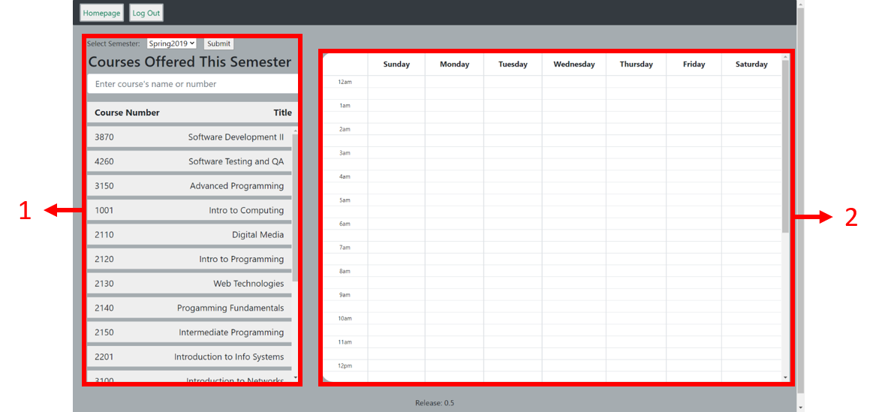The “courselist” page is where Administrators can view, search, create, and remove courses in the Scheduler’s database. However, courses can’t be modified, instead that feature can be handled through the “upload-sheet” page.

1. The list of courses currently in the database.
2. A calendar view of what time courses take place. Blue courses are normal, while red courses have a conflict where there are more than one professor registered for the course. Clicking a course shows more detail about that course through a modal.
3. 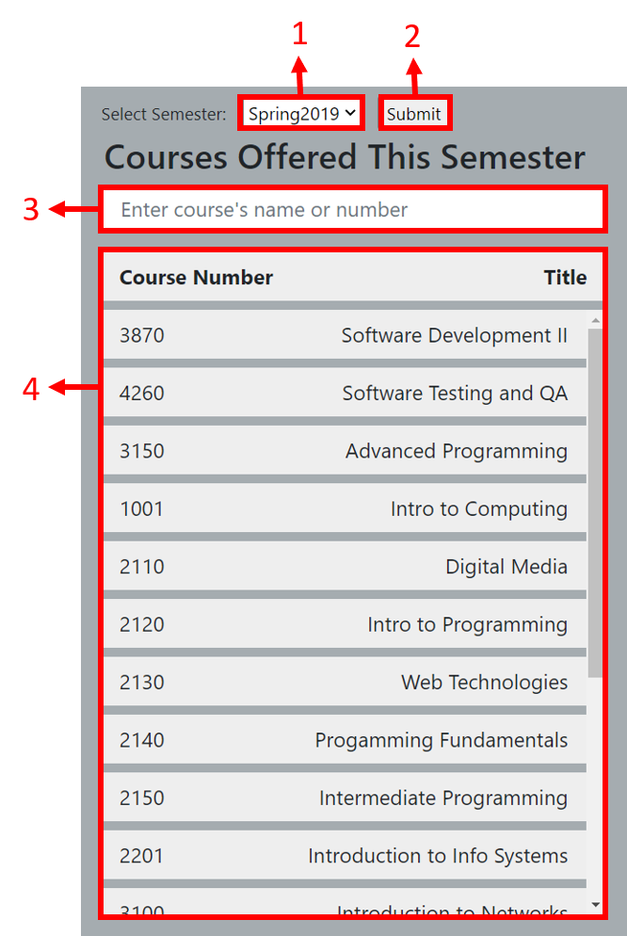A dropdown menu for switching between semesters. The options currently available are Spring2019 and Fall2019. (Functionality is not yet implemetned)
4. Confirms switching between semesters (Functionality is not yet implemented)
5. A search bar for searching for courses based on either the course name or number
6. The list of courses. Selecting a course shows their sections on the list and the calendar view. Options are also given for the sections: creating a new section, removing the currently selected section, going back to searching for courses, or copying the currently selected course (Copying course is not yet implemented) (Any created and removed course are not saved, refreshing or exiting the page reverts the page as if it was never modified)

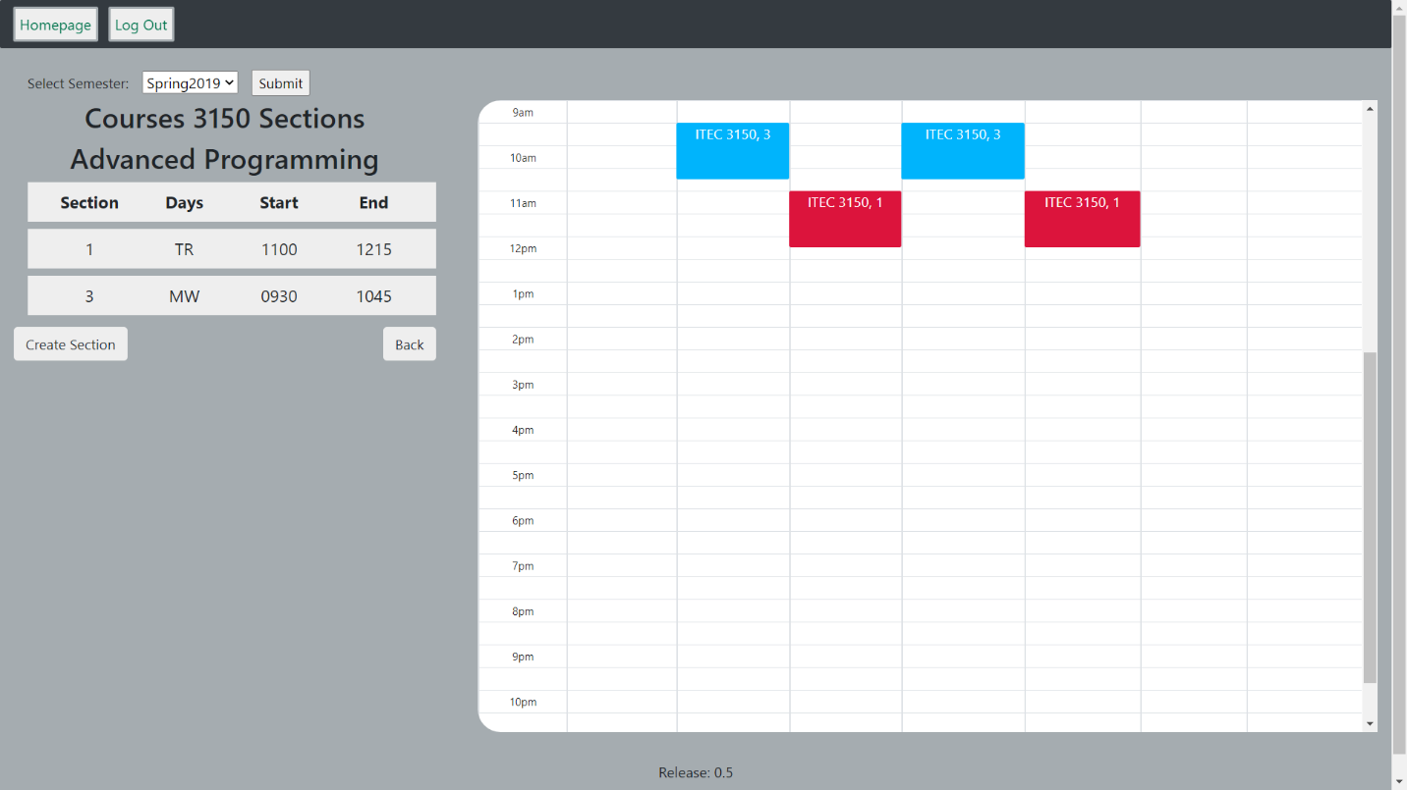

The page after selecting a course

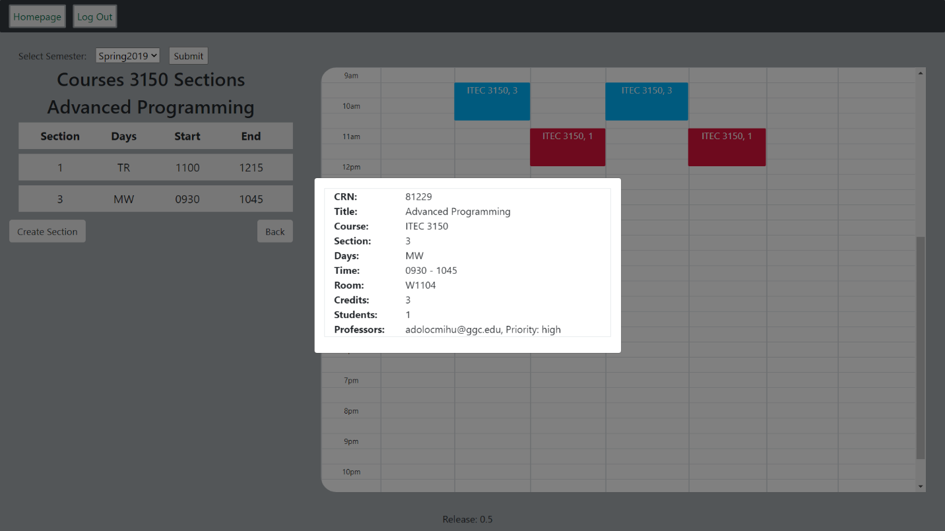

The page after clicking a course on the calendar. Clicking outside the modal closes it

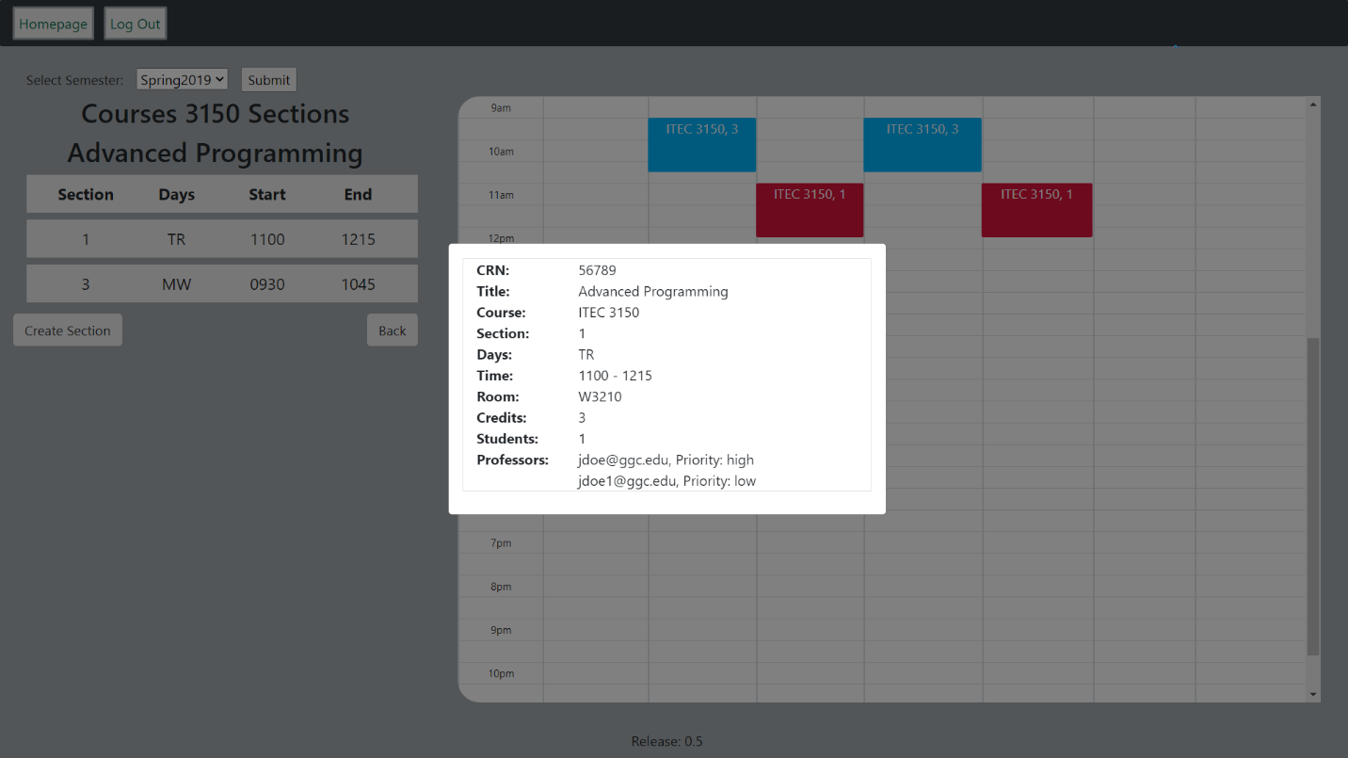

The page after clicking a conflicting course marked red. Courses with two or more professors are marked as having conflicts

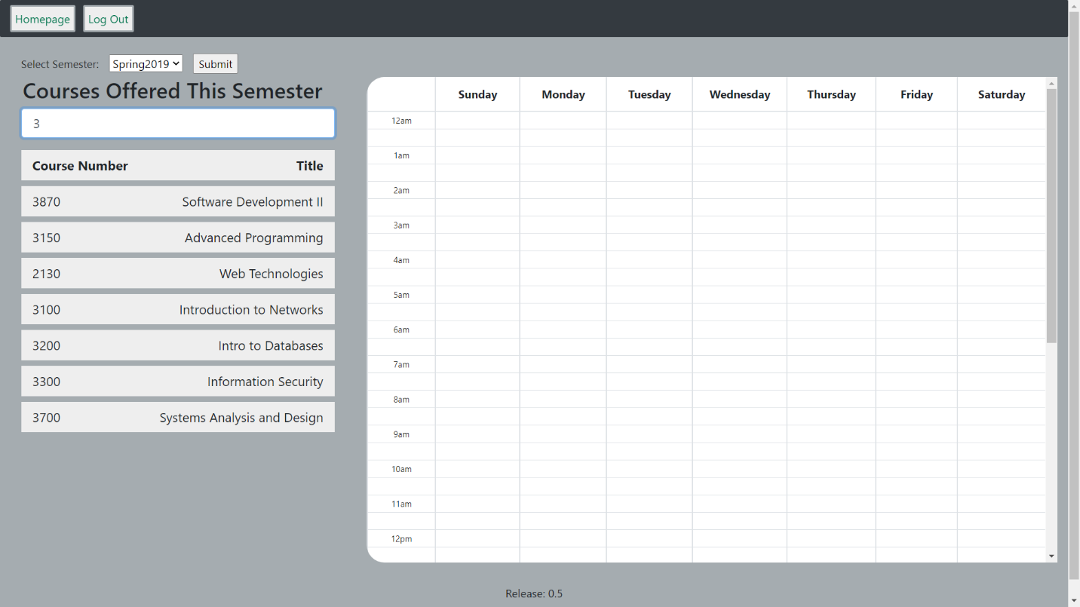

Searching courses based on Course Number

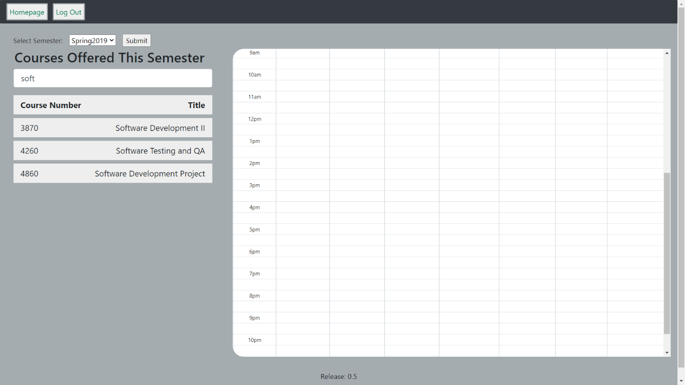

Searching courses based on Title

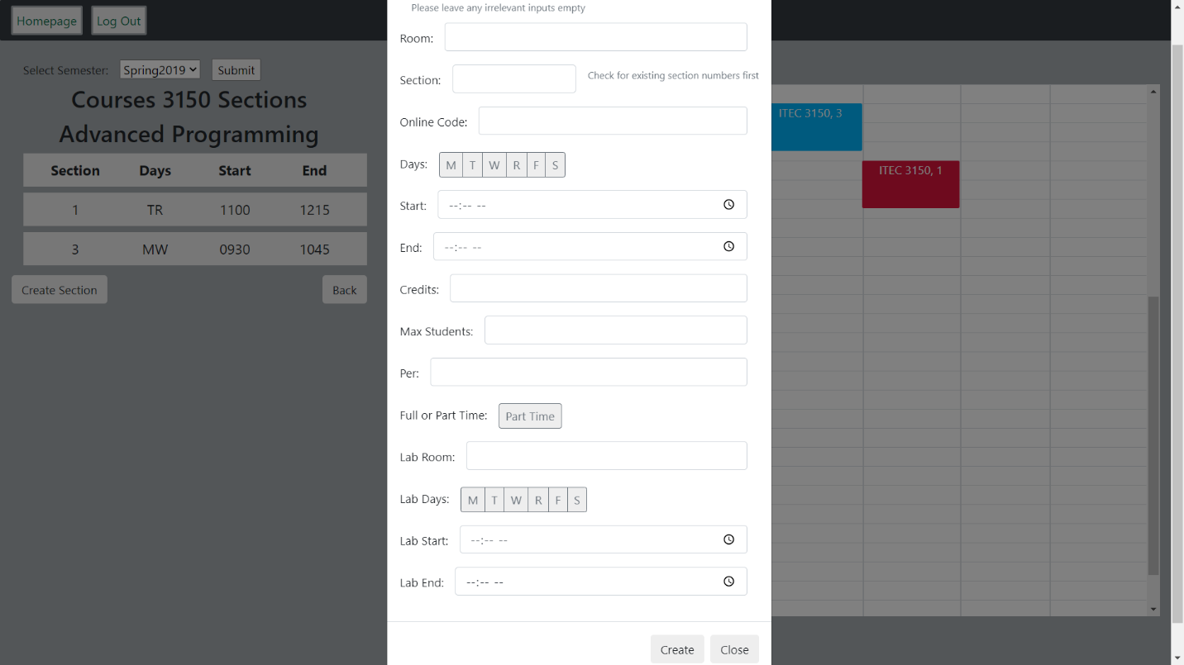

Clicking on “Create Section”, which pops up a modal for setting the attributes of the course being added

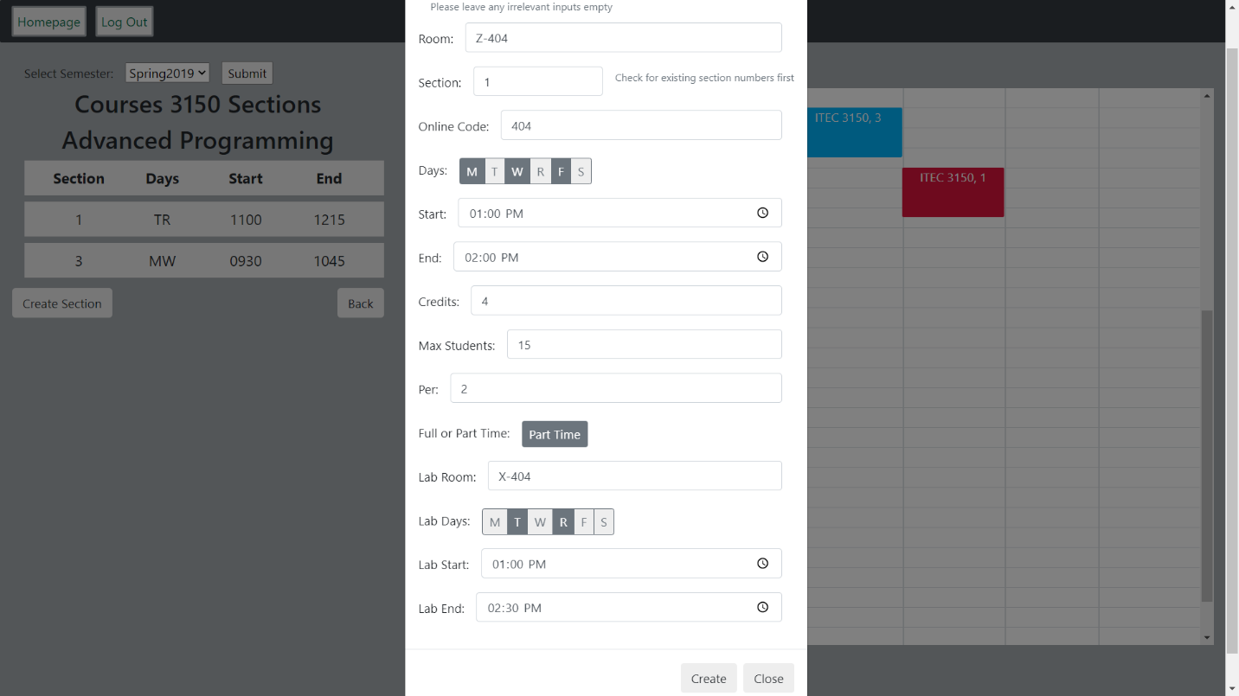

Example of data being added

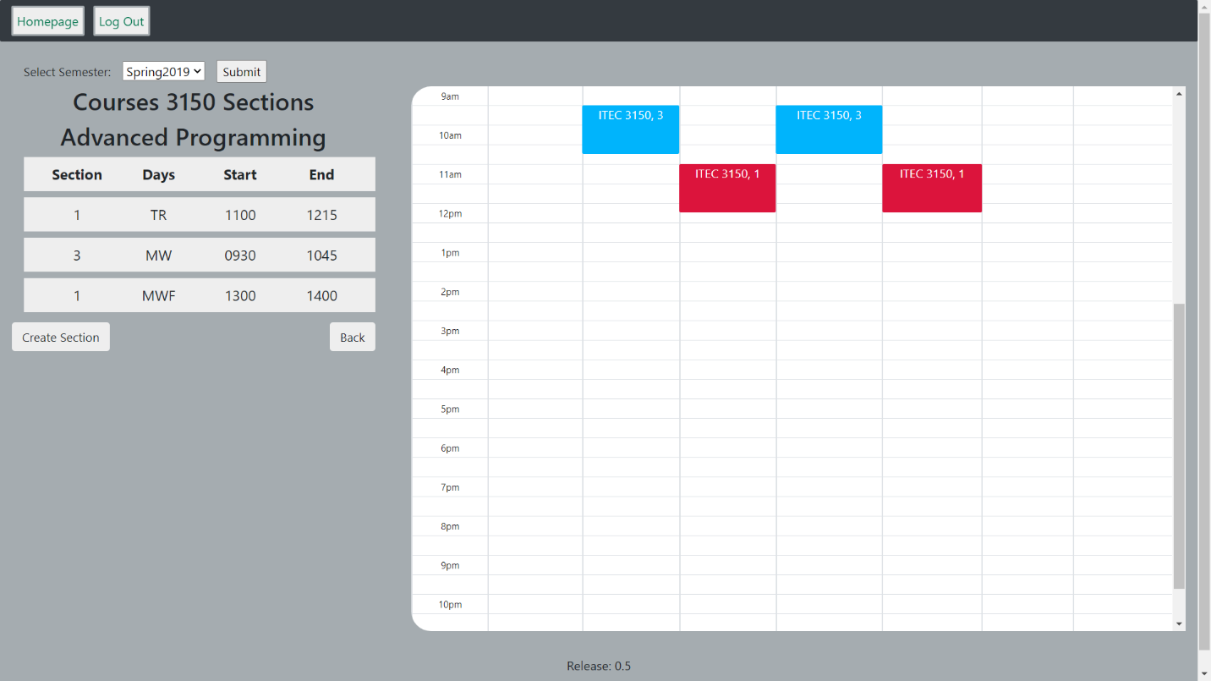

Result of a course being added. Note that the courses have not been added to the calendar view

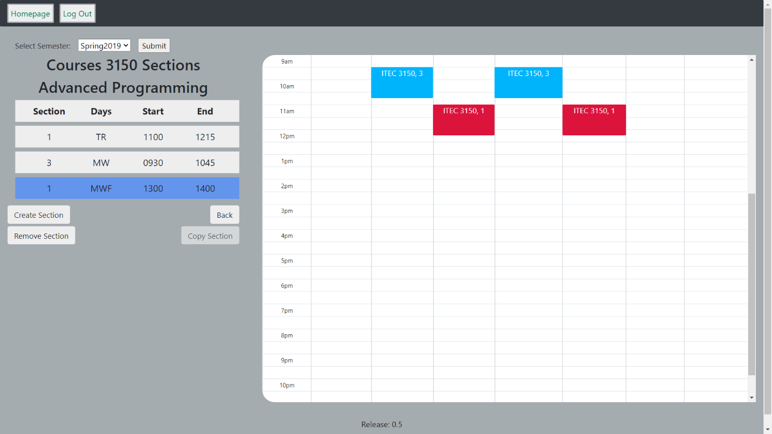

Options given upon selecting a section

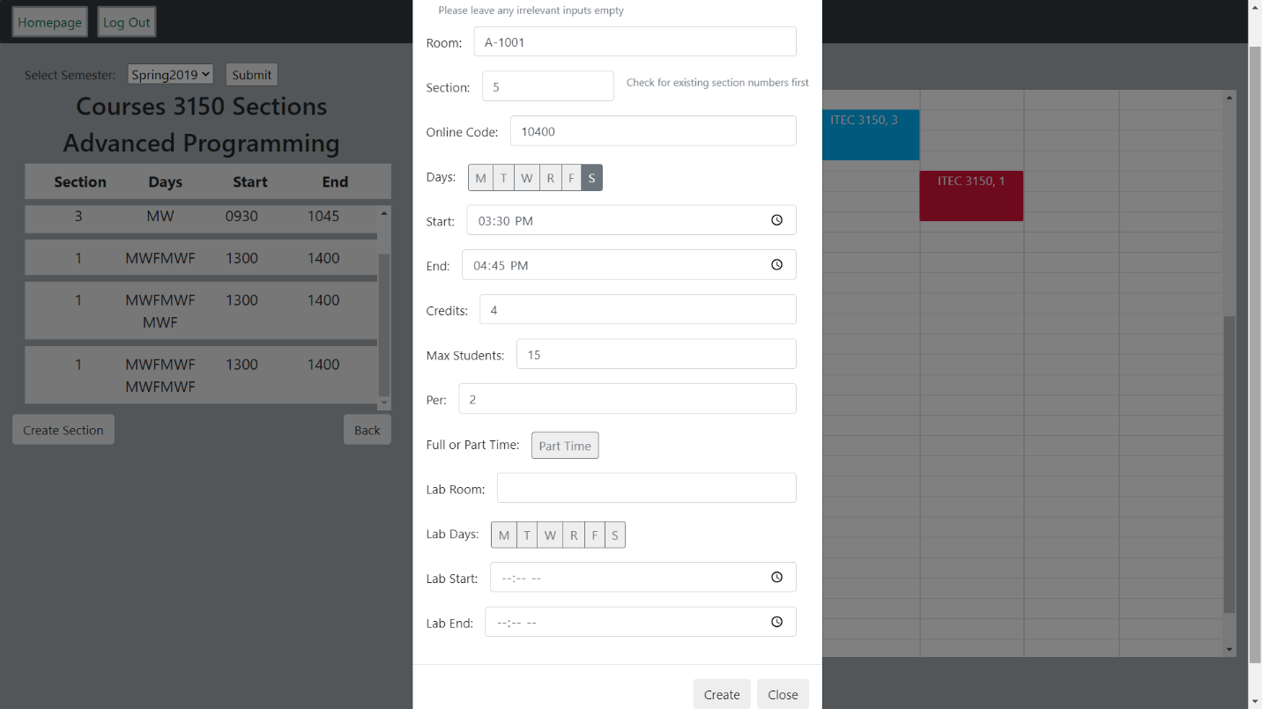

Bug: Creating subsequent sections result in the newly created sections keeping the “Days” of the previous sections

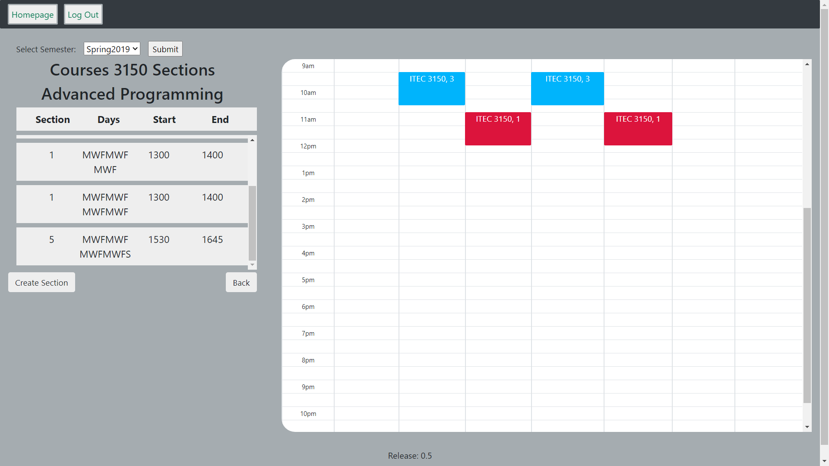

As seen in the previous picture, the Saturday is added to the bugged “Days”