Faculty Courselist User Guide

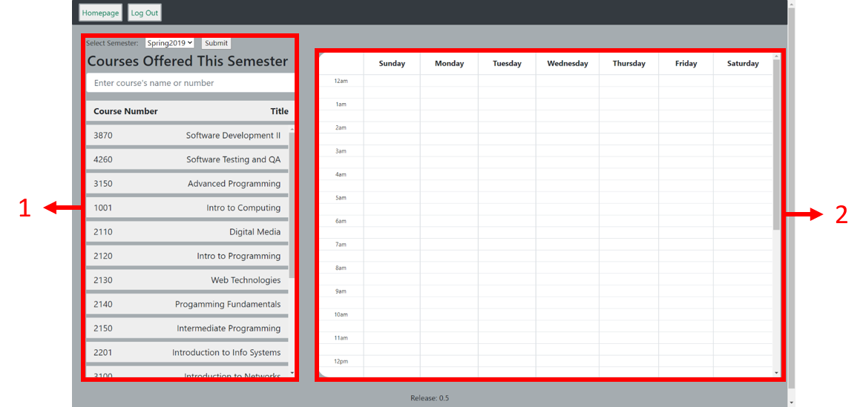The “faculty-courselist” page is where professors can view and search all courses in the Scheduler’s database.

1. The list of courses currently in the database. Selecting a course shows all sections in the course both on the list and calendar.
2. A calendar view of what time courses take place. Blue courses are normal, while red courses have a conflict where there are more than one professor registered for the course. Clicking a course shows more detail about that course through a modal.
3. 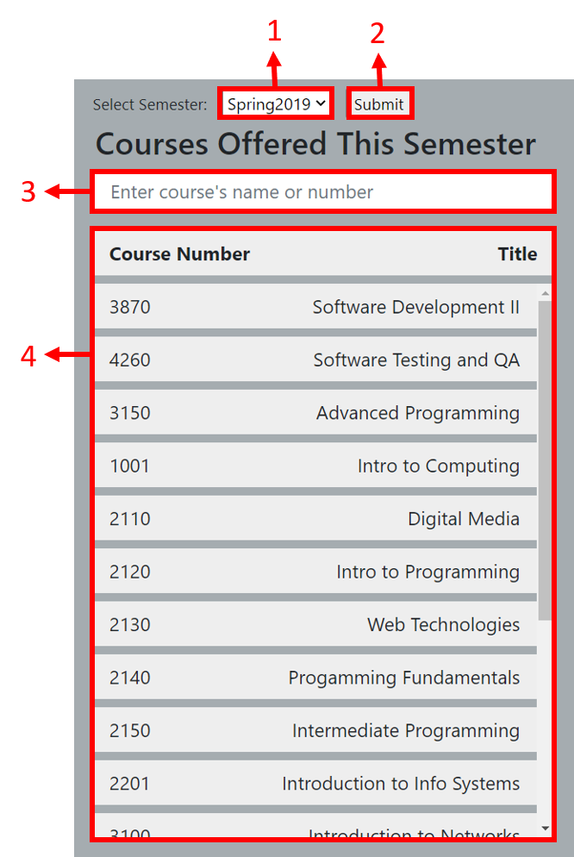A dropdown menu for switching between semesters. The options currently available are Spring2019 and Fall2019. (Functionality is not yet implemetned)
4. Confirms switching between semesters (Functionality is not yet implemented)
5. A search bar for searching for courses based on either the course name or number
6. The list of courses. Selecting a course shows their sections on the list and the calendar view.

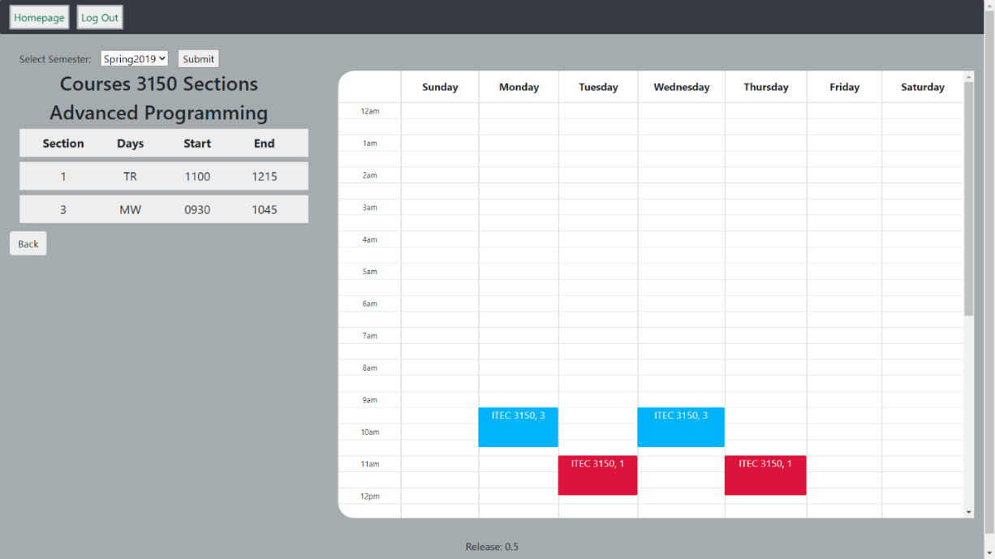

The page after selecting a course

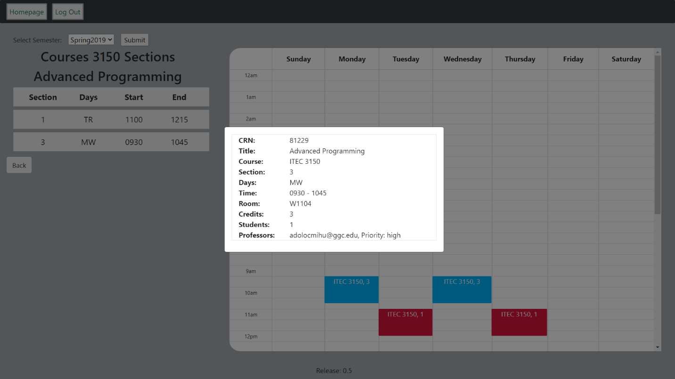

The page after clicking a course on the calendar. Clicking outside the modal closes it

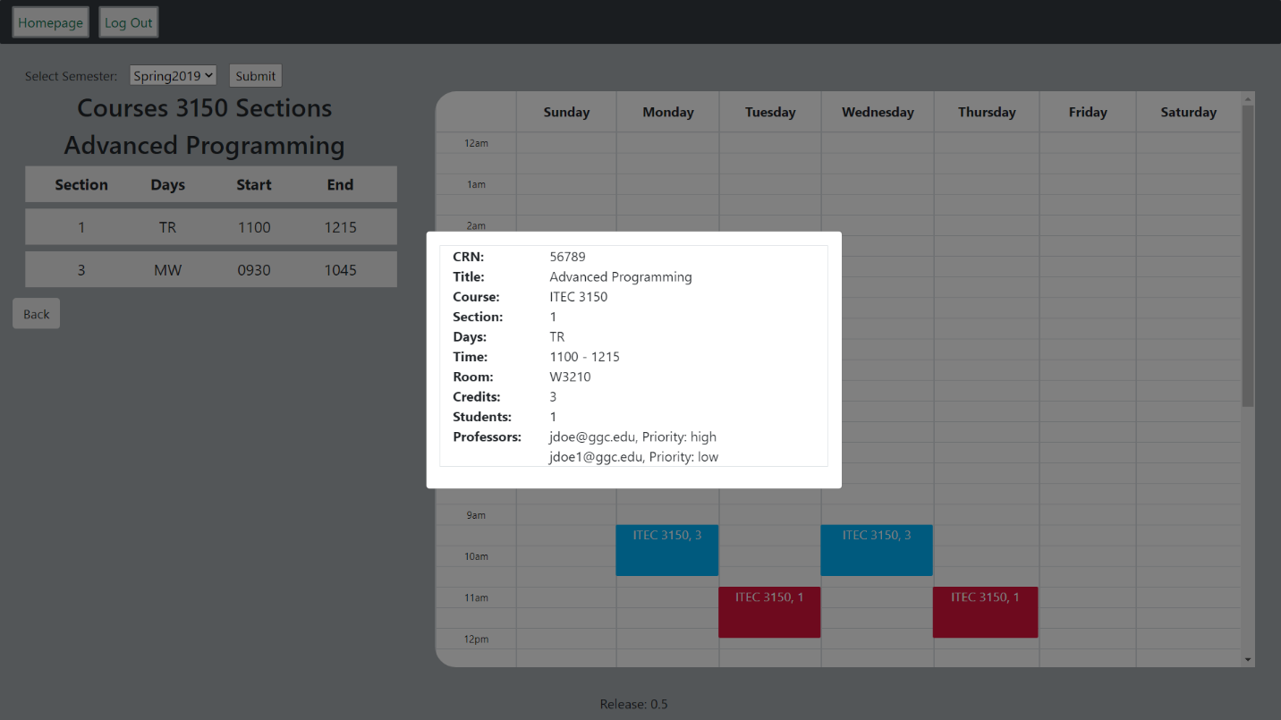

The page after clicking a conflicting course marked red. Courses with two or more professors are marked as having conflicts

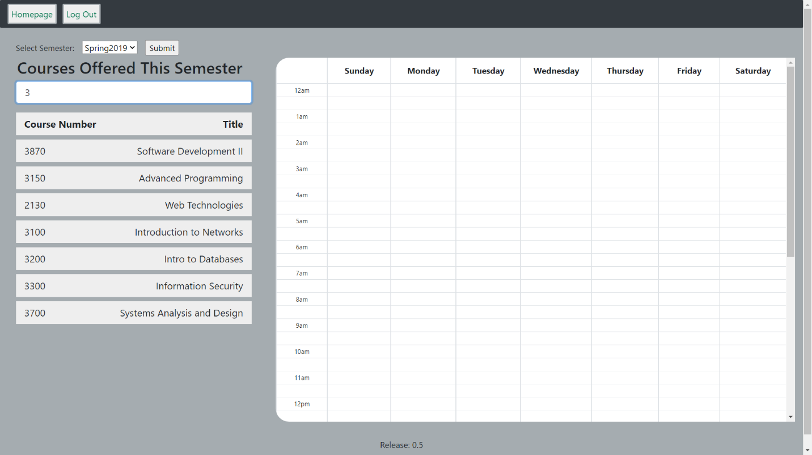

Searching courses based on Course Number

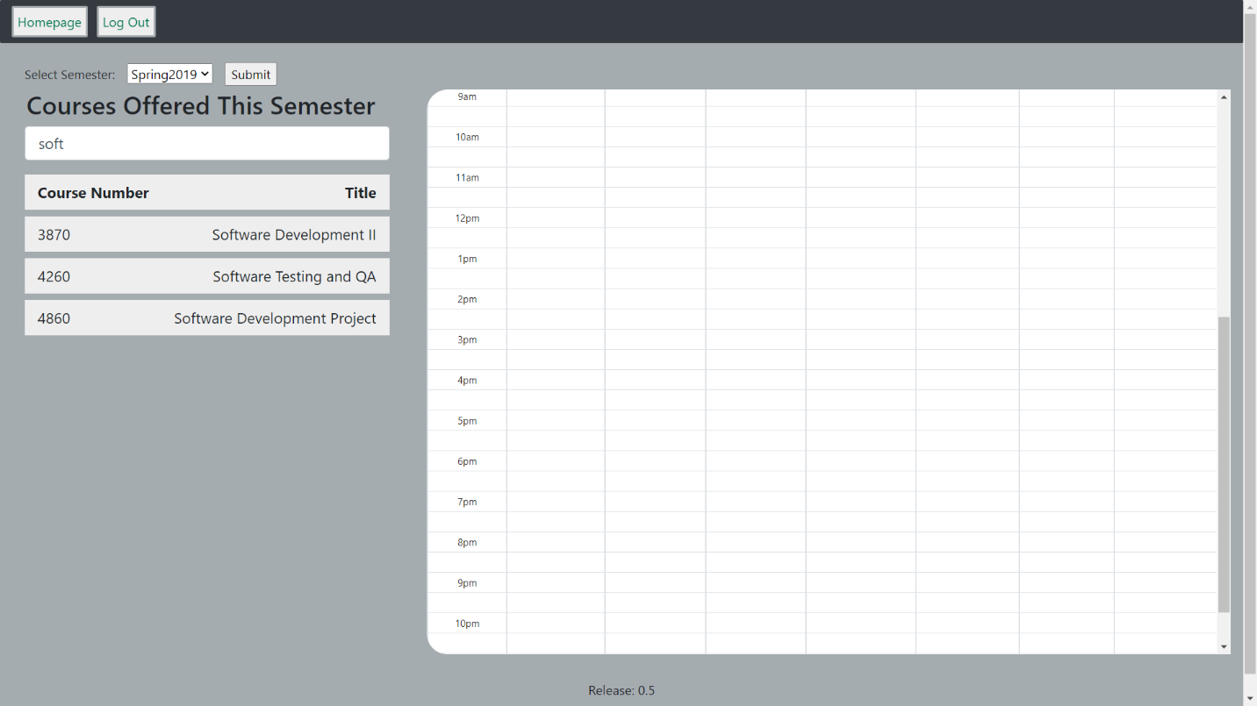

Searching courses based on Title