Login Page – User Guide

The Login Page is where the user authenticates their identity so that the Scheduler can properly load and save their data.

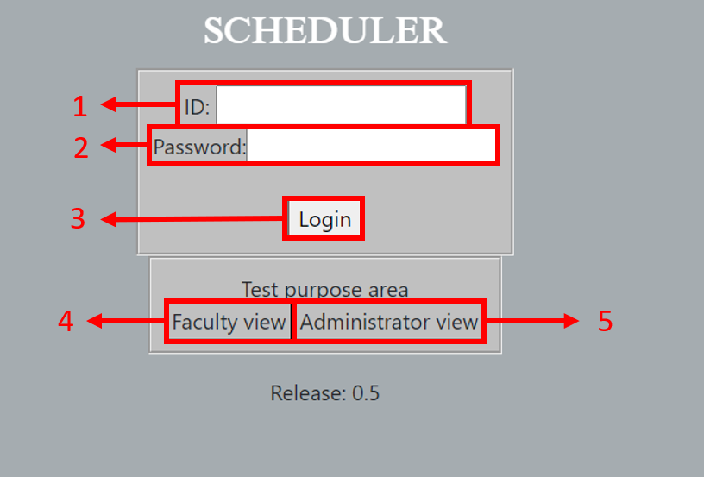

1. ID- Where the user inputs their identification. (Not yet functional)
2. Password- Where the user inputs their password. (Not yet functional)
3. Login Button- Verifies if the inputs for ID and Password are valid, either directing the user to the Faculty or Admin homepage, or telling the user that their input is invalid.
4. Faculty View Button- Takes the user to the Faculty Homepage. (A debugging button)
5. Administrator View Button- Takes the user to the Admin Homepage. (A debugging button)