Towards Pressure-Adherence & Education Driven Service in Diabetic Foot Disease (PARADISE trial)
Applicant | De Buyser Janou janou.debuyser@kuleuven.be
Supervisor (promotor) | Prof. Kevin Deschamps, Department of Rehabilitation Sciences, KU Leuven (kevin.deschamps@kuleuven.be)
Co-supervisor(s) | Prof. Fabienne Dobbels, Academic Centre for Nursing and Midwifery,  KU Leuven (fabienne.dobbels@kuleuven.be)  Prof. Maaike Fobelets, Faculty of Medicine and Pharmacy, VUB  (Maaike.Fobelets@vub.be)  Prof. Koen Putman, Faculty of Medicine and Pharmacy, VUB  (koen.putman@vub.be)
Research location  (for correspondence) | KU Leuven Campus Bruges, Department of Rehabilitation Sciences, Musculoskeletal Research Group.  Spoorwegstraat 12, 8200 Brugge (Belgium)
Available grant support | FWO-TBM project “PARADISE” (application no. T000226N; KU Leuven host budget €847,774.00 over 48 months).
Ethical Committee | EC Research UZ/KU Leuven (S71769); FAMHP multicentre trial registration (class 1 custom-made foot orthoses)
Animal experiments? | No
Thematic programme | Doctoral Programme in Biomedical Sciences,  Movement and Rehabilitation Sciences
Starting date | 03-07-2026 (expected end date: 03-07-2030)
PhD format | Full-time; Joint PhD (KU Leuven home institution, VUB host institution)
1. Introduction and background
Diabetes is a growing global health burden; in Belgium, diagnosed prevalence reached 7.6% in 2023 and continues to rise with an ageing population.¹ Recurrent diabetic foot ulcers (DFUs) remain a leading cause of morbidity, reduced quality of life and healthcare expenditure: about 40% of healed ulcers recur within one year, making recurrence prevention a central priority.^{2,3,4}
In Belgium, high-risk patients are managed within multidisciplinary Diabetic Foot Clinics (DFCs) recognised by the national health insurer (RIZIV–INAMI). This model provides specialised care, yet a gap remains between evidence-based prevention and routine practice: pressure-optimised therapeutic footwear and objective adherence monitoring have each demonstrated value,^{5,6,7} but they are not yet systematically combined in Belgian diabetic-foot pathways.
Adherence remains a major barrier: objective monitoring shows that patients spend approximately 29% of their steps outside prescribed footwear, and only a minority reach the ≥80% threshold associated with improved outcomes.^{5,6} Existing education strategies prioritise knowledge transfer over sustained behavioural change, and objective adherence data are seldom fed back into personalised or clinical decision-making.^{8,9}
PARADISE (Pressure-, Adherence-, and Education-Driven Service) addresses this translational gap through an integrated intervention combining pressure-guided optimisation of therapeutic footwear and foot orthoses, structured education on adequate foot care and footwear use, and sensor-based adherence monitoring. Education and behavioural support are delivered as two distinct components within the Structured Education and Behavioural Intervention Approach (SEBIA): education addresses knowledge and skills for adequate foot care and for the prescribed orthoses, while behavioural support draws on motivational interviewing, solution-focused brief therapy and behaviour change wheel principles, among other evidence-based behavioural change methods, to identify and address individual barriers.^{8,10,11}
PARADISE has been piloted in one Belgian DFC but has not yet undergone large-scale clinical validation. A Dutch precursor combining structured education, motivational interviewing and custom-made indoor footwear did not significantly increase overall wear time after three months; wear time rose mainly after the indoor footwear was provided.¹² PARADISE extends this approach through personalised behavioural feedback, prolonged follow-up, and integration into routine Belgian multidisciplinary care.
2. General hypothesis and specific aims
General hypothesis. In adults with diabetes and a high-risk foot, adding PARADISE to standard care (Optimal Care) will reduce biomechanical risk factors, improve objectively measured footwear adherence, and decrease 18-month plantar foot-ulcer recurrence compared with standard care alone (Usual Care).
Specific aims
- A1 — Trial operationalisation, site readiness and protocol development. Standardise and pilot the PARADISE trial across six DFCs by finalising protocols, assessment procedures, workflows and documentation pathways, and prepare the trial protocol for publication.
- A2 — Ulcer recurrence (primary endpoint). Determine whether adding PARADISE to usual care reduces 18-month plantar foot-ulcer recurrence compared with usual care alone.
- A3 — Mechanistic pathway (pre-specified mediation). Determine whether PARADISE reduces in-shoe peak plantar pressure and raises objectively measured footwear adherence beyond the clinically relevant ≥80% threshold, and whether adherence mediates the effect of PARADISE on ulcer recurrence.⁵
- A4 — Secondary outcomes and health impact. Evaluate recurrence characteristics, ulcer-free survival, foot-care behaviour (Nottingham Assessment of Functional Footcare, NAFF), health-related quality of life (EQ-5D-5L), and, jointly with the parallel doctorate, health-economic outcomes.
Candidate’s contribution and joint PhD. This is a joint KU Leuven–VUB doctorate in which two complementary doctoral projects run on the same trial. The present candidate leads the clinical trial: protocol development, ethics and regulatory submission, multicentre coordination, recruitment oversight, quality and fidelity monitoring, data management, and the analyses of ulcer recurrence, plantar pressure and footwear adherence. The parallel doctorate leads the process evaluation and the health-economic evaluation. Both researchers contribute to study conduct and outputs, with authorship aligned to responsibilities. Alongside the trial, the PhD candidate will conduct a registered scoping review on patient-specific offloading insole design, and a comparison of 3D-printed custom-made foot orthoses in a healthy and diabetic population, carried out independently of the trial.
3. Methodology
Design and participants. A prospective, multicentre, parallel-group randomised controlled trial (RCT) will randomise 144 adults with diabetes and an IWGDF category 3 high-risk foot in a 1:1 ratio, stratified by centre, across six Belgian RIZIV–INAMI-recognised DFCs. Participants will be followed for 18 months. Eligible participants have type 1 or type 2 diabetes with a plantar ulcer healed within the preceding 18 months or a partial foot amputation, and use, or are willing to use, prescribed therapeutic footwear.
Interventions. PARADISE integrates three evidence-based components addressing the main determinants of diabetic foot-ulcer recurrence: biomechanical risk, footwear adherence, and adequate foot care.
(1) Pressure-driven orthosis optimisation. Existing in-shoe plantar-pressure systems (Novel pedar) identify peak plantar pressure and guide iterative orthosis optimisation towards a target peak pressure below 200 kPa or a reduction of at least 25% relative to the measurement without the orthosis in the same session, with up to three modification rounds per session.⁵
(2) Objective footwear-adherence monitoring. Sensor-based technologies (Orthotimer and MoveMonitor) quantify footwear wearing time and contextualise adherence against daily activity exposure, addressing the limitations of self-reported footwear use; because awareness of being monitored can itself affect wearing behaviour, sensors are worn in both arms.^{6,13,14}
(3) Structured education and behavioural support. Education covers adequate daily foot care and the rationale for wearing the prescribed orthoses and footwear. Behavioural support, delivered through SEBIA, draws on motivational interviewing, solution-focused brief therapy and behaviour change wheel principles, among other evidence-based behavioural change methods, to identify and address individual barriers to adherence.^{10,15}
Plantar-pressure and adherence-monitoring technologies are validated techniques already used within participating centres; no new measurement technology will be developed. A methodological substudy will assess concordance between the Novel pedar and F-Scan GO systems.
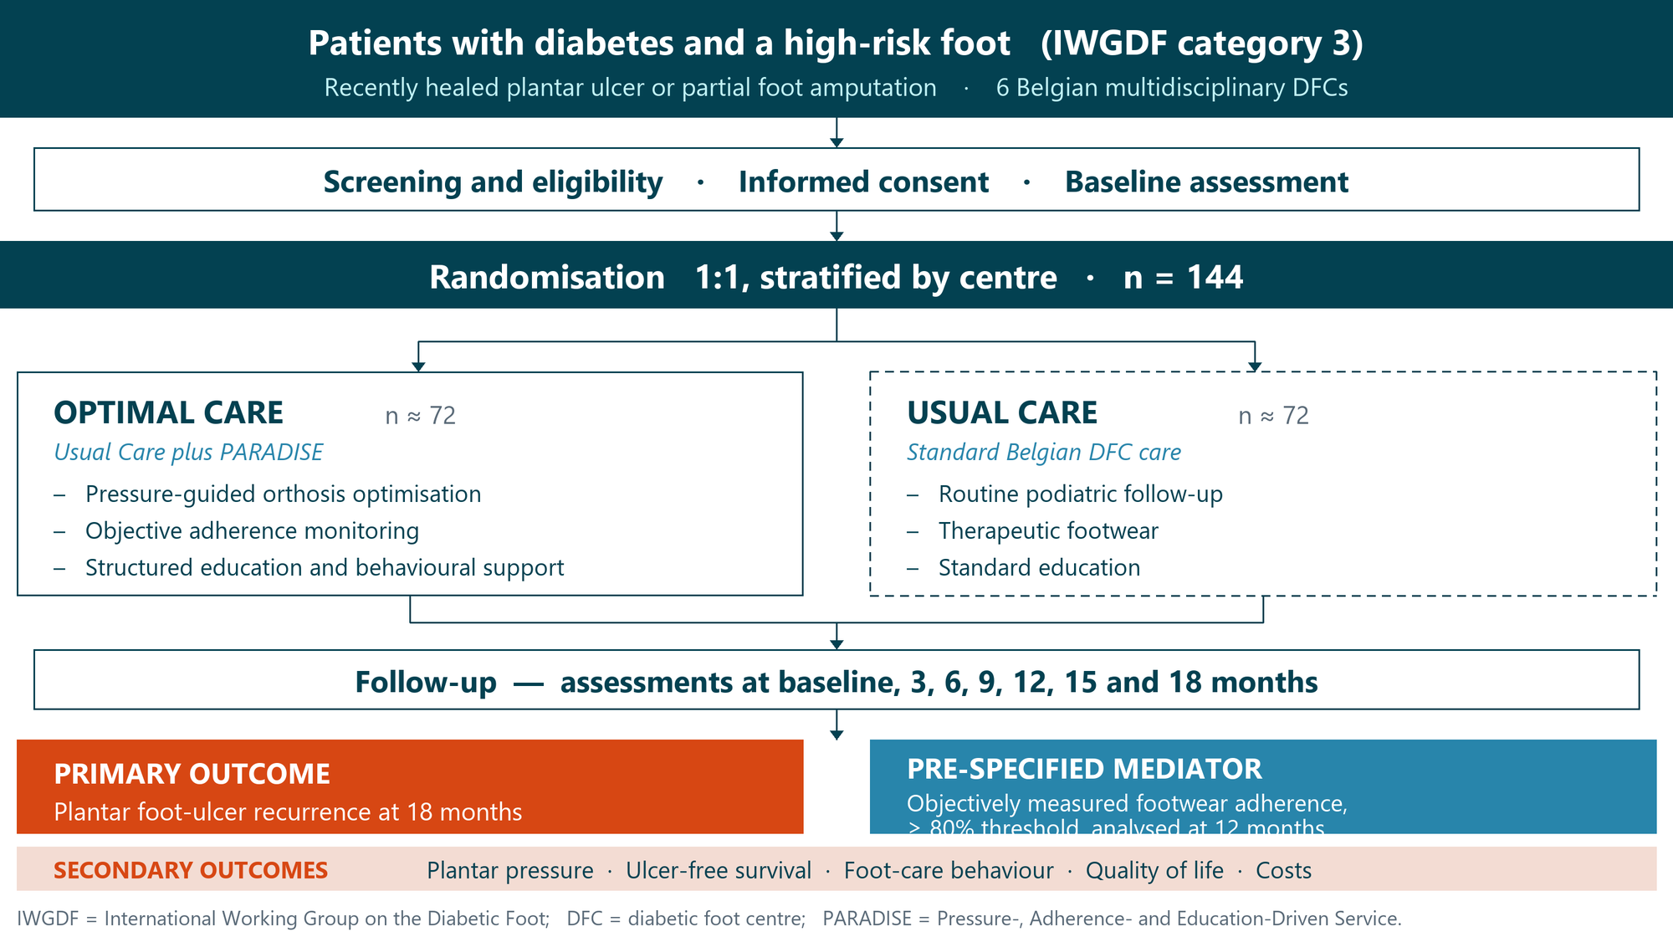
Figure 1. Design and outcome structure of the PARADISE multicentre RCT.
Outcomes. PARADISE has a single primary outcome; the proposed mechanistic pathway is analysed as a pre-specified mediator rather than as a second endpoint.
The primary outcome is plantar foot-ulcer recurrence at 18 months, defined as a new plantar ulcer occurring after enrolment and reflecting the combined impact of pressure management, prevention strategies, and footwear adherence.^{5,16} Objectively measured footwear adherence is the pre-specified mediator, quantified as the proportion of ambulatory activity performed while wearing the prescribed footwear, with ≥80% as the clinically relevant threshold, and analysed at 12 months with the full 18-month profile reported as a secondary summary.^{5,6,9} Exploratory analyses will compare indoor and outdoor footwear use, as indoor behaviour influences overall adherence.¹²
Secondary outcomes comprise ulcer-free survival, recurrence characteristics, plantar-pressure change at 6, 12, and 18 months, foot-care behaviour (NAFF), objectively measured adherence over the full 18 months, self-reported adherence (7-day recall), health-related quality of life (EQ-5D-5L), and healthcare resource utilisation.
Sample size and statistics. The trial is powered at 80% with a two-sided α of 0.05 for the single primary outcome, so no multiplicity correction is required. Assuming a reduction in 18-month ulcer recurrence from 50% to 25%, informed by prior footwear and offloading studies,⁵ 62 evaluable participants per arm are required; accounting for 15% loss to follow-up, the target sample size is 144 participants (~24 per centre).
All analyses follow the intention-to-treat principle. Recurrence outcomes will account for competing mortality risk using appropriate competing-risk methods; longitudinal biomechanical and adherence outcomes will be analysed using mixed-effects models accounting for centre- and participant-level variability. The mediating role of footwear adherence will be examined in a pre-specified causal mediation analysis. Missing data will be addressed using multiple imputation by chained equations.^{17,18}
Assessments and collaborations. Patient-centred outcomes are captured with validated instruments, the NAFF for foot-care behaviour and the EQ-5D-5L for health-related quality of life^{19,20}, alongside device-derived measures of plantar pressure, footwear wearing time and daily activity. The trial is conducted with the six participating DFCs and with the technical partners supporting the pressure-measurement systems.
Ethics and regulatory submission. Central submission to the EC Research UZ/KU Leuven and the FAMHP is scheduled for October 2026, with the six local approvals expected between November 2026 and January 2027. The trial will be prospectively registered and conducted under a GDPR-compliant data-management framework. Ulcer recurrence is ascertained by the multidisciplinary clinical team; the absence of an independent blinded adjudication committee is acknowledged as a limitation.
4. Milestones, timing and feasibility
Timeline (Figure 2). Months 1–8 cover the protocol, clinical assessment booklet, case-report forms and the ethics and regulatory submissions, following SPIRIT,²¹ and close with an operational pilot that verifies workflow feasibility and data capture. Recruitment and randomisation of 144 participants run from month 8 to month 24; intervention delivery, follow-up and fidelity monitoring continue to month 42. Months 43–48 cover database closure, analyses and the thesis, while manuscript development runs throughout.
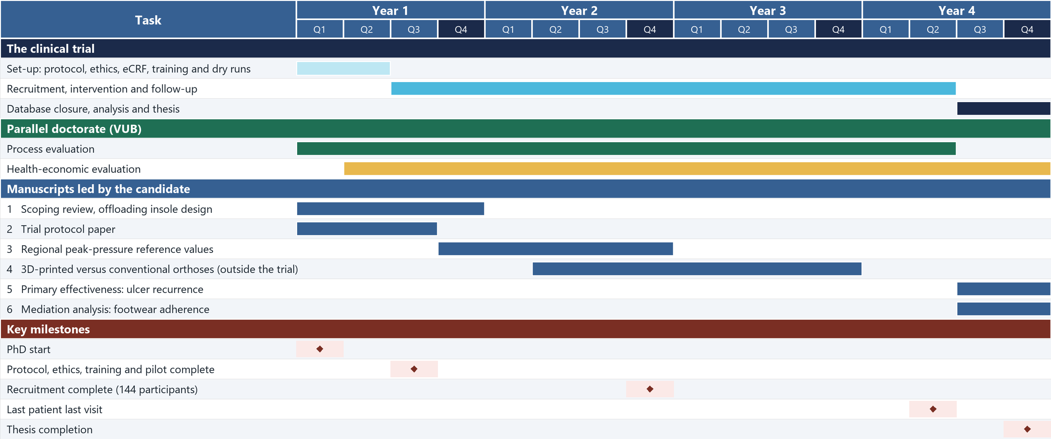
Figure 2. Indicative 48-month PhD timeline, with the manuscripts led by the candidate and the key milestones.
Feasibility. Recruitment is feasible: each participating DFC treats at least 52 eligible high-risk patients annually, supporting a recruitment rate of 1–2 participants per centre per month. This is consistent with recruitment rates reported across randomised trials more broadly.²²
Risks and mitigations. Recruitment delays and variability in intervention delivery are the principal risks. These will be mitigated through recruitment monitoring, QuinteT-based barrier identification,²³ standardised operating procedures, investigator training, and intervention-fidelity assessments following NIH Behavior Change Consortium recommendations.²
5. Conclusion: planned outputs and pre-existing data
Planned outputs. The project delivers the first multicentre RCT of PARADISE within Belgian multidisciplinary DFCs. Six manuscripts are planned: (1) the scoping review on patient-specific offloading insole design; (2) the trial protocol paper, following SPIRIT 2025 and TIDieR; (3) regional peak plantar-pressure reference values in people with diabetes, from low- and high-resolution in-shoe measurements; (4) a comparison of plantar-pressure redistribution with 3D-printed custom-made foot orthoses, conducted outside the trial; (5) the primary effectiveness analysis of ulcer recurrence at 18 months; and (6) the pre-specified mediation analysis of footwear adherence. Timing is shown in Figure 2, and trial publications follow CONSORT.²⁵
Pre-existing data. Pilot observations from a 2023–2024 pressure-guided footwear pathway may inform trial preparation; their use will be assessed and, where appropriate, approved by the doctoral committee. The comparison study of 3D-printed CMFOs is based on data collected during a previous doctoral project; these data have not yet been analysed or published.
References

1. Sciensano. Diabetes. In: For a Healthy Belgium [Internet]. Brussels: Sciensano; 2025 [cited 2026 Jun 4]. Available from: https://www.healthybelgium.be/en/health-status/non-communicable-diseases/diabetes
2. Armstrong DG, Boulton AJM, Bus SA. Diabetic Foot Ulcers and Their Recurrence. N Engl J Med. 2017;376:2367-75.
3. Waaijman R, de Haart M, Arts MLJ, Wever D, Verlouw AJWE, Nollet F, et al. Risk Factors for Plantar Foot Ulcer Recurrence in Neuropathic Diabetic Patients. Diabetes Care. 2014;37:1697-705.
4. Bouly M, Laborne FX, Tourte C, Henry E, Penfornis A, Dardari D. The Post-Healing Follow-Up of Diabetic Foot Ulcers by a Multidisciplinary Team to Reduce Their Recurrence: An Observational Retrospective Study. J Clin Med. 2025;14:4975.
5. Bus SA, Waaijman R, Arts M, de Haart M, Busch-Westbroek T, van Baal J, et al. Effect of Custom-Made Footwear on Foot Ulcer Recurrence in Diabetes. Diabetes Care. 2013;36:4109-16.
6. Waaijman R, Keukenkamp R, de Haart M, Polomski WP, Nollet F, Bus SA. Adherence to Wearing Prescription Custom-Made Footwear in Patients With Diabetes at High Risk for Plantar Foot Ulceration. Diabetes Care. 2013;36:1613-8.
7. Kamogawa M, Kajiwara K, Sakuramoto H, Yamamoto K. Non-pharmacological Interventions for the Prevention and Progression of Diabetic Foot Ulcers in Individuals With Type 2 Diabetes Mellitus: A Scoping Review. Cureus. 2026;18:e100710.
8. Goodall RJ, Ellauzi J, Tan MKH, Onida S, Davies AH, Shalhoub J. A Systematic Review of the Impact of Foot Care Education on Self Efficacy and Self Care in Patients With Diabetes. Eur J Vasc Endovasc Surg. 2020;60:282-92.
9. Exterkate SH, Jongebloed‐Westra M, ten Klooster PM, Koffijberg H, Bode C, van Gemert-Pijnen JEWC, et al. Objectively assessed long‐term wearing patterns and predictors of wearing orthopaedic footwear in people with diabetes at moderate‐to‐high risk of foot ulceration: a 12 months observational study. J Foot Ankle Res. 2023;16:60.
10. Michie S, van Stralen MM, West R. The behaviour change wheel: A new method for characterising and designing behaviour change interventions. Implement Sci. 2011;6:42.
11. Gingerich WJ, Peterson LT. Effectiveness of Solution-Focused Brief Therapy: A Systematic Qualitative Review of Controlled Outcome Studies. Res Soc Work Pract. 2013;23:266-83.
12. van Netten JJ, Vossen LE, Driebergen FM, Wolthuis D, Merkx MJM, Bus SA. Short-Term Efficacy of a Multi-Modal Intervention Program to Improve Custom-Made Footwear Use in People at High Risk of Diabetes-Related Foot Ulceration. J Clin Med. 2025;14:3635.
13. López-Moral M, Molines-Barroso RJ, Herrera-Casamayor M, García-Madrid M, García-Morales E, Lázaro-Martínez JL. Usability of Different Methods to Assess and Improve Adherence to Therapeutic Footwear in Persons with the Diabetic Foot in Remission. A Systematic Review. Int J Low Extrem Wounds. 2026;25:55-64.
14. Lutjeboer T, van Netten JJ, Postema K, Hijmans J. Effect of awareness of being monitored on wearing of orthopaedic footwear. J Rehabil Med. 2020;52:jrm00127.
15. Jongebloed-Westra M, Bode C, van Netten JJ, ten Klooster PM, Exterkate SH, Koffijberg H, et al. Using motivational interviewing combined with digital shoe-fitting to improve adherence to wearing orthopedic shoes in people with diabetes at risk of foot ulceration: study protocol for a cluster-randomized controlled trial. Trials. 2021;22:750.
16. Vossen LE, van Netten JJ, Bakker CD, Berendsen HA, Busch-Westbroek TE, Peters EJG, et al. An integrated personalized assistive devices approach to reduce the risk of foot ulcer recurrence in diabetes (DIASSIST): study protocol for a multicenter randomized controlled trial. Trials. 2023;24:663.
17. White IR, Royston P, Wood AM. Multiple imputation using chained equations: Issues and guidance for practice. Stat Med. 2011;30:377-99.
18. Mallinckrodt C, Lipkovich I, Dickson S, Hendrix S, Molenberghs G. Handling Missing Data in Participants with Baseline but No Post‐Baseline Data. Pharm Stat. 2026;25:e70076.
19. Lincoln N, Jeffcoate W, Ince P, Smith M, Radford K. Validation of a new measure of protective footcare behaviour: the Nottingham Assessment of Functional Footcare (NAFF). Pract Diab Int. 2007;24:207-11.
20. Herdman M, Gudex C, Lloyd A, Janssen MF, Kind P, Parkin D, et al. Development and preliminary testing of the new five-level version of EQ-5D (EQ-5D-5L). Qual Life Res. 2011;20:1727-36.
21. Chan AW, Boutron I, Hopewell S, Moher D, Schulz KF, Collins GS, et al. SPIRIT 2025 statement: updated guideline for protocols of randomised trials. BMJ. 2025;389:e081477.
22. Jacques RM, Ahmed R, Harper J, Ranjan A, Saeed I, Simpson RM, et al. Recruitment, consent and retention of participants in randomised controlled trials: a review of trials published in the National Institute for Health Research (NIHR) Journals Library (1997–2020). BMJ Open. 2022;12:e059230.
23. Donovan JL, Rooshenas L, Jepson M, Elliott D, Wade J, Avery K, et al. Optimising recruitment and informed consent in randomised controlled trials: the development and implementation of the Quintet Recruitment Intervention (QRI). Trials. 2016;17:283.
24. Bellg AJ, Borrelli B, Resnick B, Hecht J, Minicucci DS, Ory M, et al. Enhancing Treatment Fidelity in Health Behavior Change Studies: Best Practices and Recommendations From the NIH Behavior Change Consortium. Health Psychol. 2004;23:443-51.
25. Hopewell S, Chan AW, Collins GS, Hróbjartsson A, Moher D, Schulz KF, et al. CONSORT 2025 statement: updated guideline for reporting randomised trials. BMJ. 2025;389:e081123.

