Individual Development Plan
Being a PhD researcher allows you to gain extensive research experience. However, this is a temporary position without a well-defined career path. You may already know if your preferred career path after your doctorate is within or outside academia. There is no bad choice, but the best one is a well-informed choice. Most of you will build a career outside academia (public sector, government, NGO, industry, teaching, ...), as only a minority of PhD researchers (1 out of 10) obtain a permanent position in academia (as professor or support staff).. By reflecting on your career and professional development, we want to increase the chance of realizing your ambitions, whether it be an academic career or not. Your Individual Development Plan (IDP) is an iterative and dynamic process, starting with a reflection stage in which you set goals and draw up an action plan. Optimal use of the IDP requires the involvement of your supervisor to align visions, receive insightful feedback, and discuss support options (dialogue stage) prior to taking action and tracking your progress (action stage). Since your work context, circumstances, and professional interests may change over time, we suggest you review your objectives and action plan on a regular basis, but it is a milestone in the third and fourth year of your PhD.
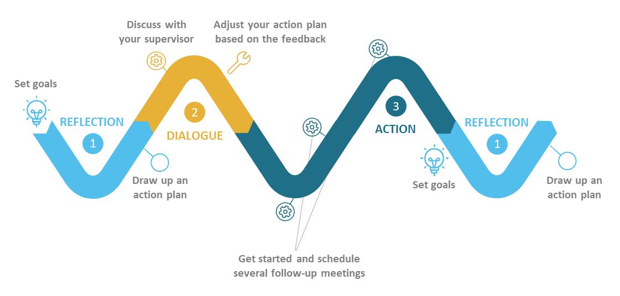
The IDP process over a 1-year period
The IDP process includes this template that you and your supervisor can use as a basis for a conversation on three topics: 1) Research, 2) Career planning and 3) Development of (transferable) skills. More background information on the IDP can be found here.

Click and type nameName of PhD researcher: Janou De Buyser
Click and type nameName of Supervisor: Prof. Kevin Deschamps (supervisor) — co-supervisors: Prof. Fabienne Dobbels, Prof. Maaike Fobelets, Prof. Koen Putman
Click and select the dateDate: 21 September 2026

Goal setting
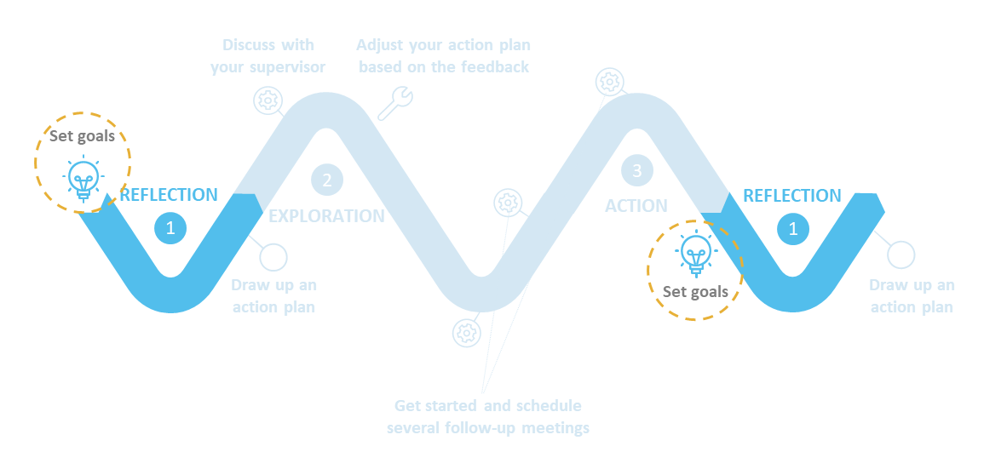

Research
- What are your main research project goals for the upcoming year?
(in bullet points and keep it brief)
Click or tap here to enter text.
• Complete the central ethics and regulatory submission (EC Research UZ/KU Leuven and FAMHP, October 2026) and obtain the six local approvals by January 2027.
• Train the six participating diabetic foot clinics and run a dry run of the four visit types in each centre; have at least two certified care providers per centre before the first patient.
• Build the central REDCap database, pass the acceptance test and lock the version before recruitment starts.
• Run the pilot per centre and pass the Go/No-Go (February 2027); include the first participant.
• Submit the PARADISE protocol paper, reported according to SPIRIT 2025 and TIDieR.
• Register the protocol of the scoping review on patient-specific offloading insole design before searching, and submit the review to a peer-reviewed journal.
• Contribute as co-author to the two publications based on the preceding study.

Career planning
Taking time to reflect on your career goals on a regular basis helps you focus and be open to opportunities that might arise or to adjustments to your career path that might be necessary.
We challenge you to start thinking about your career plans with an open mind and to consider job opportunities both within and outside academia. This reflection exercise encourages you to explore a ‘Plan B’ as well, an alternative career path in case your first choice does not work out.
Some questions to ask yourself regarding your career.
- What long-term career path would you like to pursue and why?
Click or tap here to enter text.
A leadership career in healthcare rather than an academic one. The intermediate steps are a first management position at department, service or programme level in a university or general hospital by 2035, a place in an executive team by 2040, and a CEO or general director role by 2045.
The reason is a gap I can name precisely. A doctorate in diabetic foot care gives credibility as a researcher, but not the skills needed to run a hospital or a large care organisation. Finance, governance and leading large teams are the domains where I have little practical experience today. What I do bring — research, implementation science and methodological depth — is exactly what is missing in many management profiles, and PARADISE is a six-centre trial that already asks me to coordinate teams, budgets and timelines across institutions.
The 2045 horizon is a direction, not a guaranteed endpoint; it depends on opportunities that cannot be foreseen today.
- What actions - other than publications - have you taken to prepare for this career path (networking, international/intersectoral experience, teaching/supervision, skills courses, career development courses, exploring postdoc options abroad)?
Click or tap here to enter text.
• Coordinating a six-centre multicentre RCT: site agreements, investigator training, dry runs, monitoring and the certification register — in practice a project-leadership role across six institutions.
• Building and running the central REDCap database, with the data management plan, processor agreements and DPO registration that go with it.
• Regulatory groundwork: ICH-GCP E6(R3) and Mind the GAP certification (2026), the central and local ethics dossier, and the FAMHP notification.
• Intersectoral by construction: a joint KU Leuven–VUB doctorate, working alongside the health-economic and process-evaluation teams.
• Executive education, deliberately sequenced around the research peaks: CSSC Lean Six Sigma Black Belt from month 7 of year 1, then three Harvard Online certificates (Health Care Strategy, Digital Health: AI and Emerging Technologies, Health Care Economics) in years 2–3, together leading to the Health Care Leadership Certificate.
• Network building in two layers: EASD, DFSG and IWGDF scientifically; Zorgnet-Icuro, RIZIV/KCE, Diabetes Liga and the Flemish Patient Platform for policy and sector.
• Seeking a quality or budget working group inside my own institution from year 2, because finance and governance are learned by sitting in them, not by reading about them.
- If you want to pursue an academic career, are you aware of the KU Leuven selection criteria for ZAP staff (e.g. experience abroad, strong track record, ability to obtain funding, evidence of autonomy, etc.)? If not, look here. If, on the other hand, you want to pursue a career outside academia, do you believe you have a good understanding of the requirements for your ideal career path?
Click or tap here to enter text.
An academic (ZAP) career is not my primary ambition, so this question is answered with that in mind. I am aware that the KU Leuven ZAP criteria ask for a substantial period abroad, an independent research line with a strong publication record, acquired competitive funding and teaching experience.
My plan meets some of these by construction — a competitive FWO-TBM mandate, a first-author publication record and teaching through investigator training — but not the international mobility requirement, because the trial is tied to six Belgian centres for its full duration.
I keep the route open rather than closed: if an academic position in implementation science or health services research were to fit later, the missing element would be a structured period abroad, which is realistic only after the defence.
- Additional to your preferred carreer path detailed above, what alternative career paths would/do you consider or are you curious about? Think outside the box and brainstorm freely!

To get inspired, check out these links:
- Testimonials of alumni
- YouReCa Recordings Library
- Option Assessment Toledo module

1. Clinical research leadership — heading a clinical trial unit or research coordination office in a hospital, or a comparable role on the sponsor side. Closest to what I am doing now.
2. Health policy and reimbursement — RIZIV/KCE, Zorgnet-Icuro or a federal agency, working on health technology assessment and the reimbursement of preventive foot care. The policy brief planned in year 3 is a deliberate first step into this.
3. Digital health and AI governance — in a hospital or at a health data agency, on the implementation, ethics and regulation of AI in care (EU AI Act).
Click or tap here to enter text.
- What do you still need to develop before embarking on these long-term career paths?
Experience, knowledge, achievement
What experience and knowledge should you acquire? What achievements should you be able to put on a resume?
• Financial management: practical budget responsibility. Today this is my weakest domain (self-assessed 2/5). Concretely: manage the work-package budget of the TBM project and join a budget or quality working group in my own institution from year 2.
• Governance: exposure to hospital governance — a board, a quality council or a comparable body. My current governance knowledge is clinical (GCP, ethics), not administrative.
• People management: formal leadership of a team beyond the trial, and co-supervision of a master student on a PARADISE sub-question.
• Strategy: a working frame for value creation and positioning in care organisations, via Harvard Online Health Care Strategy (year 2) and Health Care Economics (year 3).
• Quality and process improvement: CSSC Lean Six Sigma Black Belt (year 1, from month 7), applied directly to the PARADISE implementation and fidelity monitoring.
• On the resume by 2030: a defended PhD, at least four first-author publications, a completed multicentre RCT, the Health Care Leadership Certificate, and a contribution to at least one RIZIV/KCE policy document.
Click or tap here to enter text.
Network & visibility
How can you increase your visibility? Who needs to know you and your ambitions? What network do you need to build or lead?
• EASD and DFSG from the 2027 editions onwards: poster in years 1–2, short oral in year 3, oral presentation of the main PARADISE results in year 4. The 2026 editions fall too early — the trial has no data yet.
• IWGDF: working relations through the consortium and the guideline community around offloading.
• Zorgnet-Icuro: an active role in a Flemish hospital umbrella from year 2, including the Zorgnet-Icuro congress.
• RIZIV/KCE: contribute to at least one policy document or briefing, so the trial results reach reimbursement decisions rather than only the literature.
• A national hospital leadership congress in year 4 as an invited speaker, to make the bridge from research to leadership visible.
• Continuous: LinkedIn thought leadership, invited talks and mentoring, building a profile as a bridge between science and healthcare management.
Click or tap here to enter text.

Development of (transferable) skills
Transferable skills are ‘generic’ skills that can be transferred from one job to another. These skills not only enhance your work efficiency and effectiveness (professionalism) but can also boost your employability and versatility. Examples of transferable skills include communication, leadership, creative problem-solving, time management, analytical thinking, project management etc.
- What skills do you want/need to develop? Consider how you can develop your current abilities to the level required for your long-term career goals. Also, see our skills brochure. Regularly check the Doctoral School’s website for a wide range of (mostly) free courses.
- As a LERU university, KU Leuven adopted the Vitae Researcher Development Framework (RDF), an approach to support the researcher’s development. See the introduction video.
List your goals here.
Do not only focus on areas for improvement but highlight your strengths as well! Your mentor / supervisor can also share his/her perceptions of your skills/strengths/weaknesses.
- (Transferable) skill  See RDF | Describe the level you want to achieve/progress you’d like to make | Target date | Why? State reasons for developing this skill and for setting this deadline.
Leadership and people management (RDF Domain B and D) | Move from coordinating a trial to leading it visibly: chair the investigator meetings of the six centres, lead the training programme and the dry runs, and hold the site teams to the protocol without losing their goodwill. Self-assessed 2/5 today, target 3/5. | September 2027 | This is the largest gap between my current profile and a management role, and PARADISE is the cheapest place to practise: six real teams, real deadlines, and consequences that are still recoverable.
Research governance, project and financial management (RDF Domain C) | Manage the work-package budget of the TBM project myself rather than only reporting on it, and understand how a hospital budget is actually built. Join a budget or quality working group in my own institution. | September 2028 | Finance is my weakest domain (2/5). The Harvard Health Care Economics certificate gives the frame, but budget responsibility is learned by carrying it. Year 2 is the first year with enough slack next to recruitment.
Quality and process improvement (RDF Domain C) | Complete the CSSC Lean Six Sigma Black Belt and apply it directly: process mapping of the four visit types, fidelity monitoring, and reducing protocol deviations across six sites. | June 2027 | It fits what I already do in research, controlling variance and using data to justify decisions, and it delivers a recognisable certification early, while the heaviest parts of the PhD are still ahead. Deliberately started in month 7, after the trial set-up period.
Communication with policy and management audiences (RDF Domain D) | Translate trial findings into a policy brief for RIZIV/KCE and a presentation aimed at hospital management, not at peers. Deliver an invited talk at a national hospital leadership congress. | September 2029 | The intended career path is precisely this bridge. Writing for a reimbursement decision is a different discipline from writing for Diabetes Care, and I have not yet practised it.

Action plan
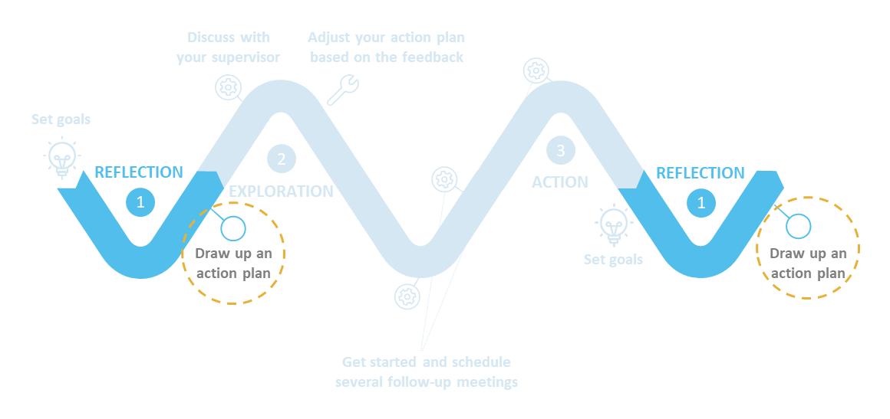
- Prioritize actions to support your research goals, skills development and career planning. Now that you have reflected on your long-term career goals, what are your short-term priorities for your PhD training period? Prioritize actions and transform them into milestones.
Tip 1: If your long-term goal is a career in academia, this tool might help you to prioritize your research activities.
Tip 2: If your long-term goal is a career outside academia, YouReCa career center can help you navigate the external labor market.
Write your action plan here. Divide in blocks for example semesters, quarters, months…
RESEARCH GOALS | Q4 2026 — Central ethics and FAMHP submission; order the pressure-measurement systems; online training blocks for the six centres.  Q4 2026 – Q1 2027 — Technology day and behaviour-training day per centre; dry run of the four visit types in each centre; REDCap acceptance test and version lock.  Q1 2027 — Pilot participant per centre, debriefing within the week, Go/No-Go; first participant included.  Q1 – Q3 2027 — Submit the protocol paper; run and submit the scoping review; co-author the two publications from the preceding study; recruitment monitoring from the first inclusion onwards.  Click or tap here to enter text.
RESEARCH GOALS | Support I need from my supervisor:  • Approve the protocol and the SAP before the central submission, and be available for the coordinating committee that has to confirm the monitoring set-up.  • Open doors at the six site PIs when dates or commitments stall: a word from the promotor moves an agenda faster than an email from me.  • A co-author round on the protocol paper and the scoping review within two weeks per draft, so submission is not delayed by review time.  • A named deputy for the technology and dry-run days, so that a single illness does not stop twelve site visits.  Click or tap here to enter text.

CAREER PLANNING | Q4 2026 — No training planned: the first months are reserved for the trial set-up. That is a deliberate choice, not a gap.  Q2 2027 — Start the CSSC Lean Six Sigma Black Belt (self-paced, 2 to 3 months) from month 7.  Q3 2027 — First exploratory contacts within EASD, DFSG and the Flemish hospital umbrellas; poster at EASD and DFSG 2027.  Q4 2027 — Start Harvard Online Health Care Strategy, after the congress week, as month 1 of the 18-month certificate window.  From year 2 — Seek a seat in a quality or budget working group in my own institution.  Click or tap here to enter text.
CAREER PLANNING | Support I need from my supervisor:  • Endorse the executive-education track as part of the doctoral trajectory rather than next to it, so the hours are legitimate.  • Introductions into Zorgnet-Icuro and the RIZIV/KCE circuit, where a personal introduction carries further than a cold approach.  • Support for the request to join a quality or budget working group in the host institution.  • A yearly review of this plan with the full supervisory team, so the career track is adjusted alongside the research track and not after it.

TRANSFERABLE SKILLS DEVELOPMENT | Q2 – Q3 2027 — CSSC Lean Six Sigma Black Belt, applied immediately to process mapping of the four visit types and to fidelity monitoring.  Q4 2026 – Q1 2027 — Leadership in practice: chair the investigator meetings, lead the training and the dry runs in six centres, and run the certification conversations.  Academic year 2027–2028 — Co-supervise a master student on a PARADISE sub-question.  Q4 2027 onwards — Harvard Online Health Care Strategy; Digital Health: AI (spring 2028); Health Care Economics (January to February 2029).  Continuous — Writing for non-academic audiences: one policy brief and one management-facing presentation per year from year 2.  Click or tap here to enter text.
TRANSFERABLE SKILLS DEVELOPMENT | Support I need from my supervisor:  • Let me chair the investigator meetings rather than attend them, and give feedback afterwards on how it went.  • Assign a master student whose subject sits inside PARADISE, so supervision costs research time only once.  • Read one policy brief per year with the eye of a policy reader instead of a reviewer.  • Honest feedback on the gap between how I think I come across to the site teams and how I actually do.

Comments from supervisor
- What recommendations do you have for the PhD researcher to help her/him achieve her/his goals for the upcoming year? What support can you / would you like to provide? Do you have any other comments?
Click or tap here to enter text.
E.g. hidden talents, suggestions for improvement, recommended courses…

