# React – HTML Code

import './App.css';  
  
function App() {  
 return (  
 <div className="App">  
 <div className="Introduction">  
 <h1>Medi</h1>  
 <h2>A Chatbot System for Remote Health Monitoring</h2>  
 <p> At Gopher industries we have created a chatbot system call “Medi” that works as a personal assistant  
 for  
 our intended demographic population to interact with the Gopher Suit and act as a frontage that is  
 the  
 introduction to the products that Gopher houses. <br/>  
 Medi allows users to chat to it as if it was a human interaction helping them with anything from  
 pain  
 assessments to water consumption, nutritional advice and log in with their patient ID. <br/>  
 Medi is designed for its users being easy to use, interacts in a friendly human way and will  
 eventually be  
 able to be interacted with via both text and voice – making the product accessible for whoever needs  
 to use  
 it. <br/>  
 With future implementations and testing of GUI environments that suits our users, it is an exciting  
 time for  
 Medi with graphical implementations and unlimited additions available – Medi is proud to be the face  
 of the  
 Gopher Range!  
 </p>  
 </div>  
  
 <div className="Features">  
 <h1>Features Within Our Application Will Include</h1>  
  
 <h2>Pain Assessment Questionnaire</h2>  
 <p>Ability for our users to log and rate their pain assessment to share with authorised health care providers</p>  
  
 <h2>Diet Plan and Tracking</h2>  
 <p>Users are able to plan, monitor and share their diet plan with their authorised health care  
 providers. It will be a space where they can keep track of their nutrition and diet plans and  
 with a quick reference on a day to day basis of their nutritional intake  
 </p>  
  
 <h2>Water Consumption and Tracking</h2>  
 <p>For anyone but in particular, the demographic that is using our app, tracking water consumption daily is important. Our MEDI will be able to  
 log a daily water goal, graphically retrieve how much their consumption and motivate them along the way to reach their goal!  
 </p>  
  
 <h2>DataExtraction and Read Write Functionality to our Database</h2>  
 <p> Exciting plans are in the works for medi to be able to hve read and write function to our  
 centralised database, meaning that the information  
 that is entered into MEDI can be logged to the other Gopher logs and vice versa. Meaning that MEDI  
 is the centralised product that users can interact with for all of their health needs.  
 </p>  
 </div>  
 </div>  
 );  
}  
export default App;

# CSS Code (However, this incredibly basic because I understand you will have a centralised format that you will use)

.Introduction {  
 display: block;  
 margin: 3cm;  
 border: 15px solid lightblue;  
 text-align: center;  
 padding: 2cm;  
}  
  
.Features {  
 display: block;  
 margin: 3cm;  
 border: 15px solid lightblue;  
 text-align: center;  
 padding: 2cm;  
}

Website Format   
Again understanding that you want content over CSS - Just trying to make life easy for you to implement   
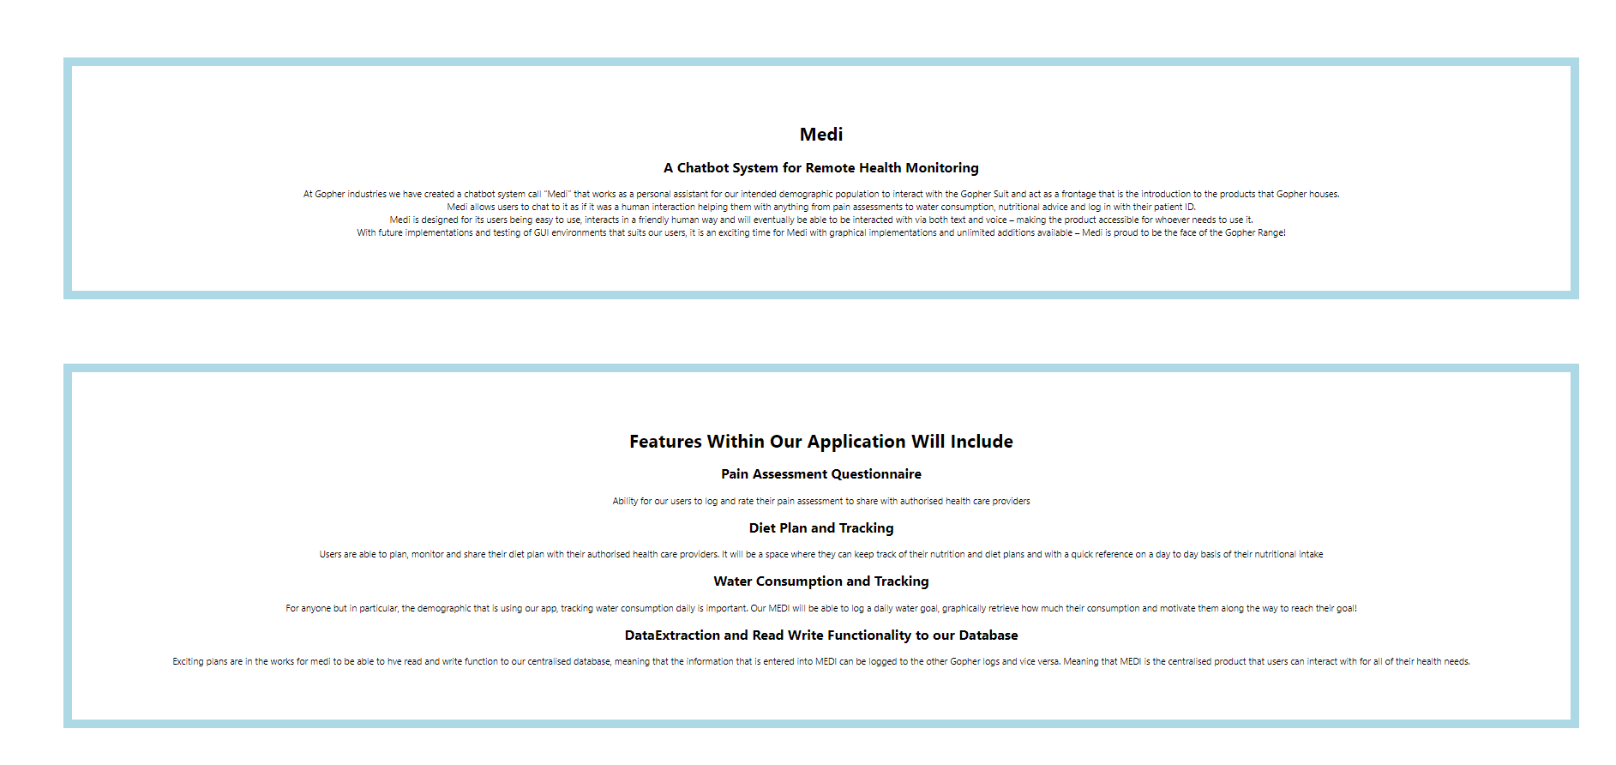

# GitHub Link <https://github.com/Delljones/Avengers_Biography_ProjectX>

Main JS file   
<https://github.com/Delljones/Avengers_Biography_ProjectX/blob/main/src/App.js>

## Main CSS - Completely changeable - made basic on purpose <https://github.com/Delljones/Avengers_Biography_ProjectX/blob/main/src/App.css>