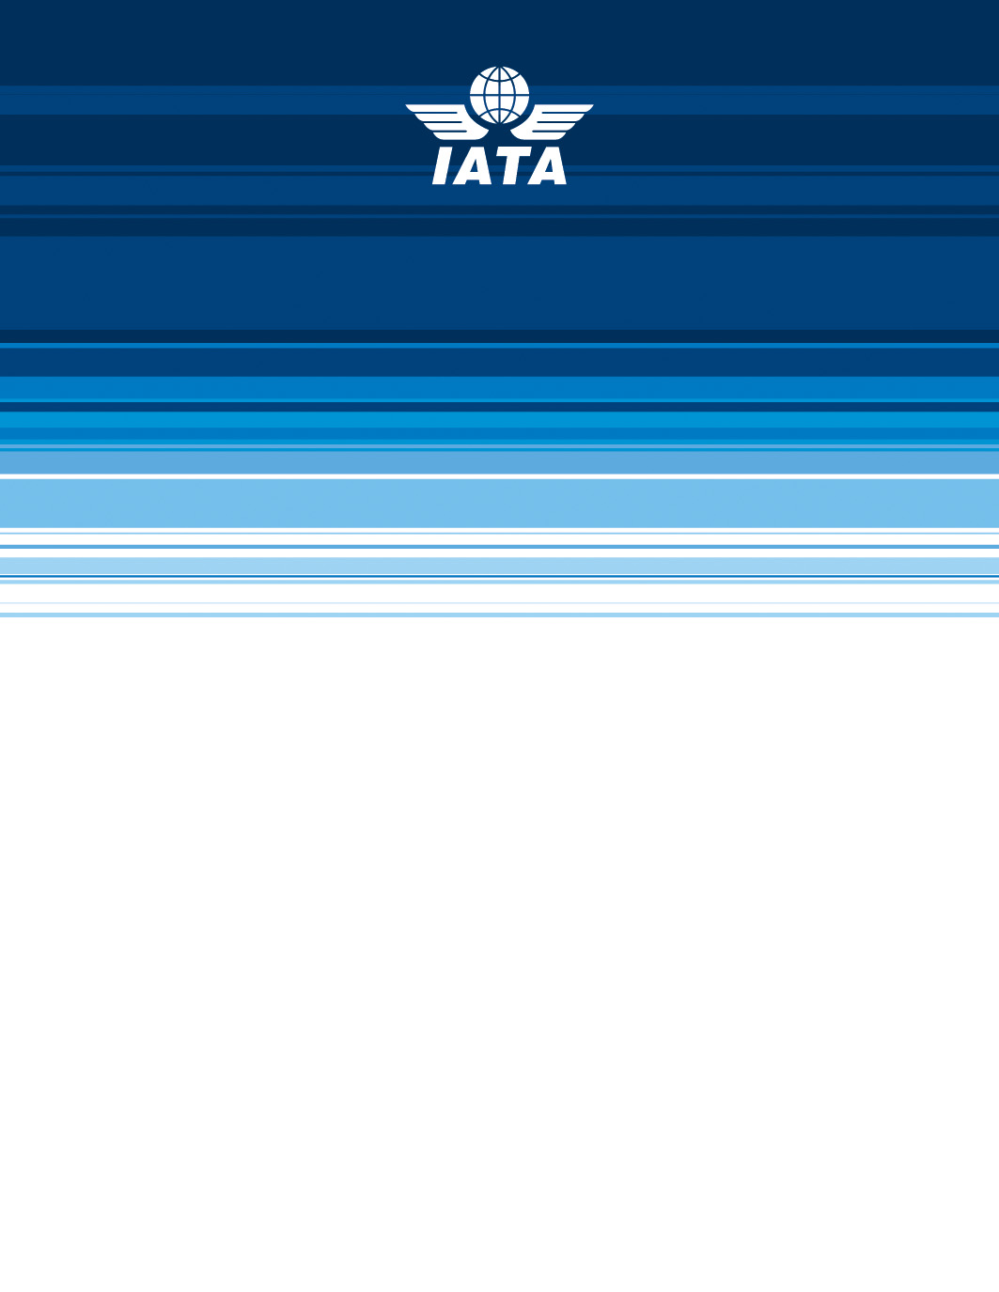

IATA
Serial Number Allocation Program

User Manual for the BSP Users

Version 1.0| 29-August-08

Copyright Information
This document is the exclusive property of International Air Transport Association (IATA) the recipient agrees that they may not copy, transmit, use or disclose the confidential and proprietary information in this document by any means without the expressed and written consent of IATA. By accepting a copy, the recipient agrees to adhere to these conditions to the confidentiality of IATA's practices and procedures; and to use these documents solely for responding to IATA's operations methodology.
© All rights reserved IATA, 2005

Revision History

Version | Change Description | Sections | Date | Author(s) | Reviewer(s) | Approval(s)
0.1 | Draft | All | April 21-2008 | Jiten Panna | Rajesh S | Rajesh S
0.2 | Draft | All | May 15- 2008 | Jiten Panna | Rajesh S | Rajesh S
1.0 | Draft | All | 29-August-2008 | Jiten Panna | Deepa D | Rajesh S.

Creation Date: 21 April’ 2008
Last Modification Date: 29 August’ 2008
Print Date: 29 August’ 2008
Reference:
Author(s): Jiten Panna
Approval(s): Rajesh S.

References
Reader should read this document in conjunction with the following documents:
Reference and Document Name | Version | Location
SRS SNAP v1 3.doc | 1.3

Trademarks
All other company and product names used herein in may be the trademarks or registered trademarks of their respective companies.

Copyright Information ii
Revision History ii
References ii
Trademarks ii
1. Preface 4
1.1. Scope 4
1.2. Audience 4
1.3. Acronyms 4
1.4. Conventions 5
1.5. Contents 5
2. Getting Started 6
2.1. Login 7
2.2. Serial Numbers 9
2.2.1. Allocation: 9
3. Glossary 15

- Preface
IATA governs the international air transportation industry and offers various services and programs to various players (for e.g., airlines, agencies, passengers etc) in the air transportation industry. In this regard, IATA undertakes the process of serial number allocation of the tickets that may be issued to the passengers.

The purpose of SNAP is to issue and maintain the serial numbers that appear on the Airline tickets. Along with the creation and maintenance of serial numbers, SNAP also takes care of the agencies that are allocated these serial numbers for issuing them to the passengers. The application presents itself to different types of users (External User and Internal User) who will be able to access it from IATA intranet and internet.

External and Internal users are categorized into four broad accounts viz. Admin (Internal), SCM (Internal) and BSP (External).

 | Apart from the above four roles there is a guest account created for some privileged users- Readonly users. These users have access to the Monitor Usage page. They can navigate through the page but the application prohibits them from making any modification to the data in the application.

The BSP users are the external users who use the SNAP application to place a request for the allocation of serial numbers to a BSP.

This manual covers the entire set of activities that can be undertaken by the BSP User.
  - Scope
This manual details the various activities undertaken by the BSP users.
  - Audience
This manual is intended for the use of IATA’s internal as well as external SNAP users. It helps the internal users in understanding the services that the application would give to the external user and how the internal users are associated with those services provided. The external users understand the application better through this manual and this will help him efficiently execute his work.
  - Acronyms
Acronym | Description
IATA | International Air Transport Association
SNAP | Serial Number Allocation Program
GDS | Global Distribution System - External user
SCM | IATA Employee
DPC | Data Processing Centre
BSP | Billing and Settlement Plan – External user
  - Conventions
Conventions | Description
Bold | Sub points are highlighted in bold.
Italic | User Interface elements are Italic.  Example: Click OK.

  - Contents
Chapter | Description
Chapter 1  Preface | This chapter provides an overview of the activities that are performed by different users as defined by IATA. It also covers the scope, audience, conventions used, and contents of the manual.
Chapter 2  Getting Started | This chapter explains the login process of the SNAP application
Chapter 3  SNAP Numbers- Allocation | This chapter explains the requests that the BSP user makes to the Admin/SCM users, for the allocation of serial numbers to the BSP.

- Getting Started
As mentioned above, the user of SNAP includes:
- Admin User
- SCM User
- BSP User
- Readonly User
The following table lists the specific responsibilities of these roles:
Role Name | Description
Admin User | This is the Super User who has the access to all the functionality of the SNAP Application
SCM User | This user is also an Internal User who has access to some of the functionality of SNAP
BSP User | This is an external user who has access to the SNAP application in which he can place a request to the Admin for the allocation of the serial numbers to the BSPs.
Readonly User | This is a readonly user who has the access to SNAP but cannot do any modification.

  - Login
Enter the User ID and Password in the login page.
Login page:
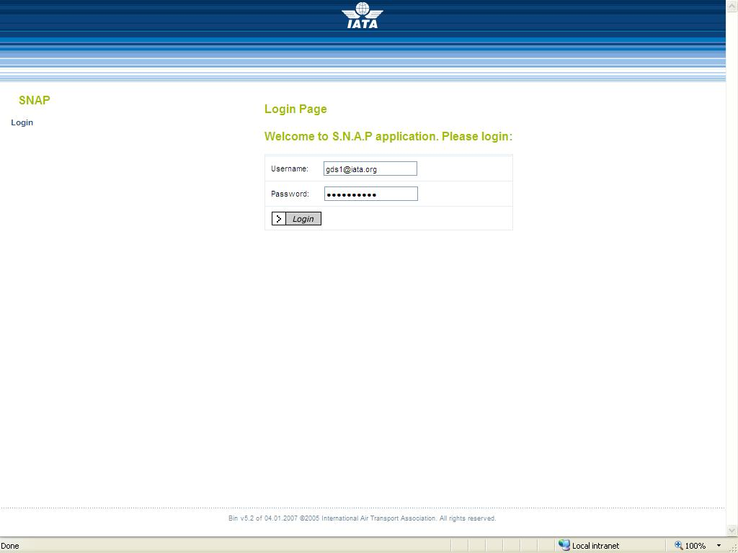
The BSP Home page displays the links to the functionality as provided by the SNAP application. Each page in the application displays the left side menu, which is linked to a specific functionality. Clicking on the Home link will redirect the user to BSP Home page. The Logout link will terminate the current logged in user’s session and redirect them to the Login Home page.
Operations are grouped into specific categories and are displayed in Blue color. The group headers are displayed in green color.

BSP Home Page:
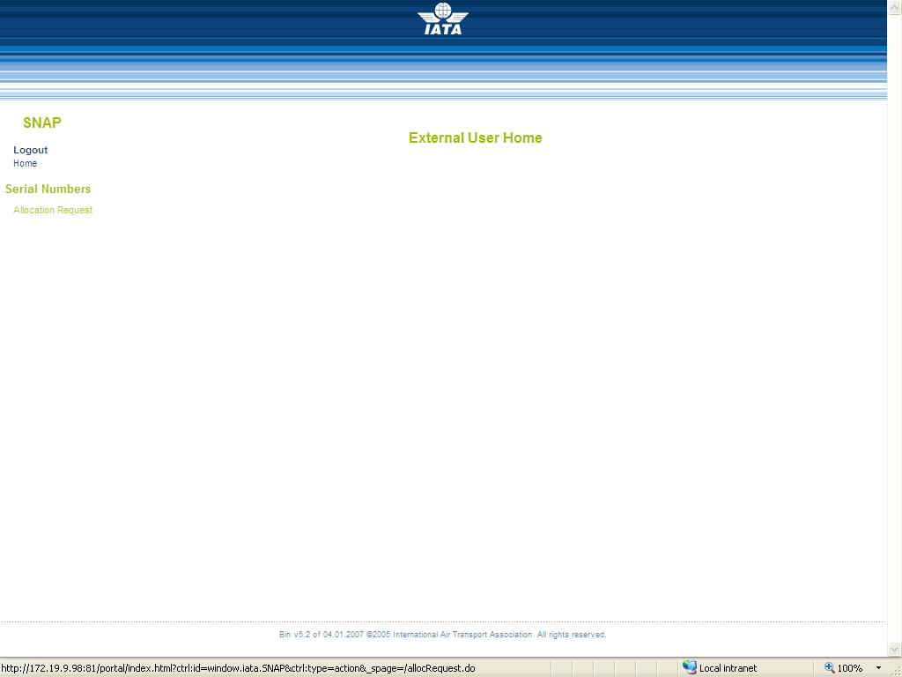
If the authentication provided was incorrect then the login page with the message- Invalid username or password is displayed.

Invalid Login Page:
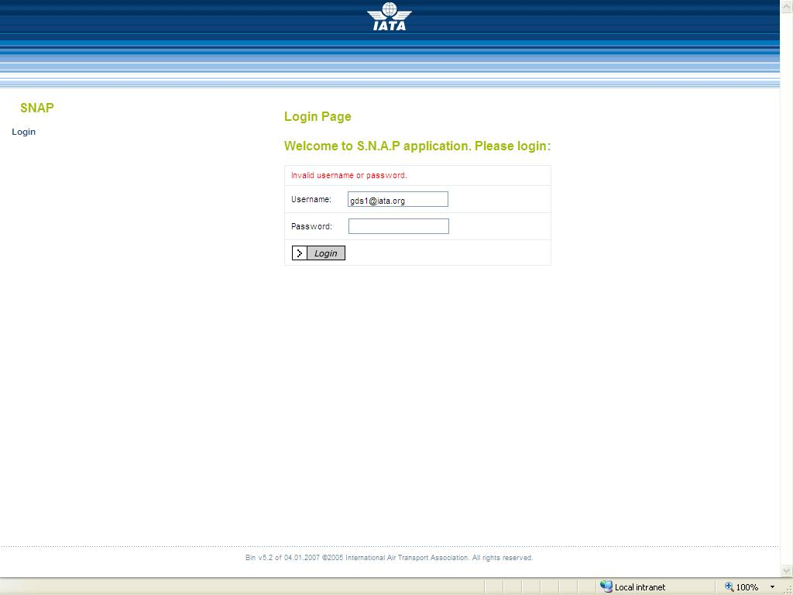
  - Serial Numbers
    - Allocation:
The BSP user uses the SNAP application to place the request to the Admin/SCM, for the allocation of the serial numbers to a BSP. He can also keep track of the entire request that he has made. The Admin/SCM user may in turn accept or reject the allocation request.
Click on the Allocation Request link on the left side of the page. The Allocation Home Page is displayed. This page displays the statistics of the Pending request, Processed request and the Rejected request. It also has two buttons-New Request and Request Details.
      - Request Details:
The Request Details button will display the details of the entire request that has been made so far by the logged in user. User may check the details and keep track of the request that have already been made. Click on the Request Details button to look at the details of the allocation request so far.
Allocation Home Page:
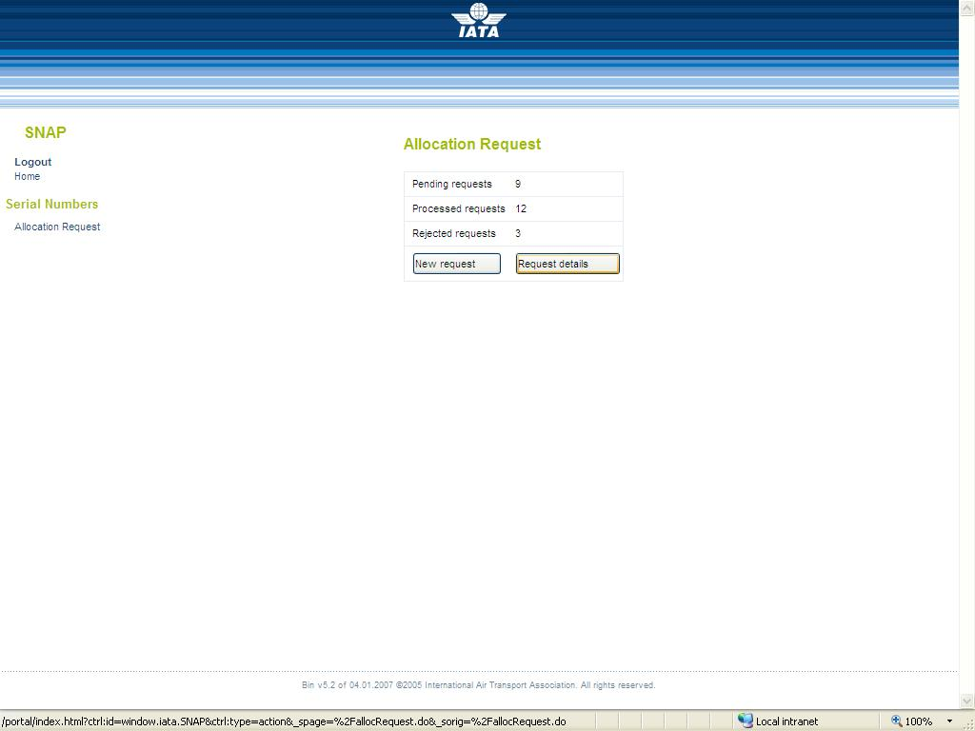
The next page displays the information of the requests that have been made so far. An additional button gets displayed – Hide Details. This button hides the details of the request made. Click on the Hide Details button to hide the details.
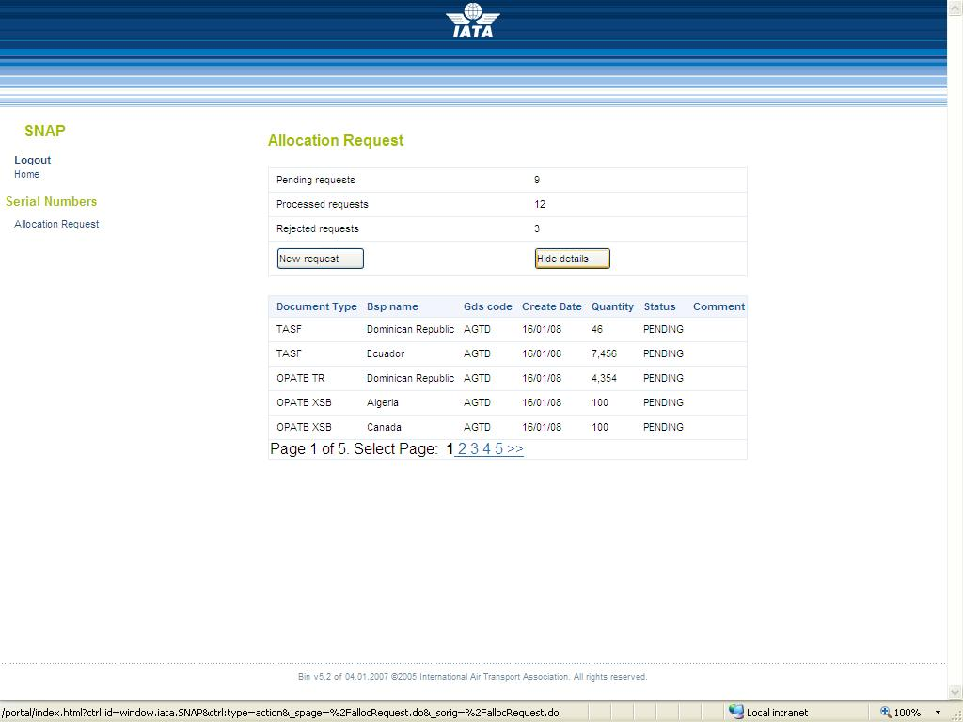
The information gets hidden on clicking the Hide Details button.
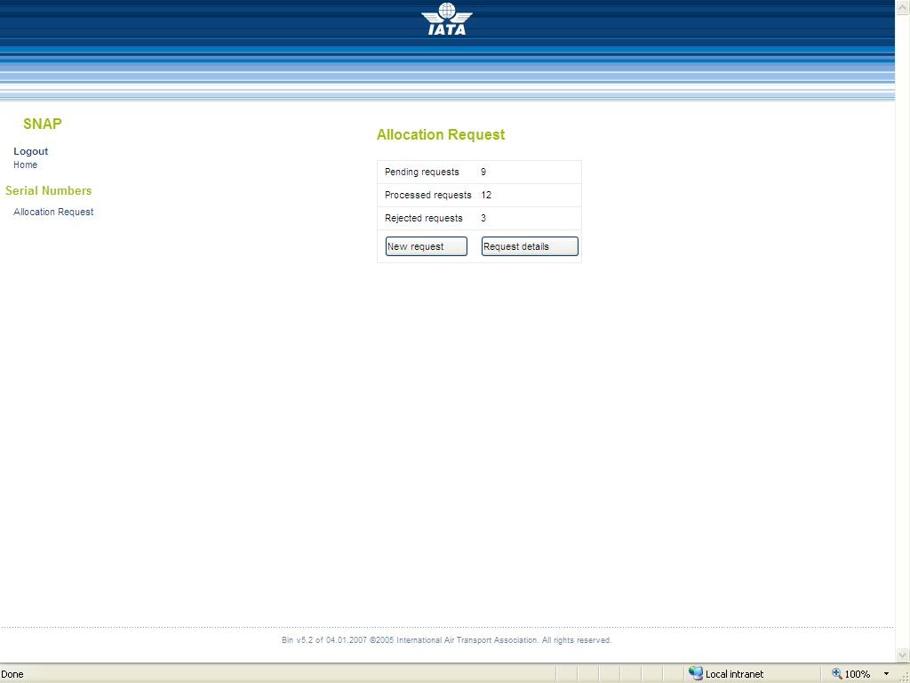
      - New Request:

A new request for the allocation of serial numbers can be made through this button. Click on the New Request button to proceed with placing a new request.
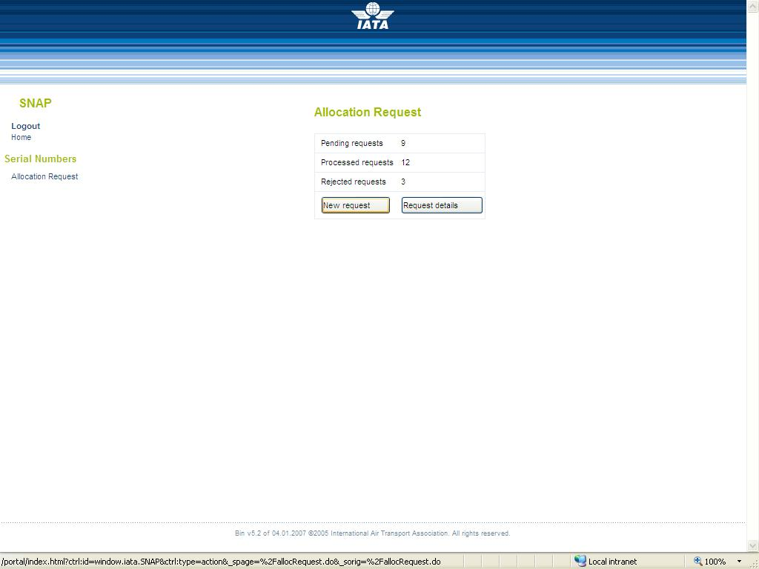
The next page displays an editable page that needs to be filled. There are three fields to be filled in, viz.:
- Document type: Select the document type for the serial number whose allocation is to be requested.
- GDS: Select the GDS to which the logged in BSP will assign the allocation to
- Quantity: Enter the quantity that needs to be allocated.
Click on the Request Allocation button to place the allocation request.

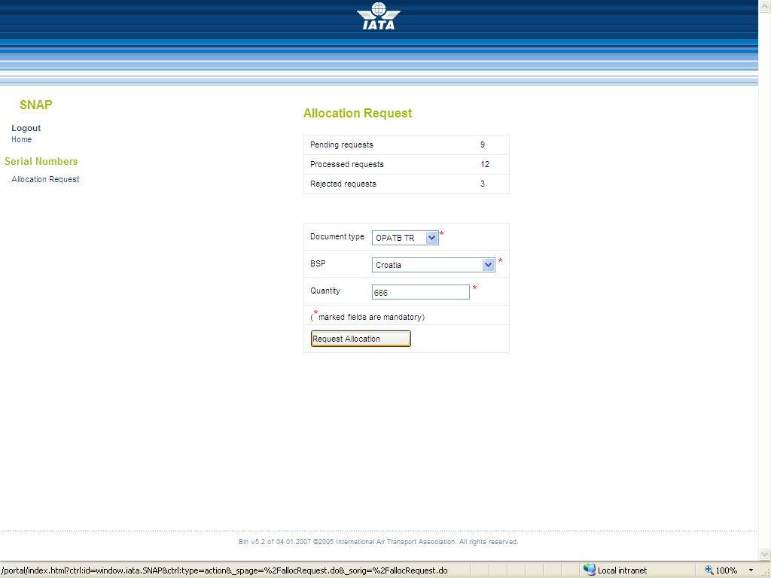

The next page displays the confirmation for placing the request. Click on the Proceed button to proceed with placing the allocation request.
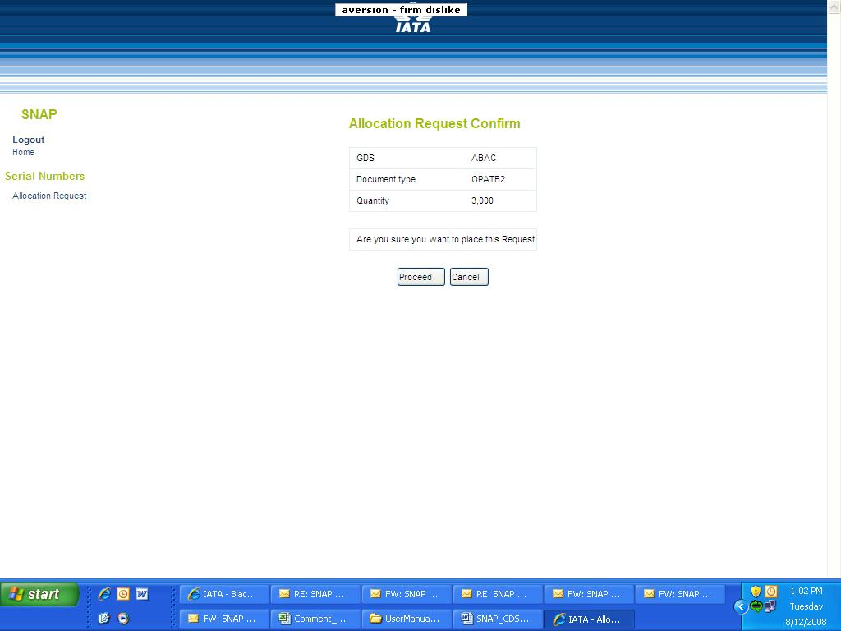
The next page displays that the request has been successfully sent to the Admin/SCM user for approval.
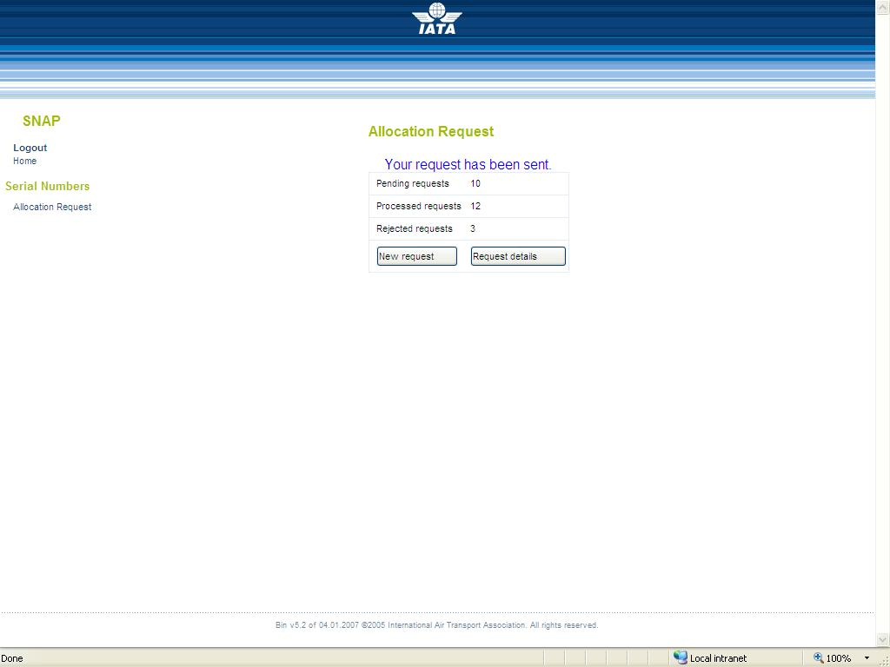
The allocation request that has been made can be checked in the Request Details page. Click on the Request Details button and the detail of the allocation request that has been made is displayed.
Approved or rejected SNAP allocation requests will be sent to the BSPs’ SNAP generic Mailbox.
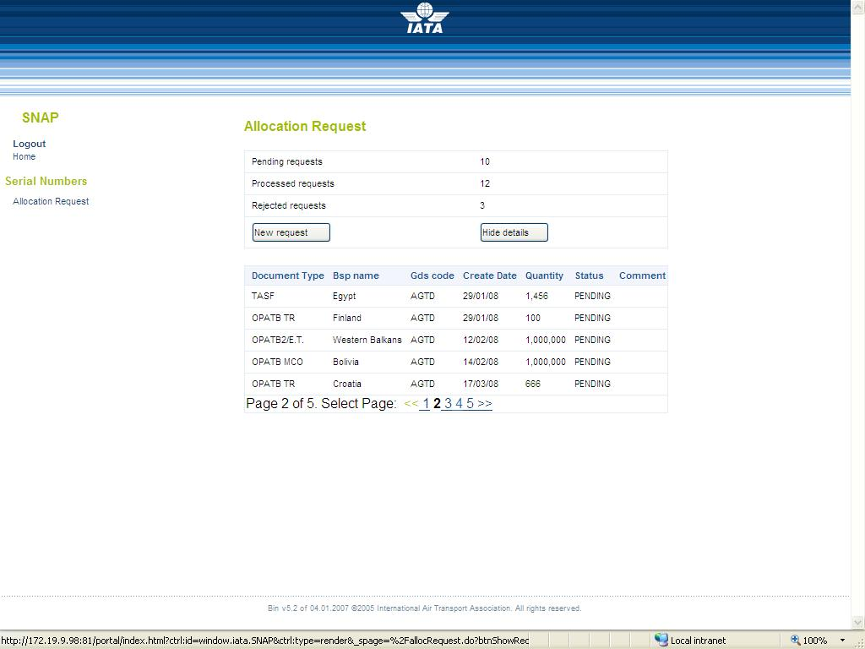

- Glossary
Term | Description
IATA | IATA is a governing body that promotes inter-airline cooperation in promoting safe, reliable, secure, and economical air services.
SNAP | Serial Number Allocation Program. This is the name given to the application which facilitates the allocation of the serial numbers to the BSP
BSP | A BSP is the central point through which data flow between travel agents and airlines. The BSP is an external user. This user will do only allocation request in the SNAP application.
DPC | The DPCs run applications for BSPs: Data Processing Center. These applications are keeping track of the usage of the serial numbers. The information entered into the DPCs is provided by the GDSs and BSPs.
GDS | The GDS is an external user. This user will do only allocation requests in the SNAP application. (This option is for future implementation)
SCM | The SCM user is an IATA employee. This user is responsible for the every day work.
TI File | Ticket Inventory data report the allocation of serial numbers in the Ticketing Systems, detailing issues, returns, re-issues and lost tickets as applicable. The file may emanate from a BSP or a Ticketing System, and will contain details of ticket allocations by country, by Ticketing System and by Agent and the allocation date.
iiNET | The intranet within IATA where the DPC places the TI File in a predefined folder. The SNAP application scans this folder periodically and if there is any uploaded file, this is made available to the SNAP application.

