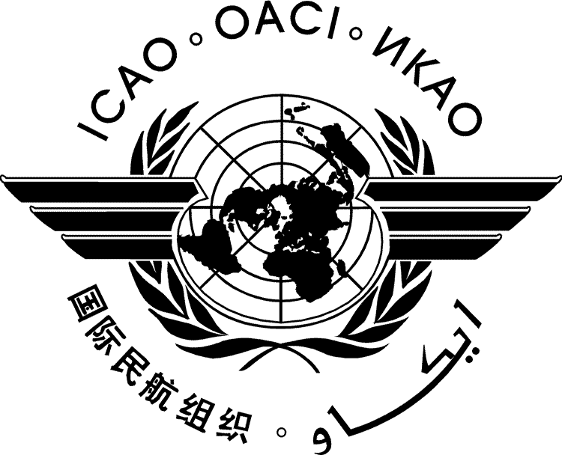
  METWSG/2-SN No. 7
  27/2/09
METEOROLOGICAL WARNINGS STUDY GROUP (METWSG)

SECOND MEETING

Montréal, 19 to 21 May 2009

Agenda Item | 5: | Content and issuance of SIGMET
 | 5.1: | Improved issuance of SIGMET

Feasibility Study on the Rationalization of the Issuance of SIGMET

(Presented by Steve Albersheim - member of ad hoc group)

SUMMARY
This study note is one of two stemming from the ad hoc group concerned and does not represent the views of the entire group. Study note 8 describes an alternative approach put forward by other members of the group. The two views are presented to assist further discussion.

- INTRODUCTION
  - At the first International Civil Aviation Organization (ICAO) Meteorological Warning Study Group (METWSG) meeting in November 2007, a group of experts discussed ways to improve the issuance of Significant Meteorological Information (SIGMET) by Meteorological Watch Offices (MWO). It has been recognized for some time by the Air Navigation Commission (ANC) that there is a need to improve MWO capabilities to issue SIGMET. In accordance with METWSG Action 1/2 an ad hoc working group was established to further review this issue. The group was requested to study ways of improving the situation by establishing dedicated regional centres in support of improved SIGMET availability. In addition, the group was also tasked to consider the improvement of the existing MWO based framework and to consider developing proposals to improve training related to SIGMET, regular testing and real-time monitoring and extend successful measures to all ICAO regions.
  - At the present time there are thought to be 188 MWO. In accordance with the Standards and Recommended Practices (SARP) of ICAO Annex 3 — Meteorological Service for International Air Navigation, these MWO have the responsibility to monitor significant weather phenomena relevant to aviation and to issue SIGMET whenever defined conditions are met, which can be either observed or forecast. The International Air Transport Association (IATA) on a number of different occasions has noted that many MWO are not able to fulfil all or part of their obligations. In response to this deficiency, ICAO for the past several years has conducted missions and taken on special projects such as Special Implementation Plans (SIP) to provide assistance to States to improve their capacity and understanding of the operational requirements for the provision of SIGMET. ICAO has also collaborated with the World Meteorological Organization (WMO) to convene seminars on the issuance of SIGMET and has published Regional Guides, Handbooks and Posters on practices and procedures for SIGMET to be used by MWO. These guides/handbooks are very detailed providing clear examples and procedures to be followed. SIGMET tests as well as web-based SIGMET monitoring tools are also in place in some ICAO regions in the past few years to monitor the MWO’s capabilities and readiness in the issuance of SIGMET. Despite these progress and steady improvements noted in the SIGMET test and monitoring results, concern remains on the degree of compliance with ICAO and WMO regulations in the monitoring and warning of weather hazards to aviation requiring the issuance of SIGMET.
  - This Study note will consider the case for the creation of regional centres in support of improved monitoring, SIGMET issuance and training. The following key issues that will be considered in this paper:
- deficiencies in compliance with ICAO Annex 3 SARPs and inconsistencies apparent by the cessation or change of hazardous weather warnings at FIR boundaries due to differences in technology, methods and procedures employed by adjacent MWO;
- skill level required by aeronautical meteorologist in support of the future Global Air Traffic Management Concept of Operations;
- training, capacity building and continuous improvement required by QMS systems;
- current ICAO Annex 3 provisions on the relationship between MWO and Volcanic Ash Advisory Centres or Tropical Cyclone Advisory Centres; and
- safety, sovereignty, cost recovery and liability issues.
- Discussion
- Compliance with Annex 3
    - An assessment by the SADIS Operations Group’s Gateway Development Team has shown occurrences of significant deficiencies in SIGMET format compliance and incorrect routing of SIGMET. At SADISOPSG/13, the SADISOPSG Gateway Development Team reported on an analysis carried out in 2008 to determine whether States adhered to the format for the SIGMET. The results were disappointing in that only 29 percent of the samples during a 14 day period were in full compliance. At the CARSAM AERMET SG/9 meeting in 2008, it was noted that at least three States did not follow the guidance on the issuance of SIGMET and one State did not even have the necessary personnel to staff the MWO. Based on a draft amendment (28 January 2009) to the ASIA/PAC Facilities and Services Implementation Document (FASID) five States are identified as not implementing a MWO. The ICAO Standard (3.4.1 in Annex 3) calling for the arrangement for another State able to do so to take up responsibility for the MWO foreseen for such cases was yet to be applied and there is no indication that States plan to implement this provision.
    - The European Air Navigation Planning Group’s Met Group has discussed the apparent inconsistent cessation or change of hazardous weather warnings at Flight Information Region boundaries due to different methodologies and working practices between MWO. Operators and flight crew have raised concern that warnings of hazardous weather phenomena are not well coordinated between Flight Information Regions, particularly where this comes under a different MWO, which in some parts of the world are relatively close together. The MetG of EANPG agreed that improved coordination between MWO was necessary but this has only resulted in limited improvements. Regionally based centres could assume a coordinating role and the potential for issuance if and when determined by regional agreement for areas consistent with ATM–defined blocks of air space.
    - Based on the analyses of the problems above, it is considered to address the existing problems on a global scale rather than for identified regions with an acute safety concern only.
    - Future Global ATM
    - Implementation of the future Global Air Traffic Management Concept of Operations will require a level of technology, quality management system and expertise in the provision of aeronautical meteorological services that may exceed the current capabilities of MWO. The future MWO will require well trained aviation meteorologist who can operate processors to ingest and analyze global model output in support of the MWO mission.
    - Over the past several years there has been an evolutionary change on how future air navigation operations will be conducted. ICAO has recognized this and has prepared the Global Air Traffic Management Operational Concept (Doc 9854) that describes the vision of the future ATM system. Much of this is focused on performance based trajectory management of aircraft. The operational concept presents the ICAO vision of an integrated, harmonized and globally interoperable ATM system.
    - Trajectory performance based operations are highly dependent on accurate and reliable information of hazardous weather phenomena impacting air space. The current text-based SIGMET messages are unlikely to be able to provide this information for decision makers on the required scales of time and space. Operators need to have access to meteorological information for specific flight paths. To achieve that capability meteorological information will be required in a 4-dimensional gridded or object-oriented format. The new information requirements are expected to also include probability and reliability information for predicted occurrence of severe events.
    - MWO with a responsibility to create and disseminate SIGMET-type information according to these evolving requirements will require data processing capabilities that can make use of Numerical Weather Prediction (NWP) data, remote sensing data as well as in-situ observation data with the capacity to determine the location, intensity and development of the hazardous weather as well the probability of severity and extreme values.
    - These requirements may exceed the current capabilities of many existing MWO. To equip all existing MWO to be able to fulfil these evolving requirements would be neither realistically feasible nor economically justifiable.
    - SIGMET tests, monitoring, and improved training
    - As far as the SIGMET tests are concerned, the group believes that the current test procedures conducted routinely in each ICAO Region are adequate. A web-based monitoring tool developed for the Asia/Pacific Region in support of routine monitoring and evaluation of the SIGMET issuance shows great promise to help monitor issuance of SIGMET that could be used in other ICAO Regions.
    - As regards training issues, ICAO in collaboration with WMO has gone to great efforts to provide training seminars to increase the skill level of existing MWO personnel including handbooks on practices and procedures with detailed examples which is followed by conducting planned tests. This has met with limited success in improving the issuance of SIGMET as has been shown in the identified deficiencies above. The cost-benefit of traditional classroom seminars to improve this situation could be questioned in the light of past experience.
    - Along with the testing, monitoring and evaluation procedures, there is still a need to maintain currency of aeronautical meteorologists. ICAO has encouraged and WMO is engaged in the development and use of online training material and web sites for MWO personnel to improve or at least maintain the current skill levels. One possible method to ensure personnel maintain their skill is to require States to incorporate training and competency assessment as part of their obligations to meet WMO Quality Management System guidelines.
    - Training will have to focus on using a 4D data base. Skills in handling a digitized data base and understanding how to access data in a net-centric approach will be most valuable in supporting the future ATM operations environment. Aeronautical meteorologists in regional centres, are envisioned to provide tailored information in support of trajectory based operations, a service that most traditional MWO would find difficult to provide.
    - Model Regional Centres
    - The Volcanic Ash Advisory (VAAC) and Tropical Cyclone Advisory Centres serve as models for providing guidance to MWO for the issuance of SIGMET. These Centres provide advisory information to States, Met Office concerning presence of volcanic ash and tropical cyclones. They use advanced modeling capabilities and satellite imagery to detect and track these hazards. The operation of these Centres has proven to be so successful that the ANC has tasked the IAVWOPSG to institute a process for the VAAC to directly inform Area Control Centres (ACC) of the accidental release of radioactive material into the atmosphere for the purpose of advising operators of the hazard. This level of service could only have been designated to the VAAC because of the resources and skill level of personnel who operate these centres. At the end, the London VAAC volunteered to provide a global service to forward a Nuclear Emergency Message to the ACC directly concerned. The group in its deliberations agreed that this type of operation could be consolidated to one VAAC.
    - While this system has worked well, it is also known that even with the provision of these advisories MWO do not issue SIGMET in compliance with Annex 3. Thus one may conclude that there is a need to consolidate MWO to Regional Centres that can issue the SIGMET.
    - An alternative to the above is to continue on with the concept of having Advisory Centres but expand their role as NWP Centres in support of MWO. Current developments in WMO are supporting such regionalized data processing. For example, the Asian Aviation Meteorology Service successfully implemented in RA II and the Severe Weather Forecast Demonstration Project successfully implemented in Southern Africa, and currently being extended to Central/South America and the Pacific region, could be expanded in to provide NWP guidance on icing, turbulence and severe convective events for use by MWO’s/FIR’s. The WMO Sand- and Duststorm warning system SDS-WAS is currently undergoing a transition from research to operational mode. Exchange of the basic data necessary for the operation of the necessary models will benefit from the development of the WMO Information System WIS and the WMO Integrated Observing System (WIGOS).
    - While this alternative proposal shows great promise it does not necessarily resolve the issues that have previously described that concerns training and capacity of the MWO to issue the SIGMET plus it adds extra service cost to operators for redundancy in an existing system that needs to be streamlined. Also, careful consideration has to be undertaken in that these WMO NWP may be in direct conflict with the current World Area Forecast System (WAFS). The mission of WAFS is to provide global aeronautical meteorological en-route forecasts in digital form. Operators have expressed a great desire to consolidate services for the purpose of not only reducing their costs but efficiency of operations in that there are not multiple products to chose from to make operational decisions.
    - Issues related to safety
    - Safety of flight is a key objective for aeronautical meteorological services. Each State is responsible to ensure that safety risks are assessed and reduced where practicable for flight conducted within its airspace. Therefore, steps would need to be taken to ensure that information provided by the regional centres would meet States’ requirements and responsibilities and not negatively impact controllers, but provides assistance to existing structures allowing them to perform their respective duties respecting State sovereignty. Adequately trained staff, management oversight and appropriate resources should ensure that Regional Centres will provide a more consistent set of warning information across Flight Information Regions.
    - At AERMET/9 one of the conclusions adopted by GREPECAS was the need for MWO to establish backup arrangements. GREPECAS when adopting the conclusion did not consider NWP as an alternative but recognized the need that at times a MWO may not be able to issue a SIGMET; and therefore, States should ensure that there is a backup capability. This is similar to how the two World Area Forecast Centres or the nine Volcanic Ash Advisory Centres operate. Each Centre has a standard operating plan to put in place for backup to ensure there is no break in service.
    - Safety, State sovereignty, cost-recovery and liability issues have to be taken into consideration in adopting any proposal to establish Regional Centres.
- Recommendation
  - There is a clear rationale for the need to re-evaluate the roles and responsibilities of the existing MWOs. The fact that a number of the MWO’s currently cannot adequately provide the required services under existing SARPs should be sufficient to promote the consolidation of MWO. In addition, the future Global ATM suggests a need to create a capability at regional levels to issue warnings of aviation weather hazards in that future operations will not be supported by MWO under the current configuration. Such centres will consist of sufficiently resourced and appropriately qualified aeronautical meteorologists, ensuring that safety is enhanced, quality is promoted and appropriate descriptions of the spatial coverage of the weather hazards are communicated effectively. Two alternatives have been raised one that promotes consolidation of MWO into Regional Centres and the other that maintains the status quo but that NWP be established to support the MWO in the issuance of SIGMET. One leads to higher cost to operators with no assurance that there will be an improvement in the issuance of SIGMET and the other leads to reduction in cost and efficiency of operations.
  - As to training ICAO together with WMO is encouraged to a) strengthen the current SIGMET monitoring and evaluation procedures by extending the web-based monitoring tool developed for Asia/Pacific Region to all ICAO regions; b) continue the efforts to make arrangements under the existing ICAO provisions for States in a position to do so to take up MWO responsibilities on behalf of those States in need for removing current deficiencies; and c) encourage development and use of online training for current MWO personnel to maintain and improve their skill levels.
- ACTION BY THE METWSG
  - The METWSG is invited to:
- note the information in this paper; and
- consider the recommendations provided.

— END —

