UO:98 Setup Guide
Contents:
- Important up-front fact.
- What is UO:98?
- About this release
- Installation prerequisites
- Installing UO:98
- Using UO:98
- Finding help

Important up-front fact.
UO:98 is a Extension of the UO Demo. It does not include any UO Demo files or UO Client files, and requires the UoDemoInstaller.exe file from your T2A CD for installation, as well as an installed copy of the UO Client. If you do not have the licensed CD containing UoDemoInstaller.exe, you may not use this product. See the “Installation prerequisites” section for more information on this and other requirements.
“Ultima Online” and “The Second Age” are trademarks of ORIGIN Systems Inc. and/or Electronic Arts. The UO Demo binaries and data files are Copyright 1998 ORIGIN Systems.

What is UO:98?
UO:98 is an extension to the UO Demo released by Origin Systems in 1998 on the Ultima Online:Second Age CD. The UO Demo (demo) is an offline tutorial for Ultima Online. The Demo featured only the town of Ocllo, and a quest that a player could complete while learning about the Game and Client.
UO:98 unlocks many of the features that exist in the UO Demo such as the ability for others to connect with a regular UO Client, the ability to use the built in staff tools, and the expansion of the playing world to the entire map, and world saving. UO:98 also adds new features such as an accounting system, full world decoration, and support for later UO Client versions.
More information on UO:98 is available on the website, http://uo98.org and on the JoinUO forums at http://joinuo.com/forums. More information and documentation of the UO Demo is available on the UODemo Wiki at http://uodemo.joinuo.com

About this release
This is a very preliminary distribution of UO:98 and we are aware of some specific bugs and shortcomings that will be addressed in the future. In addition to the website and forums, you can keep up with the development of UO:98 and other JoinUO projects on our projects website, http://projects.joinuo.com/redmine/projects/uo98

Installation prerequisites
This UO:98 distribution requires (at a minimum), the following software installed or available on the target platform.
- Microsoft Windows XP, Vista or 7
- Microsoft .Net 4.0 Client Profile.
- Ultima Online Client version 1.25.35 through 5.x
  - (6.x packet protocols not yet implemented)

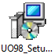
Installing UO:98
You must have the UO Client installed to your PC first. Note that under Windows 7 and Vista it is not recommended to install the UO Client in "Program Files" or on the root of the C drive (C:\) due to security issues with these folders.
The installer will offer to direct you to the Download page for the Microsoft .Net 4.0 framework. If it is not installed at the time of installation you will need to re-run the installer after the completion of the Framework install.
It's best practice to place the Ultima Online : The Second Age CD in your CD Rom drive before beginning the installation so that the installer can find your copy of the required UoDemoInstall.exe file on that disk. If you are reading this document as part of the installation process, it's fine to insert that disk now. If you are unable to insert the disk into your PC, you will be able to browse to the file during the install.
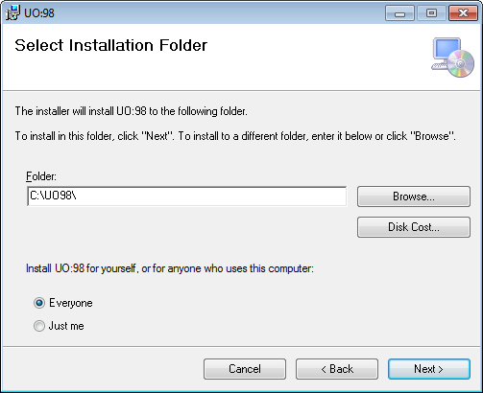
At this step it's recommended to choose a simple path. The root of a drive will allow you to navigate to the folder easily, and it will keep the internal paths short.
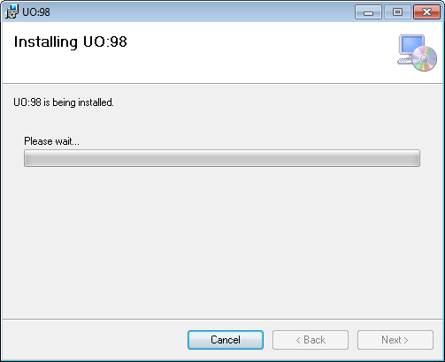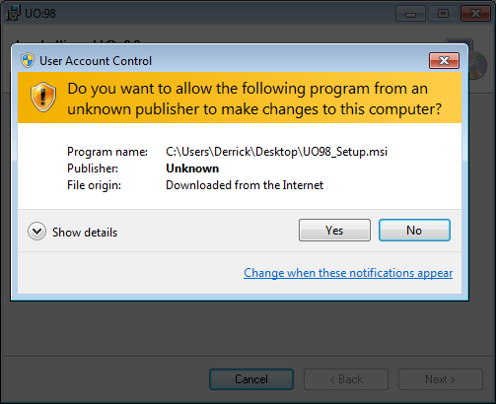
You will be prompted to provide administrative access to the installer. The installer makes registry entries in HKEY_LOCALMACHINE during install.
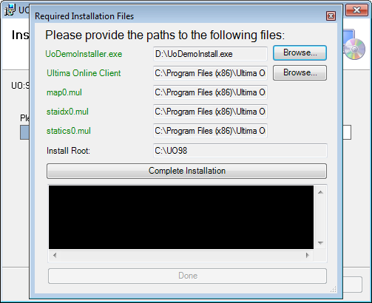
Once the base UO:98 files are installed, the installer will install the required files from the UO:T2A Cd and copy files from your Ultima online directory. The installer also makes a modification to your UO.cfg file so that the UODemo will run properly.
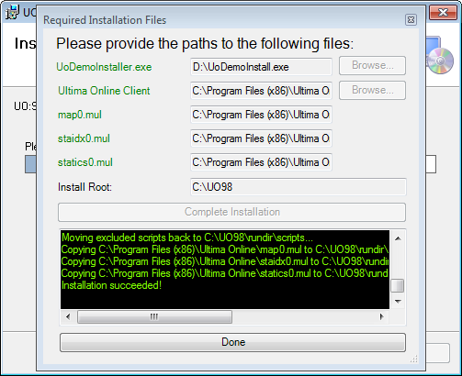
If everything was successful you will see this screen and may press "Done" to complete the installation. If there is an error, please copy the text in the black box and submit via email to Derrick@JoinUO.com

Using UO:98
You will need to browse to the file system folder to which you installed UO:98 to run the program. No shortcuts are created during the install process. The default folder is C:\UO98
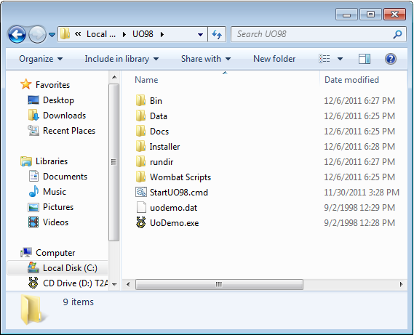
StartUO98.cmd will launch UO:98. UODemo.exe will run the original UO Demo without modification.
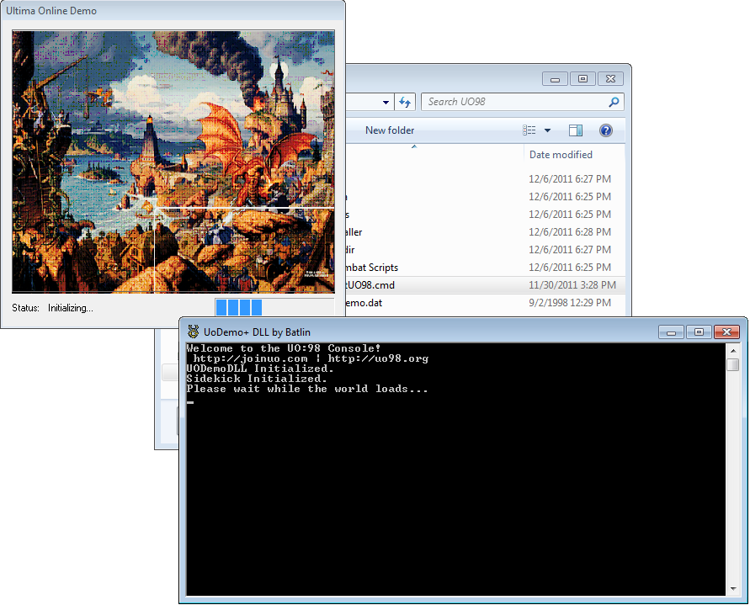
Upon running StartUO98.cmd (double click) you should see this after a few moments.
There is a lot of console output during the UO:98 load and during it's operation. You will see a lot of cryptic messages while the script files are compiled.
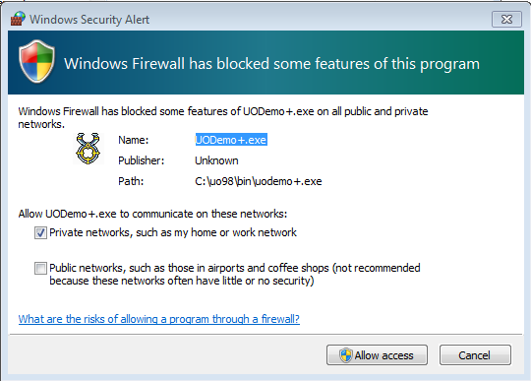
When UODemo+ opens its listening port you may be prompted to enable firewall access for the program. If you intend to allow connections to UO:98 from outside your local network, you should check both boxes in this dialog.
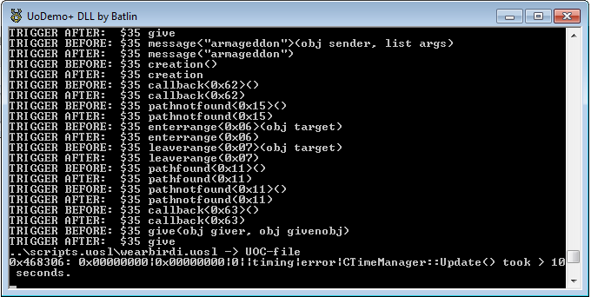
Once you see “Sharpkick Initialized!”, and Server Status messages, the server is ready for incoming connections (default is port 2593).
UO:98 supports the client version on the UO:T2A (1.25.35) through 5.x. You may also use Razor to connect to UO:98. The default port for UO:98 is 2593. This may be modified within the file UO98\rundir\UO98\server.txt.q
It's not recommended at this time to modify fields other than <port XXX> in the server.txt.q file.
The server as distributed has one administrator account:
Username: Admin
Password: password
Additional accounts can be auto created by simply attempting login on a non-existent account.
Further documentation on administrating and modifying the server will be provided in the near future.

Finding help
UO:98 Home Page: http://uo98.org
UO:98 Wiki page on UODemo Wiki: http://uodemo.joinuo.com/index.php?title=Uo98
UO:98 Forums on JoinUO.com: http://www.joinuo.com/forums/viewforum.php?f=34
UO:98 Project Page: http://projects.joinuo.com/redmine/projects/uo98
To report bugs please post in our forums, or email derrick@joinuo.com.
Have fun!

