DPH User Guide
  - Delphi Project Handoff
Windows desktop experimental software
Last changed 11 October 2026
For the person inspecting a Delphi project and recording its handoff knowledge
This guide describes the implemented application and its evidence limits. Use the phase acceptance records for exact measured results and unresolved release gates.

Contents

Purpose and evidence 3
Start DPH 3
Attach a source project 3
Open cached work 4
Learn the selected project 4
Explore and search 7
Read source and graph evidence 7
Inspect screens 7
Import actual screenshot evidence 8
Write attributed knowledge 8
Review and retire knowledge 8
Publish manuals and handoffs 9
Validate and preserve exports 9
Troubleshoot common states 9
Practice a maintenance handoff 10
Source and revision evidence 10

Purpose and evidence
Delphi Project Handoff explains an explicitly selected Delphi project through source inventory, form information, symbols, relationships, control flow and attributed knowledge. It stores its work in one SQLite knowledge database per selected project. DPH is experimental Windows desktop software. Its static analysis is not a Delphi compiler and does not prove every runtime behavior.
Use the generation number, source hashes, certainty labels and diagnostics together. A complete captured analysis means the implemented analysis stages accepted their captured inputs. It does not mean a human approved the business explanation. PARTIAL means unavailable dependencies, unsupported syntax or bounded analysis prevented full coverage. DPH does not compile or execute the selected project, run its build scripts, load its component classes or connect to its production services.

Start DPH
Start DelphiProjectHandoff.exe from its deployed folder. Keep the migrations folder and Microsoft WebView2 loader with the deployment. WebView2 Runtime supports the optional embedded HTML preview. An unavailable preview must leave the exported HTML usable independently. The initial validated target is Windows Win32; another operating system has not been validated.
The Getting started page opens before a project is loaded. It explains the first ten minutes, each workspace tab, a small learning exercise, Delphi terms and repeatable checks. The header Getting started button returns to it at any time. Its native text fallback remains available without WebView2. Keep the help folder with the deployment.
DPH opens maximized to fill the available Windows desktop. The far-left list contains project objects, the centre contains workspace tabs, and the right-hand pane is labeled Selection details. Double-click an object in the far-left list to read its identity, signature and source location on the right. Its text wraps to fit; scroll inside the pane for more. Click the central Explain tab for behavior or Source for code. Drag either vertical divider to resize the panes. In a smaller restored window, scroll horizontally below the top command buttons to reach commands that do not fit.
Read current activity and captured status on the line along the bottom edge of the window. To read analysis gaps, click the Learn the project tab in the centre, then click Coverage and troubleshooting in that tab's topic list. PARTIAL means incomplete evidence. The last successfully opened database identity is remembered in the local user profile and reopens detached.

Attach a source project
Click Attach project at the top and select the application you want to document using its dproj, dpr or groupproj file. DPH rejects its own project, including renamed copies retaining its GUID or program declaration. The current workspace stays loaded when a selection is rejected. Choose a database filename ending in dphdb. The save dialog defaults to Databases under the Handoff application folder: the top-level Databases folder in the source checkout, or beside the executable in an extracted distribution. Existing databases are not moved. You may browse elsewhere outside the selected source folder. DPH rejects database and export locations inside the source boundary and rejects reparse paths that could bypass that boundary. Keep each selected project in its own database.
Select Debug or Release and Win32 or Win64 as appropriate before analysis. Win64 is an analysis configuration choice; the current DPH executable is built for Win32. Extra defines use semicolons. Explicit dependency roots also use semicolons. Add only roots you intend to permit DPH to read. A missing dependency is a visible gap, not a reason to let discovery search neighboring projects without a boundary.
For the pinned VCL2FMXConverter Win32 reference, enter MSWINDOWS;WIN32 as extra defines to reproduce the recorded baseline. DPH does not synthesize every compiler built-in from the platform label. Supply the symbols required by the selected compiler environment; unknown conditional expressions remain uncertain.
Analysis runs in the background. Explorer data belongs to its displayed generation while the worker prepares another. Changed inputs during a scan supersede the capture and request reassessment. A partial or failed capture does not replace a previous complete published head. DPH retains the evidence needed to inspect partial results honestly.

Open cached work
Click Open cache at the top to inspect a saved dphdb database. The picker defaults to Databases under the Handoff application folder; browse to your existing database if it is elsewhere. DPH validates the cached workspace artifact against its SHA256 and generation before displaying it. Cached identity facts also reject old self-analysis databases without relying on their filename or the original source being present. A rejected cache leaves the current workspace intact. A rejected remembered or command-line startup cache leaves Getting started visible. Cached opening does not start a source scan. The cache opens detached until you explicitly attach its source project.
Detached mode allows historical inspection and authored notes. It does not follow cached filesystem paths to display source text or approve a current-source review. Attach the source when you want live hash checks, source navigation and human verification against current evidence. A missing or damaged cached artifact is reported rather than silently treated as a current view.
A damaged supplemental screenshot does not block opening valid cached analysis. DPH reports Screenshot evidence unavailable and omits the rejected image from display. Repair or restore its managed evidence before publishing a bundle that uses it; do not replace its hash to disguise damaged content.
Keep a copied database with its adjacent database.dphdb.views folder. DPH resolves cache files beside the opened database and verifies their hashes instead of following old absolute artifact paths. To move the source project, choose Relocate verified source and select the same project entry. Exact file identities, content hashes, availability and analysis selection must match the captured generation. A different copy is rejected. Accepted relocation preserves logical symbols and notes, requests human review and reassesses the new context.

Learn the selected project
Begin with Learn the project rather than trying to interpret the complete symbol index. Start here gives a six-step route: read actual startup statements, identify a familiar screen control, follow its event into code, inspect decisions and data, check gaps, then plan a controlled maintenance change. Each topic describes how to read the evidence and supplies project-specific starting points.
How the program starts quotes parsed program-body expressions with source locations and hashes. It does not substitute the first routine in a graph for the entry point. Screens and user actions links declared components. Follow an event explains binds, calls, callbacks and possible scheduling. Architecture, data and maintenance topics explain what their relationship kinds mean and where conclusions remain unsupported.
Double-click an Explorer object or follow a learning link to open Explain. It presents the declared contract, nearby source-author comments when captured, callers and consumers, outgoing interactions, decisions, attributed knowledge and a bounded execution trace. Source comments remain author documentation, not independently verified behavior. Expand a connection to see the precise evidence and derivation rule.
The learning and Explain pages run locally through WebView2. If the runtime is unavailable, a readable text fallback remains. Local learning projections avoid export-only redaction work; the publisher refuses to export them. A separately constructed publication model always applies redaction and exclusions.

The displayed learning pages
These images are direct WebView2 captures from the running DPH test application, not proposed interface mockups. They show the visible portion of scrollable pages.
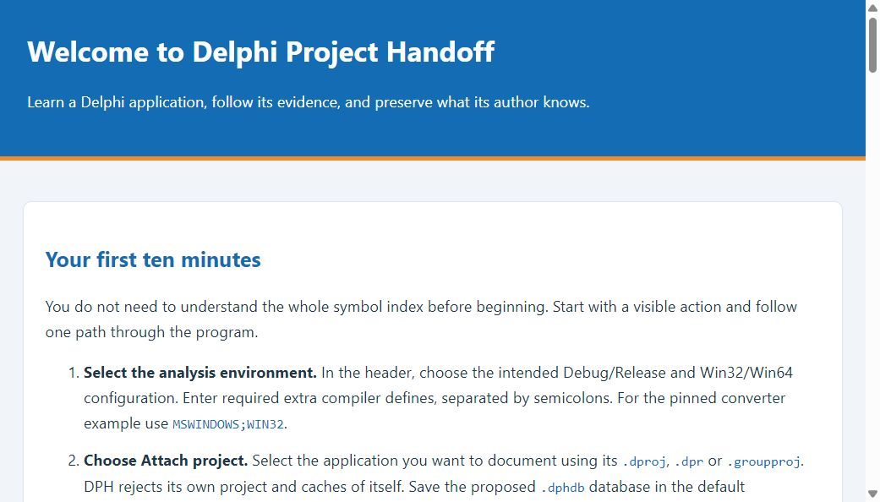
Getting started: first-launch education before a project is loaded.
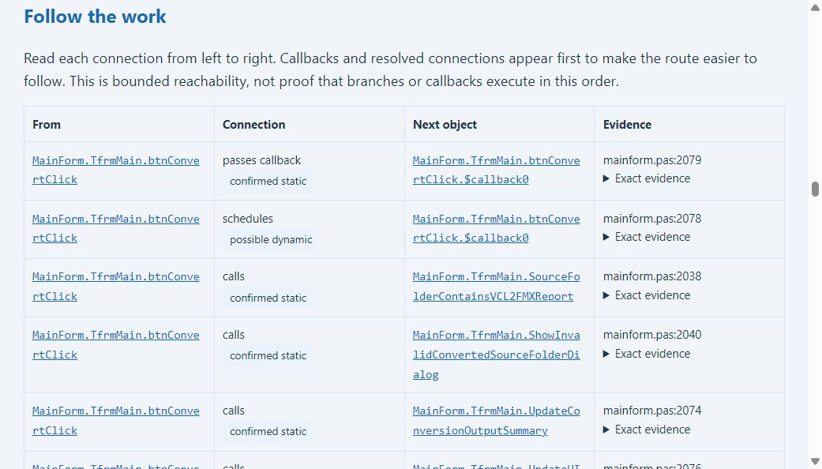
Explain: actual event/callback reachability in the pinned converter, retaining certainty and evidence.

Explore and search
Double-click an object in the far-left Explorer list to select it. Selection details on the right shows its name, kind, signature, declared type, source location, generation and evidence hash. Open the central Explain tab for behavior and serialized properties when captured. Units, types, components and routines provide drill-down scopes. The breadcrumb reports the active scope and page. Parent moves upward; Back restores a prior selection.
Search matches object names, kinds and signatures across the project. A kind filter narrows the result. Pages contain at most 250 objects; Next page advances the result set. Clear the search or use Parent to broaden your route. Bookmark records the current canonical selection, and Bookmarks displays those selections. Bookmarks belong to the captured generation and reset when a new generation is loaded.
The References tab lists forward and reverse relationships with their certainty and derivation labels. Double-click a resolvable related object to inspect it. An unresolved target remains unresolved; the relationship is not proof that a named method actually ran.

Read source and graph evidence
The Source tab reads the attached source file and compares its bytes with the captured SHA256 before applying the source range. If the live file changed or cannot be decoded, DPH displays a stale or unavailable message instead of presenting the old range as a confirmed live location. External dependencies remain in the evidence model but are not followed by the local source viewer through an invented path.
The Graphs tab offers Execution, Procedure CFG, Caller / callee, Form navigation, Data flow and Change impact. Select a relevant routine or component before choosing a narrow graph. Graphs show at most 120 nodes and 960 edges. A narrower selection is preferable to interpreting a truncated large view as the complete program.
Confirmed static edges use blue. Uncertain edges use orange. Procedure CFG opens a labeled source-derived diagram when WebView2 is available, with a native graph fallback. Large routines collapse ordinary straight-line statements while retaining control nodes; arrows identify omitted statements. More than 70 retained control nodes produces an explicit limit instead of a misleading complete diagram. Other graph views retain their 120-node bound. Form navigation does not prove runtime window activation; Change impact is possible reachability. Click a native graph node to inspect its evidence.

Inspect screens
The Form designs tab reconstructs rectangles and text from serialized FMX or DFM data. It never creates untrusted component classes. The result is explicitly an approximate design-time view, not an actual runtime screenshot. Custom painting, runtime geometry, styles and unavailable inherited resources may differ from the running program.
Thumbnail displays a gallery of up to 60 forms. Fit scales the selected form to the viewport, Native uses its reconstructed size, Zoom displays 200 percent, and Full screen uses the larger window. The Full screen button toggles the DPH window size. Click a component rectangle to navigate to the corresponding canonical object when a source association is available.

Import actual screenshot evidence
Open Screenshots, enter the named contributor and a description including capture date and environment, then choose Import an existing PNG screenshot. Select an image you already captured and are authorized to preserve. DPH does not launch the selected application. PNG files are bounded to 20 MiB, 8192 pixels per dimension and 32 million pixels.
The managed image and its metadata are checksummed beside the knowledge database. Select a row to view the actual image and attribution. Runtime origin, capture time and environment are contributor claims and remain user supplied unverified. The associated generation is displayed, including when it is historical. Copy the adjacent views folder when moving the database.
Publishing includes only imported images matching the exported generation and included object scope. Excluding a linked source excludes its screenshot. The exported caption identifies the contributor and unverified state; private storage paths are omitted. Review screenshots for confidential material before sharing.

Write attributed knowledge
Use the Knowledge tab for notes, business rules, engineering rules, user help, maintenance, build and deployment details, troubleshooting, orientation, decisions and unknowns. Select the relevant Explorer object before starting New to link the record to that object. With no selected object, a new record applies to the project.
Enter a stable title, choose its kind, supply a named author and write the body. Save creates a new immutable revision pending human review. Titles and kinds remain stable after creation; update the body, or create and retire a replacement. Selecting a saved row displays its text, links, current state and complete authored and review history.
Unsaved text survives a background refresh. Save or explicitly Discard edit before switching projects, selecting another record, starting another record or closing. DPH will not silently approve an old saved revision while different unsaved text is visible.

Review and retire knowledge
Enter the named reviewer and select a saved revision. Verify review records your explicit approval of that text against the captured generation. Reject records a rejected explanation. Retire preserves an obsolete record and its history while resolving its pending task. The Pending reviews only filter shows records that still need attention.
Source or configuration changes invalidate human review separately from analysis. A successful rescan preserves authored text but cannot approve it. When a linked method disappears or is renamed, DPH keeps the old link as historical evidence and refuses to transfer verified knowledge automatically. Investigate continuity and create the appropriate reviewed replacement.
Attribution is a local named-author record, not an enterprise authentication system. A verified human explanation records the reviewer decision; it does not establish unwritten historical business intent automatically. Detached review requires source attachment first.

Publish manuals and handoffs
Open Publish. Choose Full project or Selected object and context. The task choice requires a selected canonical object and includes its incident technical context rather than a blind truncation of a full export. Enter explicit relative file or folder exclusions separated by semicolons. External source roots and sensitive filename categories are excluded by default.
Choose a new export folder name outside the source tree. DPH refuses an existing destination to avoid overwriting unrelated files. It creates offline index.html, local assets, canonical.json, editable engineering and user guides, technical JSONL indexes, evidence references, coverage and a checksum manifest. Generated AGENTS.md and source snapshots are excluded unless a separate explicit request is implemented and authorized.
Preview offline HTML opens the approved local index and generated hash-named object explanation pages through Edge. External addresses and arbitrary file navigation are blocked. Offline search and internal links work without a translation service. Atlas is unconfigured. The GTranslate region is disabled in the offline edition, and the language-label helper is local. No external translation or AI service receives source through this feature.
Run tools/export-pdf.ps1 with the BundleDirectory parameter for optional PDF companions. It uses LibreOffice and the approved Python 3.13 with pypdf, populates cached TOC page numbers while retaining changeable fields, and refreshes bundle checksums. Read coverage and known unknowns before treating an export as a final operating manual. Automatic documentation cannot invent missing end-user procedures.

Validate and preserve exports
Run DPH.ValidateHandoff.exe with the bundle directory and a separately retained trusted input fingerprint. It rejects stale exports by default. Add --allow-stale only to inspect the integrity of a historical or partial bundle; the flag does not establish current or complete source evidence.
Validate artifact filenames and SHA256 values against validation/manifest-sha256.json. The manifest records generation, input fingerprint, template version, scope, stale state and canonical hash. The validator also checks symbol, relationship, control-flow and evidence references and source ranges. A changed expected fingerprint rejects a stale bundle.
Hashes detect changed artifacts relative to their checksum index. They are not a digital signature proving the identity of an untrusted bundle author. Keep a trusted copy of the source fingerprint and export identity. Redaction recognizes common credential assignments, access keys, tokens and private keys; explicit exclusions and a disclosure review remain necessary for sensitive projects.
Keep the dphdb database together with its managed dphdb.views folder. The database is the authority for authored knowledge; generated manuals and diagrams are derived outputs. At the owner's direction, D: development backups are suspended until explicitly resumed. Validated changes are still committed and pushed to both configured GitHub repositories.

Troubleshoot common states
PARTIAL analysis: read diagnostics and source availability. Unavailable framework units and unsupported syntax remain visible gaps. Do not clear the label by treating unresolved facts as verified. Source changed during analysis: allow reassessment or invoke Full reassessment after the source settles.
Cached artifact missing or damaged: retain the database and its previous backups, then attach the correct source to rebuild a derived workspace. Different source root: DPH rejects cross-project reuse; relocation must preserve and verify project identity rather than attach an unrelated project. Knowledge changed since loading: refresh and review the current immutable revision before saving.
Embedded preview unavailable: inspect index.html in the exported folder and check the deployed Microsoft loader and WebView2 Runtime. No named author or reviewer: enter an attributable name. Closing waits for background work: cancellation is checked at safe stage boundaries; a long parser stage does not execute the analyzed program.

Practice a maintenance handoff
Locate startup from the selected project inventory. Find the main form and a visible action, follow its serialized event to the handler, inspect callbacks and downstream calls, and distinguish certain edges from inferred ones. Locate a dry-run branch or another configuration-dependent path, then identify the model used to produce a report.
Record what the evidence establishes and what remains unknown. Add an attributed author answer for missing business rationale, reassess a controlled source change, and verify that the explanation remains pending review. Export a focused task bundle and validate its hashes. This scripted practice supports onboarding; it does not replace the required independent first-time programmer acceptance exercise.

Source and revision evidence
The following source files and resources define this guide. SHA256 values identify the inspected implementation. Rebuild the guides after validated changes and retain the associated acceptance evidence.
DPH.Analysis.Explanations.pas
c4e1ae7eebad50048fad16025f9aeb49884c94321cafef7b4ba5227a39aa3444
DPH.Analysis.Flow.pas
7ae133ca49ea4461c3cfa5a2f659bb035acfa463d34668eac091f405eee0fbad
DPH.Analysis.Model.pas
63797e406476e2e527b8fd28b75bbccedbe0820657217457e0329252792bd417
DPH.Analysis.Persistence.pas
5771a6e098cd57a17d6221474e0864785675b7240875ccc4e4f9ff284a92a6e6
DPH.Analysis.Symbols.pas
3af351398e978e521920fbbd33b8da9d35c1d129176b11437ef836231d0b9a31
DPH.Parse.Forms.pas
8b0a82186f7831bd1c27bf377409ac6e49b77c228666e6087fca8758c85d4cc7
DPH.Parse.Lexer.pas
6ce5bbc66f8170b17eaeda536b8e500ca9992131477c09bc8e1a33bb6dd1c7f0
DPH.Parse.Model.pas
5eb5afb595a879cde199cd029349890990cc58cefdea20e643447dca7bca4f4e
DPH.Parse.Pascal.pas
e89e29fce1ece85d5a0ecafad0cf397f42d4797e9f12c997a6ffafe19e0db0c8
DPH.Parse.Preprocessor.pas
34b7513019a41bc9911babfda72041addd563959ee54c54d0759b8cc9fa7fefc
DPH.Project.Analysis.pas
fc94776733a225a0c8bea34797ee35e0bc7160dac32fa268a92a83e6f0b8504f
DPH.Project.Inventory.pas
31d9ff9f79aa8697cefbc66e08cb963d17aa910e9ed05ab7c8901ee5b9ae1ce7
DPH.Project.Source.pas
c2e1ff86fc0ee3435be23cb6fd07bd9df6d43c6954def70cca23f2edf62162cd
DPH.Publish.BrowserPolicy.pas
e4bcf5a33bbed2cf2e9906aed11262bcb14ba9df295719e28dfbb1ad111ee0b6
DPH.Publish.Export.pas
7fde26fc5fb07cdae8ca6bf7aa398ca442121d6da9edafc0f602c9478504c5ff
DPH.Publish.Model.pas
38f2800eb6b9337263a39a8b7aca47ae9bfae3bb79a0cd3e5be6f2a12aa4826f
DPH.Publish.Translation.pas
d211794576a0e234d1aa8ac347d09f6a981e9590346204ef142608aa5aa400b2
DPH.Storage.Database.pas
16648fd015ff3821f189f7985042522c6bc27c451943404df8d3a8ec19d514a9
DPH.Storage.Types.pas
1e83ccbe6868979ff9d763a4f2bf4d64691c2b2343de6717391f03e204d5d219
DPH.UI.Main.pas
caa1012a20e072685bedf136541aae6c1316127b96b604541f33cc796b3467a3
DPH.Workspace.Model.pas
4caaea4c68bf59566d0c5378f1834bb4cbf005228566b289056103793f292381
DPH.Workspace.Screen.pas
68305e6ec36664e76d05b8c9af21416dd51a32116d47ea55156977b4c10855de
DPH.Workspace.Worker.pas
ffd302794055c7d7aa00d33ac7f89a4fcab97a3b640188f6667293d64a827eee
DPH.UI.Main.fmx
3808077afa7553d968055e8b4470d2d6aadaf322b80a8f4cc2cd7fcac4ec9332
DelphiProjectHandoff.dpr
3a7069ba071bb567f4d61da03cca38db4a12b1c700bca885c7e2a46a52d71732
DelphiProjectHandoff.dproj
23428c608a2cee9b8e1bb343af3e201abbe3579e3e49bac25a3b773744701839

