# **Youtube Video Program Design**

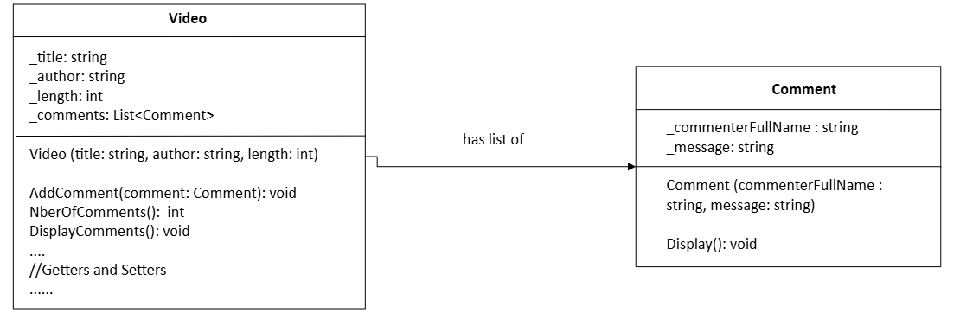

# Simple Flowchart of the Application

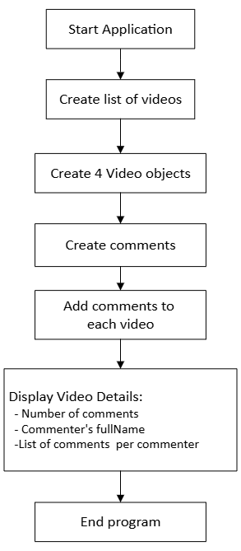

# **Online Ordering Program Design**