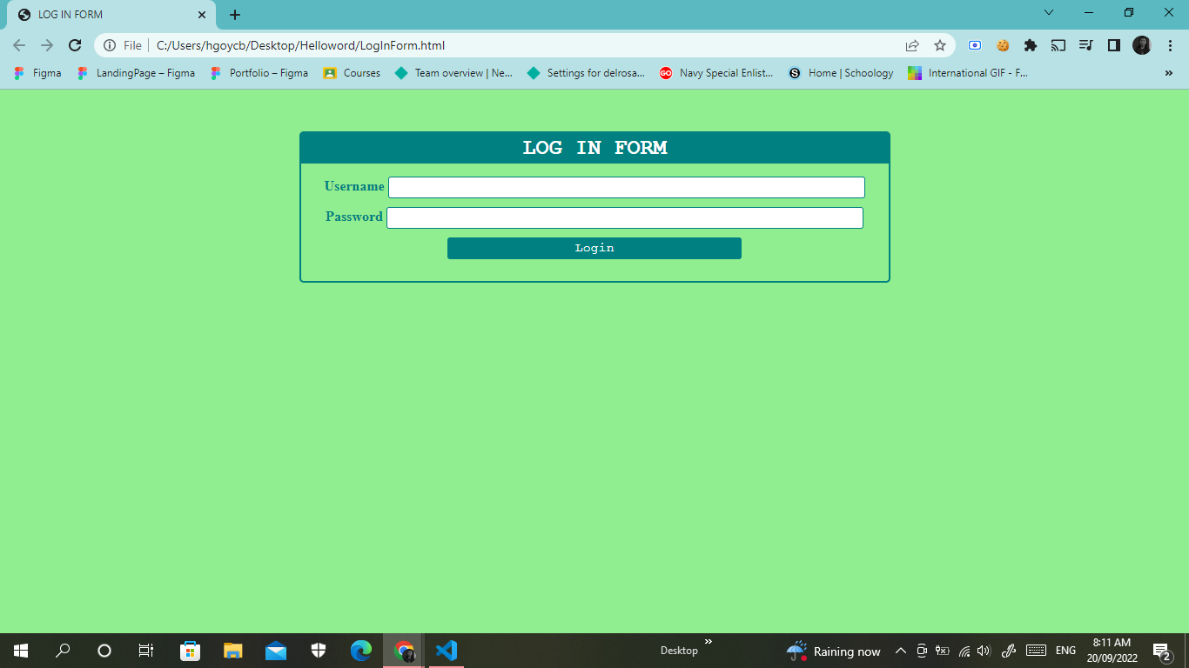**LOGIN FORM**

**REGISTRATION FORM**

