**Module 7) JQuery Basic, Effects & Advanced**

# Q-1 What is jQuery?

Ans} JQuery is a lightweight , less write and do more Javascript library.

Purpose of jquery is make a javascript much easier to use on your website.

Jquery library contains following features.

* HTML/DOM manipulation
* CSS manipulation
* HTML event methods
* Effects and animations
* AJAX
* Utilities

There are many Javascript library but mostly used Jquery.

To add Jquery in your web page used the CDN link from google.

This is the CDN of jquery:-

<head>  
<script src="https://ajax.googleapis.com/ajax/libs/jquery/3.7.1/jquery.min.js"></script>  
</head>

Following is the example of Jquery.

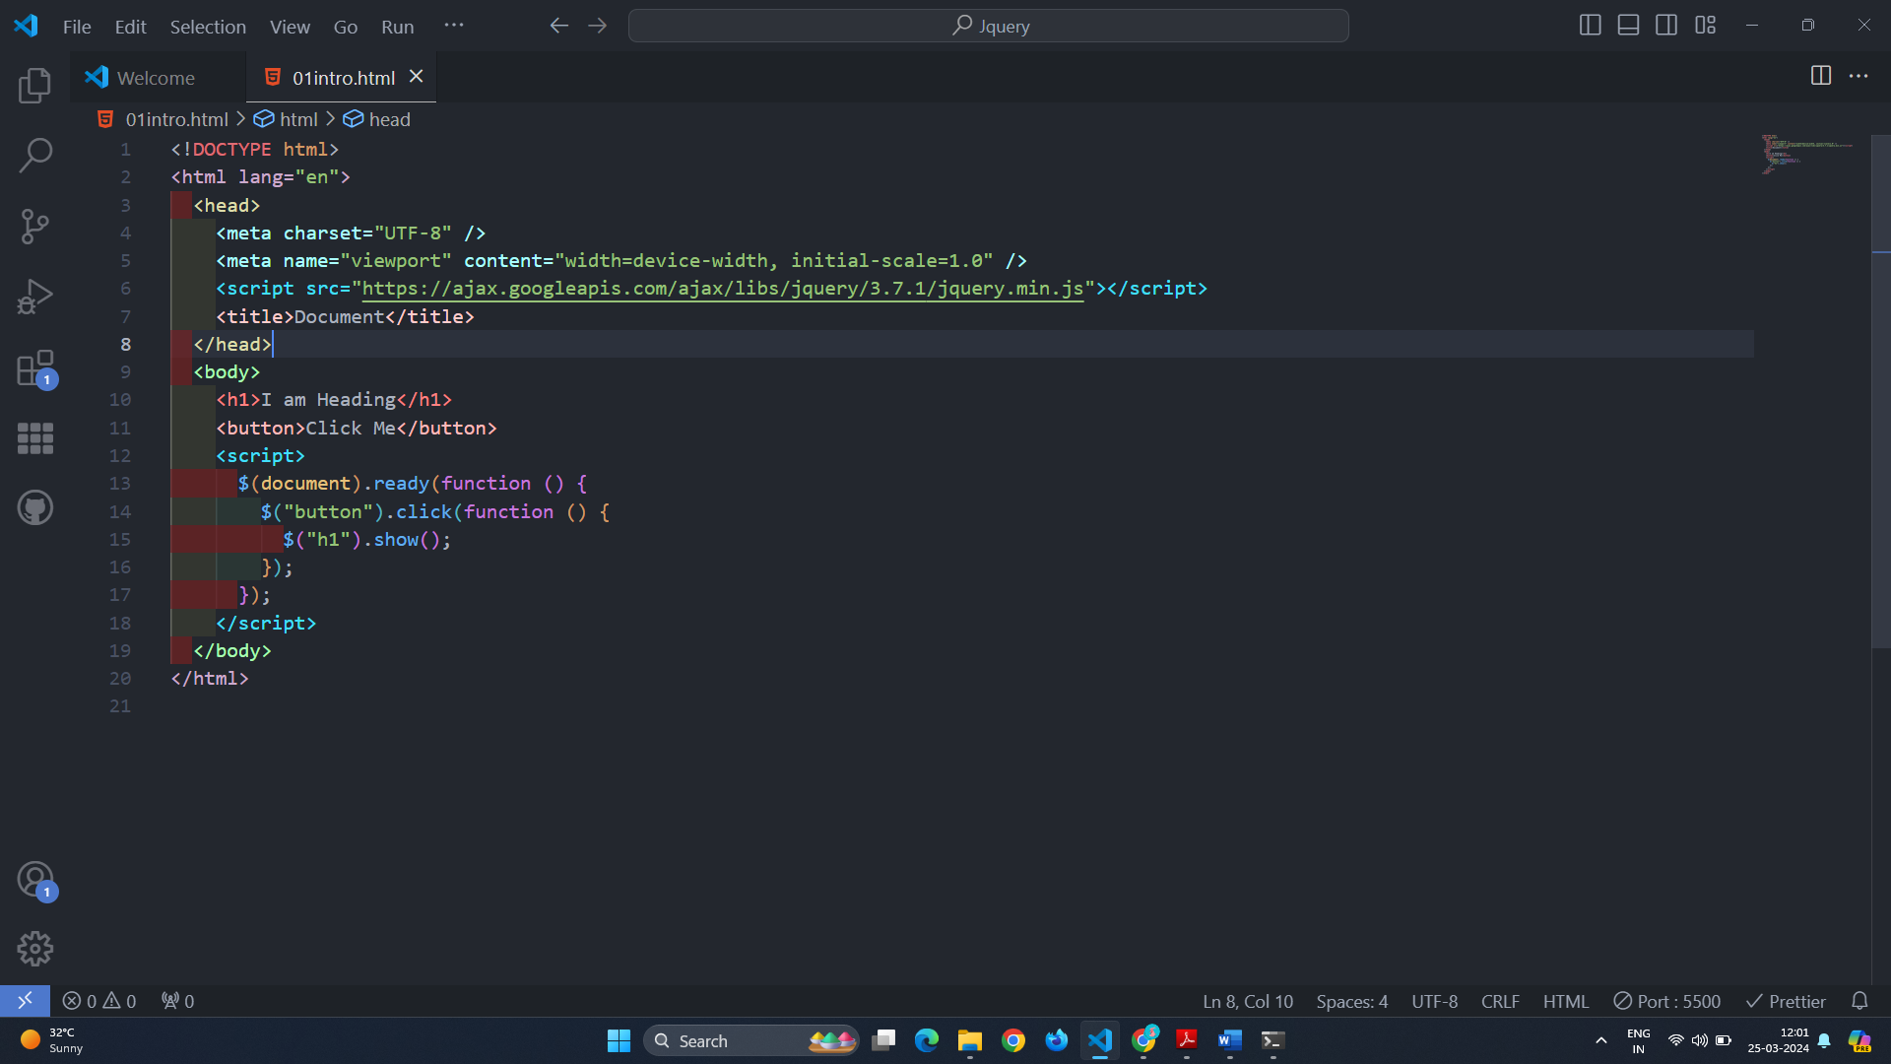

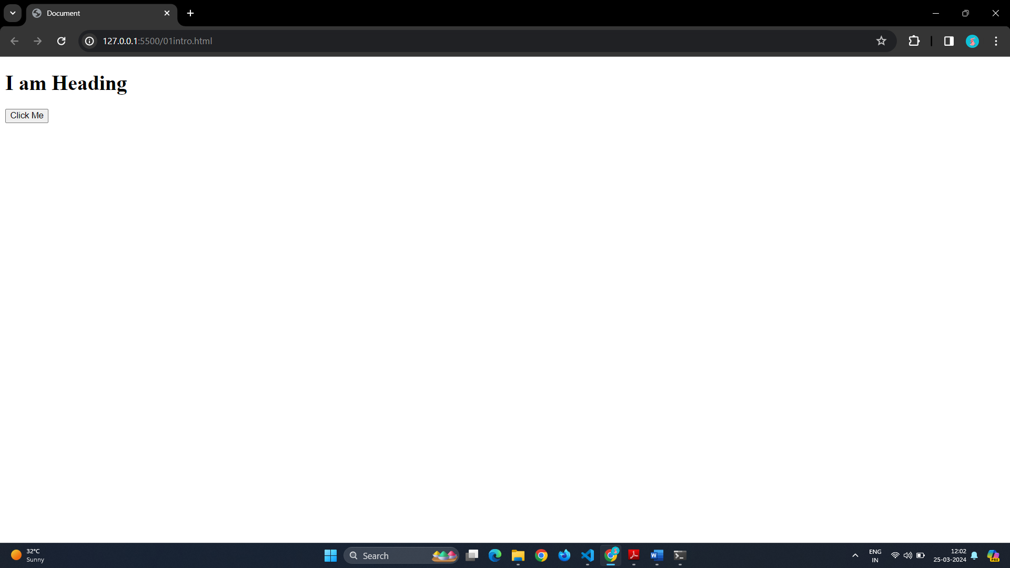

# Q 2 ]How to Apply CSS Using JQuery, How to Add Class and Remove Class in Jquery, JQuery Animation?

Ans } To apply CSS using JQuery:-

To apply CSS using JQuery you have to add first CDN in HTML then add a css what you want to style in your page that will give you the style.

Following is the example of add CSS in jquery.

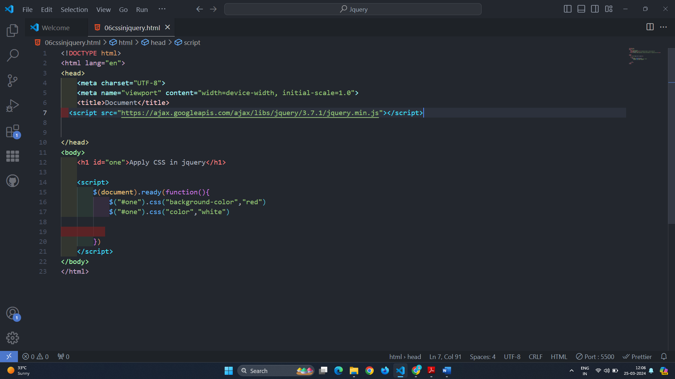

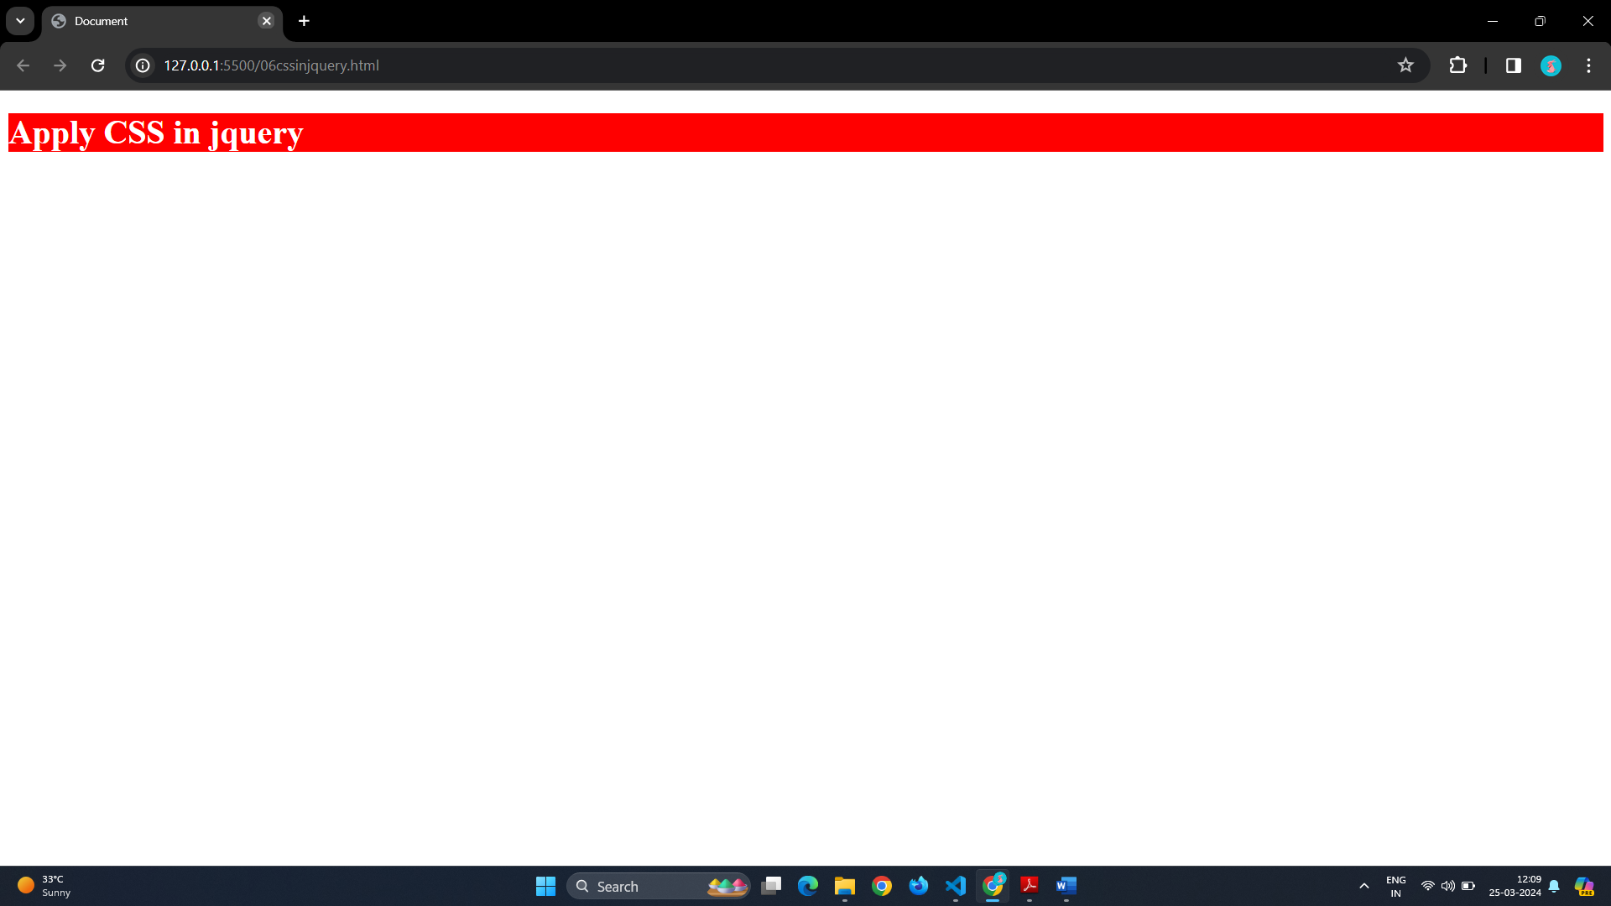

To remove class in jquery you have to use removeClass() method.

Following is the example of that

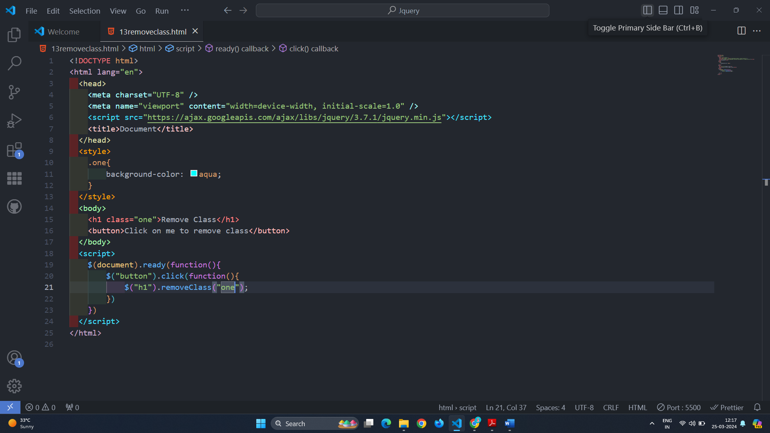

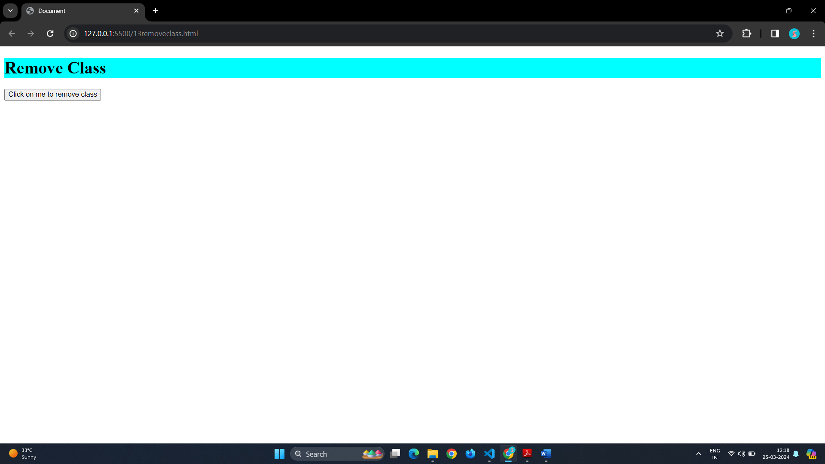

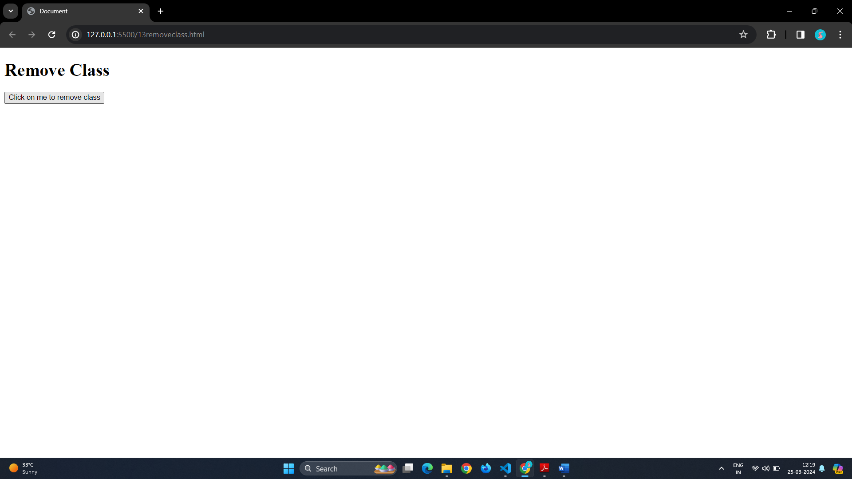

To add class in Jquery we have to use this method addClass().

Following is the example of it.

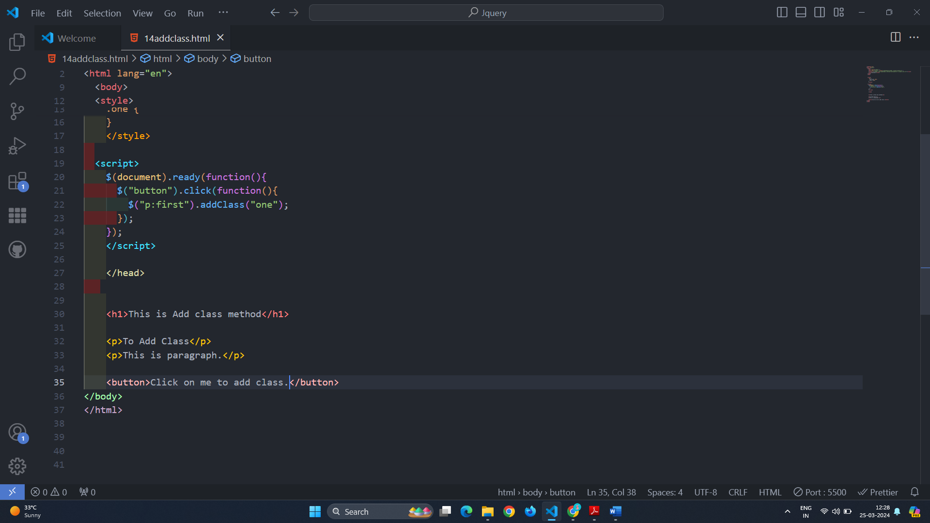

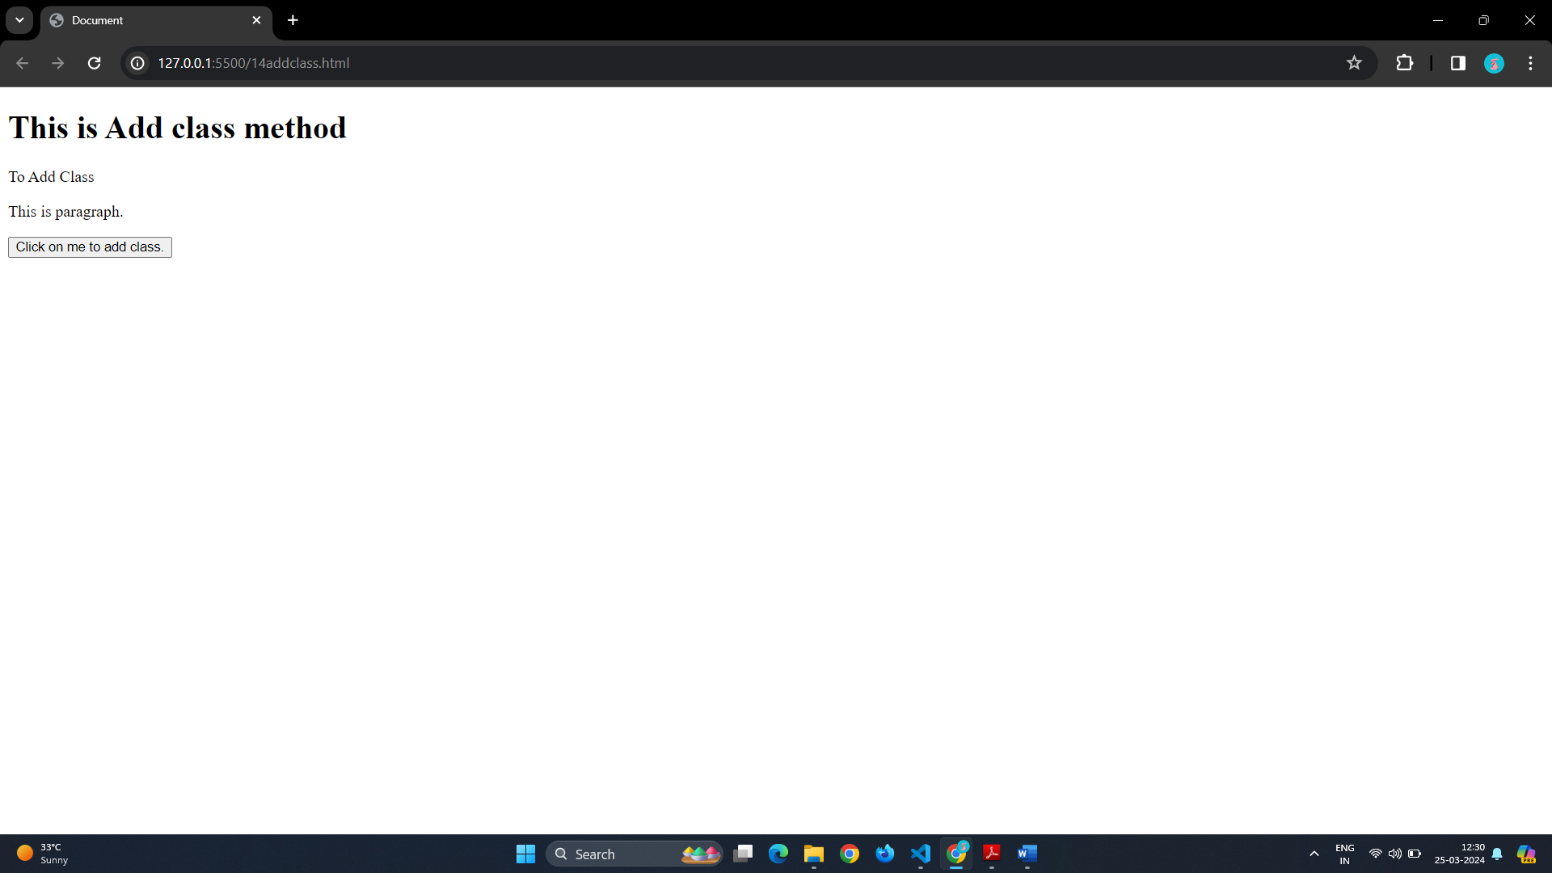

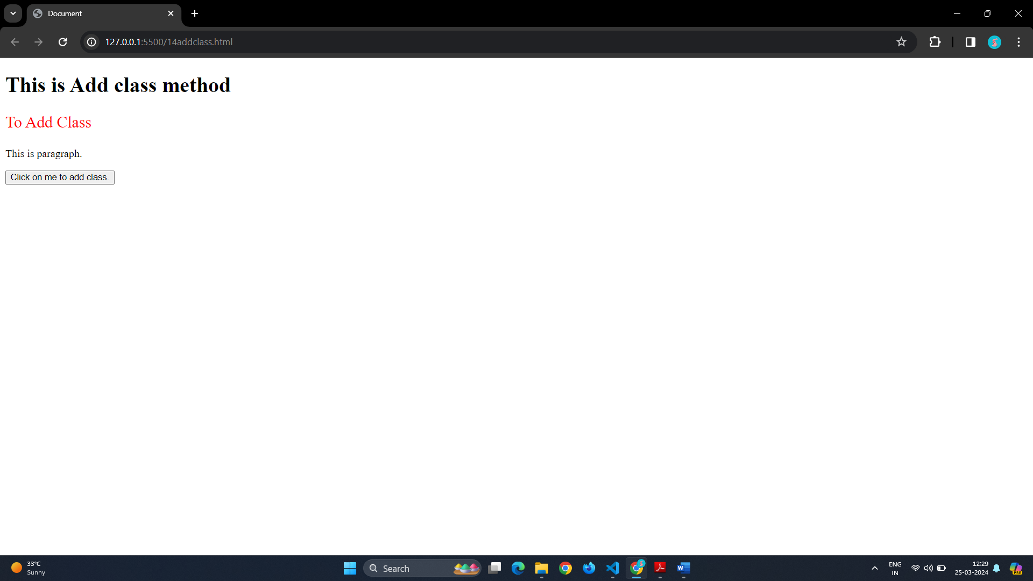

JQuery Animation:-

Jquery animation is used to animate content. You have to write animation in your page to add animation. Following is the example of animate something:-

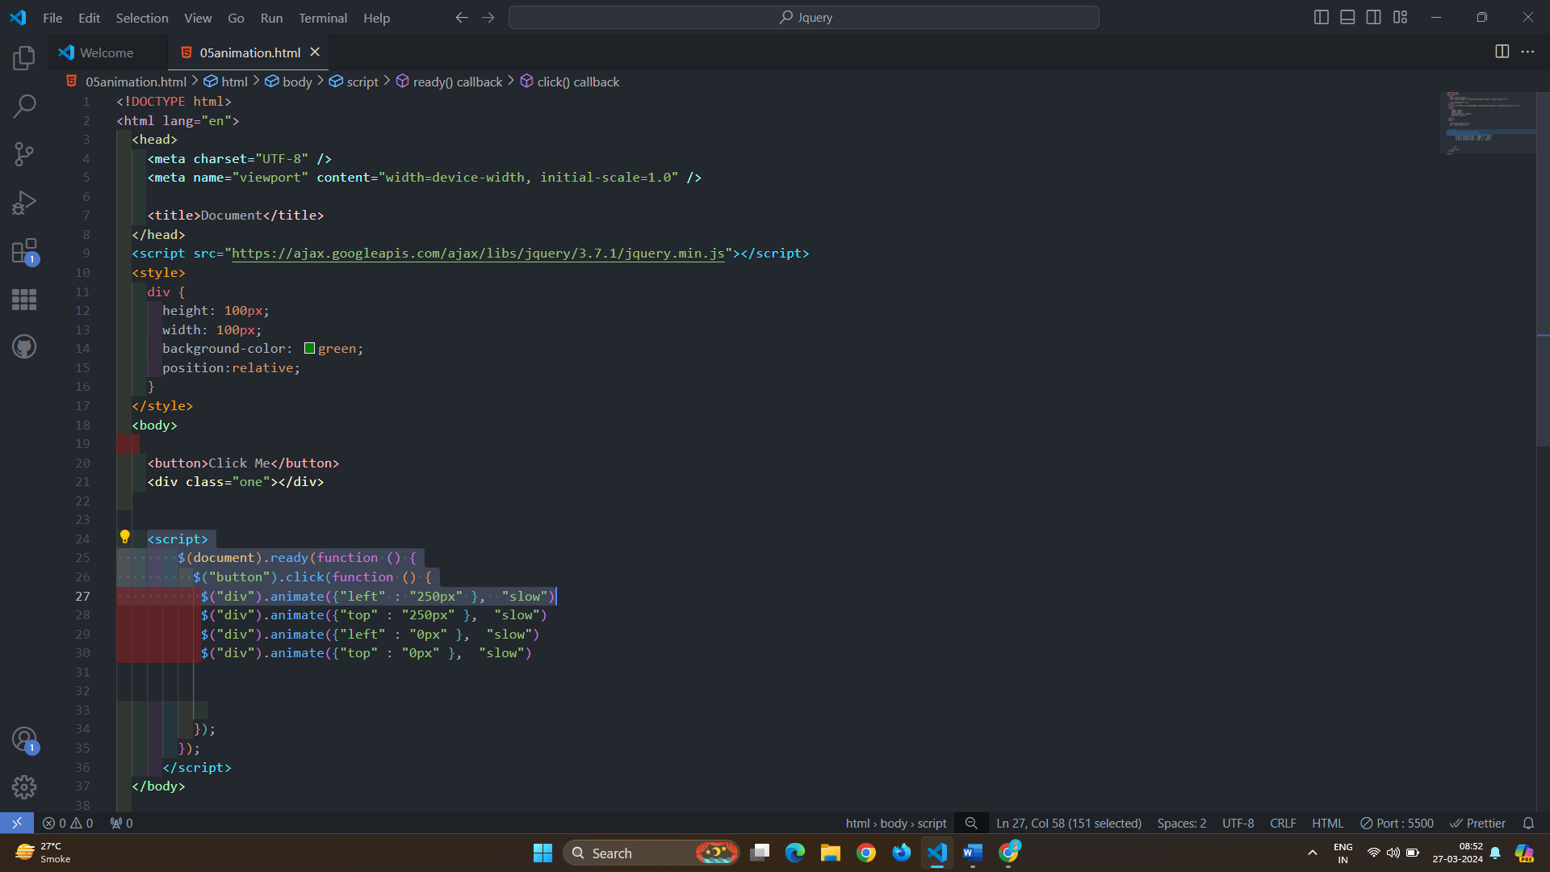

# 

# Q 3]How to create slider with animation?

Ans } There are basically three main slider that is

1. Slide Up:- To using of slide up you can click on button and you can slide up the content.

Following is the example of that.

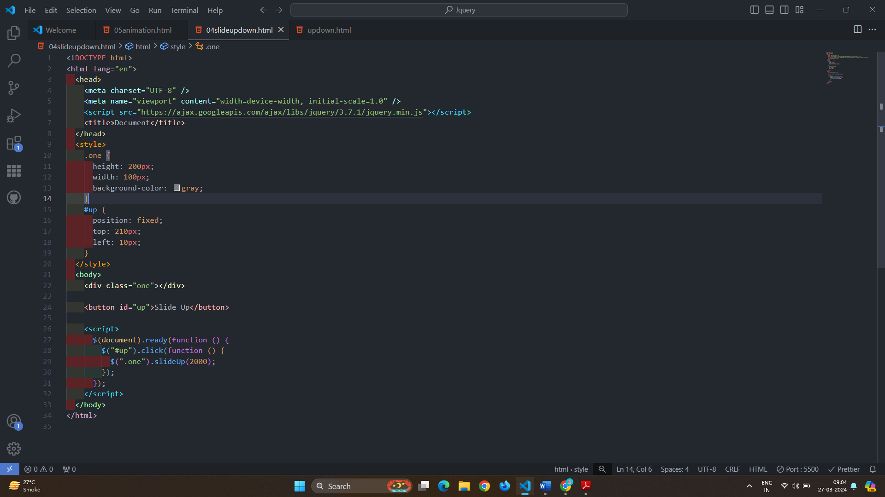

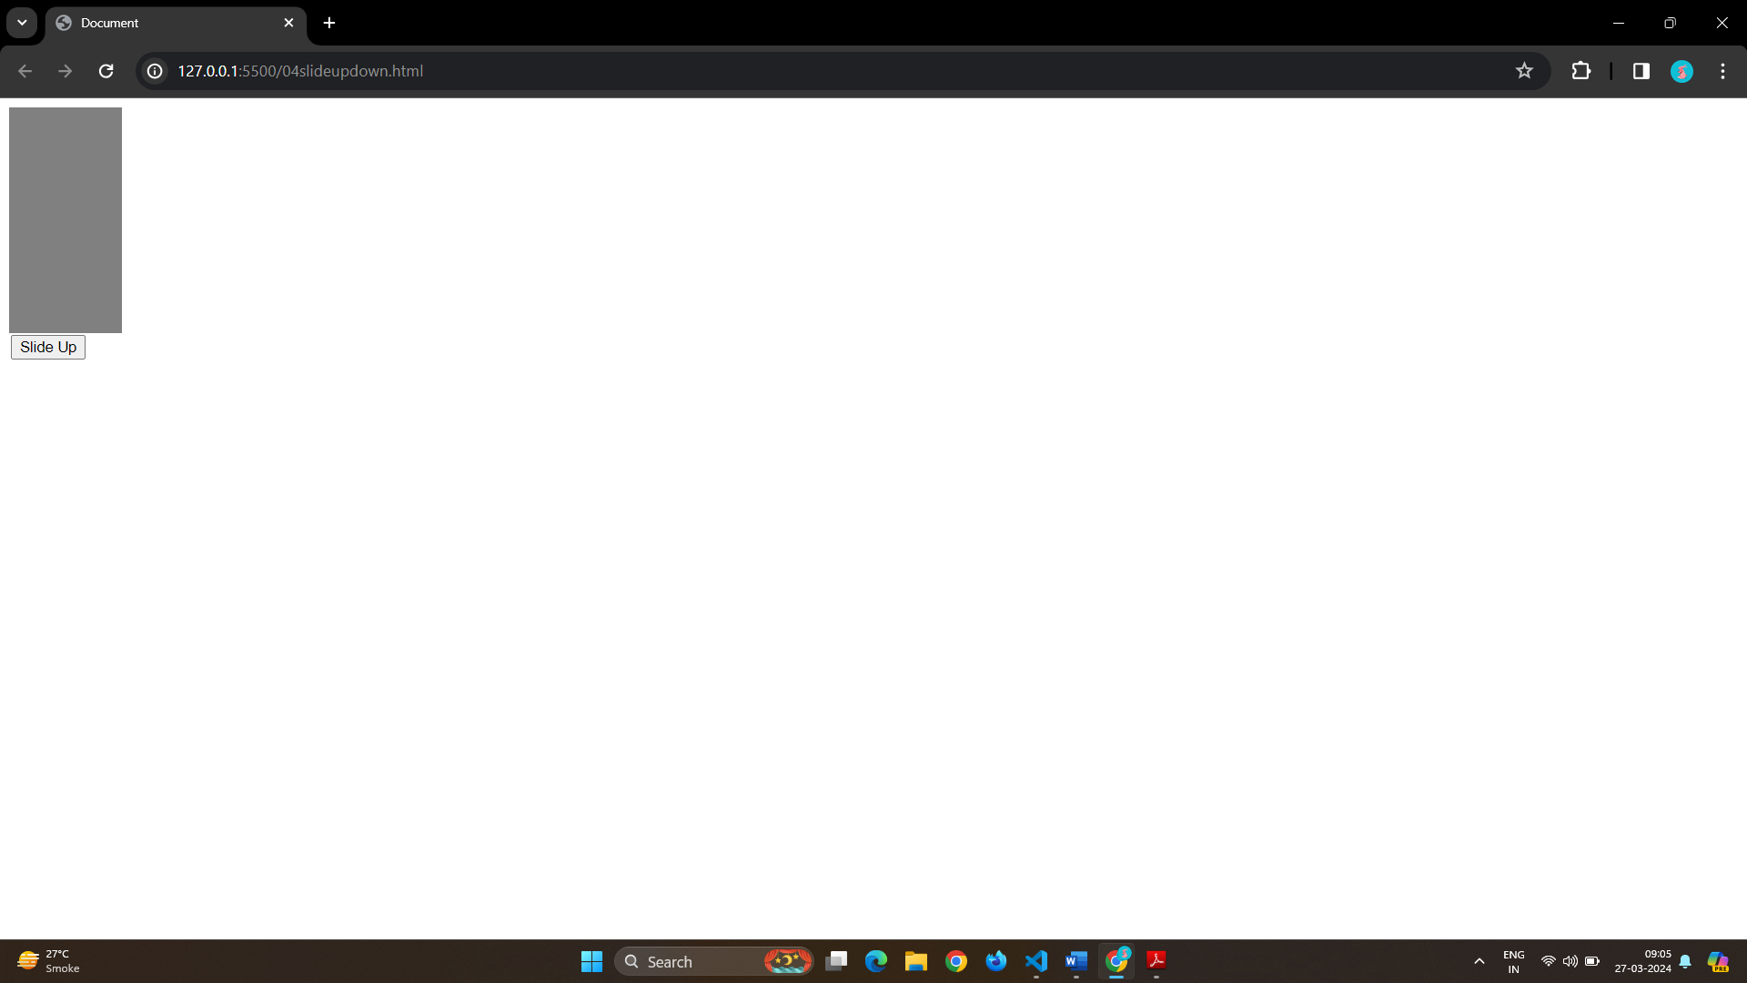

1. Slide Down:- To using of slide down you can click on button and you can slide down the content.

Following is the example of that.

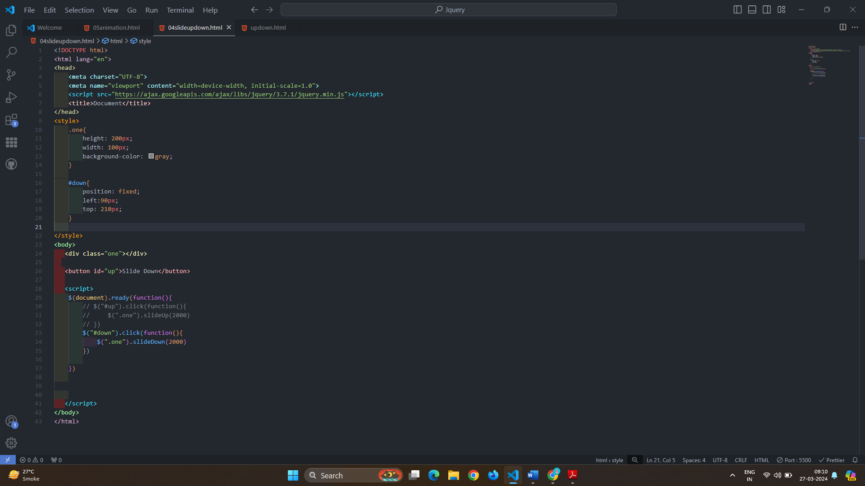

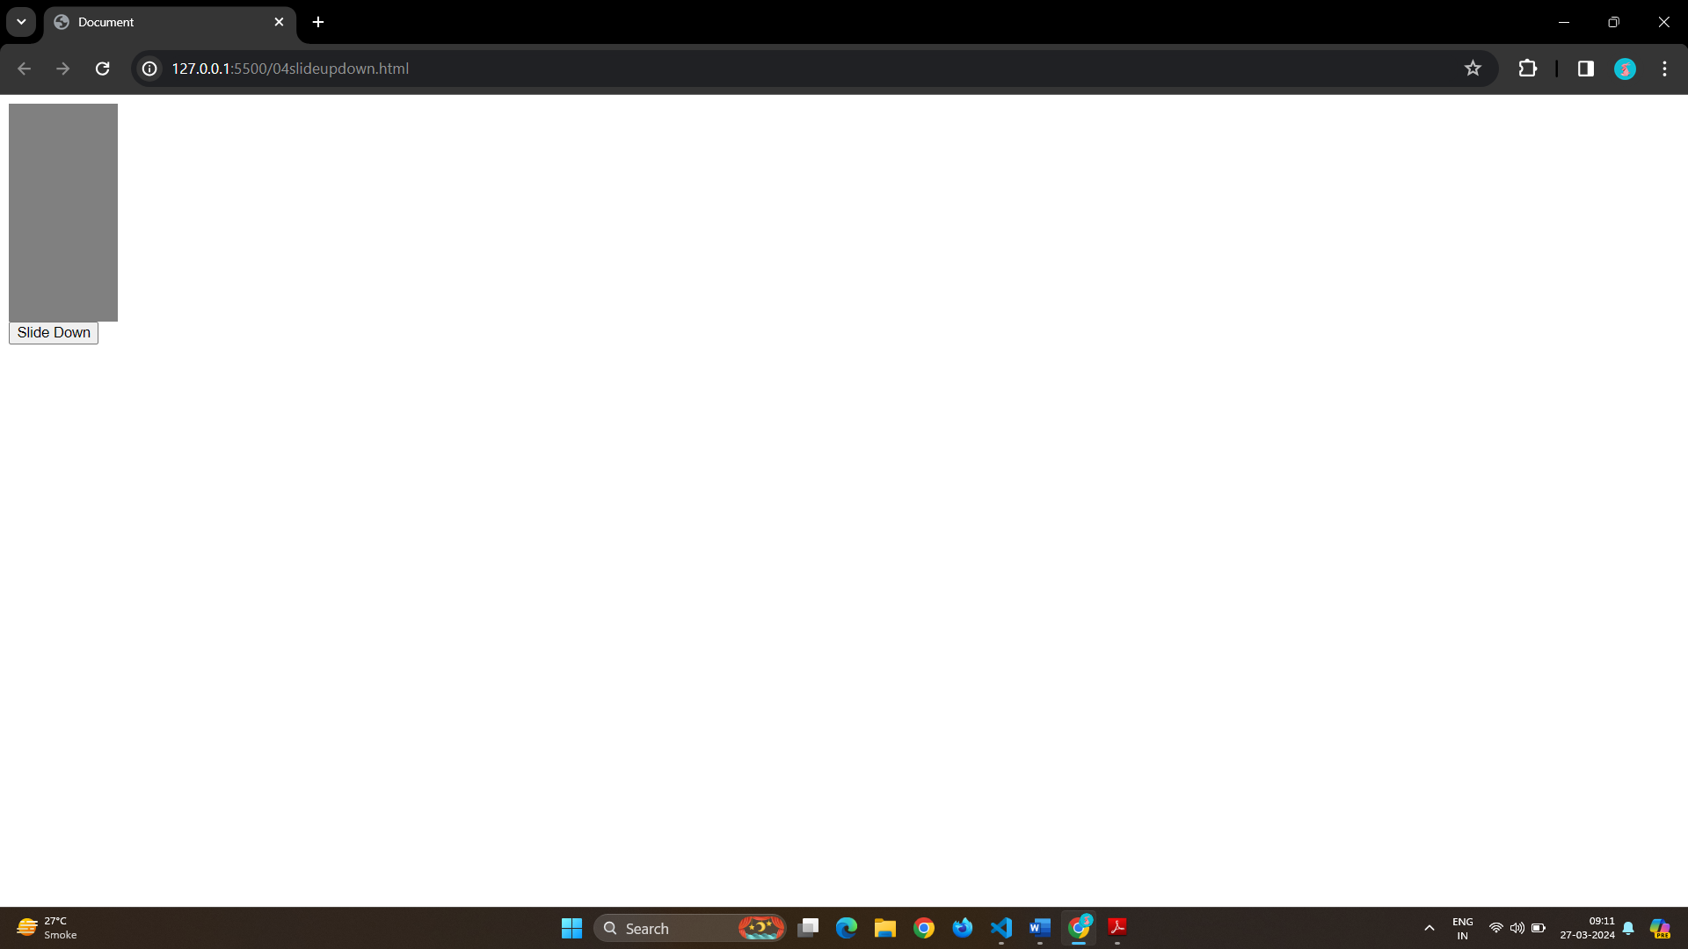

1. Toggle:- The use of Toggle button you can do both slide up and down

Following is the example of that.

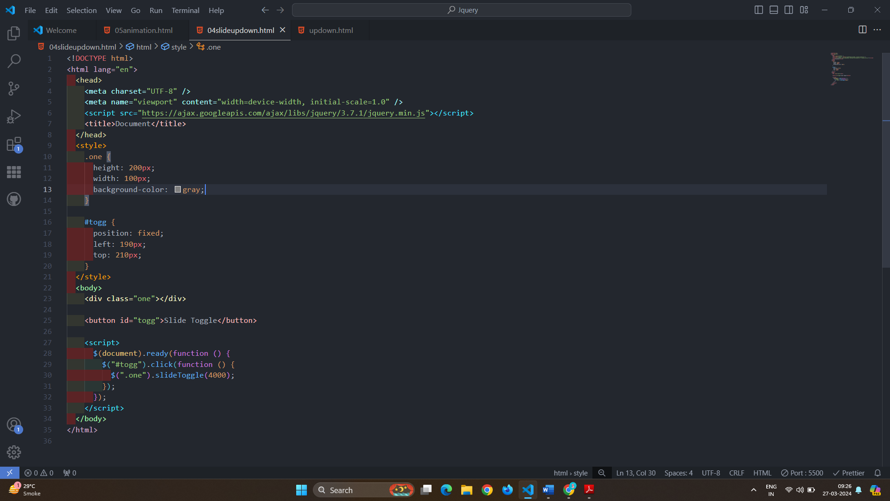

# 

# Q 4]Event bubbling tickling example



Ans } You can make this to use of parent ,parents and parentUntil.

Parents is the event that used to make this bubbling tickling .

You have must add the border in it.

# 

