# Metadata: Discrete flow, water temperature, chlorophyll and inundation, Sacramento-San Joaquin Delta, CA, 1999-2019

Version: 1.1

## Dataset Title

Discrete water temperature, flow, solar radiation, chlorophyll-a and inundation, Sacramento-San Joaquin Delta, CA, 1999-2019

## Abstract

The objective of our study is to better understand the factors affecting chlorophyll-a production within a floodplain and its transport downstream to determine how lateral connectivity influences longitudinal connectivity. The Yolo Bypass is a floodplain of the Sacramento River that inundates during periods of high outflow via overtopping weirs. Water traveling through the Yolo Bypass flows parallel to the Sacramento River and re-connects to the mainstem at the southern extent of the floodplain. Several monitoring programs in the Sacramento San-Joaquin Delta and Yolo Bypass collect discrete and continuous water quality data, including chlorophyll measurements. For this study, we synthesized available flow, solar radiation (modeled), water temperature, chlorophyll and inundation data between March 1999 to December 2019 to investigate the effects of environmental variables and inundation on chlorophyll-a production in the floodplain, the mainstem, and downstream of the floodplain/mainstem.

## Investigators

| First Name | Middle Initial | Last Name | Organization | e-mail address | ORCID ID (optional) |
| --- | --- | --- | --- | --- | --- |
| Catarina |  | Pien | Bureau of Reclamation | [cpien@usbr.gov](mailto:cpien@usbr.gov) | 0000-0003-4427-6300 |
| Elizabeth |  | Stumpner | Department of Water Resources | [Elizabeth.Stumpner@water.ca.gov](mailto:Elizabeth.Stumpner@water.ca.gov) | 0000-0003-2356-2244 |
| Pascale |  | Goertler | Department of Water Resources | [Pascale.Goertler@water.ca.gov](mailto:Pascale.Goertler@water.ca.gov) | 0000-0001-6259-5108 |
| Ryan |  | Peek | California Department of Fish and Wildlife | [Ryan.Peek@wildlife.ca.gov](mailto:Ryan.Peek@wildlife.ca.gov) | 0000-0002-9577-6885 |
| Dylan |  | Chapple | Delta Science Program | [Dylan.chapple@deltacouncil.ca.gov](mailto:Dylan.chapple@deltacouncil.ca.gov) | 0000-0001-9124-7831 |
| Lauren |  | Yamane | U.S. Fish and Wildlife Service | [Lauren_yamane@fws.gov](mailto:Lauren_yamane@fws.gov) | 0000-0002-0666-4196 |
| Mattea |  | Berglund | UC Davis | [mkberglund@ucdavis.edu](mailto:mkberglund@ucdavis.edu) | 0000-0002-3076-9465 |
| Shruti |  | Khanna | California Department of Fish and Wildlife | [Shruti.Khanna@wildlife.ca.gov](mailto:Shruti.Khanna@wildlife.ca.gov) | 0000-0003-1724-248X |

## License

This information is released under the Creative Commons license - Attribution - CC BY (<https://creativecommons.org/licenses/by/4.0/>). The consumer of these data ("Data User" herein) is required to cite it appropriately in any publication that results from its use. The Data User should realize that these data may be actively used by others for ongoing research and that coordination may be necessary to prevent duplicate publication. The Data User is urged to contact the authors of these data if any questions about methodology or results occur. Where appropriate, the Data User is encouraged to consider collaboration or co-authorship with the authors. The Data User should realize that misinterpretation of data may occur if used out of context of the original study. While substantial efforts are made to ensure the accuracy of data and associated documentation, complete accuracy of data sets cannot be guaranteed. All data are made available "as is." The Data User should be aware, however, that data are updated periodically, and it is the responsibility of the Data User to check for new versions of the data. The data authors and the repository where these data were obtained shall not be liable for damages resulting from any use or misinterpretation of the data. Thank you.

## Keywords

chlorophyll a, primary productivity, connectivity, floodplain, river, Sacramento-San Joaquin Delta

## Funding of this work:

This project was supported by an agreement with the Delta Science Program, Delta Stewardship Council (DSC contract 19167). Funding was provided by the Delta Science Program and activities were supported by the National Center for Ecological Analysis and Synthesis (NCEAS) Learning Hub. The contents may not necessarily reflect the official views or policies of the State of California.

Delta Science Program, Department of Water Resources, California Department of Fish and Wildlife, United States Geological Survey, Bureau of Reclamation, US Fish and Wildlife Service and UC Davis contributed (via staff time) to this collaborative synthesis project, supported by the Delta Science Program in collaboration with the NCEAS Learning Hub.

## Timeframe

* Begin date: 3/9/1999
* End date: 12/27/2019
* Data collection ongoing or completed: completed

## Geographic location

* Verbal description: Sacramento-San Joaquin Delta, including mainstem Sacramento River, Yolo Bypass, and downstream reaches
* North bounding coordinate (decimal degree): -121.353
* South bounding coordinate (decimal degree): -122.002
* East bounding coordinate (decimal degree): 38.08453
* West bounding coordinate (decimal degree): 38.77435

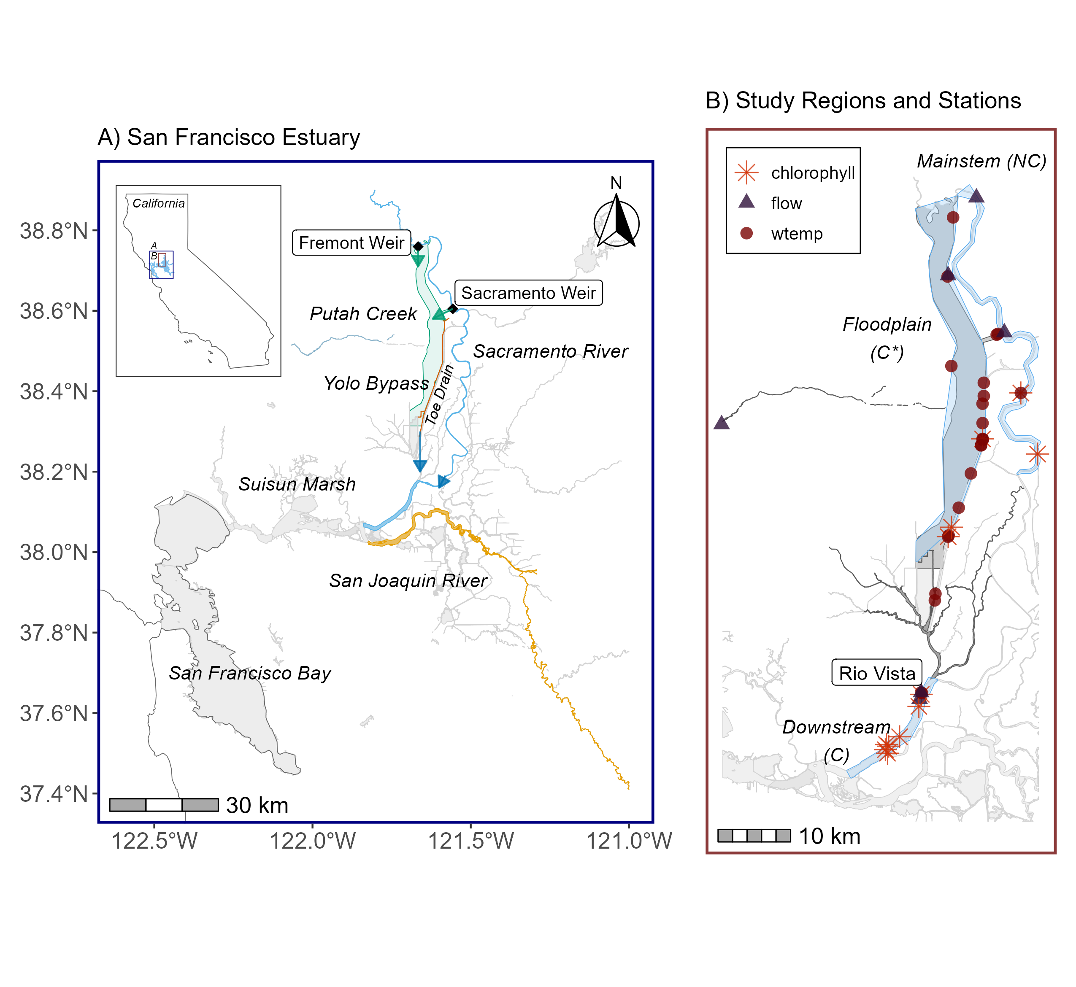

Figure 1. Map of A) San Francisco Estuary, B) Regions and Stations used in study. A) Green arrows denote lateral connectivity between the mainstem and floodplain. Blue arrows denote longitudinal connectivity to downstream region. B) NC = not connected, C* = conditionally connected (during inundation), C = connected.

## Methods

We integrated data collected from various agencies to examine the relationship between chlorophyll and water temperature, solar radiation, flow, and inundation. Please see original data sources for metadata and associated code. Data were downloaded and integrated using R Version 4.3.0.

* We downloaded parameters of interest (flow, inundation, solar radiation, water temperature) from original data sources (Table 1).
  + Flow
    - We obtained USGS daily mean flow data using the “readNWISdv” function from the *dataRetrieval* package (DeCicco et al. 2022).
    - We obtained dayflow data using the “calc_inundation” function from the *inundation* package (Clark & Goertler 2022; Goertler 2022).
  + Inundation
    - We obtained inundation data using the “calc_inundation” function from the *inundation* package (Clark & Goertler 2022).
  + Solar radiation
    - We obtained solar radiation data using the “download_daymet” function from the *daymetr* package (Hufkens et al. 2018).
  + Water temperature
    - We obtained water temperature data from Goertler & Pien (2022).
* We further processed data and created a full dataset for covariates.
  + We used the “rollapply” function from the *zoo* package (Zeileis & Grothendiek 2005) to calculate weekly mean water temperature and solar radiation.
  + Missing data
    - We filled missing flow data at Sacramento River at Rio Vista using linear regression with an upstream station (USGS-11447905, Sacramento River below Georgiana Slough; R2 = 0.938). For any remaining missing data, values were imputed with the *imputeTS* R package (Moritz and Bartz-Beielstein 2017).
    - Missing solar radiation data were filled with the “fill” function from the *tidyr* package when data were missing (Wickham & Girlich 2023).
  + We assigned each data point to the designated region (Figure 1B).
* We downloaded chlorophyll a data from original data sources (Table 1), and assigned each station to the designated region. When there was more than one chlorophyll value for a given station on a given date (8 instances), we used the mean of the values.
* We joined covariates to the chlorophyll-a data, thus removing dates when chlorophyll-a data were not available.
* We filtered the dataset to March 1999 to December 2019 to cover the period of data availability.
* We filtered the dataset to period of potential inundation (December 5 to May 2) based on historical dates of inundation.
* Processing code are available at: <https://github.com/Delta-Stewardship-Council/swg-21-connectivity/tree/main/data_publication/R>

Table 1. Summary of Data Sources and Metrics in Integrated Dataset.

|  |  |  |  |  |
| --- | --- | --- | --- | --- |
| **Data type** | **Metric** | **Dataset** | **Description of dataset** | **Reference** |
| Chlorophyll-a | Chlorophyll-a (µg/L) | Yolo Bypass Fish Monitoring Program | Discrete chlorophyll data | Adams and Pien 2023 |
| Chlorophyll-a | Chlorophyll-a (µg/L) | Discrete Water Quality Integrated Dataset | Discrete chlorophyll from 16 monitoring programs | Bashevkin et al. 2023 |
| Flow | Daily mean flow (cfs) | USGS flow data | Continuous discharge (parameter 00060) from USGS 11445500 (Sacramento River at Verona) | USGS 2023 |
| Flow | Daily mean flow (cfs) | USGS flow data | Continuous tidally filtered discharge (parameter 72137) from USGS 11455420 (Sacramento River at Rio Vista) | USGS 2023 |
| Flow | Daily mean QYOLO (cfs) | Dayflow | Modeled Yolo Bypass flow | CDWR 2022 |
| Solar radiation | Mean weekly solar radiation | Daymet | Simulated daily solar radiation | Hufkens et al. 2018 |
| Water temperature | Mean weekly water temperature | Yolo Bypass water temperature dataset | Continuous and discrete water temperature from the Yolo Bypass, Rio Vista and Sacramento River at Sherwood Harbor | Goertler & Pien 2022 |
| Inundation | Inundation duration factor (no inundation, short inundation <21 days, long inundation >= 21 days) | Yolo Bypass Inundation | Inundation metrics based on stage height at Fremont Weir and modeled flow data | Clark & Goertler 2022 |

### Methods References

Adams, J. and C. Pien. 2023. Interagency Ecological Program: Discrete water quality and phytoplankton data from the Sacramento River floodplain and Yolo Bypass tidal slough, collected by the Yolo Bypass Fish Monitoring Program, 1998 - 2022 ver 1. Environmental Data Initiative. https://doi.org/10.6073/pasta/5791d7eaca09fb9471c5589c66f86863.

Bashevkin, S.M., D. Bosworth, S.E. Perry, E.B. Stumpner, and R. Hartman. 2023. Six decades (1959-2022) of water quality in the upper San Francisco Estuary: an integrated database of 16 discrete monitoring surveys in the Sacramento San Joaquin Delta, Suisun Bay, Suisun Marsh, and San Francisco Bay ver 7. Environmental Data Initiative. https://doi.org/10.6073/pasta/8dbd29c8c22f3295bbc5d3819fb51d00.

California Department of Water Resources (CDWR). 2023. Dayflow data available on the World Wide Web, accessed in 2023. https://data.cnra.ca.gov/dataset/dayflow.

Clark J, Goertler P (2022). _inundation: Calculate Delta Inundation Metrics_. R package version 0.1.0. <https://zenodo.org/records/6450272>

De Cicco, L.A., Hirsch, R.M., Lorenz, D., Watkins, W.D., Johnson, M., 2022, dataRetrieval: R packages for discovering and retrieving water data available from Federal hydrologic web services, v.2.7.12, doi:10.5066/P9X4L3GE

Goertler, P. 2022. Modeled daily Yolo Bypass inundation ver 1. Environmental Data Initiative. https://doi.org/10.6073/pasta/d57a74bcff69ed673bfac1de994dd9d2.

Goertler, P. and C. Pien. 2022. Daily water temperature (C) in the Yolo Bypass and Sacramento River, 1998-2019 ver 2. Environmental Data Initiative. https://doi.org/10.6073/pasta/5d84e5b8ea74dd0854d4aba1e4a6122d.

Hufkens et al. (2018). An integrated phenology modelling framework in R: modelling vegetation phenology with phenor Methods in Ecology & Evolution, 9(2), 1-10.

Moritz S, Bartz-Beielstein T (2017). “imputeTS: Time Series Missing Value Imputation in R.” _The R Journal_,9(1), 207-218. doi:10.32614/RJ-2017-009 <https://doi.org/10.32614/RJ-2017-009>.

U.S. Geological Survey (USGS). 2023, National Water Information System data available on the World Wide Web (Water Data for the Nation), accessed in 2023. http://waterdata.usgs.gov/nwis/.  
  
Wickham H, Vaughan D, Girlich M (2023). _tidyr: Tidy Messy Data_. R package version 1.3.0, <https://CRAN.R-project.org/package=tidyr>.

## Data Table

**Table name:** Chlorophyll and Covariate Data

**Table description:** Chlorophyll, Solar Radiation, Water Temperature, Flow and Inundation Data, 1999-2019

| **Column name** | **Description** | **Unit or**  **code explanation or date format** | **Missing value code** |
| --- | --- | --- | --- |
| date | Date | M/D/Y |  |
| doy1998 | Count of days since January 1, 1998 | nominalDay |  |
| dowy | Day of water year | nominalDay |  |
| month | Month | dimensionless |  |
| water_year | Water year | nominalYear |  |
| inundation | Inundated or not inundated | 0 = no inundation; 1 = inundation |  |
| inund_days | Number of days inundated during the current inundation event | nominalDay |  |
| inund_factor | Categorical classification of number of days inundated | None = no inundation; Short = less than or equal to 21 days of inundation; Long = greater than 21 days inundation |  |
| region | Region | Upstream = mainstem, yolo = floodplain, downstream = downstream |  |
| Q_sday | Mean daily flow | cubicFeetPerSecond |  |
| log_qsdy | Log of mean daily flow | cubicFeetPerSecond |  |
| WTmwk | Mean weekly water temperature | celsius |  |
| sradmwk | Mean weekly solar radiation | wattPerMeterSquared |  |
| chlorophyll | Chlorophyll-a concentration | microgramsPerLiter |  |
| log_chla | Log of chlorophyll-a concentration | microgramsPerLiter |  |
| station | Station code or number |  |  |

**Table name:** Stations

**Table description:** Station Locations, Descriptions, Frequency of Sampling

| **Column name** | **Description** | **Unit or**  **code explanation or date format** | **Missing value code** |
| --- | --- | --- | --- |
| latitude | Latitude | decimalDegree |  |
| longitude | Longitude | decimalDegree |  |
| station | Station code or number |  |  |
| region | Region name |  |  |
| data_type | Metric |  |  |
| station_name | Station name |  |  |
| agency_program | Agency and/or Program name |  |  |
| sampling_frequency | Sampling frequency |  |  |

## Data provenance

| **Dataset title** | **Dataset DOI or URL** | **Creator (name & email)** | **Contact (name & email)** |
| --- | --- | --- | --- |
| Six decades (1959-2022) of water quality in the upper San Francisco Estuary: an integrated database of 16 discrete monitoring surveys in the Sacramento San Joaquin Delta, Suisun Bay, Suisun Marsh, and San Francisco Bay | <https://doi.org/10.6073/pasta/8dbd29c8c22f3295bbc5d3819fb51d00> | Sam Bashevkin (Sam.Bashevkin@waterboards.ca.gov) | Sam Bashevkin (Sam.Bashevkin@waterboards.ca.gov) |
| Interagency Ecological Program: Discrete water quality and phytoplankton data from the Sacramento River floodplain and Yolo Bypass tidal slough, collected by the Yolo Bypass Fish Monitoring Program, 1998 - 2022 | <https://doi.org/10.6073/pasta/5791d7eaca09fb9471c5589c66f86863> | Jesse Adams (Jesse.Adams@water.ca.gov) | Jesse Adams (Jesse.Adams@water.ca.gov) |
| USGS Flow Data | <https://waterservices.usgs.gov/> | Elizabeth Stumpner ([Elizabeth.Stumpner@water.ca.gov](mailto:Elizabeth.Stumpner@water.ca.gov)), Cathy Ruhl ([cruhl@usgs.gov)](mailto:cruhl@usgs.gov)) | Elizabeth Stumpner ([Elizabeth.Stumpner@water.ca.gov](mailto:Elizabeth.Stumpner@water.ca.gov)), Cathy Ruhl ([cruhl@usgs.gov)](mailto:cruhl@usgs.gov)) |
| Dayflow | <https://data.cnra.ca.gov/dataset/dayflow> | Robin Cheng (robin.cheng@water.ca.gov) | Robin Cheng (robin.cheng@water.ca.gov) |
| Daily water temperature (C) in the Yolo Bypass and Sacramento River, 1998-2019 | <https://doi.org/10.6073/pasta/5d84e5b8ea74dd0854d4aba1e4a6122d> | Pascale Goertler (Pascale.Goertler@water.ca.gov) | Pascale Goertler (Pascale.Goertler@water.ca.gov) |

### Versioning History

| **Version number** | **Date created** | **Description of changes** | **Justification for change** | **Version editor(s)** | **Contact info** |
| --- | --- | --- | --- | --- | --- |
| v1.0 | 12/4/2023 | Initial document | Initial document | Catarina Pien | cpien@usbr.gov |
| v1.1 | 12/12/2023 | Edited methods references to be citation instead of table; Added an ORCID | More traditional way to cite resources | Catarina Pien | cpien@usbr.gov |

-END OF DOCUMENT-