connectivity_coding
Pascale
4/28/2022

libraries
##
## Attaching package: 'dplyr'
## The following objects are masked from 'package:stats':
##
## filter, lag
## The following objects are masked from 'package:base':
##
## intersect, setdiff, setequal, union

data
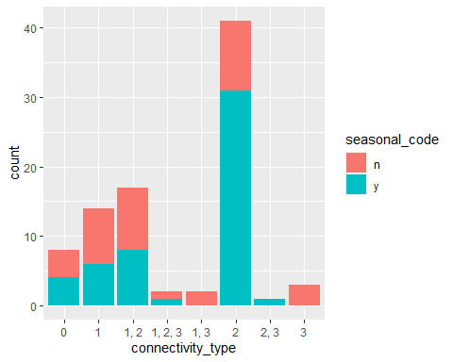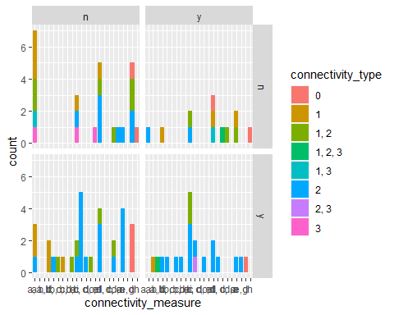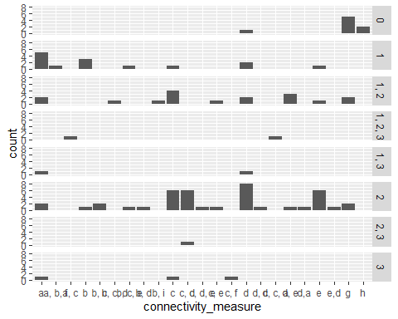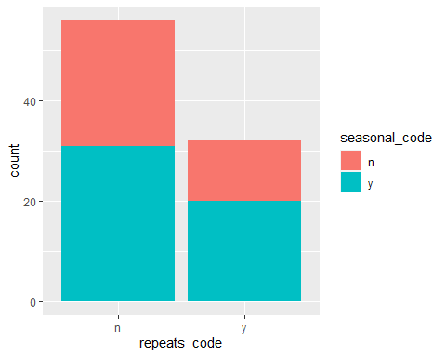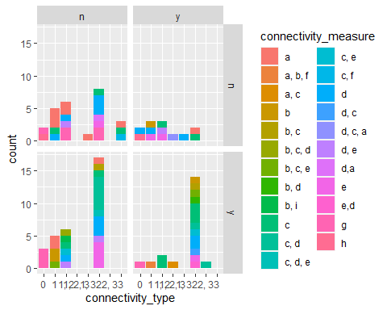
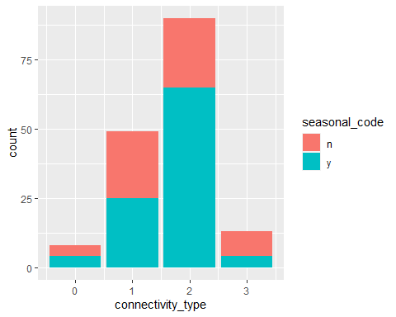
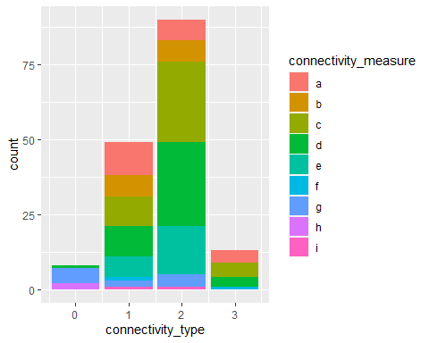
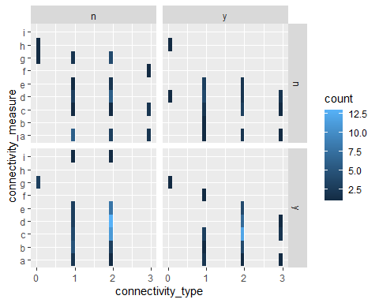
## [1] "2008"
## [2] "1880-present"
## [3] "2003-2004"
## [4] "2007"
## [5] NA
## [6] "2000"
## [7] "Not Specified (potentially 2016)"
## [8] "2002, 03, 04, 07, 09"
## [9] "2009"
## [10] "2002-2003"
## [11] "2013-204"
## [12] "1991-2003"
## [13] "1998, 2000, 2001"
## [14] "2017"
## [15] "2008-2013"
## [16] "2015"
## [17] "2002-2008"
## [18] "2014"
## [19] "na"
## [20] "2005, 2006"
## [21] "2011"
## [22] "1998, 1999"
## [23] "1996-2010"
## [24] "2013, 2014"
## [25] "2012"
## [26] "2015-2016"
## [27] "2001"
## [28] "2004"
## [29] "2005"
## [30] "2017-2019"
## [31] "1999-2005"
## [32] "manipulation in 2017, historical data"
## [33] "2005-2014"
## [34] "NA (no sampling occurred, simulation period was 2006-2009)"
## [35] "2010-2015"
## [36] "2006-2008"
## [37] "NA (pre 2007)"
## [38] "2009-2010"
## [39] "2010-2011"
## [40] "2003-2005"
## [41] "1996-1998 for all?"
## [42] "2004-2005"
## [43] "1995-2009"
## [44] "2008-2009"
## [45] "2 years of sampling, dates unclear"
## [46] "1999"
## [47] "1997-1999, 2003"
## [48] "2010"
## [49] "2012-2013"
## [50] "2008 or 2009"
## [51] "2014 - 2016"
## [52] "1991, 1995, 1996, 1999, 2001"
## [53] "2006"
## [54] "2008 - 2011"
## [55] "2016"
## [56] "1994-2011"
## [57] "1995-1996"
## [58] "1993-1994"
## [59] "1984-2003"
## [60] "2016-2017"
## [61] "2013"
## [62] "2006-2007"
## [63] "Varied; 1998-1999"
## [64] "1996, 1999-2002"
## [65] "1988-1990"
## [66] "1982-1991"
## [67] "2012-2014"
## [68] "2005-2006"
## [69] "1991"
## [70] "2013-2014"
## [71] "2009, 2013"
## [72] ""
## [73] "2004-2010"
## [74] "2006-2008, 2013"
## [75] "1983-2012"
## [76] "2003-2006"
## [77] "2003-2013"

