Main Colors:

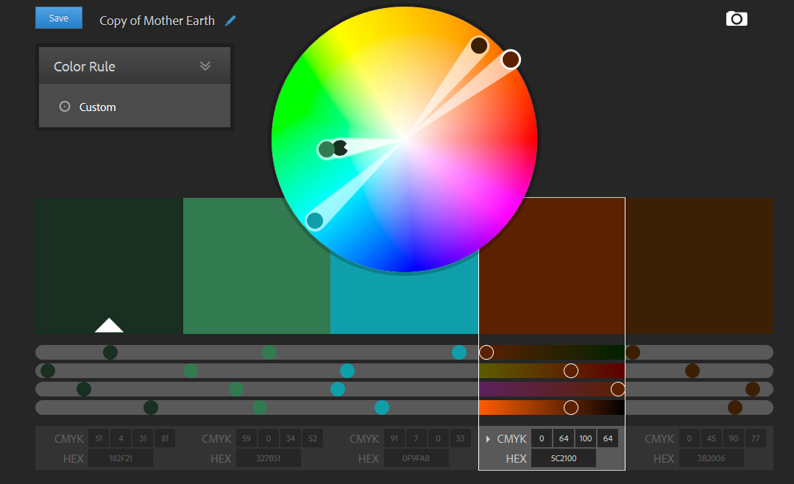

Table Row Color: #9BF2BB

