Flexibility Dimensions
Options:
- Supply:
  - Ramping (up/down) rates
  - Start-up/Shut-down times
  - Min/Max up/down times
  - Max/Minimum capacity
  - Inertia
- Demand:
  - Demand response
    - Residential
    - Commercial
    - Industrial
- Network:
  - Transmission
  - Distribution
- Storage:
  - Batteries
  - Pumped Hydro Storage (PHS)
  - Hydrogen
  - Compressed Air
  - Flywheel
- Sector Coupling:
  - Heating
  - Transport
Mechanisms:
- Operating strategies:
  - Strategy
  - Forecasting
  - Aggregation
- Economics/Market:
  - Regulated
  - Deregulated
- Social:

Methods

Flexibility Metrics

Reserve sizing [1]:
- Paper presents an old method using forecasting errors of load and variable generation to create distributions which can be used to select a percentile which defines reserve sizing.

Loss of Load Expectation (LOLE) (probabilistic metric) [2]:
- Can be used to set the capacity margin in planning studies.
- $LOLE=\sum_{i=1}^{N}{\operatorname{Pr}\left(LL≥C_{i}-L_{i}\right)}$
- $C_{i} available capacity$
- $L_{i} Forecasted peak load in day (i)$
- $N number of days in period$
- $\operatorname{Pr}\left(LL≥C_{i}-L_{i}\right) probability of a loss load≥C_{i}-L_{i}$

Loss of Largest Unit (LLU) (deterministic metric):
- Can be used to set the capacity margin in planning studies.

Expected Energy Not Served (EENS):

Expected Unserved Energy (EUE):

Insufficient Ramping Resource Expectation (IRRE) [3]:
- Highlights time horizons of most risk. Provides insight into when there may be a lack of flexibility in the system.
- Probabilistic metric
- $IRRE=\sum_{∀t∈T_{+/-}}{IRRP_{t,i,+/-}}$
- $IRRP_{t,i,+/-}=AFD_{i,+/-}(NLR_{x,i,+/-}-1)$
- $Flex_{t,system,i,+/-}=\sum_{∀u}{Flex_{t,u,i,+/-}}$
- $Flex_{t,i,u,+}=RR_{u,+}*\left(i-\left(1-Online_{t,u}\right)*S_{u}\right)$
  - $s.t. Prod_{t,u}+Flex_{t,u,i,+}≤Gen_{MAX,u}$
  - $Prod_{t,u}+Flex_{t,u,i,+}∈ R \backslash (0,Gen_{MIN,u})$
- $Flex_{t,i,u,-}=RR_{u,-}*i*Online_{t,u}$
  - $s.t. Prod_{t,u}-Flex_{t,u,i,+}≤0$
  - $Prod_{t,u}-Flex_{t,u,i,+}∈ R \backslash (0,Gen_{MIN,u})$

Periods of Flexibility Deficit (PFD):
- Deterministic

Economic Carrying Capacity [4]:

Realizable Flexibility (RF) [5]:
- Network related..
- Solve an LP w/ DC-OPF to see Maximum Realizable Flexibility
  - Var: Production.
  - s.t. Flexibility from original production schedule.
  - s.t. Network constraints
- System based metric not focused on flexibility available at each node…
  - This metric is surely upper bounded by the flexibility without a network model

Reserve modelling approach in POWER [6], [7]:
The technique used by Bethany Frew during her PhD Dissertation and creation of POWER. The reserves were modelled as follows:
$$k:Balancing regions (FERC regions), t:Timeslice$$
$$R_{k,t }^{Spin}≥R_{k,t }^{Reg}+\frac{1}{2}*R_{k,t}^{Cont}+\frac{1}{3}*R_{k,t}^{For}$$

$$R_{k,t }^{NonSpin}≥\frac{1}{2}*R_{k,t}^{Cont}+\frac{2}{3}*R_{k,t}^{For}$$
Contingency reserve: Used for unpredictable forced outage of generators or transmission. This reserve is based on the following standard, “WECC Reliability Standard BAL-002-WECC-1”:
$$R_{k,t }^{Cont}=max⁡\{1.5* SLH_{k},6\%*L_{k,t}\}$$
$SLH_{k}$: Single Largest Hazard
$L_{k, t}$: Load
Frequency Regulation: Reserve for sub-minute variations (i.e. AGC) followed same technique as ReEDS [8].
$$R_{k,t}^{reg}=1.5\%*L_{k,t}$$
Forecasting Reserve: This reserve is set based on forecasting errors, assumed wind and solar are the dominating forecasting errors (i.e. ignores load forecasting errors). In this work the forecasting timescale is hourly, therefore, only 1/3 (i.e. 1 s.t.d) of the forecasting reserve is allocated to spinning reserves and the rest is allocated to non-spinning (quick-start).
$$R_{k,t}^{For}=3*σ_{k,t}^{agg}$$
Wind is forecast using a persistent forecast model while the solar is forecast with a modified persistent model following the method employed in [8].
$d:Day$
$$\overline{w_{k,t+1}}=w_{k,t}$$
$$\overline{s_{k,d,t+1}}=s_{k,d,t}+(\frac{1}{15}\sum_{i=1}^{15}{s_{k,d-i,t+1}-s_{k,d-i,t}})$$
$$\overline{w_{k,t+1}}$$
The forecast errors are then calculated based on the following:
$$w_{k,t}^{err} =w_{k,t}- \overline{w_{k,t}}$$
$$s_{k,t}^{err} =s_{k,t}- \overline{s_{k,t}}$$
The forecast errors are then used to interpolate the expected s.t.d of forecasting errors, a method from [7]. This method uses the following steps:
- Estimate the s.t.d within each decile over the modelling horizon (Points are normal within each decile). The deciles are delineated based on the wind/solar production value for each forecasting error datum.
- Next a piecewise linear is used to fit the s.t.d against the average production value for each decile.
- This piecewise linear function is then used to generate the expected s.t.d for a timeslice based on the VRE generation of the previous hour..
$$σ_{k,t}^{site}=f(w_{t-1})$$

- Next, all forecasting error resources are aggregated assuming no correlations exists.
$$σ_{k,t}^{agg}$$
- Finally, the aggregated s.t.d is adjusted based on following logic: If the wind resource drops in the current hour and the reserves were held based on a forecast from the previous hour, the model is forced to dispatch. This is done to avoid dispatching
  - If $w_{k,t+1}< w_{k,t}$:
$$R_{k,t}^{For,Adjusted}=R_{k,t}^{For}-min⁡(R_{k,t}^{For},w_{k,t}- w_{k,t+1})$$
1 more detail needed to add to the investment/production problem.
Notes:
- They mention the errors are found to match gaussian distributions well in [7], however, in work focusing on wind power forecasting error distributions they found that in reality the distribution changes based on the timescale of forecasting [9].
Proposed change:
The issue with their approach is the adjustment is being made based on the actual VRE production rather than the forecasting error. The adjustment should be made based on production lower than the forecast as this amount of dispatch is what would be taken from the reserves for forecasting errors.
- If $\overline{w_{k,t+1}}> w_{k,t+1}$:
$$R_{k,t}^{For,Adjusted}=R_{k,t}^{For}-min⁡(R_{k,t}^{For},\overline{w_{k,t+1}}- w_{k,t+1})$$

NERC:
Planning Reserve Margin:
- 15% reserve margin for thermal dominated systems.
- 10% reserve margin for hydro dominated systems.
- “Planning Reserve Margin equals the difference in Deliverable or Prospective Resources and Net Internal Demand, divided by Net Internal Demand”

BPA:
Operating reserves: [10]
- Spinning:
  - 1.5% of load + 1.5% of generation
- Supplemental (non-spinning):
  - 1.5% of load + 1.5% of generation
- Or loss of most severe single contingency:
- “In addition to contingency reserves, which must be available in case of a sudden forced outage, the standards require regulation reserves, which is generation connected to the balancing authority’s AGC system. The standards do not require any specific megawatt or percentage level of regulation reserves. Rather, they require that the balancing authority hold a sufficient amount so that its ACE can be controlled within the required limits”
- Follow up: https://www.nrel.gov/docs/fy11osti/51978.pdf
- Follow-up: https://ieeexplore-ieee-org.proxy.lib.sfu.ca/abstract/document/6299425

A review of operating reserves in power systems with high penetration of RES [11]:
This paper presented endogenous vs exogenous reserve sizing. It also discussed following characteristics of reserve sizing, this was for operational models.
- Heuristics:
  - N-1 Criteria
  - % of load
- Probabilistic:
  - LOLP
  - EENS
  - Depends on VOLL
- Stochastic or deterministic model formulations can use the probabilistic based metrics:
- Time of deployment consideration:
  - Primary reserves (5-10 seconds for at least 5 minutes)
  - Secondary reserves (~5 minutes for 30 to 60 minutes)
  - Tertiary reserves (non-spinning)

An endogenous Approach to Quantifying Wind Power Reserve [12]:
To do

Quantifying Spinning Reserve in Systems with Significant Wind Power Penetration [13]:
To do
The Value of Operation Flexibility in Power Systems with Significant Wind Power Generation [14]:
To do
Operating Reserves and Variable Generation (NREL) [15]:
In progress… (long but comprehensive review… looks promising)
Regulation reserve:
The regulation reserve is affected by variability and uncertainty and these components might be able to decompose and size separately.
$$Reg_{t} ∝ E\left[{\left(L_{t}^{avg}-L_{t}^{For}\right)}^{2}\right]+E\left[{\left(L_{t}-L_{t}^{avg}\right)}^{2}\right]$$
$$Variability component:E\left[{\left(L_{t}-L_{t}^{avg}\right)}^{2}\right]$$
$$Uncertainty component: E\left[{\left(L_{t}^{avg}-L_{t}^{For}\right)}^{2}\right]$$

Classification of Operating Reserves:
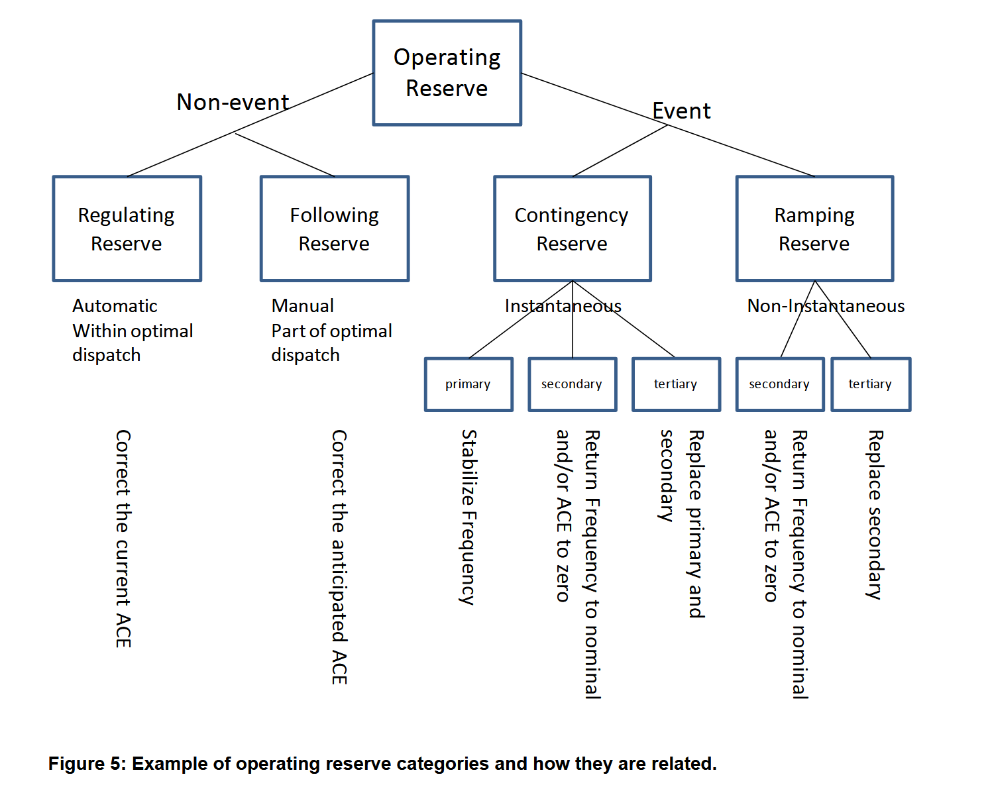
Methodologies to Determine Operating Reserves Due to Increased Wind Power [16]:
To do
Summary of work by Yuri Makarov [17], [18]:
To do

References:
[1] L. Soder, “Reserve margin planning in a wind-hydro-thermal power system,” IEEE Trans. Power Syst., vol. 8, no. 2, pp. 564–571, May 1993, doi: 10.1109/59.260826.
[2] R. Billinton and R. N. Allan, Reliability evaluation of power systems, 2nd ed. New York: Plenum Press, 1996.
[3] E. Lannoye, D. Flynn, and M. O’Malley, “Evaluation of Power System Flexibility,” IEEE Trans. Power Syst., vol. 27, no. 2, pp. 922–931, May 2012, doi: 10.1109/TPWRS.2011.2177280.
[4] P. Denholm, J. Novacheck, J. Jorgenson, and M. O’Connell, “Impact of Flexibility Options on Grid Economic Carrying Capacity of Solar and Wind: Three Case Studies,” Renew. Energy, p. 125, 2016.
[5] E. Lannoye, D. Flynn, and M. O’Malley, “Transmission, Variable Generation, and Power System Flexibility,” IEEE Trans. Power Syst., vol. 30, no. 1, pp. 57–66, Jan. 2015, doi: 10.1109/TPWRS.2014.2321793.
[6] “BCorcoran_Frew_Dissertation_FINAL-augmented.pdf.” https://stacks.stanford.edu/file/druid:hr320qr0229/BCorcoran_Frew_Dissertation_FINAL-augmented.pdf (accessed Nov. 18, 2022).
[7] “Eastern Wind Integration and Transmission Study.” https://www.nrel.gov/docs/fy11osti/47078.pdf (accessed Nov. 22, 2022).
[8] W. Short et al., “Regional Energy Deployment System (ReEDS),” NREL/TP-6A20-46534, 1031955, Dec. 2011. doi: 10.2172/1031955.
[9] B.-M. Hodge and M. Milligan, “Wind power forecasting error distributions over multiple timescales,” in 2011 IEEE Power and Energy Society General Meeting, Jul. 2011, pp. 1–8. doi: 10.1109/PES.2011.6039388.
[10] “NW Council Operating and Planning Reserves.” https://www.nwcouncil.org/sites/default/files/7thplanfinal_chap10_opplanningreserves_1.pdf (accessed Nov. 24, 2022).
[11] T. Rafael Garcia, M. Martinez, and P. Mercado, “A Review of Operating Reserves in Power Systems with High Penetration of Renewable Energy Sources,” in 2021 IEEE URUCON, Nov. 2021, pp. 194–199. doi: 10.1109/URUCON53396.2021.9647308.
[12] H. Huang, M. Zhou, and G. Li, “An Endogenous Approach to Quantifying the Wind Power Reserve,” IEEE Trans. Power Syst., vol. 35, no. 3, pp. 2431–2442, May 2020, doi: 10.1109/TPWRS.2019.2954844.
[13] G. Liu and K. Tomsovic, “Quantifying Spinning Reserve in Systems With Significant Wind Power Penetration,” IEEE Trans. Power Syst., vol. 27, no. 4, pp. 2385–2393, Nov. 2012, doi: 10.1109/TPWRS.2012.2207465.
[14] F. Bouffard and M. Ortega-Vazquez, “The value of operational flexibility in power systems with significant wind power generation,” in 2011 IEEE Power and Energy Society General Meeting, Jul. 2011, pp. 1–5. doi: 10.1109/PES.2011.6039031.
[15] E. Ela, M. Milligan, and B. Kirby, “Operating Reserves and Variable Generation,” NREL/TP-5500-51978, 1023095, Aug. 2011. doi: 10.2172/1023095.
[16] H. Holttinen et al., “Methodologies to Determine Operating Reserves Due to Increased Wind Power,” IEEE Trans. Sustain. Energy, vol. 3, no. 4, pp. 713–723, Oct. 2012, doi: 10.1109/TSTE.2012.2208207.
[17] Y. V. Makarov, C. Loutan, J. Ma, and P. de Mello, “Operational Impacts of Wind Generation on California Power Systems,” IEEE Trans. Power Syst., vol. 24, no. 2, pp. 1039–1050, May 2009, doi: 10.1109/TPWRS.2009.2016364.
[18] Y. V. Makarov, P. Du, M. A. Pai, and B. McManus, “Calculating Individual Resources Variability and Uncertainty Factors Based on Their Contributions to the Overall System Balancing Needs,” IEEE Trans. Sustain. Energy, vol. 5, no. 1, pp. 323–331, Jan. 2014, doi: 10.1109/TSTE.2013.2283712.

