Motor driver pin layout

Operation
Dual DC motor driver?
- Parallel driving
- Bi-directional
- Output current up to 35A each device

Connections

Power supply
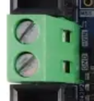
- 12V
- Screw terminal
- Can use simple cables

Signal input
- Speculated connector description: 2.54mm Pitch C-Grid III Crimp Housing Dual Row,
16 Circuits, Black (there is probably a better one)
- Connection
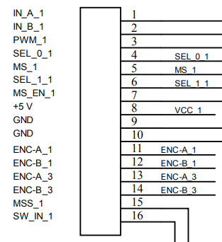
  - JP1
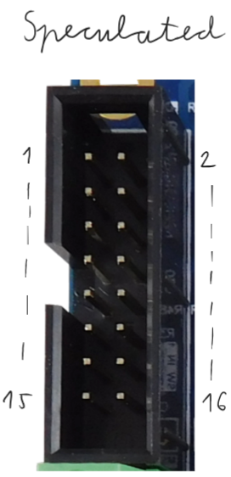

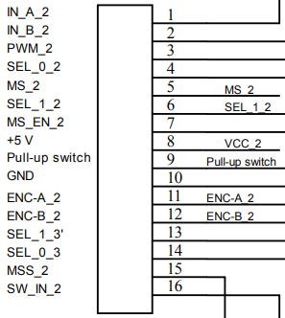
  - JP2

  - Simple jumper cable could work

Outputs
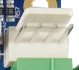
Encoder output
- One for each motor output
- Connector supplied
- Probably won't be needed

Motor output
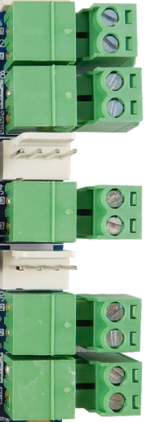
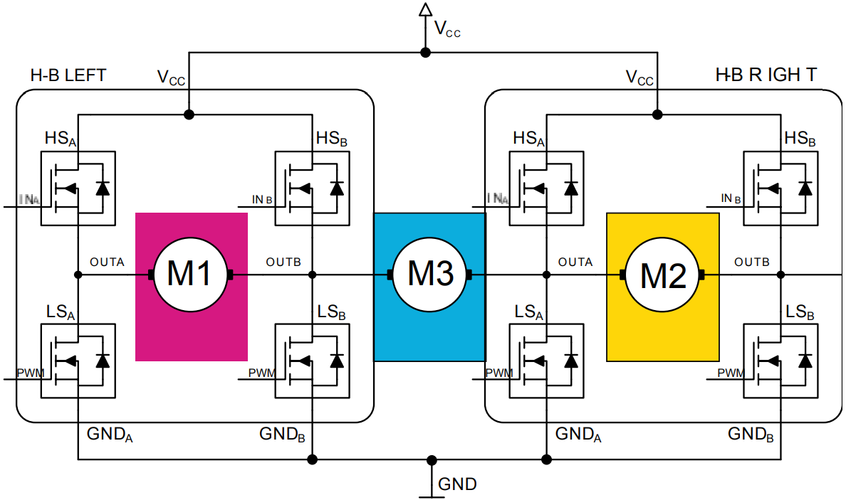
- Output of H-bridges
- Paired ones have an output for the motor and one for the load
- Header teminals
- Can be connected with plugs to be used as screw terminals

Signal pins
