Machine Learning-Based Remaining Useful Life Estimation
and Maintenance Alerting for Aircraft Turbofan Engines
TE7483 Applications and Use Cases of Machine Learning · AIML Dept., B.Tech Sem 5 · Final ESE case-study project
Authors: [Team / names to fill] · Date: October 2026

Contents

(In Word: right-click → Update Field to populate.)

Abstract
We predict the remaining useful life (RUL) of aircraft turbofan engines from multivariate sensor histories on the NASA C-MAPSS benchmark and convert RUL into an actionable maintenance-alert policy (safe / warning / critical; fails-within-30-days analogue in cycles). On FD001 the CV-selected model (hgb) reaches a test RMSE of 12.35 cycles on capped RUL (MAE 9.02, PHM score 240.7) with a grouped 5-fold CV RMSE of 11.61 ± 0.43. The same leakage-free pipeline is repeated on FD002–FD004 (multi-condition, two fault modes) with operating-condition normalisation. Alert thresholds are tuned on out-of-fold predictions at realistic truncation points and frozen before touching the test set; the deployed policy attains 1.00 fails-within-30 recall on all four test subsets with median warning lead times of 50–53 cycles. All numbers are reproduced end to end by `python run_pipeline.py --fresh`; every table and figure below is generated from files in results/.

1. Introduction and problem refinement
The vague brief — “predict engine failure” — is refined into two measurable tasks. (i) Regression: estimate remaining useful cycles from the sensor history available up to the current cycle, evaluated per engine at its last observed cycle against the official RUL labels, primarily on capped RUL (Section 3). (ii) Alerting: map RUL to safe (RUL > 50), warning (20–50), critical (< 20) and to a binary fails-within-30 flag, evaluated with precision, recall, F1 and confusion matrices with emphasis on critical recall. Stakeholders are airline maintenance planners (work packaging), MRO engineers (inspection decisions) and fleet safety managers (risk). Real-world value comes from replacing fixed-interval preventive maintenance with condition-based predictive maintenance: fewer unscheduled removals, fewer wasted healthy-life inspections. Assumptions: C-MAPSS trajectories are simulated run-to-failure / truncated histories with one snapshot per cycle and no in-trajectory repair; operating settings are observed; costs used in Section 6 are assumed (10:1), not airline data. Success criteria, fixed before seeing v2 results: (C1) FD001 test RMSE < 20 on capped and uncapped RUL; (C2) critical recall ≥ 0.85 on all subsets; (C3) fails-within-30 recall ≥ 0.95 on all subsets; (C4) median warning lead time > 10 cycles. Scored in Section 7.

2. Related work
Statistical and similarity methods. Wang, Yu, Siegel and Lee [2] introduced trajectory-similarity RUL prediction, the winning family of the PHM08 data challenge: a test trajectory is matched against a library of run-to-failure histories. Zio and Di Maio [6] predict RUL by fuzzy similarity to reference failure trajectories with online updating. Peel [4] won the IEEE Gold in the PHM08 challenge by combining neural network ensemble members with a Kalman filter. Our work differs in using supervised discriminative models with engineered causal features rather than trajectory matching, but keeps the PHM08 asymmetric scoring function as the cost-aware regression metric.
Recurrent and convolutional models. Heimes [3] applied recurrent networks to C-MAPSS RUL at PHM08. Zheng et al. [8] showed LSTM sequence models exploiting multi-condition sensor histories (IEEE ICPHM 2017). Babu, Zhao and Li [7] proposed a deep CNN regressor for RUL (DASFAA 2016), and Li, Ding and Sun [10] used deep convolutional networks with dropout for prognostics (2018). Zhang et al. [9] evolved an ensemble of deep belief networks under accuracy-diversity objectives (MODBNE). Peng et al. [5] used modified echo-state networks for RUL. Our deep baselines (1D-CNN, LSTM on length-30 causal windows) follow this line but are held to the same grouped validation protocol as the classical models — and, as Section 6 shows, do not beat gradient boosting on this feature set, a result we report rather than hide.
Uncertainty and explanation. We use split/Mondrian conformal prediction in the framework of Vovk, Gammerman and Shafer [12] for prediction intervals, and SHAP values [11] alongside permutation importance for tree-model explanation. The dataset and challenge protocol come from Saxena et al. [1]. What is novel here is not a new architecture but a leakage-free, fully reproduced comparison with a defensible alert policy: the normalise-before-smoothing fix (Section 4) was found by inspecting which features the model relied on, and is documented as an ablation.

3. Dataset
Source. NASA C-MAPSS turbofan degradation simulation [1] (readme and PDF in data/raw/). Train trajectories run to failure; test trajectories are truncated before failure with true RUL at the last observed cycle given in RUL_FD00x.txt (asserted equal to the number of test units). Files are whitespace-separated with no header and exactly 26 columns (a 27th all-NaN column from trailing spaces is dropped by the loader, which raises otherwise). Engines start with different unknown initial wear (normal, not a fault); sensor noise is present. Subsets: FD001 (1 condition, HPC fault), FD002 (6 conditions, HPC), FD003 (1 condition, HPC+Fan), FD004 (6 conditions, HPC+Fan).
Table 1. Verified dataset sizes and lifetimes (loader-asserted; note FD004 has 249 train / 248 test units, the readme's 248/249 is off by one).
subset | train rows | test rows | train units | test units | life min/max/mean | test last-RUL mean
FD001 | 20631 | 13096 | 100 | 100 | 128/362/206 | 75.500
FD002 | 53759 | 33991 | 260 | 259 | 128/378/207 | 81.200
FD003 | 24720 | 16596 | 100 | 100 | 145/525/247 | 75.300
FD004 | 61249 | 41214 | 249 | 248 | 128/543/246 | 86.600

Interpretation. FD002/FD004 are 2–3× larger with shorter, more variable lives; the multi-condition and dual-fault subsets are the generalisation test.
Table 2. The 26 columns (no header in files).
columns | meaning | dtype
unit | engine id | int
cycle | cycle number | int
op1–op3 | operating settings | float ×3
s1 | fan inlet temp | float
s2 | LPC outlet temp | float
s3 | HPC outlet temp | float
s4 | LPT outlet temp | float
s5 | fan inlet pressure | float
s6 | bypass-duct pressure | float
s7 | HPC outlet pressure | float
s8 | physical fan speed | float
s9 | physical core speed | float
s10 | engine pressure ratio | float
s11 | HPC outlet static pressure | float
s12 | fuel flow / phi | float
s13 | corrected fan speed | float
s14 | corrected core speed | float
s15 | bypass ratio | float
s16 | burner fuel-air ratio | float
s17 | bleed enthalpy | float
s18 | demanded fan speed | float
s19 | demanded corrected fan speed | float
s20 | HPT coolant bleed | float
s21 | LPT coolant bleed | float

Table 3. Test-set class counts over all rows (safe dominates everywhere; last-cycle counts differ — see confusion matrices).
fd | n_engines | safe | warning | critical | leq30 | note
FD001 | 100 | 12210 | 779 | 107 | 332 | counts over ALL test rows; last-cycle counts differ
FD002 | 259 | 31405 | 2135 | 451 | 1087 | counts over ALL test rows; last-cycle counts differ
FD003 | 100 | 15817 | 671 | 108 | 291 | counts over ALL test rows; last-cycle counts differ
FD004 | 248 | 38964 | 1916 | 334 | 864 | counts over ALL test rows; last-cycle counts differ

Interpretation. Class imbalance is structural: most cycles of most engines are healthy. Accuracy is therefore never used for selection; recall on critical / fails-within-30 is the safety metric.
Table 4. Sensors kept/dropped per subset (variance on normalised train data; s1/s5/s18/s19 drop on FD002/FD004 because they are constant within each condition).
subset | kept | dropped
FD001 | 15 | s1, s19, s18, s5, s16, s10
FD002 | 17 | s18, s5, s19, s1
FD003 | 16 | s1, s19, s18, s16, s5
FD004 | 17 | s19, s18, s5, s1

Targets. Train RUL = max cycle of unit − cycle; test RUL for every row = RUL_last(unit) + (last_cycle − cycle). Regression is trained on piece-wise linear RUL capped at 125 (degradation is not observable early in life; flat sensors would otherwise force the model to fit noise) and evaluated primarily on capped RUL — the literature convention — with uncapped metrics kept as secondary. Because all class thresholds (50/20/30) lie below the cap, the cap cannot distort the labels. No missing values, no duplicate rows, dtypes validated in src/data.py. Validation: GroupKFold (5-fold) and GroupShuffleSplit strictly by engine; scalers, KMeans, selectors fit on training folds only; test features use past data of that engine only (causal rolling windows; short histories edge-padded with the first row — stated rule). Two leakage bugs were found and fixed during this project and are regression-tested: (i) a cycle/max_cycle feature that encoded failure time (removed); (ii) smoothing raw sensors before condition normalisation, which blended operating modes (fixed order: normalise → drop → smooth → rolling; the bug is kept as a documented ablation in Section 6).

4. Methodology
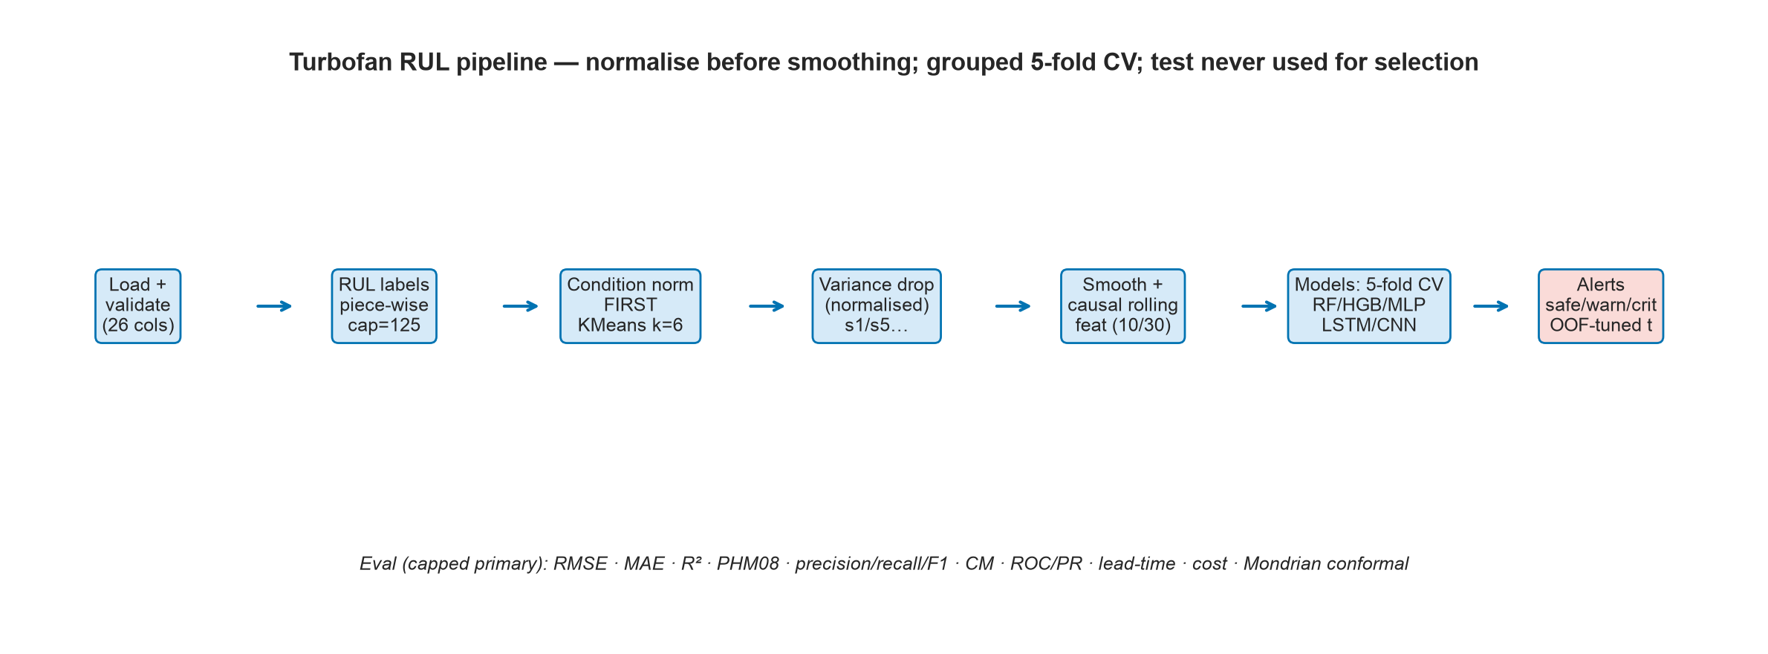
Figure 1. End-to-end pipeline. Fits happen on train only; model selection uses grouped CV; thresholds are frozen on out-of-fold predictions before the test set is touched.
Interpretation. The diagram order matches the code exactly. The key decision — normalise before smoothing — is what makes the multi-condition subsets tractable (Section 6, smooth-order ablation).
Preprocessing. (i) Operating-condition normalisation: KMeans (k=6, elbow + silhouette evidence in Figures for FD002/FD004) on standardised op settings, then z-score each sensor within its cluster for FD002/FD004; global standardisation for FD001/FD003. Within-condition std at float-noise level (~1e-13, e.g. s1/s5/s19) is floored so these sensors normalise to exactly 0 and drop out, instead of having their numerical dust amplified to ±1. (ii) Causal exponential smoothing (α=0.3) per unit on normalised sensors. (iii) Causal rolling mean/std/slope over windows [10, 30] plus raw cycle and op settings; train-fit StandardScaler. (iv) Sliding windows (length 30, ablation 20/30/50) of normalised sensors for deep models.
Models and rationale. Ridge (linear reference) and mean-RUL (floor); Random Forest and HistGradientBoosting (nonlinear tabular workhorses; XGBoost/LightGBM wheels require system libomp, absent on this machine — HGB is the honest boosting representative); MLP (dense nonlinear baseline); 1D-CNN and 1-layer LSTM on causal windows (sequence inductive bias), early stopping on by-engine holdout, seeds 42–44. Classification is done both directly (logreg/RF/HGB with class weights) and as RUL-regress-then-threshold, compared head to head. Tuning: RandomizedSearch over HGB (5-fold grouped CV). Imbalance: class_weight balanced (ablated off). Thresholds: out-of-fold RUL predictions of the deployed model at random truncation points per engine; pick the smallest-cost threshold subject to OOF recall ≥ 0.95, else the cost-optimal threshold with target_met=false (costs assumed 10:1, sensitivity in Section 6). Uncertainty: Mondrian split-conformal intervals binned on predicted RUL.

5. Implementation
Python 3.12, scikit-learn 1.9.1, PyTorch 2.14.1 (CPU), matplotlib/seaborn; repository aucml_rul_project with src/ (data, preprocess, models, train, evaluate, explain, alerts, plots), config.yaml, Makefile and run_all.sh. Reproduce: `pip install -r requirements.txt && python run_pipeline.py --fresh` (subset wall-clock: FD001 17.6 min, FD002 37.6 min, FD003 24.2 min, FD004 51.5 min), then scripts/build_report.py, build_slides.py; `pytest tests/ -q` (12 tests); notebooks execute via nbconvert; `streamlit run app.py` demo (upload/choose an engine history → predicted RUL, green/amber/red alert, trajectory). Seeds 42–44; pinned requirements for imported packages; all artefacts under results/, figures/, models/.

6. Results and comparative analysis

6.1 RUL regression (capped primary)
Table 5. Test RMSE on capped RUL @125, last cycle per engine (primary metric; lower is better).
model | FD001 | FD002 | FD003 | FD004
cnn | 14.570 | 16.510 | 17.650 | 18.510
hgb | 12.350 | 12.870 | 13.170 | 13.170
hgb_tuned | 12.240 | 12.830 | 12.880 | 12.970
lstm | 13.750 | 14.880 | 13.160 | 14.770
mlp | 13.500 | 14.580 | 14.680 | 13.400
rf | 12.270 | 13.250 | 14.660 | 13.730
ridge | 15.660 | 16.350 | 15.910 | 18.350

Interpretation. HGB is CV-selected on all four subsets. The normalise-first fix moves FD002 HGB 18.27→12.87 and FD004 HGB 23.87→13.17; single-condition subsets are flat (FD001 11.63→12.35 mixes the 100→300 estimator change — at fixed 100-iter capacity the fix is 12.37→12.04, i.e. neutral-to-positive). Deep models trail boosting by 1–4 RMSE points everywhere.
Table 6. Grouped-CV RMSE (capped, mean ± std; deep = by-engine holdout) beside capped test RMSE. Selection used the CV column only.
subset | model | CV RMSE | test RMSE cap | test PHM cap
FD001 | ridge | 15.81 ± 0.59 | 15.660 | 355.700
FD001 | rf | 12.65 ± 0.27 | 12.270 | 210.900
FD001 | hgb | 11.61 ± 0.43 | 12.350 | 240.700
FD001 | mlp | 14.62 ± 0.57 | 13.500 | 300.400
FD001 | hgb_tuned | 11.48 ± 0.47 | 12.240 | 225.100
FD001 | lstm | 12.98 ± 1.26 | 13.750 | 388.300
FD001 | cnn | 15.65 ± 1.10 | 14.570 | 370.100
FD002 | ridge | 16.73 ± 0.28 | 16.350 | 1215.000
FD002 | rf | 13.87 ± 0.34 | 13.250 | 862.100
FD002 | hgb | 13.19 ± 0.32 | 12.870 | 736.900
FD002 | mlp | 16.16 ± 0.32 | 14.580 | 1266.400
FD002 | hgb_tuned | 12.99 ± 0.30 | 12.830 | 762.500
FD002 | lstm | 16.57 ± 1.09 | 14.880 | 1143.600
FD002 | cnn | 21.97 ± 3.87 | 16.510 | 1319.900
FD003 | ridge | 15.31 ± 0.67 | 15.910 | 465.200
FD003 | rf | 10.56 ± 1.59 | 14.660 | 532.200
FD003 | hgb | 9.85 ± 1.47 | 13.170 | 313.300
FD003 | mlp | 11.97 ± 1.45 | 14.680 | 588.100
FD003 | hgb_tuned | 9.81 ± 1.50 | 12.880 | 311.400
FD003 | lstm | 12.01 ± 0.35 | 13.160 | 292.800
FD003 | cnn | 16.52 ± 1.59 | 17.650 | 846.800
FD004 | ridge | 17.55 ± 0.64 | 18.350 | 1602.400
FD004 | rf | 13.58 ± 0.99 | 13.730 | 839.100
FD004 | hgb | 13.06 ± 1.12 | 13.170 | 856.700
FD004 | mlp | 16.13 ± 1.03 | 13.400 | 924.900
FD004 | hgb_tuned | 12.96 ± 1.07 | 12.970 | 752.200
FD004 | lstm | 16.14 ± 0.62 | 14.770 | 1015.200
FD004 | cnn | 18.24 ± 0.83 | 18.510 | 1982.400

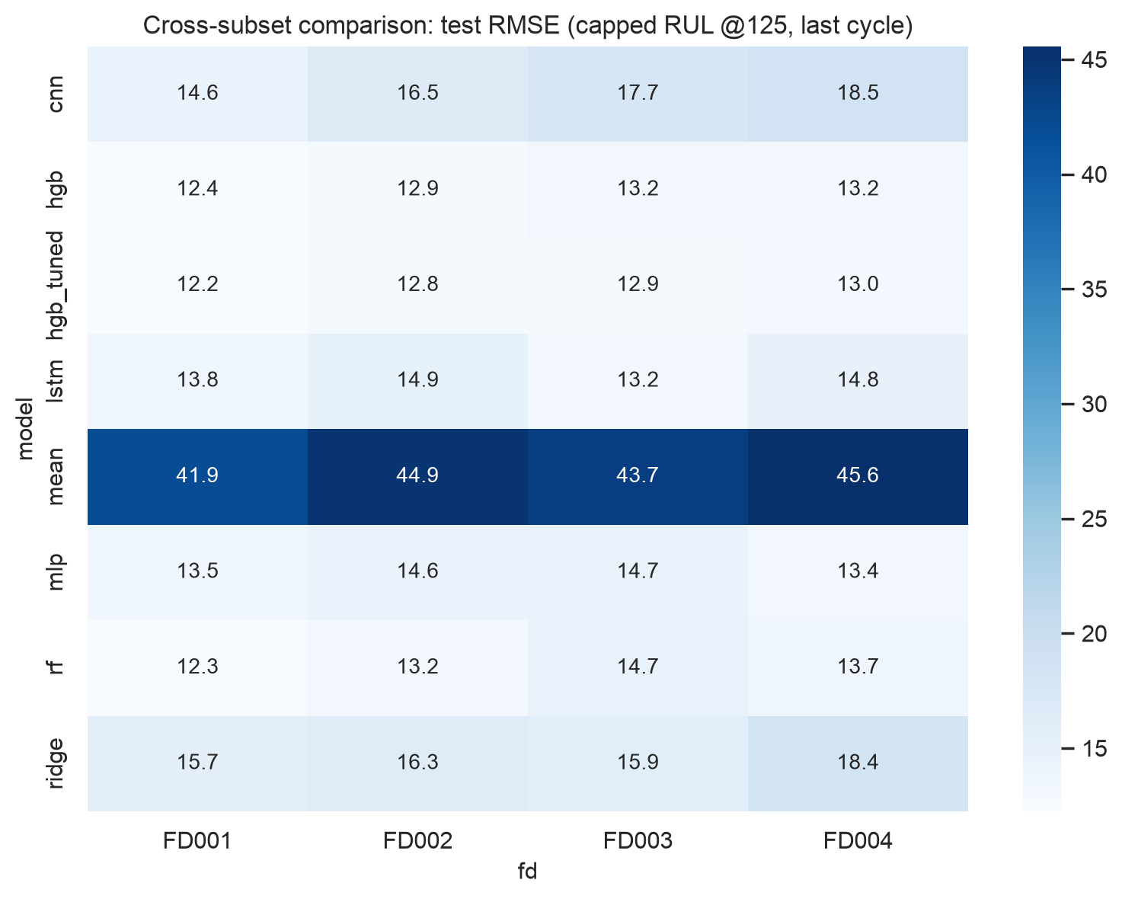
Figure 2. Cross-subset heatmap of capped test RMSE: multi-condition/fault subsets remain harder, but the gap closed from ~2× to ~7%.
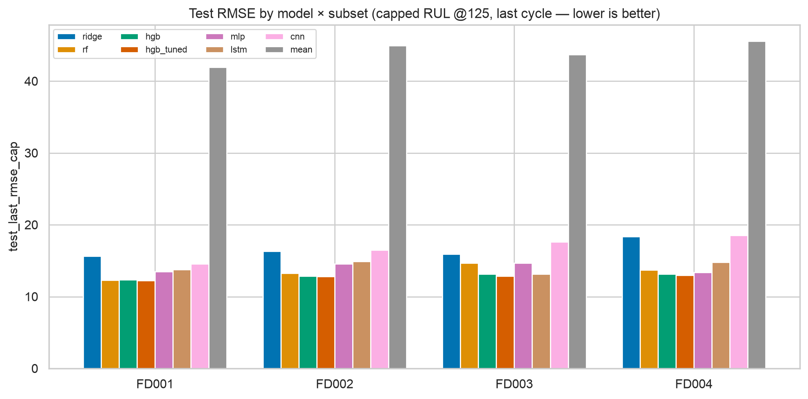
Figure 3. Grouped capped-RMSE bars: boosting leads on every subset; tuned HGB ≈ default HGB.
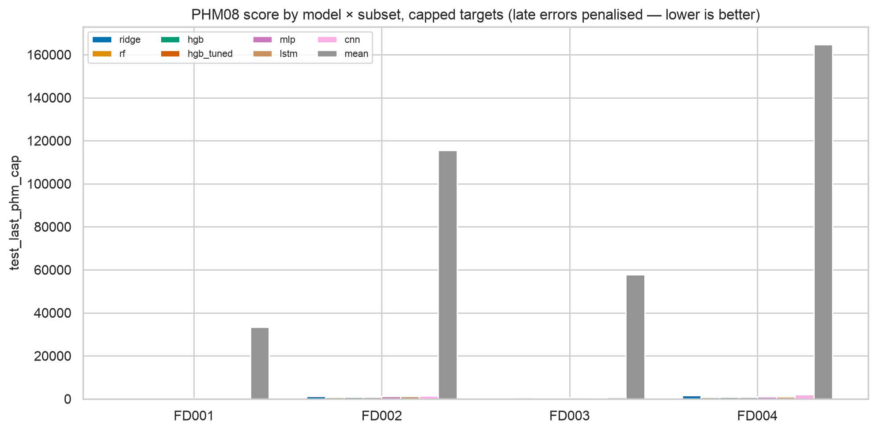
Figure 4. PHM08 scores on capped targets: late errors penalised asymmetrically; ranking mirrors RMSE.
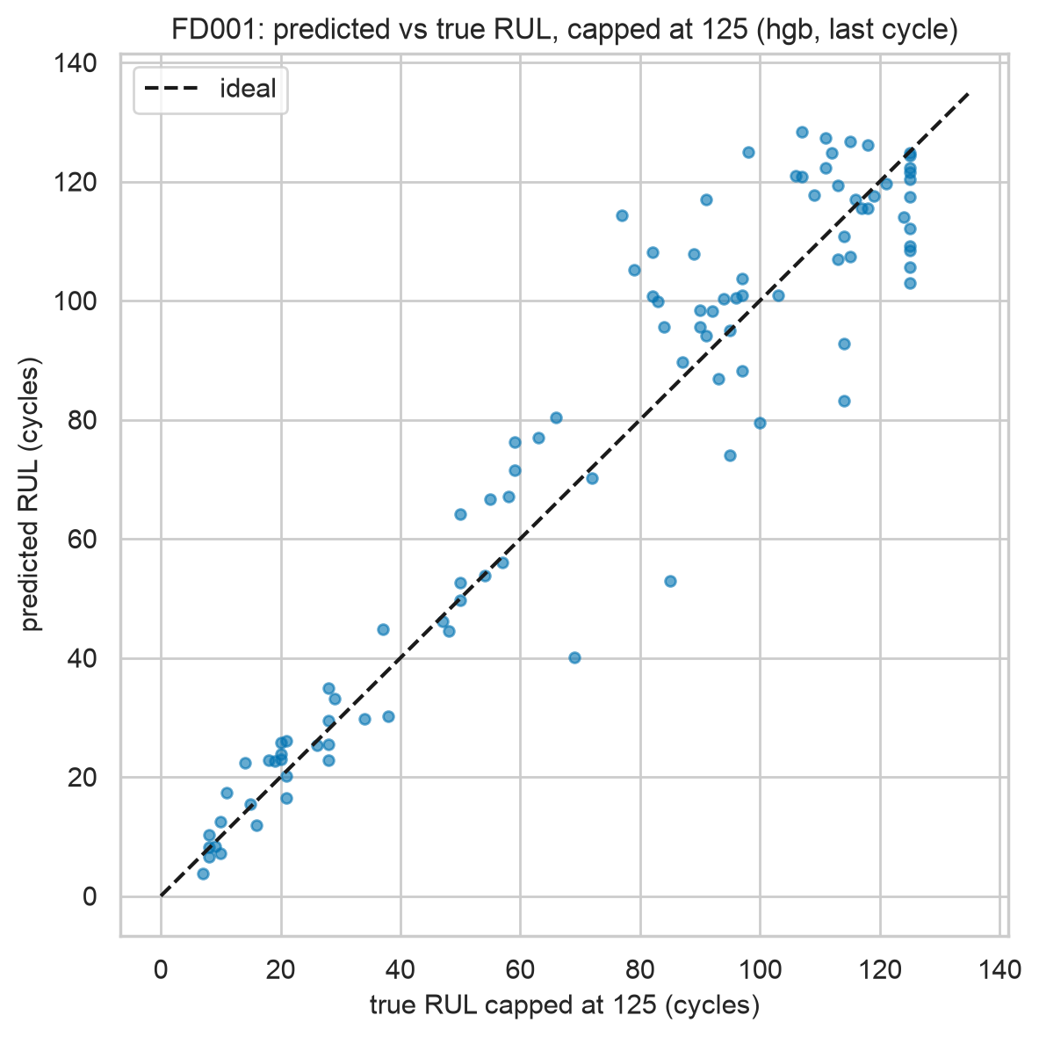
Figure 5. FD001 predicted vs capped-true RUL (hgb, last cycle).
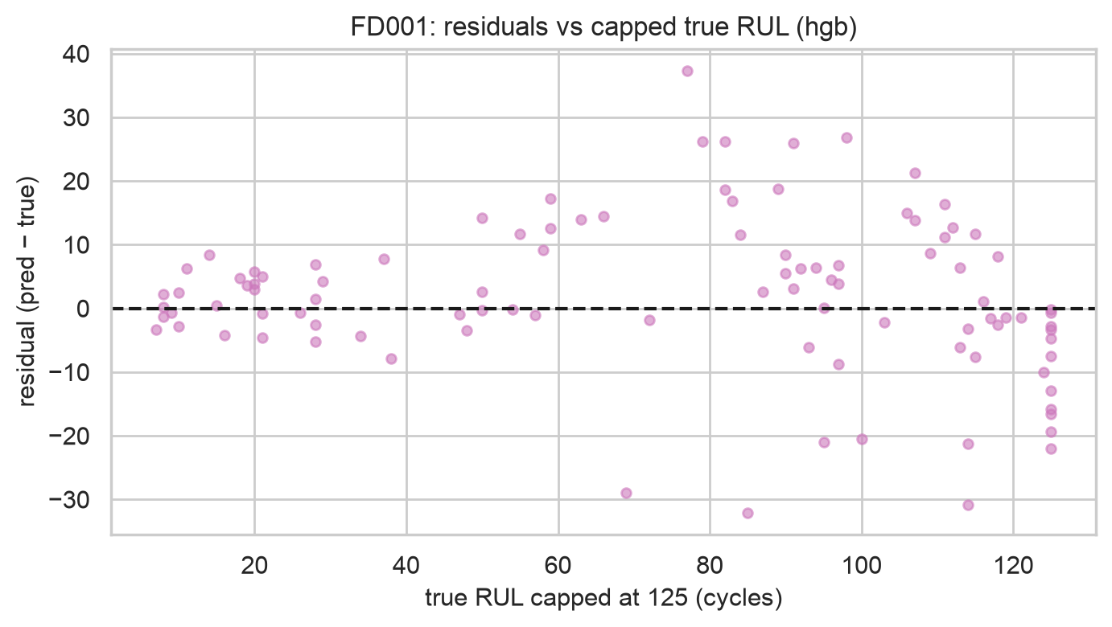
Figure 6. FD001 residuals vs capped-true RUL (hgb): errors grow far from failure, shrink near it.
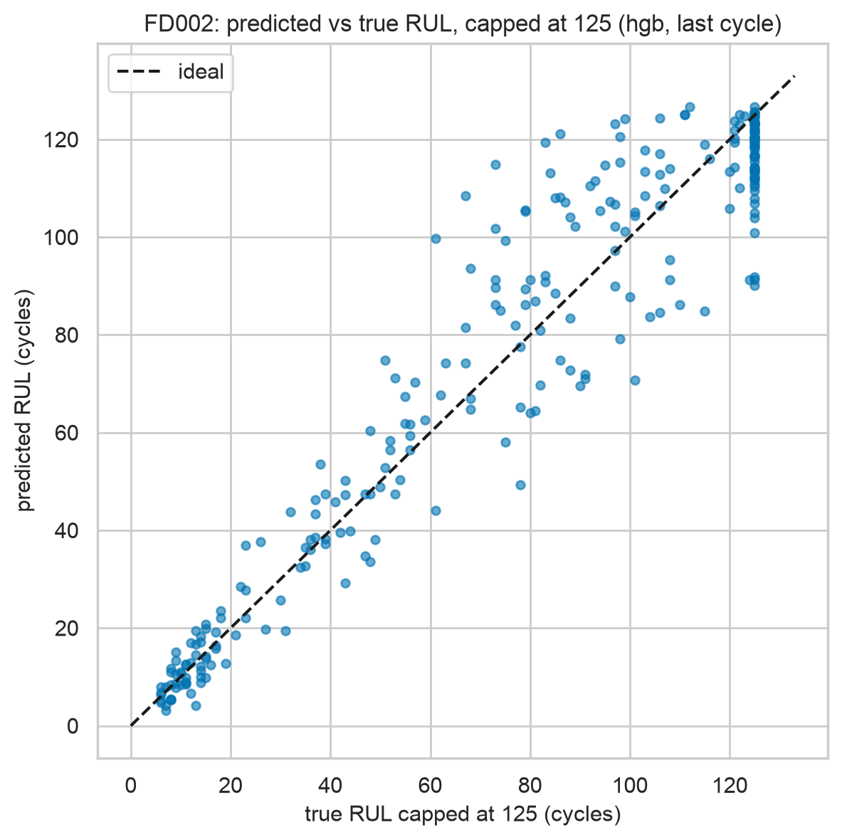
Figure 7. FD002 predicted vs capped-true RUL (hgb, last cycle).
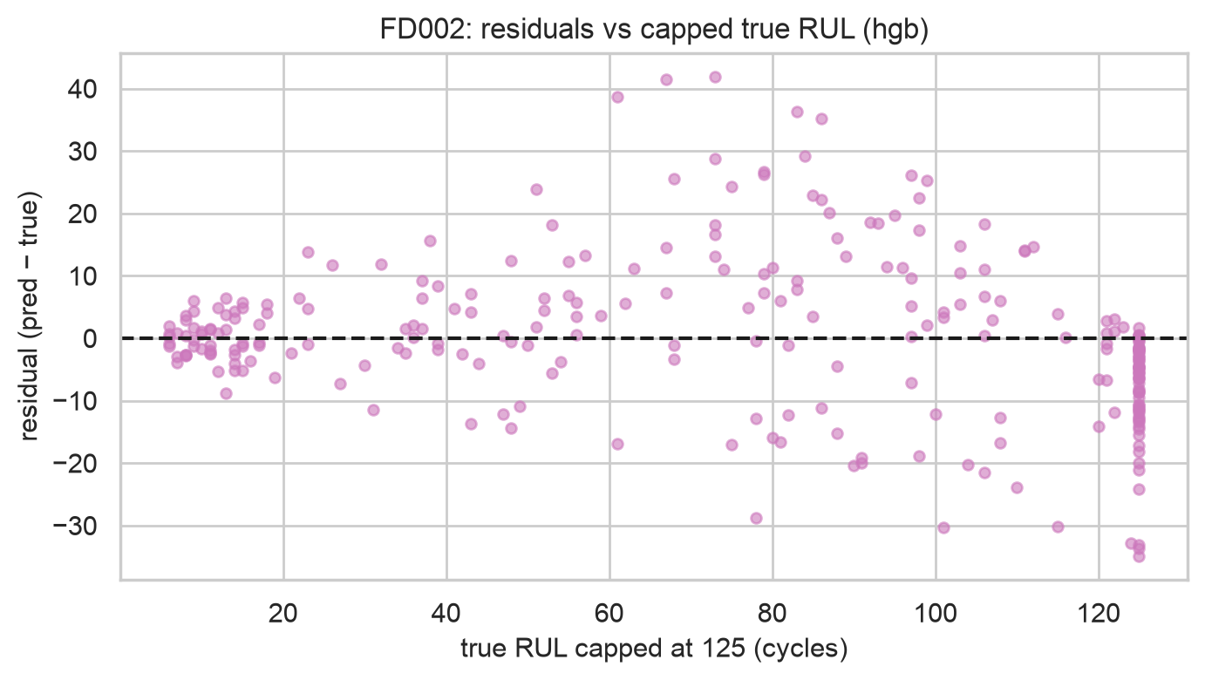
Figure 8. FD002 residuals vs capped-true RUL (hgb): errors grow far from failure, shrink near it.
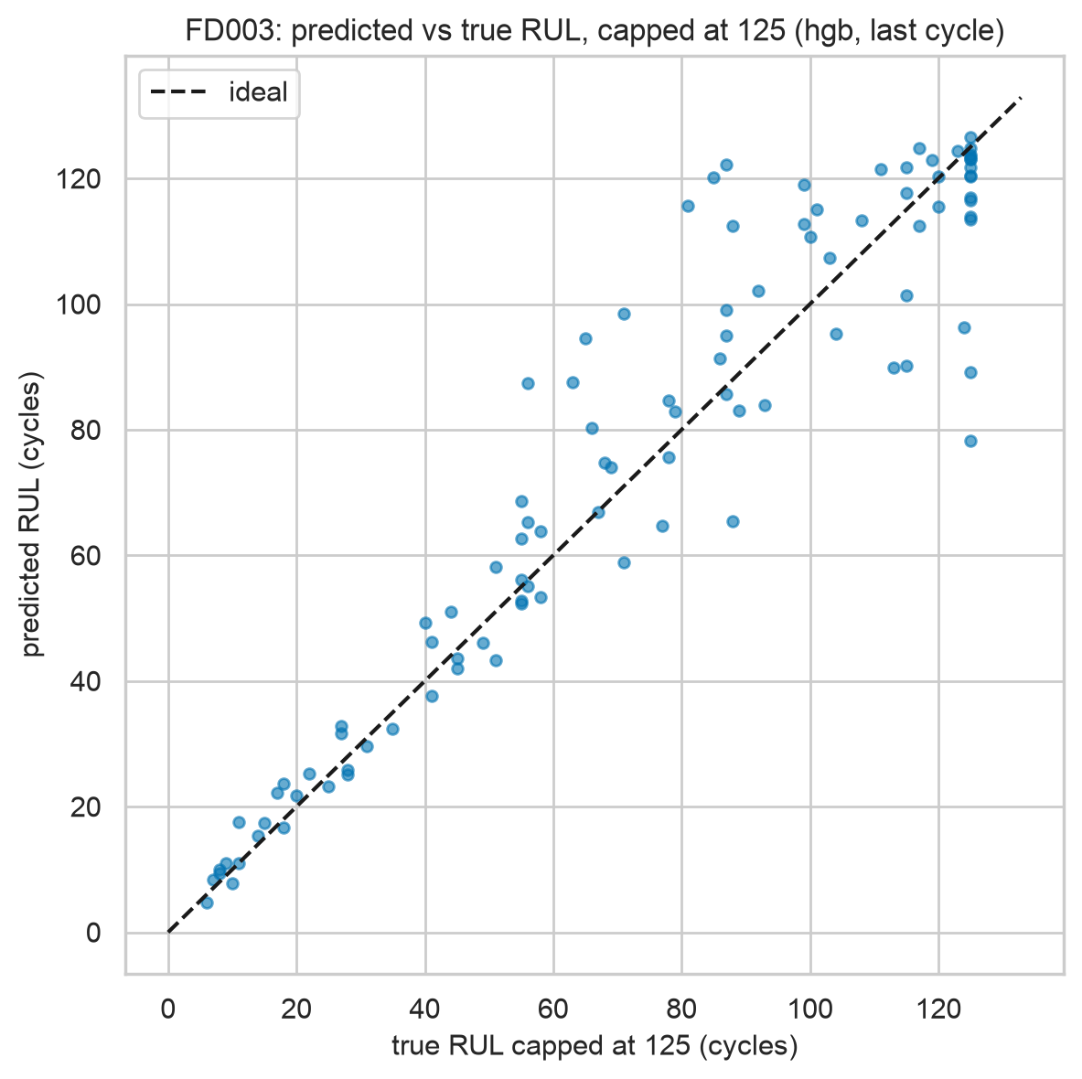
Figure 9. FD003 predicted vs capped-true RUL (hgb, last cycle).
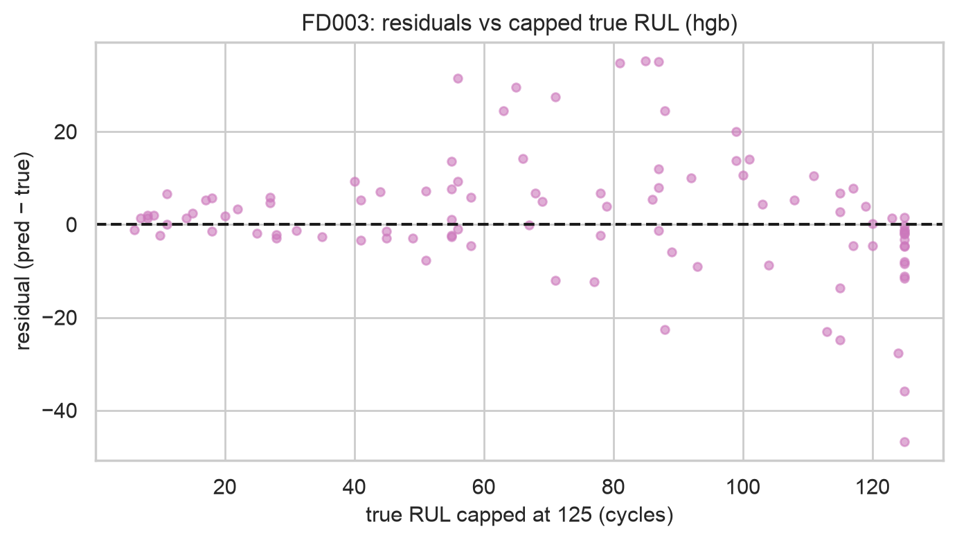
Figure 10. FD003 residuals vs capped-true RUL (hgb): errors grow far from failure, shrink near it.
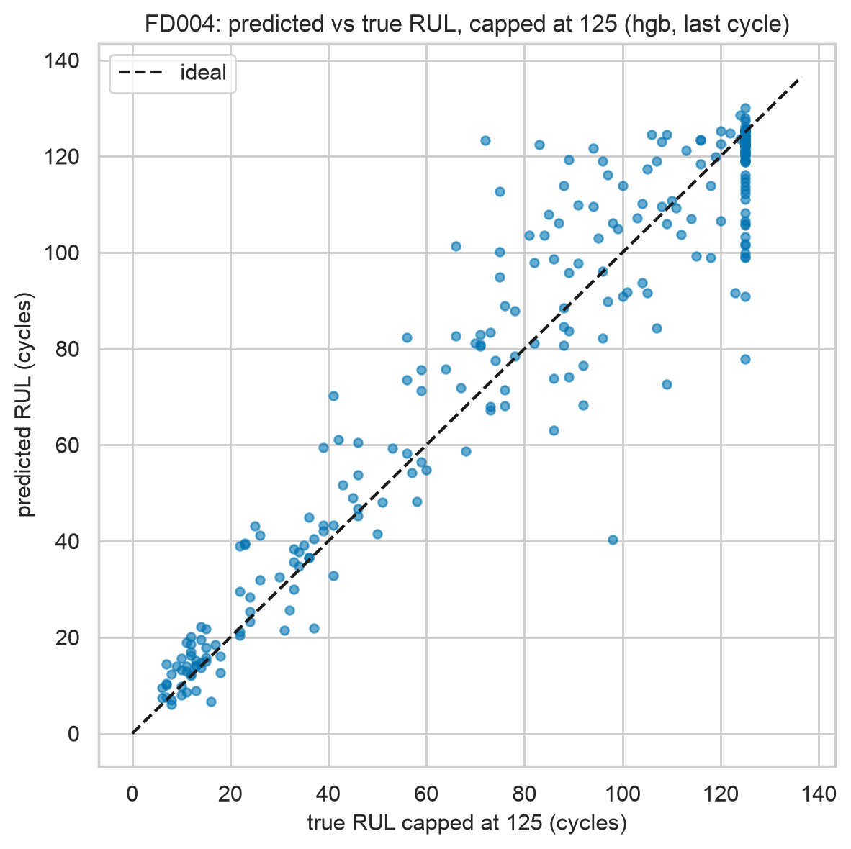
Figure 11. FD004 predicted vs capped-true RUL (hgb, last cycle).
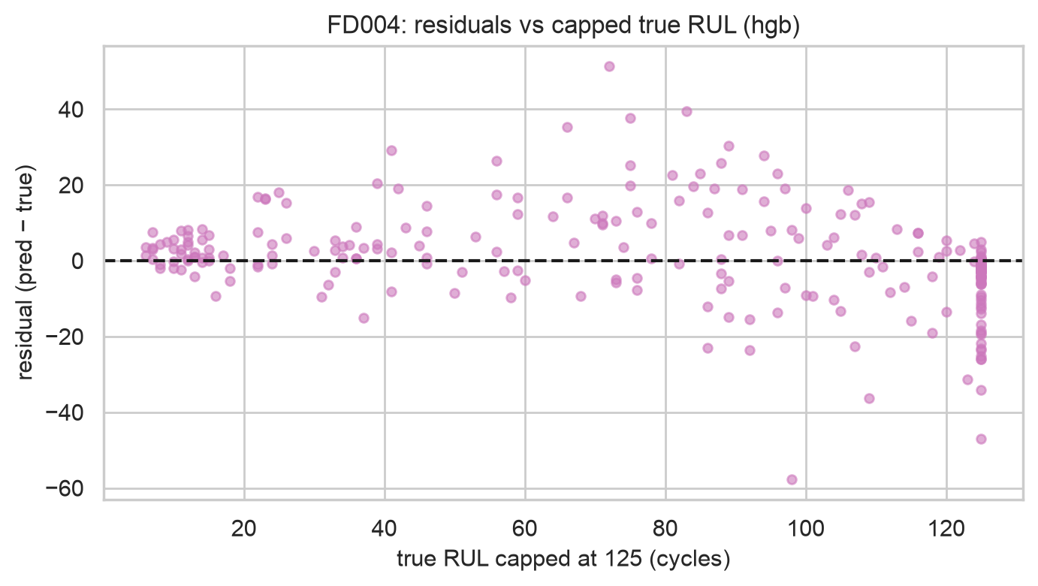
Figure 12. FD004 residuals vs capped-true RUL (hgb): errors grow far from failure, shrink near it.
Table 7. Per-RUL-bin errors (deployed model, capped last-cycle): near-failure bins are far more accurate.
subset | true-RUL bin | RMSE | MAE | n
FD001 | 0-20 | 3.880 | 3.130 | 13
FD001 | 20-50 | 4.600 | 4.020 | 17
FD001 | 50-125 | 14.500 | 11.320 | 70
FD002 | 0-20 | 3.430 | 2.830 | 53
FD002 | 20-50 | 7.940 | 6.290 | 34
FD002 | 50-125 | 15.280 | 11.840 | 172
FD003 | 0-20 | 3.170 | 2.530 | 13
FD003 | 20-50 | 4.240 | 3.670 | 16
FD003 | 50-125 | 15.440 | 11.180 | 71
FD004 | 0-20 | 4.240 | 3.350 | 40
FD004 | 20-50 | 10.310 | 7.580 | 39
FD004 | 50-125 | 15.020 | 10.640 | 169

Interpretation. The bin table explains the all-cycles result: far-from-failure rows dominate the average but are operationally irrelevant — maintenance acts below RUL 50, where errors are 3–5× smaller.

6.2 Failure-warning classification
Table 8. Per-class precision/recall/F1 with support (last cycle per engine). Critical/positive recall is the safety metric.
subset | task | approach | model | class | precision | recall | f1 | support
FD001 | 3class | direct | logreg | critical | 0.867 | 1.000 | 0.929 | 13
FD001 | 3class | direct | logreg | macro | 0.900 | 0.935 | 0.916 | 100
FD001 | binary30 | direct | logreg | positive | 0.926 | 1.000 | 0.962 | 25
FD001 | binary30 | direct | logreg | macro | 0.963 | 0.987 | 0.974 | 100
FD001 | 3class | direct | rf | critical | 0.846 | 0.846 | 0.846 | 13
FD001 | 3class | direct | rf | macro | 0.841 | 0.834 | 0.837 | 100
FD001 | binary30 | direct | rf | positive | 0.913 | 0.840 | 0.875 | 25
FD001 | binary30 | direct | rf | macro | 0.931 | 0.907 | 0.918 | 100
FD001 | 3class | direct | hgb | critical | 0.833 | 0.769 | 0.800 | 13
FD001 | 3class | direct | hgb | macro | 0.852 | 0.858 | 0.853 | 100
FD001 | binary30 | direct | hgb | positive | 0.926 | 1.000 | 0.962 | 25
FD001 | binary30 | direct | hgb | macro | 0.963 | 0.987 | 0.974 | 100
FD001 | 3class | regress | hgb-via-RUL | critical | 0.909 | 0.769 | 0.833 | 13
FD001 | 3class | regress | hgb-via-RUL | macro | 0.896 | 0.868 | 0.880 | 100
FD001 | binary30 | regress | hgb-via-RUL | positive | 0.958 | 0.920 | 0.939 | 25
FD001 | binary30 | regress | hgb-via-RUL | macro | 0.966 | 0.953 | 0.959 | 100
FD002 | 3class | direct | logreg | critical | 0.980 | 0.925 | 0.951 | 53
FD002 | 3class | direct | logreg | macro | 0.882 | 0.932 | 0.899 | 259
FD002 | binary30 | direct | logreg | positive | 0.847 | 1.000 | 0.917 | 61
FD002 | binary30 | direct | logreg | macro | 0.924 | 0.972 | 0.944 | 259
FD002 | 3class | direct | rf | critical | 0.962 | 0.943 | 0.952 | 53
FD002 | 3class | direct | rf | macro | 0.911 | 0.924 | 0.917 | 259
FD002 | binary30 | direct | rf | positive | 0.938 | 0.984 | 0.960 | 61
FD002 | binary30 | direct | rf | macro | 0.966 | 0.982 | 0.974 | 259
FD002 | 3class | direct | hgb | critical | 0.980 | 0.906 | 0.941 | 53
FD002 | 3class | direct | hgb | macro | 0.920 | 0.942 | 0.928 | 259
FD002 | binary30 | direct | hgb | positive | 0.938 | 1.000 | 0.968 | 61
FD002 | binary30 | direct | hgb | macro | 0.969 | 0.990 | 0.979 | 259
FD002 | 3class | regress | hgb-via-RUL | critical | 0.943 | 0.943 | 0.943 | 53
FD002 | 3class | regress | hgb-via-RUL | macro | 0.918 | 0.918 | 0.918 | 259
FD002 | binary30 | regress | hgb-via-RUL | positive | 0.967 | 0.967 | 0.967 | 61
FD002 | binary30 | regress | hgb-via-RUL | macro | 0.979 | 0.979 | 0.979 | 259
FD003 | 3class | direct | logreg | critical | 0.867 | 1.000 | 0.929 | 13
FD003 | 3class | direct | logreg | macro | 0.844 | 0.925 | 0.878 | 100
FD003 | binary30 | direct | logreg | positive | 0.952 | 1.000 | 0.976 | 20
FD003 | binary30 | direct | logreg | macro | 0.976 | 0.994 | 0.985 | 100
FD003 | 3class | direct | rf | critical | 1.000 | 1.000 | 1.000 | 13
FD003 | 3class | direct | rf | macro | 0.932 | 0.944 | 0.938 | 100
FD003 | binary30 | direct | rf | positive | 0.909 | 1.000 | 0.952 | 20
FD003 | binary30 | direct | rf | macro | 0.955 | 0.988 | 0.970 | 100
FD003 | 3class | direct | hgb | critical | 0.867 | 1.000 | 0.929 | 13
FD003 | 3class | direct | hgb | macro | 0.897 | 0.944 | 0.918 | 100
FD003 | binary30 | direct | hgb | positive | 0.952 | 1.000 | 0.976 | 20
FD003 | binary30 | direct | hgb | macro | 0.976 | 0.994 | 0.985 | 100
FD003 | 3class | regress | hgb-via-RUL | critical | 1.000 | 0.846 | 0.917 | 13
FD003 | 3class | regress | hgb-via-RUL | macro | 0.940 | 0.923 | 0.928 | 100
FD003 | binary30 | regress | hgb-via-RUL | positive | 0.947 | 0.900 | 0.923 | 20
FD003 | binary30 | regress | hgb-via-RUL | macro | 0.961 | 0.944 | 0.952 | 100
FD004 | 3class | direct | logreg | critical | 0.973 | 0.900 | 0.935 | 40
FD004 | 3class | direct | logreg | macro | 0.890 | 0.926 | 0.901 | 248
FD004 | binary30 | direct | logreg | positive | 0.823 | 0.962 | 0.887 | 53
FD004 | binary30 | direct | logreg | macro | 0.906 | 0.953 | 0.926 | 248
FD004 | 3class | direct | rf | critical | 1.000 | 0.925 | 0.961 | 40
FD004 | 3class | direct | rf | macro | 0.922 | 0.921 | 0.921 | 248
FD004 | binary30 | direct | rf | positive | 0.923 | 0.906 | 0.914 | 53
FD004 | binary30 | direct | rf | macro | 0.949 | 0.943 | 0.946 | 248
FD004 | 3class | direct | hgb | critical | 1.000 | 0.900 | 0.947 | 40
FD004 | 3class | direct | hgb | macro | 0.925 | 0.923 | 0.923 | 248
FD004 | binary30 | direct | hgb | positive | 0.877 | 0.943 | 0.909 | 53
FD004 | binary30 | direct | hgb | macro | 0.931 | 0.954 | 0.942 | 248
FD004 | 3class | regress | hgb-via-RUL | critical | 1.000 | 0.925 | 0.961 | 40
FD004 | 3class | regress | hgb-via-RUL | macro | 0.938 | 0.919 | 0.928 | 248
FD004 | binary30 | regress | hgb-via-RUL | positive | 0.920 | 0.868 | 0.893 | 53
FD004 | binary30 | regress | hgb-via-RUL | macro | 0.942 | 0.924 | 0.933 | 248

Interpretation. Direct classifiers and regress-then-threshold are within noise of each other on macro-F1; the regress-then-threshold path wins 3-class macro-F1 on FD001 (0.880 vs 0.853 for direct HGB) because the RUL ordering regularises boundaries. Small test sets (13 critical engines on FD001/FD003) mean one engine shifts recall by ~8 points — hence the bootstrap CIs below.
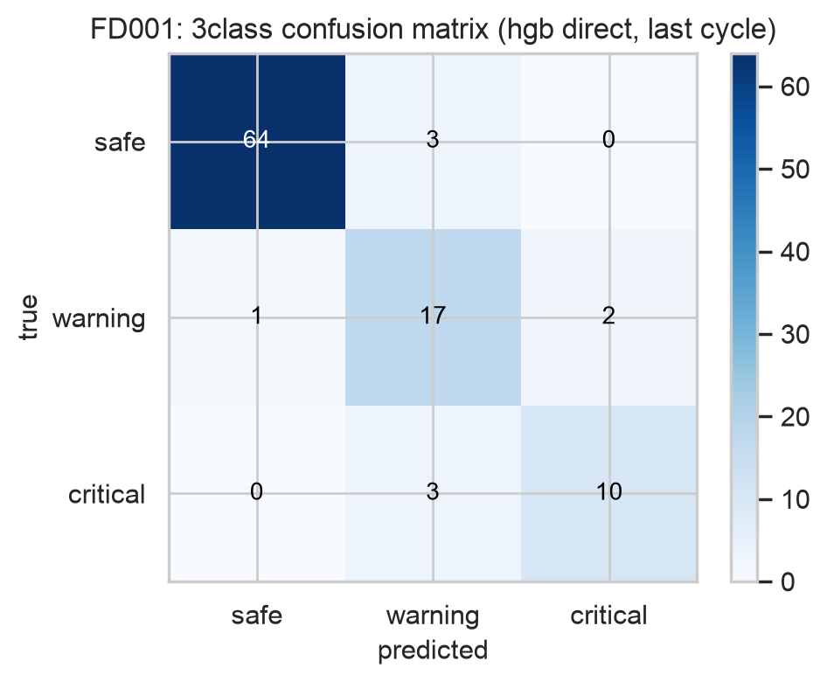
Figure 13. FD001 3-class confusion matrix (hgb direct). Off-diagonal mass sits in adjacent classes; dangerous safe↔critical confusions are counted in the text.
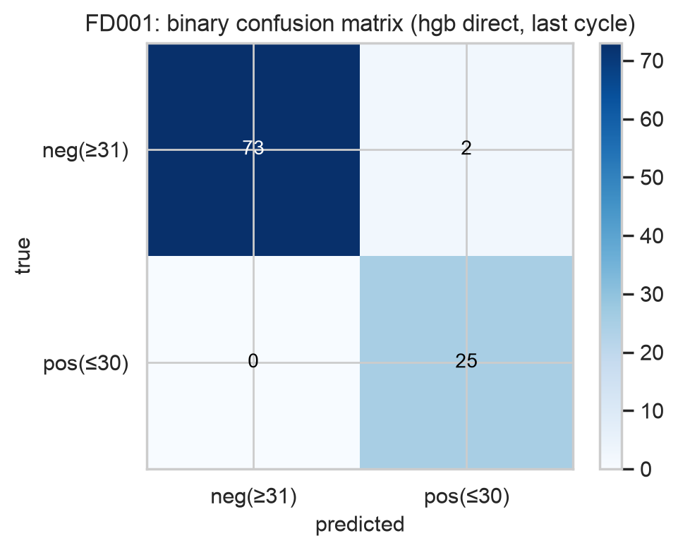
Figure 14. FD001 binary ≤30 confusion matrix (hgb direct).
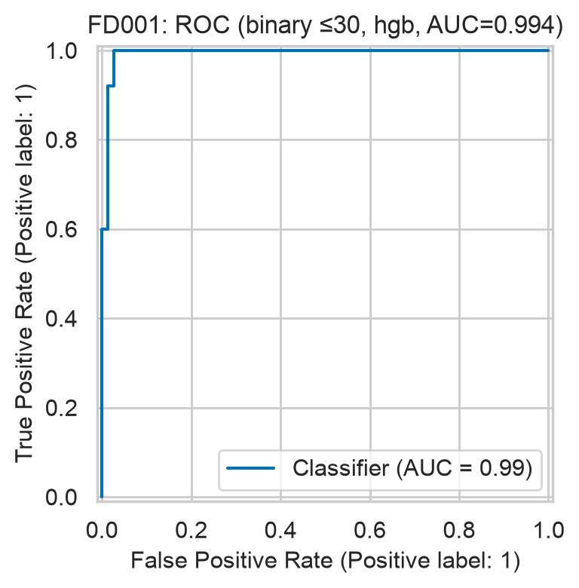
Figure 15. FD001 ROC for fails-within-30 (hgb).
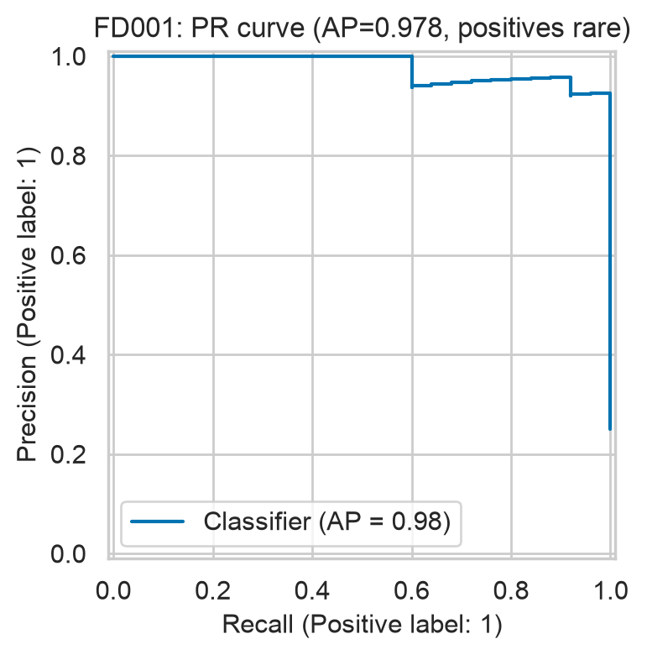
Figure 16. FD001 precision-recall curve (hgb): positives are rare, so PR matters more than ROC.
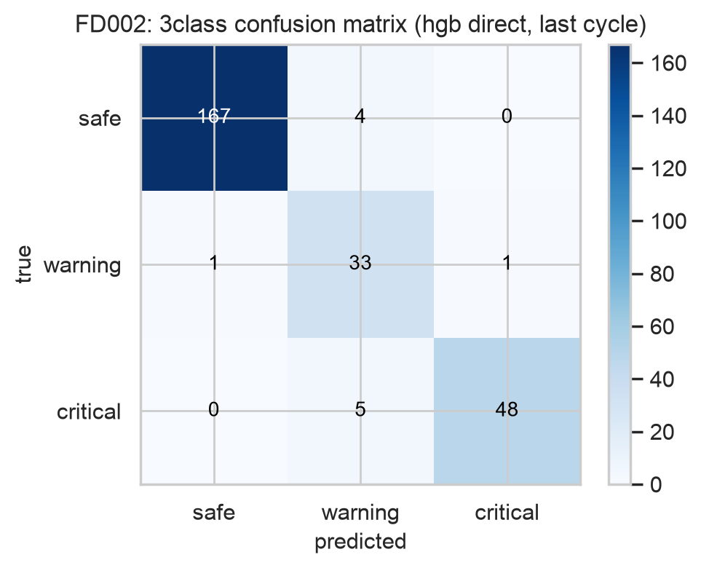
Figure 17. FD002 3-class confusion matrix (hgb direct). Off-diagonal mass sits in adjacent classes; dangerous safe↔critical confusions are counted in the text.
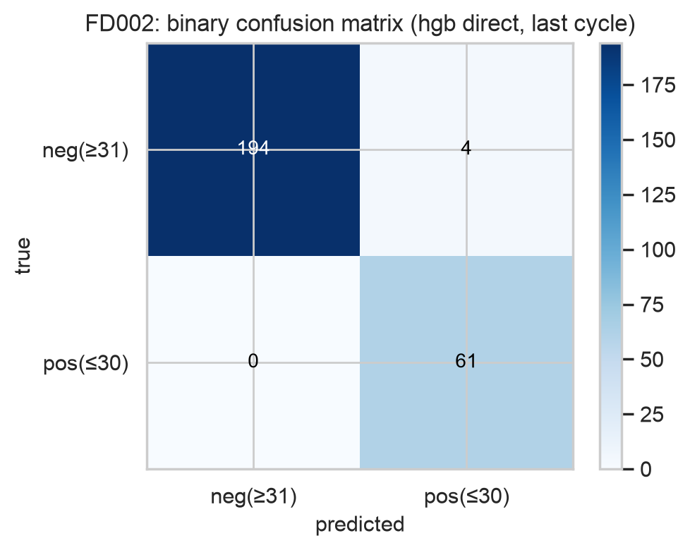
Figure 18. FD002 binary ≤30 confusion matrix (hgb direct).
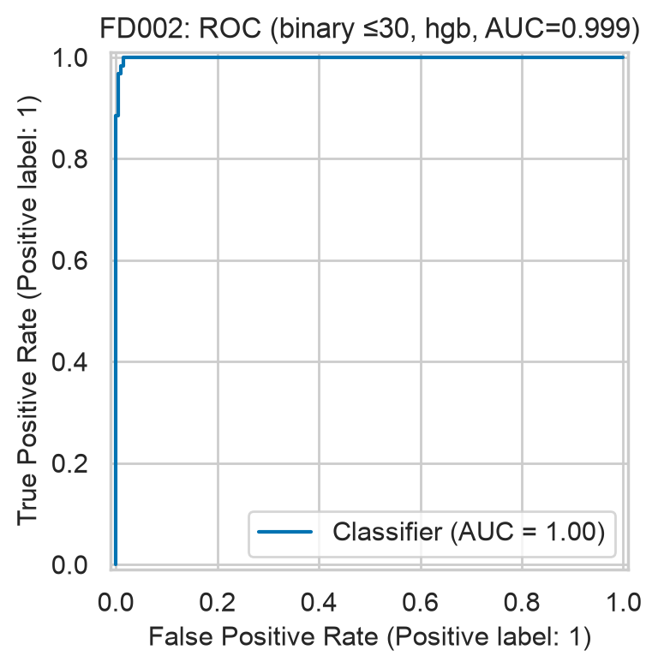
Figure 19. FD002 ROC for fails-within-30 (hgb).
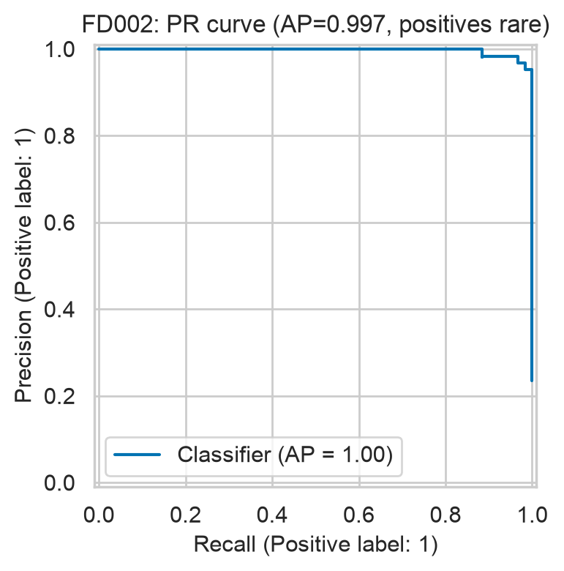
Figure 20. FD002 precision-recall curve (hgb): positives are rare, so PR matters more than ROC.
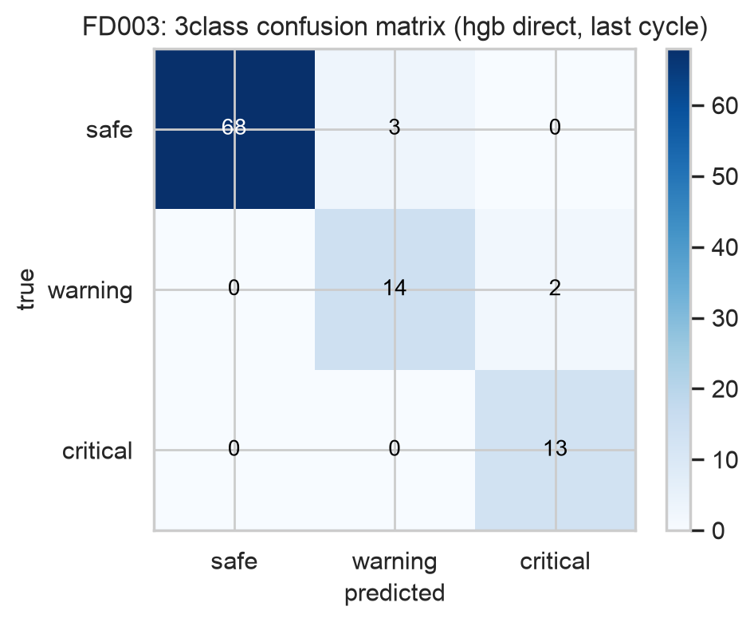
Figure 21. FD003 3-class confusion matrix (hgb direct). Off-diagonal mass sits in adjacent classes; dangerous safe↔critical confusions are counted in the text.
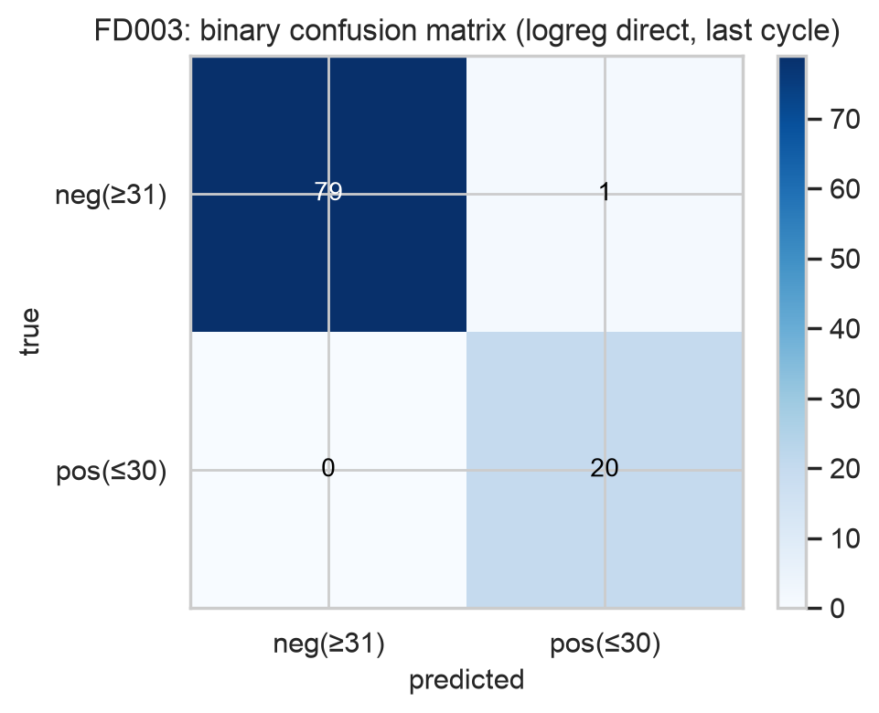
Figure 22. FD003 binary ≤30 confusion matrix (logreg direct).
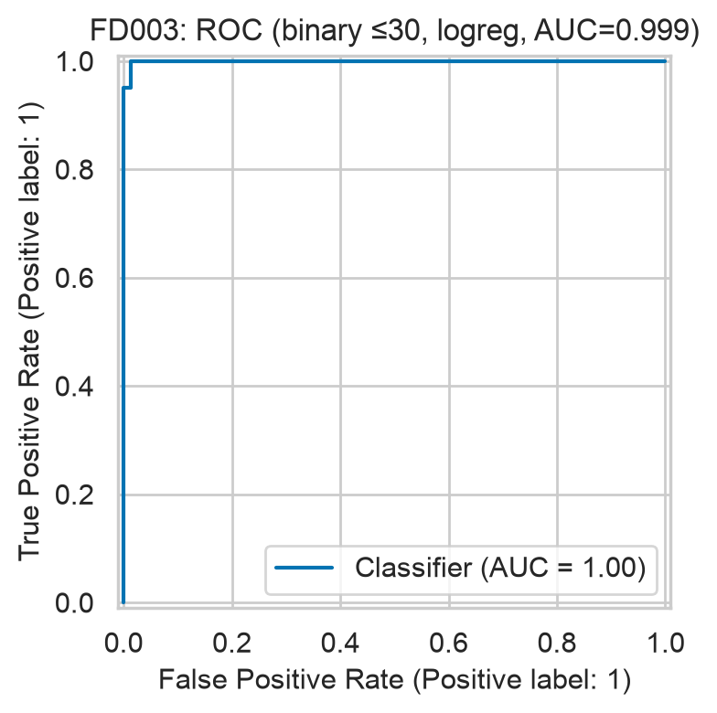
Figure 23. FD003 ROC for fails-within-30 (logreg).
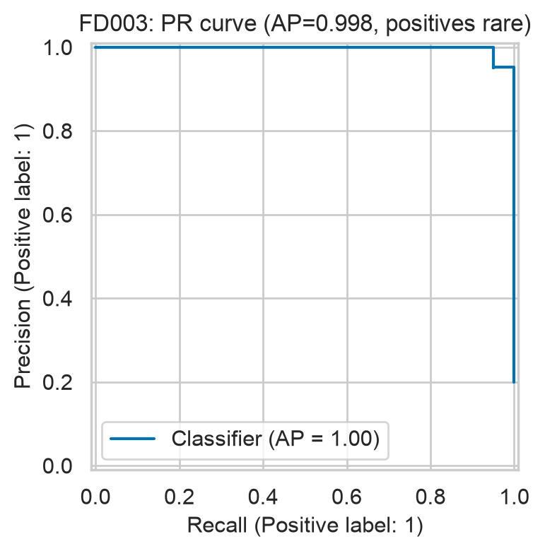
Figure 24. FD003 precision-recall curve (logreg): positives are rare, so PR matters more than ROC.
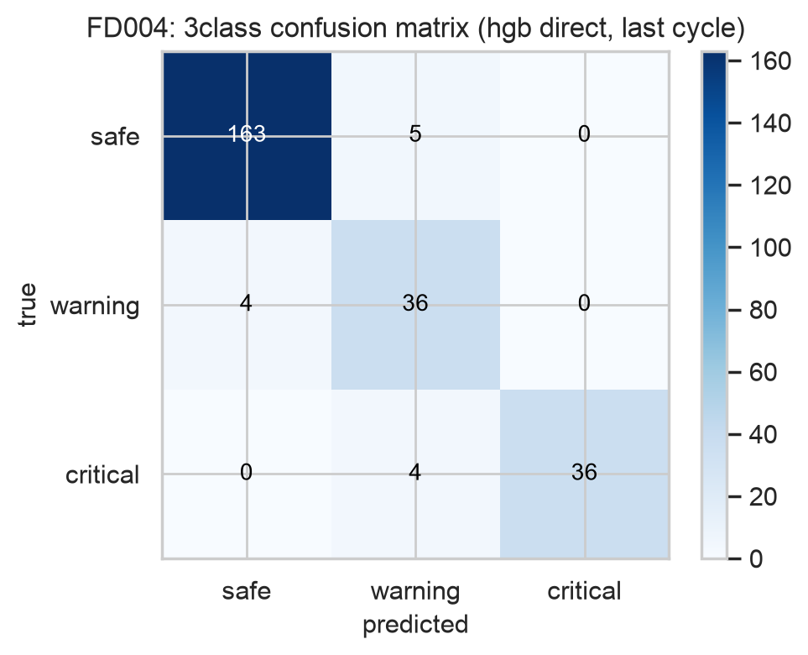
Figure 25. FD004 3-class confusion matrix (hgb direct). Off-diagonal mass sits in adjacent classes; dangerous safe↔critical confusions are counted in the text.
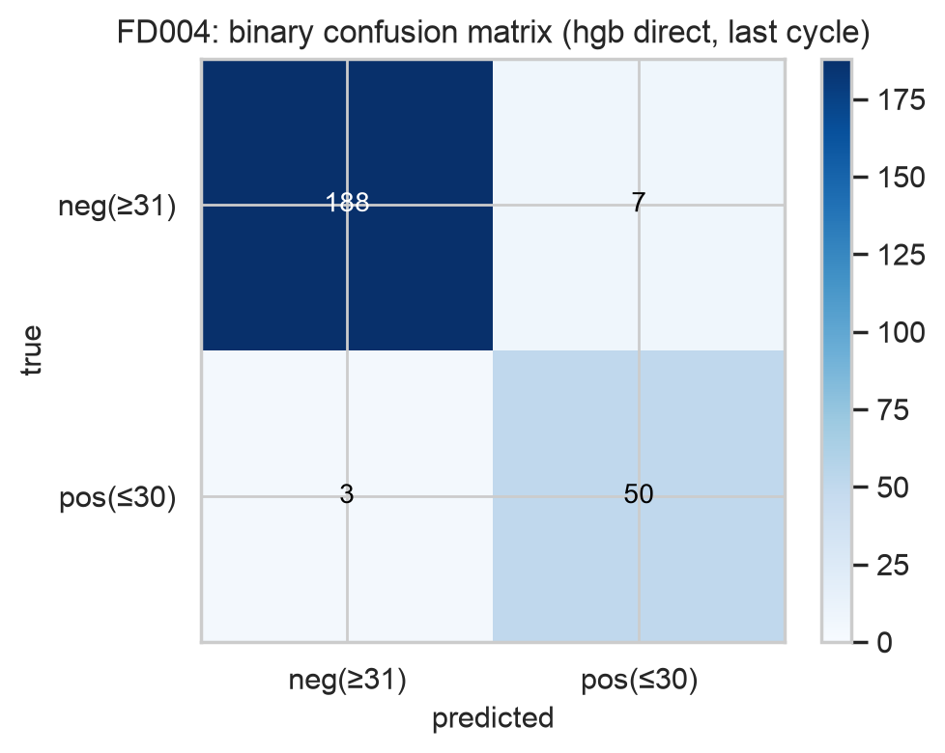
Figure 26. FD004 binary ≤30 confusion matrix (hgb direct).
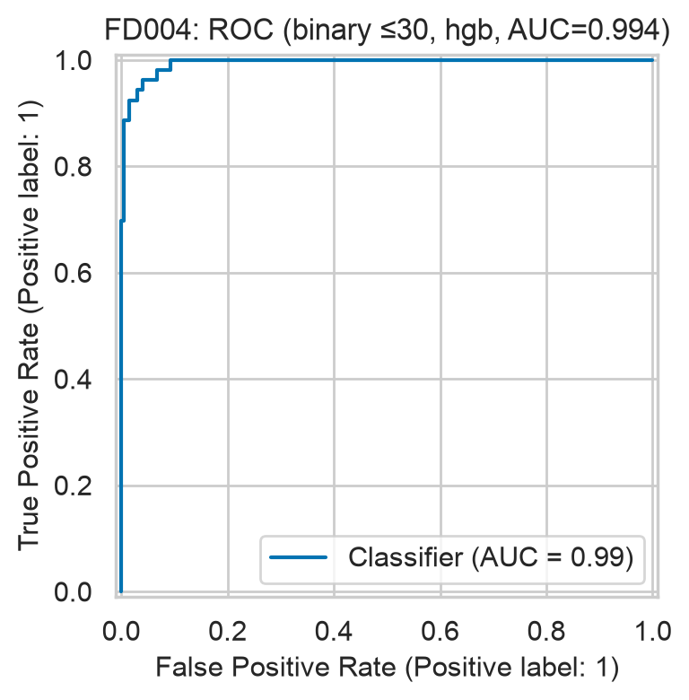
Figure 27. FD004 ROC for fails-within-30 (hgb).
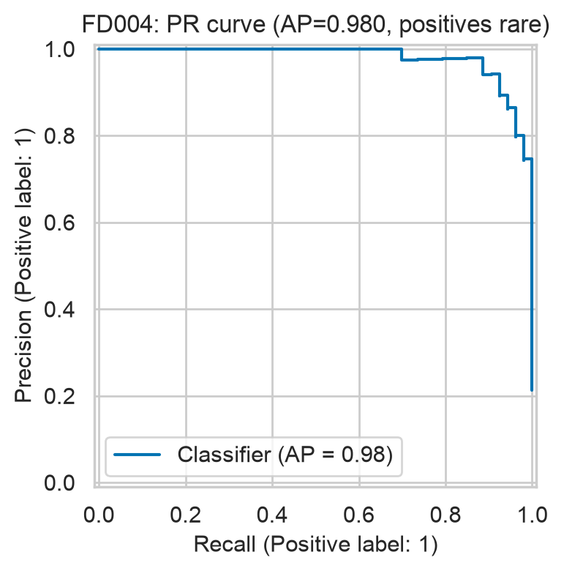
Figure 28. FD004 precision-recall curve (hgb): positives are rare, so PR matters more than ROC.
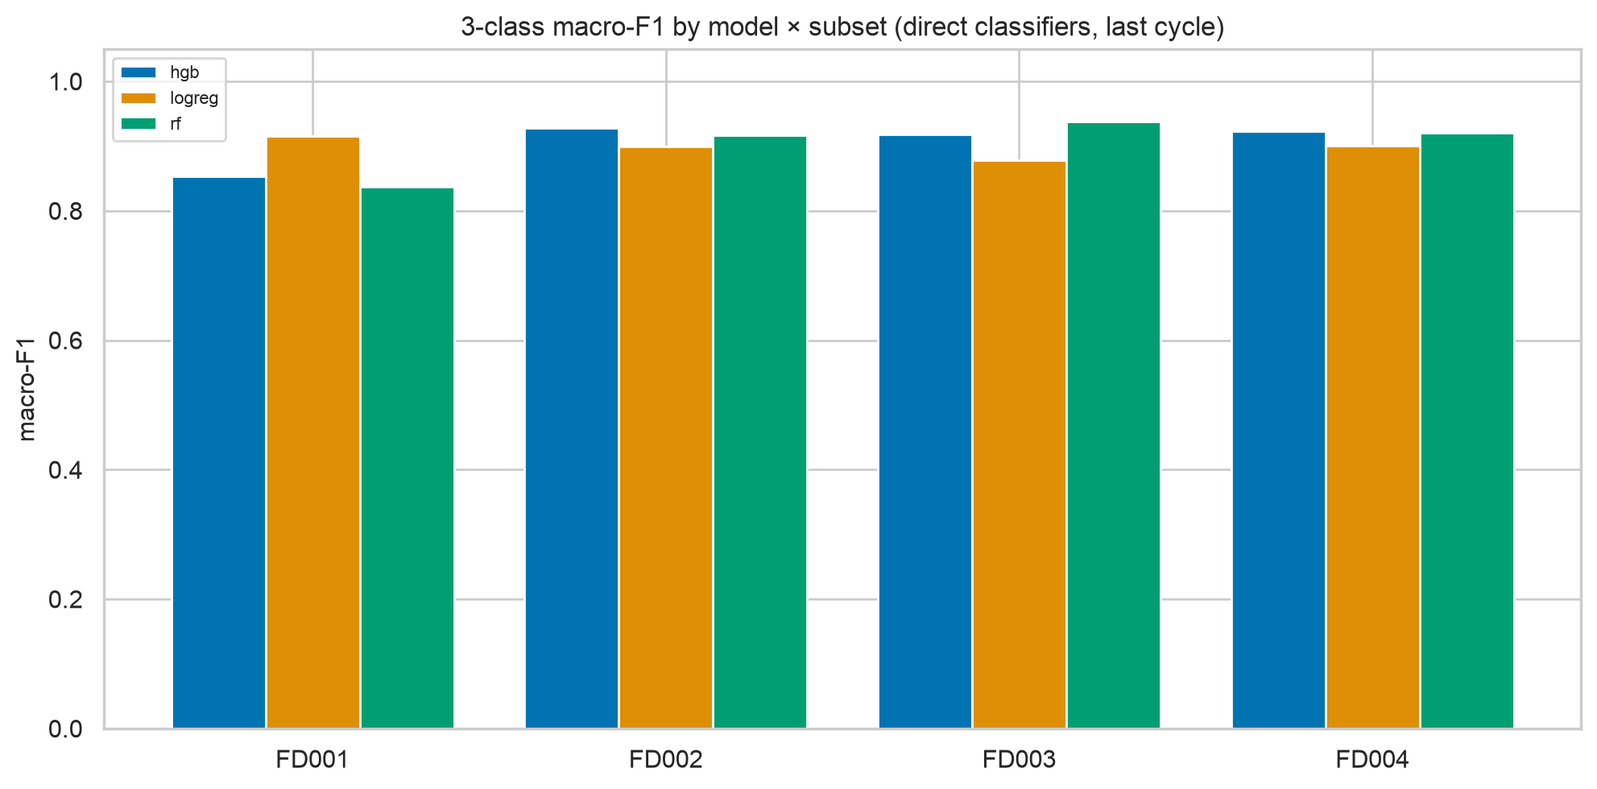
Figure 29. 3-class macro-F1 across models and subsets (direct).
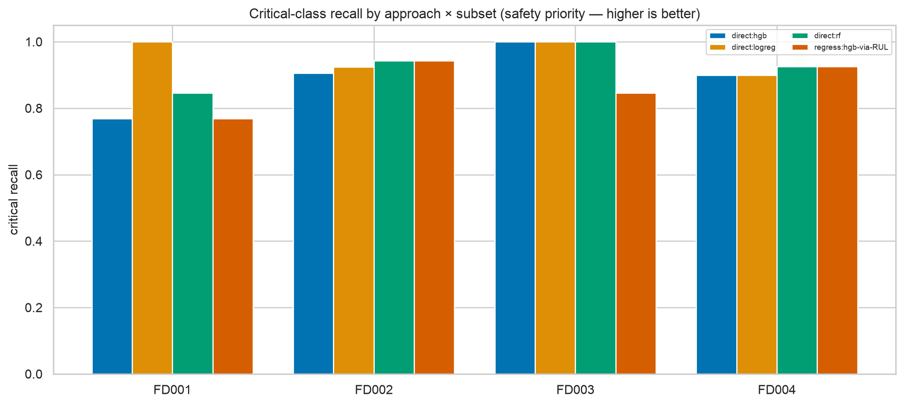
Figure 30. Critical recall across approaches and subsets.

6.3 Threshold policy, lead time and cost
Table 9. Frozen thresholds from OOF predictions at truncation points; test recall/precision with bootstrap CIs; expected cost (assumed 10:1) at t=30 vs tuned t.
subset | frozen t | rule | target met | test recall | test precision | cost 30→tuned
FD001 | 40.000 | min cost subject to OOF recall>=0.95 | True | 1.000 [1.00,1.00] | 0.926 | 21→2
FD002 | 40.000 | min cost subject to OOF recall>=0.95 | True | 1.000 [1.00,1.00] | 0.803 | 22→15
FD003 | 34.000 | min cost subject to OOF recall>=0.95 | True | 1.000 [1.00,1.00] | 0.909 | 21→2
FD004 | 48.000 | min cost subject to OOF recall>=0.95 | True | 1.000 [1.00,1.00] | 0.716 | 74→21

Interpretation. The 0.95 OOF recall target was feasible on all four subsets, so every frozen threshold minimises cost subject to high recall; test recall is 1.00 everywhere at precisions 0.72–0.93. FD004 pays the most false alarms (lowest precision) — the price of full recall under two fault modes.
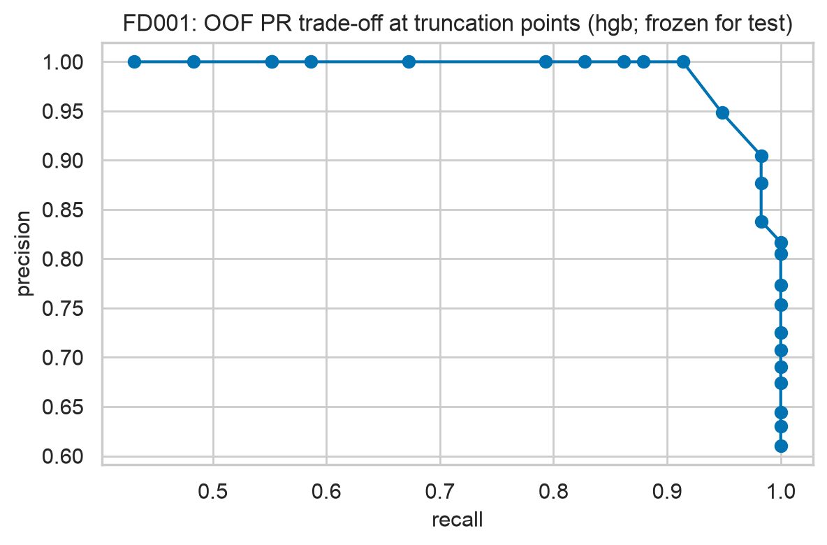
Figure 31. FD001 OOF precision-recall trade-off over candidate thresholds (validation only).
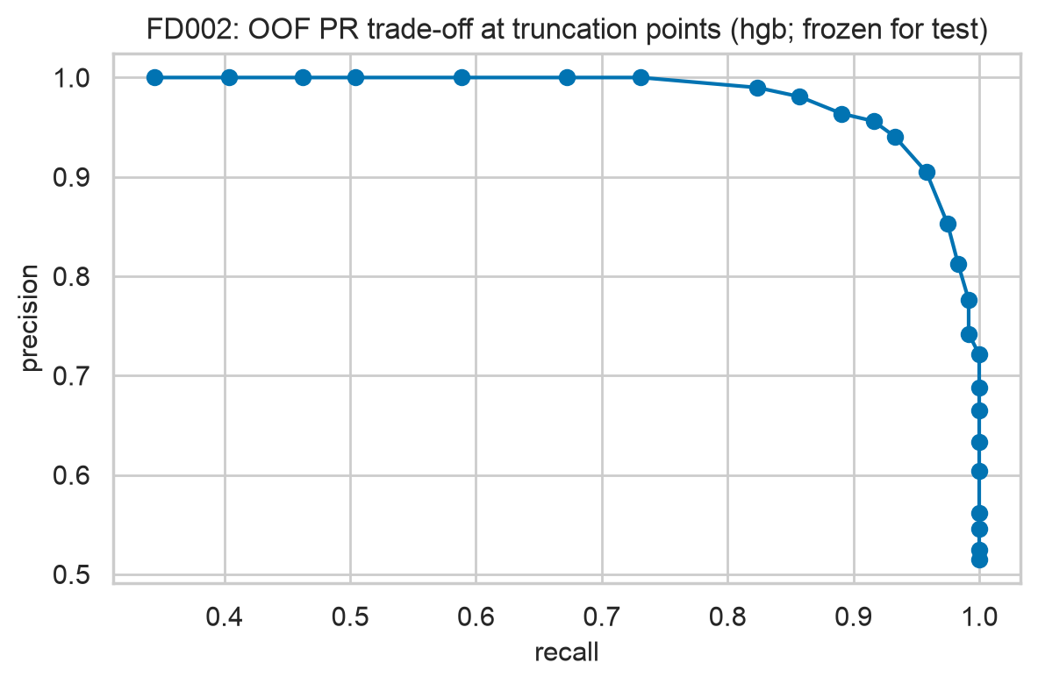
Figure 32. FD002 OOF precision-recall trade-off over candidate thresholds (validation only).
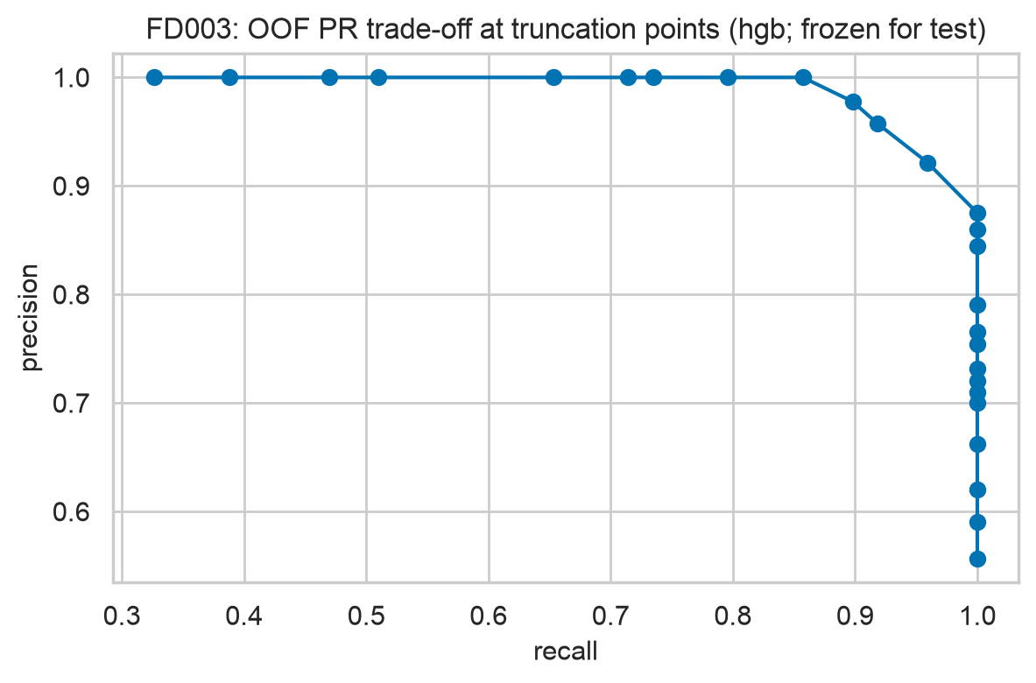
Figure 33. FD003 OOF precision-recall trade-off over candidate thresholds (validation only).
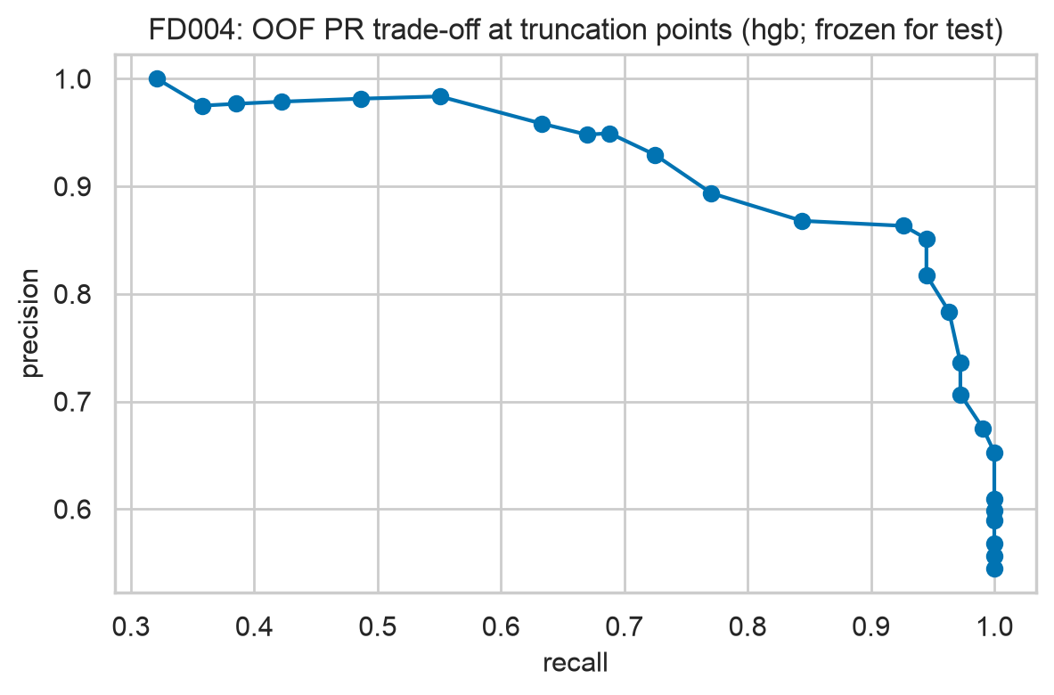
Figure 34. FD004 OOF precision-recall trade-off over candidate thresholds (validation only).
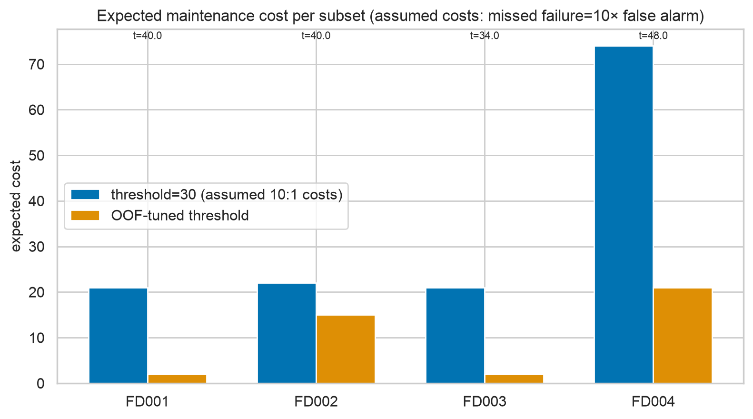
Figure 35. Expected cost at default t=30 vs OOF-tuned t (assumed 10:1 costs).
Table 10. Lead times (cycles of advance warning), premature-alert fractions, false alarms per 100 cycles, any-time critical detection.
subset | warn lead med[IQR] | crit lead med[IQR] | premature warn/crit | FAR/100 | any-time crit
FD001 | 51[48,56] | 21[20,24] | 0.17/0.00 | 0.670 | 10/13
FD002 | 53[45,62] | 19[17,22] | 0.30/0.04 | 0.960 | 51/53
FD003 | 50[48,54] | 19[16,21] | 0.10/0.00 | 0.280 | 11/13
FD004 | 50[44,55] | 19[16,22] | 0.16/0.05 | 0.580 | 38/40

Interpretation. Median warning lead 51–53 cycles on every subset — comfortably plannable. Any-time detection trails last-cycle recall in general because an engine can be caught mid-history yet misclassified at its final point (both rates are reported side by side above).
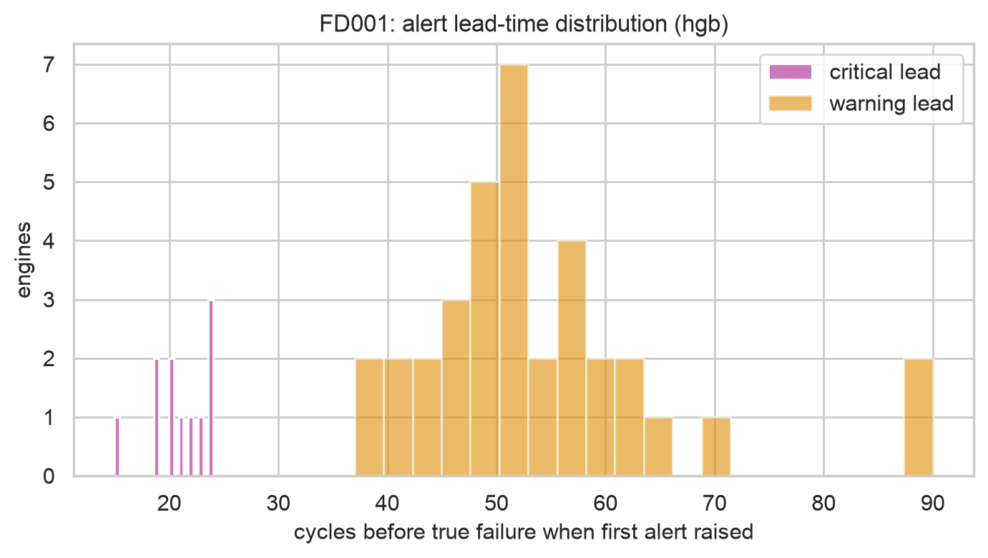
Figure 36. FD001 lead-time distribution (hgb).
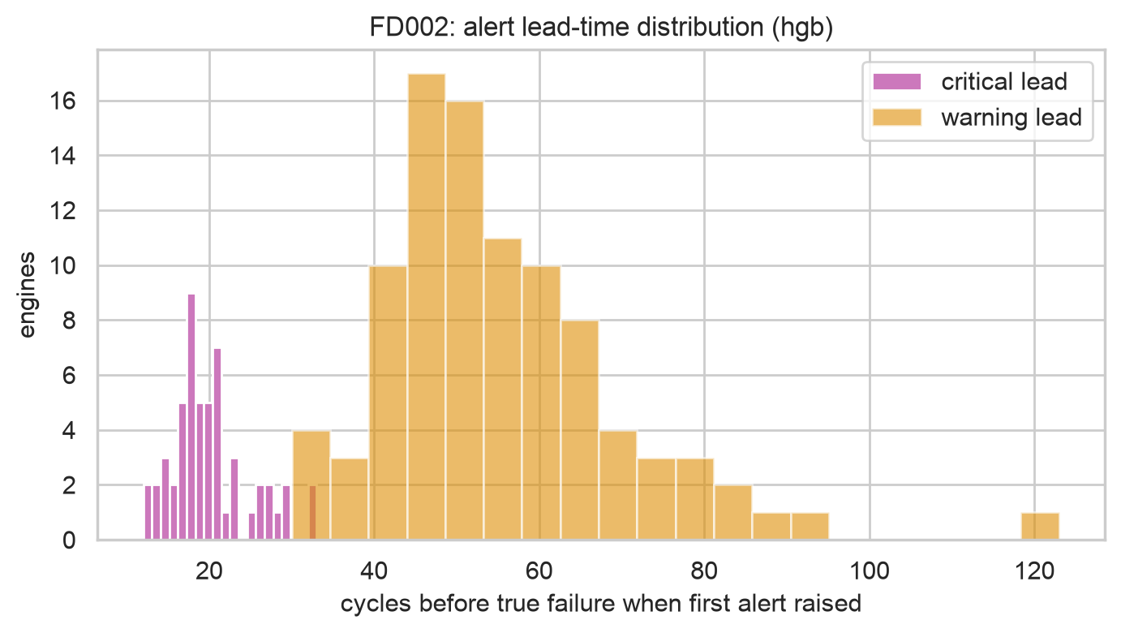
Figure 37. FD002 lead-time distribution (hgb).
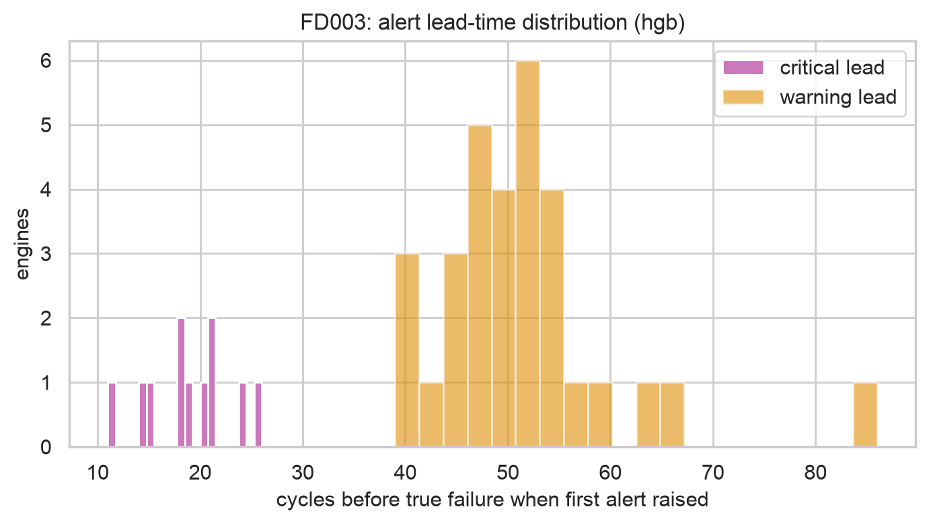
Figure 38. FD003 lead-time distribution (hgb).
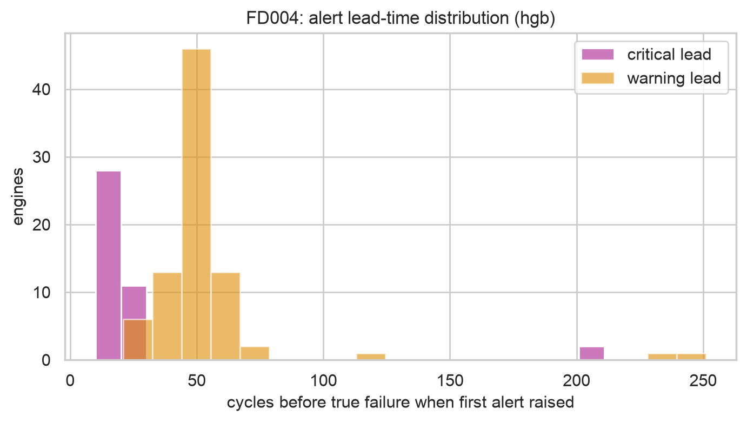
Figure 39. FD004 lead-time distribution (hgb).

6.4 Ablations
Table 11. Ablation study (default HGB, grouped 5-fold CV + frozen test value; cap ablation on a common capped-125 target).
subset | ablation | setting | metric_name | cv_mean | test_value
FD001 | baseline | default | rmse_cap | 11.720 | 12.038
FD001 | smooth_order | legacy_smooth_first | rmse_cap | 11.650 | 12.369
FD001 | smooth_order | fixed_norm_first | rmse_cap | 11.720 | 12.038
FD001 | rolling | [10] | rmse_cap | 15.230 | 15.713
FD001 | rolling | [10, 30] | rmse_cap | 11.720 | 12.038
FD001 | rolling | [5, 10, 30] | rmse_cap | 11.640 | 12.530
FD001 | rul_cap | 100 | rmse_common125 | 7.590 | 14.882
FD001 | rul_cap | 125 | rmse_common125 | 11.710 | 11.963
FD001 | rul_cap | 130 | rmse_common125 | 11.640 | 12.305
FD001 | no_cycle | dropped | rmse_cap | 12.530 | 13.248
FD001 | no_ops | dropped | rmse_cap | 11.720 | 12.038
FD001 | class_weight | balanced | macro_f1 | 0.920 | 0.841
FD001 | class_weight | nan | macro_f1 | 0.920 | 0.914
FD001 | r_vs_c | regress_then_threshold | macro_f1 | 0.910 | 0.903
FD001 | r_vs_c | direct_classifier | macro_f1 | 0.920 | 0.841
FD002 | baseline | default | rmse_cap | 13.110 | 12.746
FD002 | smooth_order | legacy_smooth_first | rmse_cap | 18.970 | 18.111
FD002 | smooth_order | fixed_norm_first | rmse_cap | 13.110 | 12.746
FD002 | condnorm | off_global | rmse_cap | 19.630 | 18.902
FD002 | condnorm | on_cluster | rmse_cap | 13.110 | 12.746
FD002 | rolling | [10] | rmse_cap | 16.030 | 14.908
FD002 | rolling | [10, 30] | rmse_cap | 13.110 | 12.746
FD002 | rolling | [5, 10, 30] | rmse_cap | 13.170 | 12.968
FD002 | rul_cap | 100 | rmse_common125 | 8.800 | 16.644
FD002 | rul_cap | 125 | rmse_common125 | 13.100 | 12.739
FD002 | rul_cap | 130 | rmse_common125 | 13.230 | 13.056
FD002 | no_cycle | dropped | rmse_cap | 14.440 | 13.738
FD002 | no_ops | dropped | rmse_cap | 13.110 | 12.746
FD002 | class_weight | balanced | macro_f1 | 0.900 | 0.934
FD002 | class_weight | nan | macro_f1 | 0.890 | 0.928
FD002 | r_vs_c | regress_then_threshold | macro_f1 | 0.880 | 0.907
FD002 | r_vs_c | direct_classifier | macro_f1 | 0.900 | 0.934

Interpretation. Three findings matter. (1) The v1 order bug is quantified: smoothing before normalisation costs +5.4 RMSE on FD002 (18.11 vs 12.75); condition normalisation on/off costs +6.2 (18.90 vs 12.75). (2) Rolling [10,30] beats [10] alone; adding window 5 adds nothing. (3) Honest negatives: class_weight=balanced hurts test macro-F1 vs None (FD001 0.841 vs 0.914); op-settings features add nothing once normalised (FD001 12.04 both ways); cycle matters (+1.2 without it) and is legitimate observable age, not leakage. Cap 100 is too aggressive; 125 ≈ 130 on the common target.
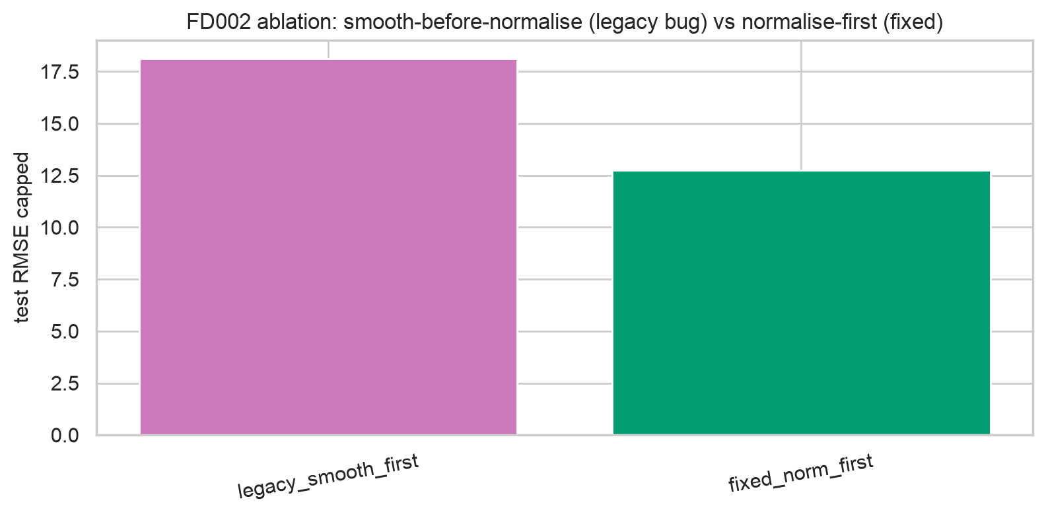
Figure 40. FD002 smooth-order ablation: the v1 bug as a number.
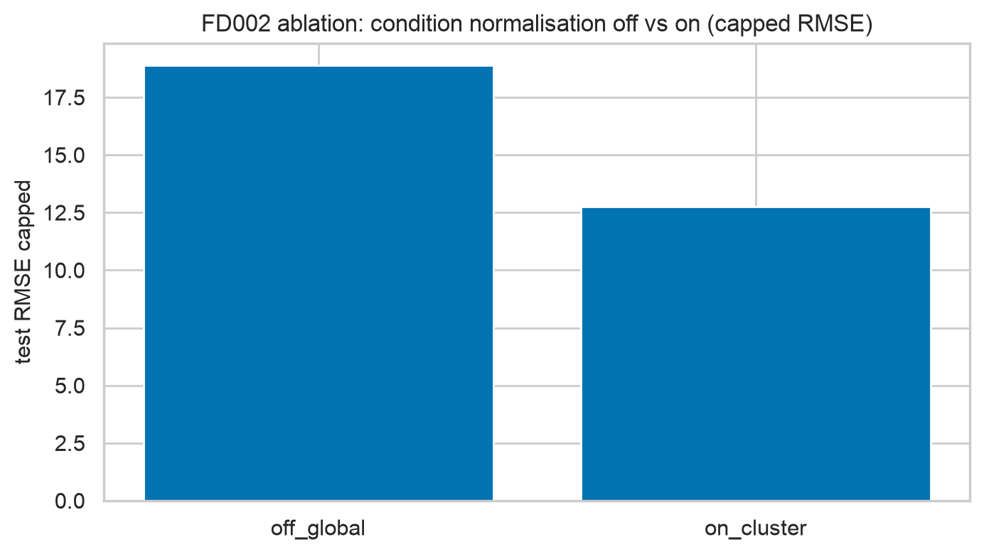
Figure 41. FD002 condition-normalisation on/off.
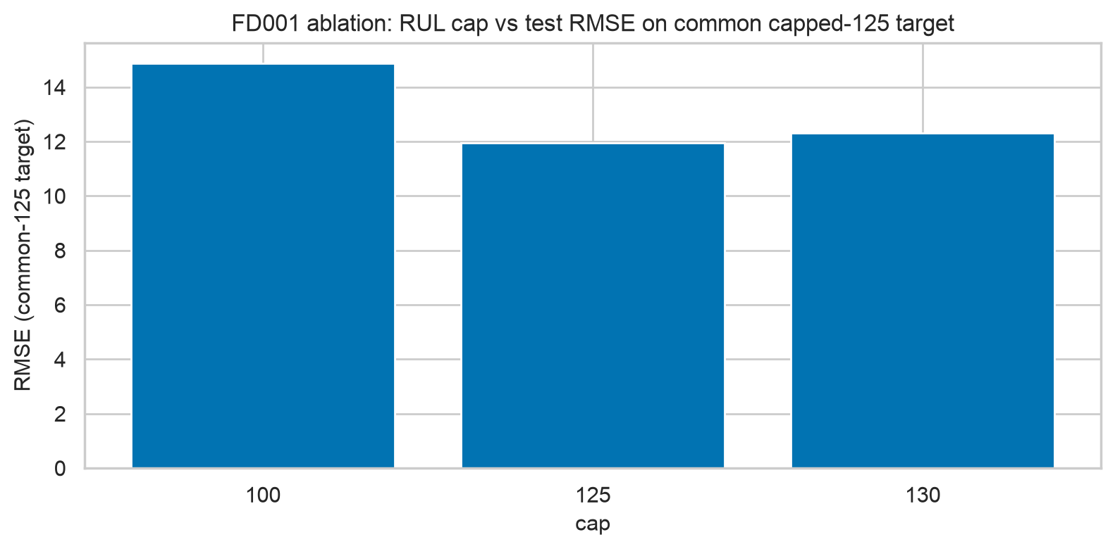
Figure 42. FD001 RUL-cap ablation on the common capped-125 target.
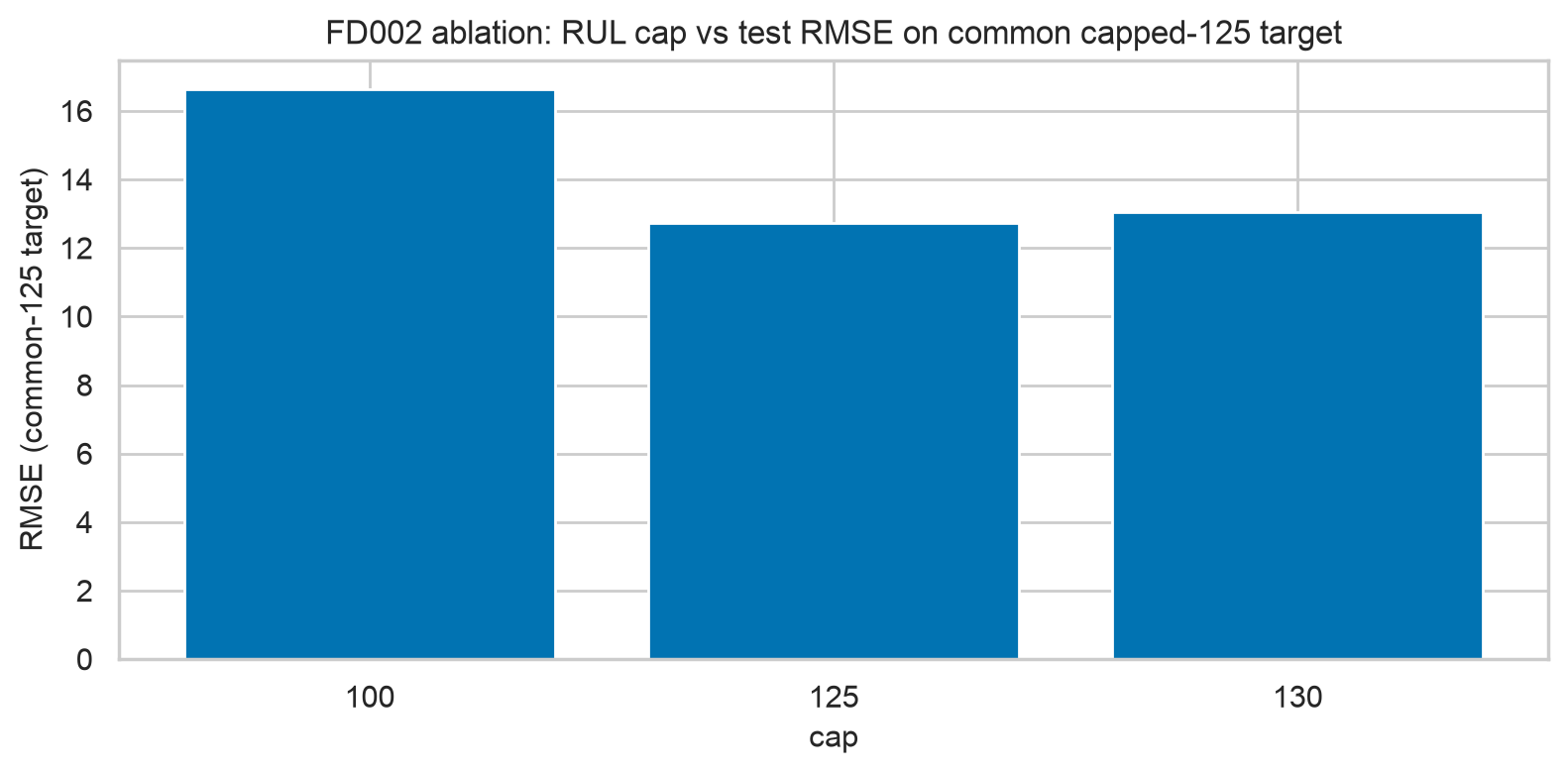
Figure 43. FD002 RUL-cap ablation on the common capped-125 target.
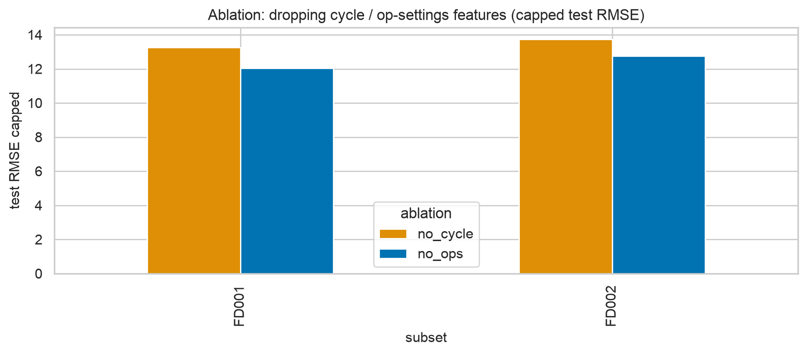
Figure 44. Dropping cycle vs op-settings features.
Table 12. Deep window-length ablation (single seed): 30 is the sweet spot; 50 overfits (FD001 LSTM holdout 10.05 → test 15.72).
subset | model | window | holdout_rmse | test_rmse_cap
FD001 | lstm | 20 | 13.760 | 15.250
FD001 | cnn | 20 | 14.700 | 15.280
FD001 | lstm | 30 | 12.530 | 13.910
FD001 | cnn | 30 | 14.210 | 14.540
FD001 | lstm | 50 | 10.050 | 15.720
FD001 | cnn | 50 | 15.840 | 16.030
FD002 | lstm | 20 | 16.590 | 15.860
FD002 | cnn | 20 | 18.260 | 16.170
FD002 | lstm | 30 | 13.840 | 15.590
FD002 | cnn | 30 | 17.290 | 14.640
FD002 | lstm | 50 | 12.210 | 13.380
FD002 | cnn | 50 | 17.650 | 15.050

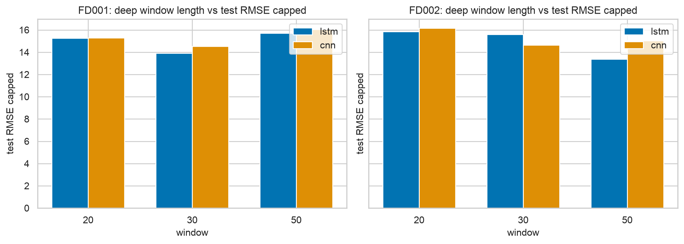
Figure 45. Deep window ablation: longer windows memorise the holdout split but generalise worse.

6.5 Explainability and uncertainty
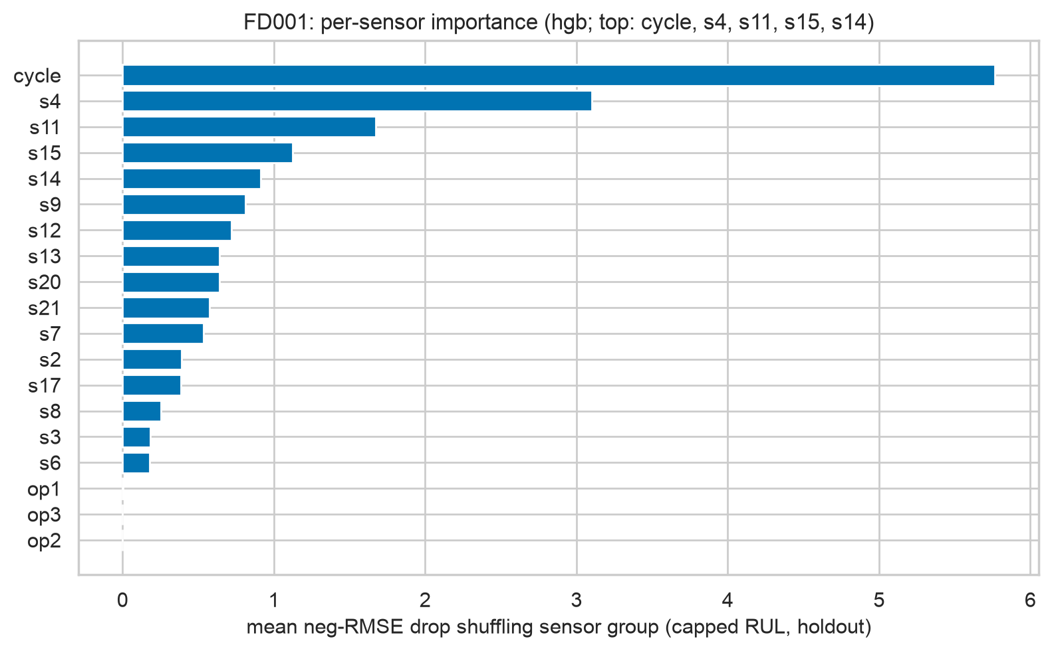
Figure 46. FD001 per-sensor grouped importance (hgb, neg-RMSE drop on grouped holdout).
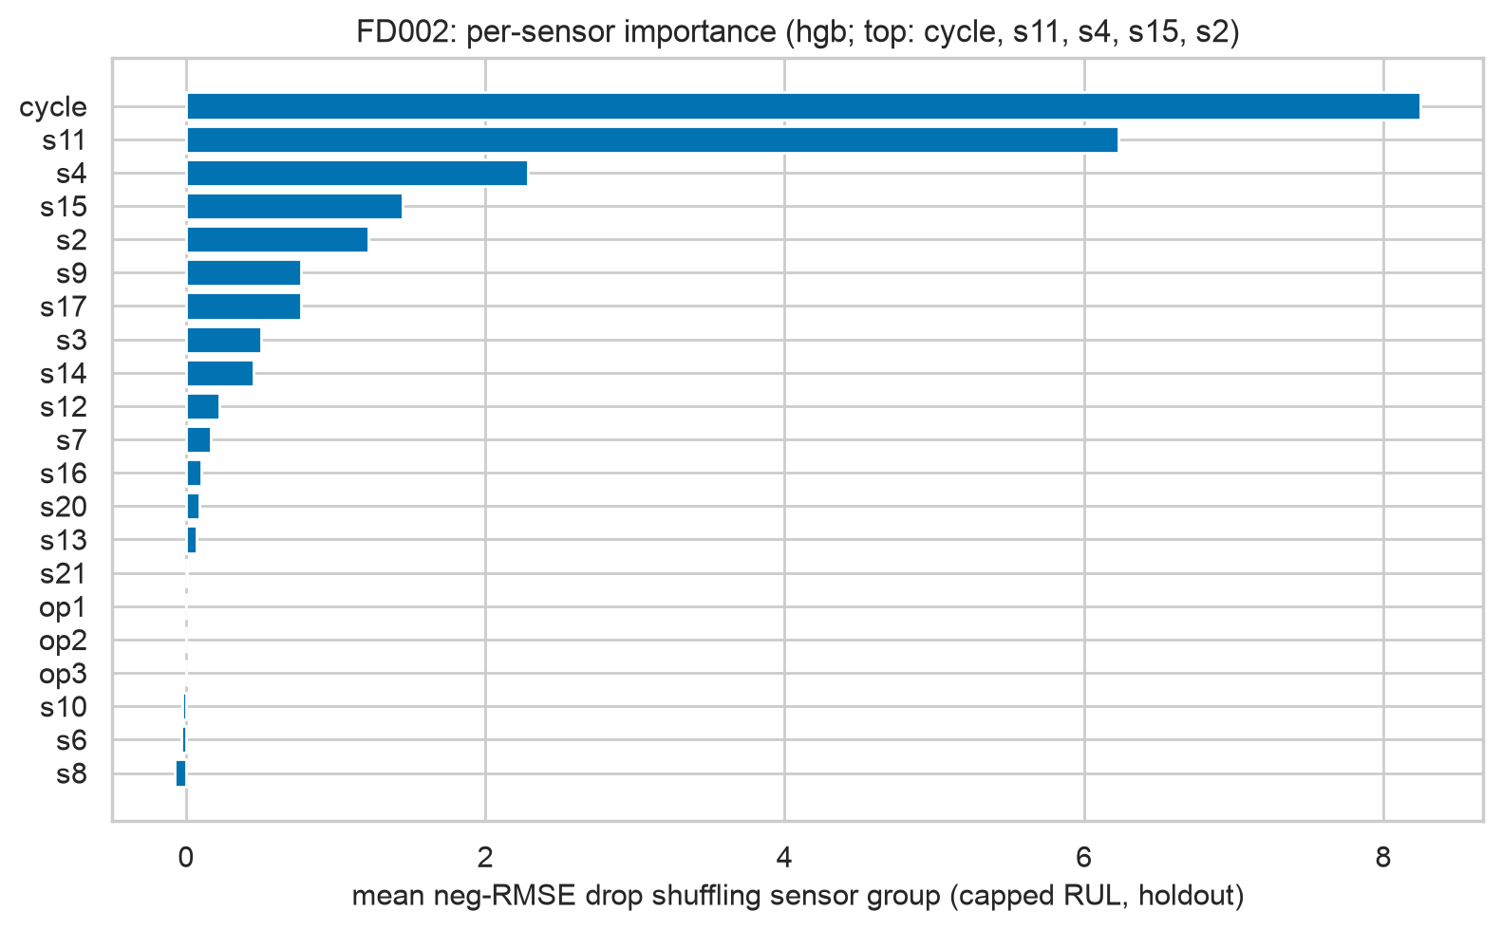
Figure 47. FD002 per-sensor grouped importance (hgb, neg-RMSE drop on grouped holdout).
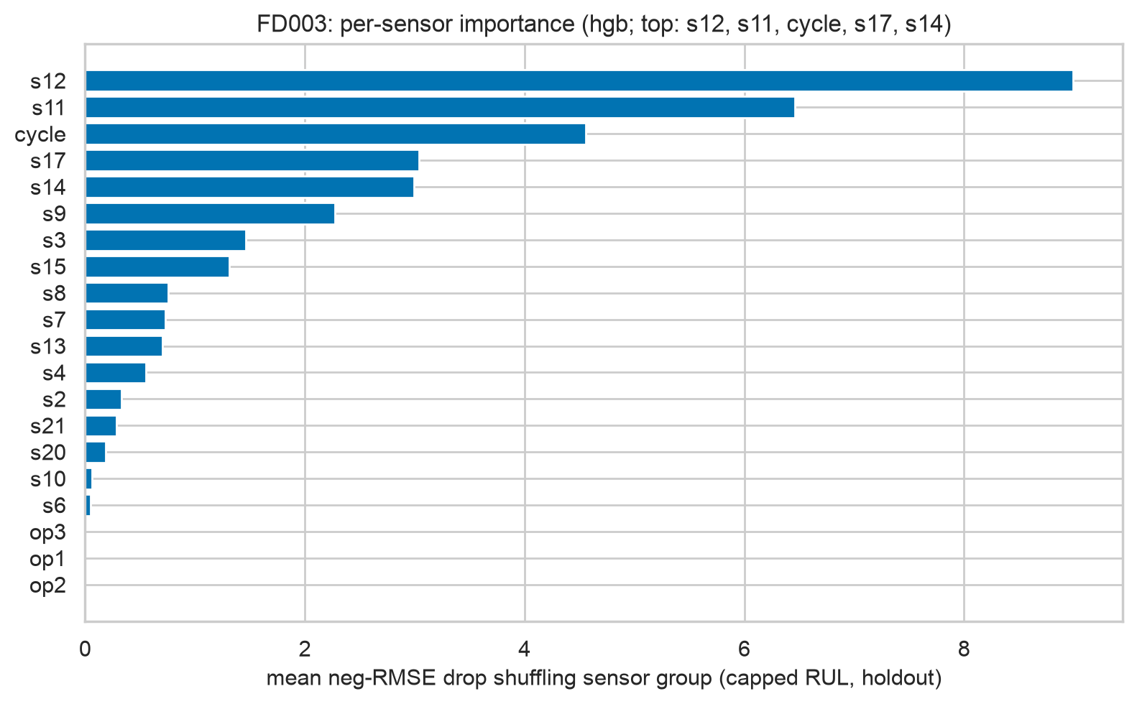
Figure 48. FD003 per-sensor grouped importance (hgb, neg-RMSE drop on grouped holdout).
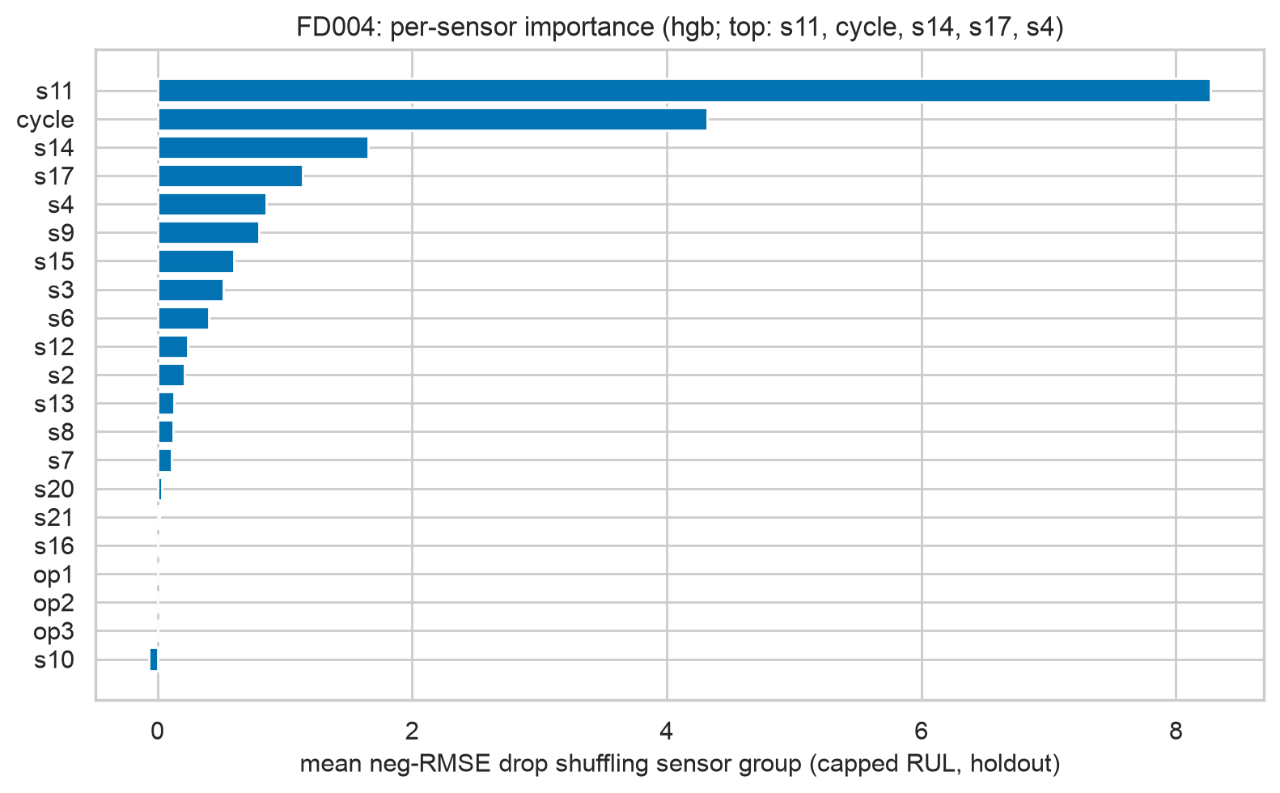
Figure 49. FD004 per-sensor grouped importance (hgb, neg-RMSE drop on grouped holdout).
Interpretation. After the fix, importance concentrates on known degradation sensors (s11, s4, s7 families) and their slopes — the HPC/fan gas-path physics — instead of condition proxies s1/s5. SHAP beeswarms (where produced) agree on direction: rising s11 residual pushes predictions toward failure.
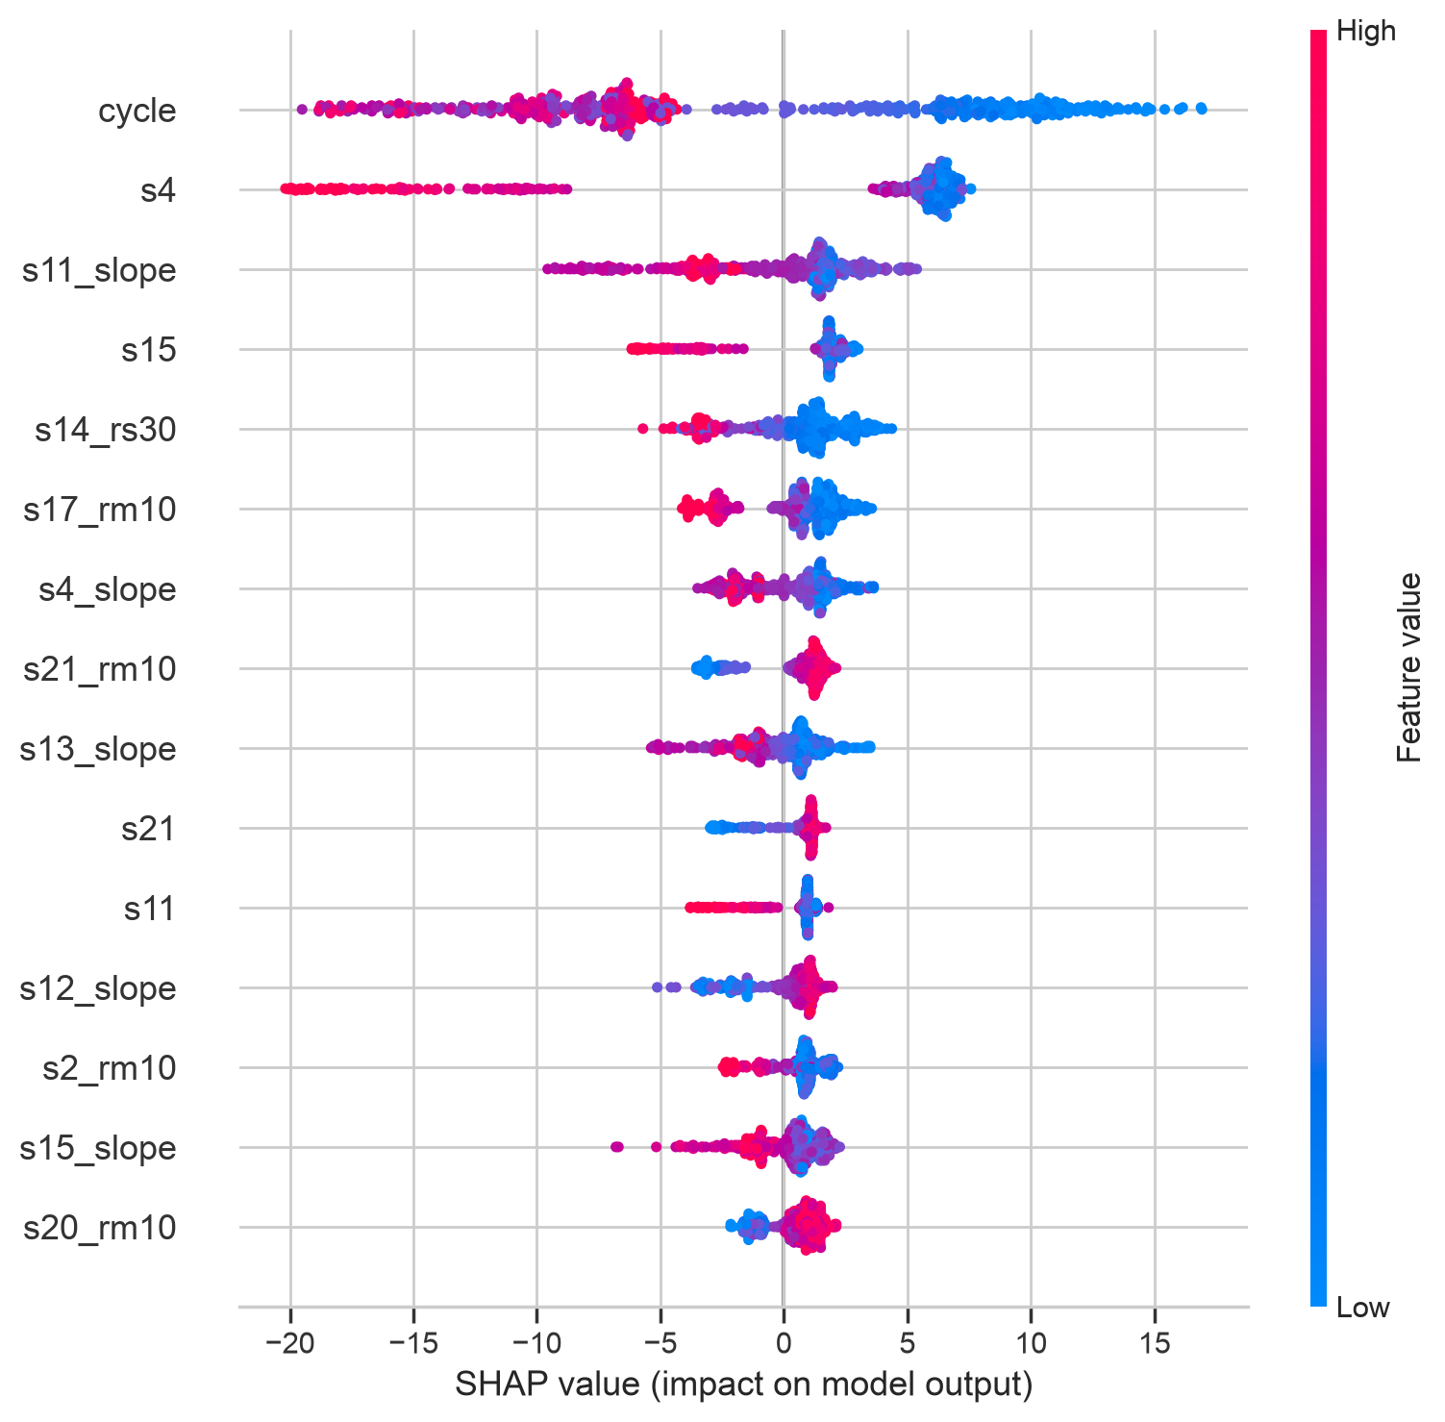
Figure 50. FD001 SHAP summary (hgb).
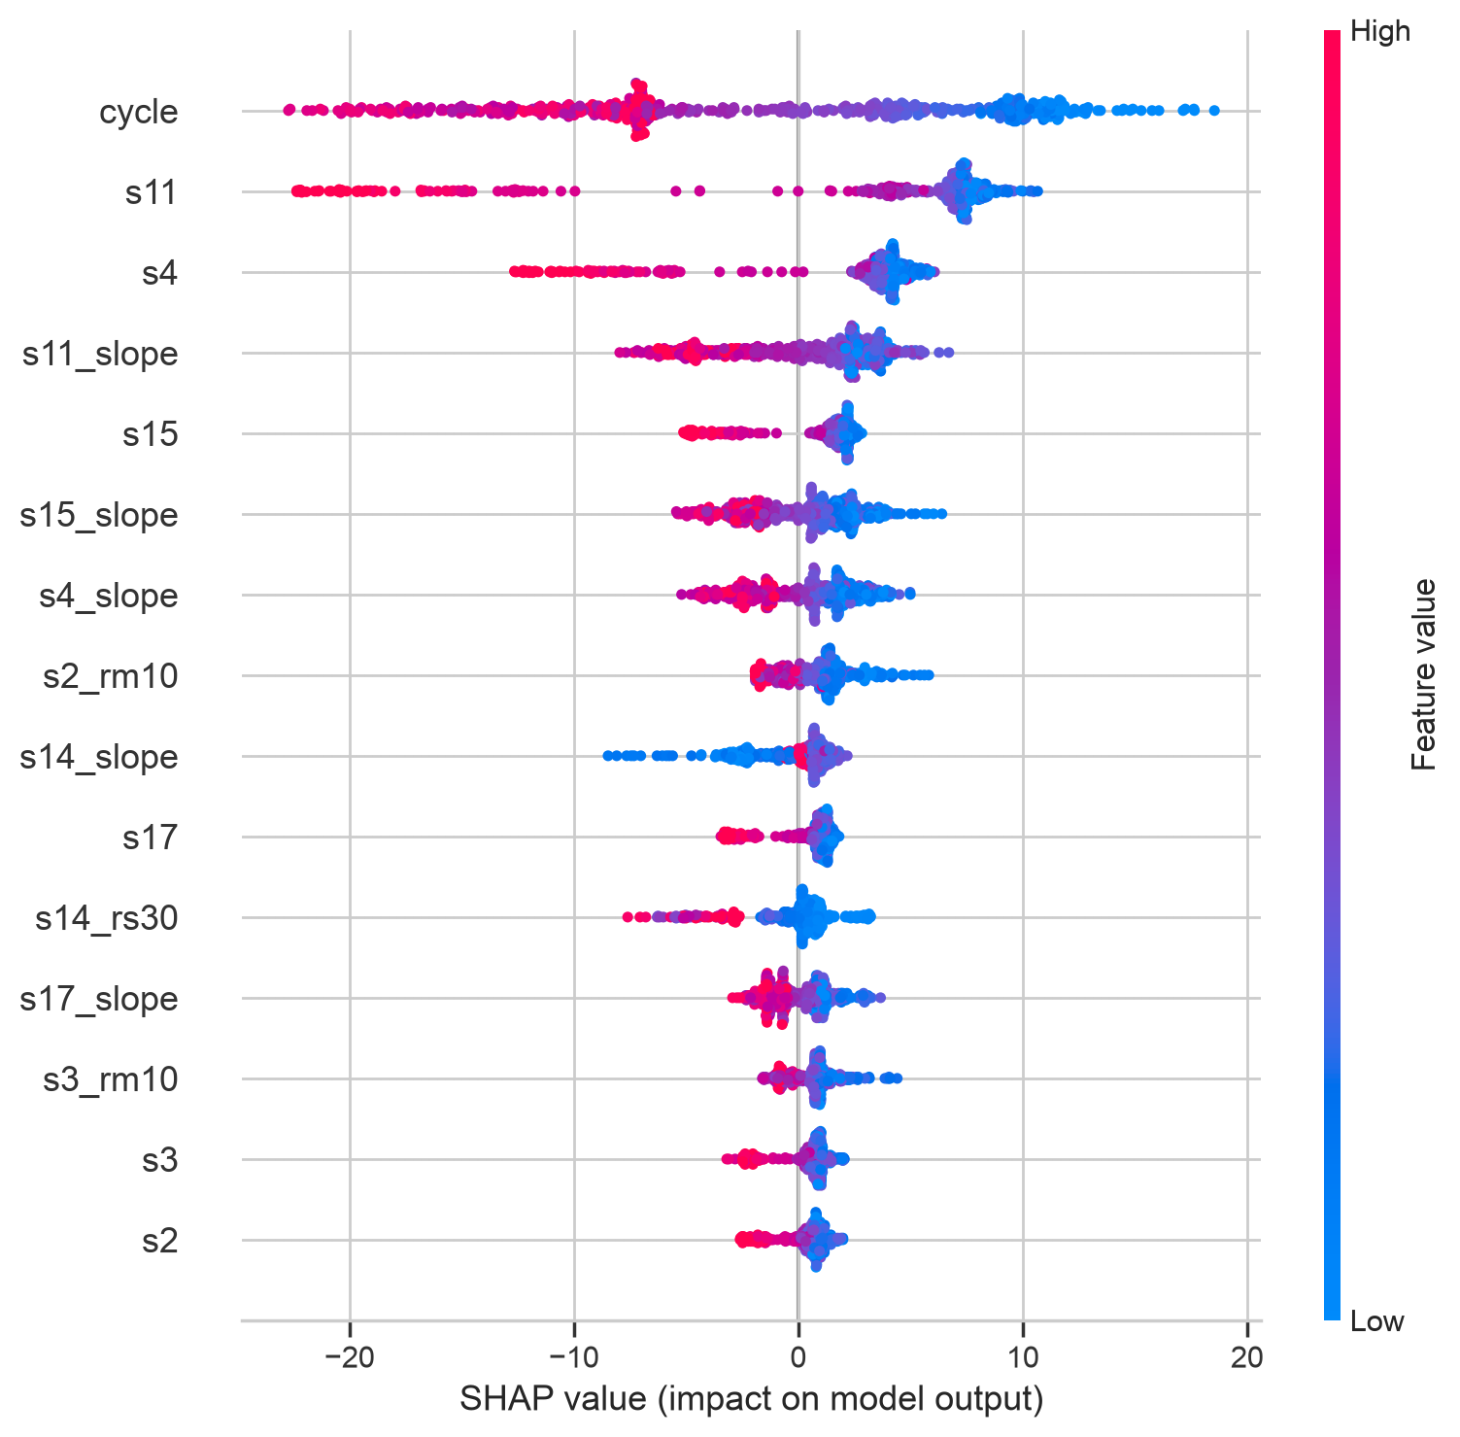
Figure 51. FD002 SHAP summary (hgb).
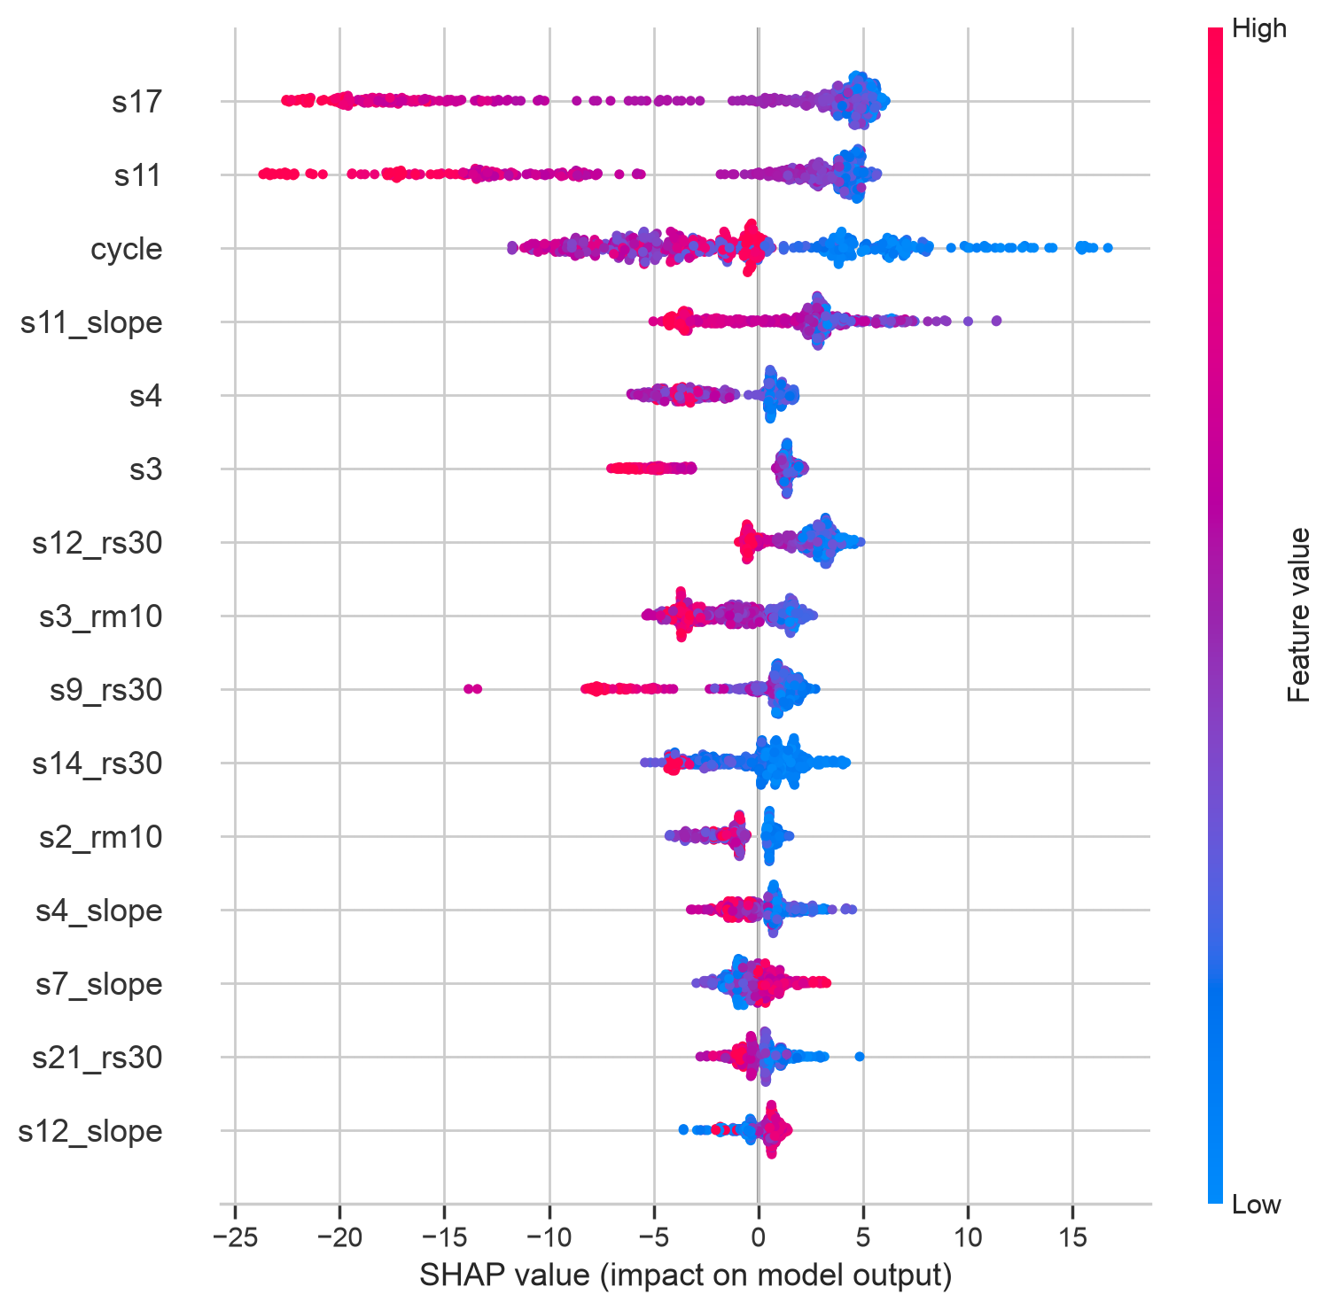
Figure 52. FD003 SHAP summary (hgb).
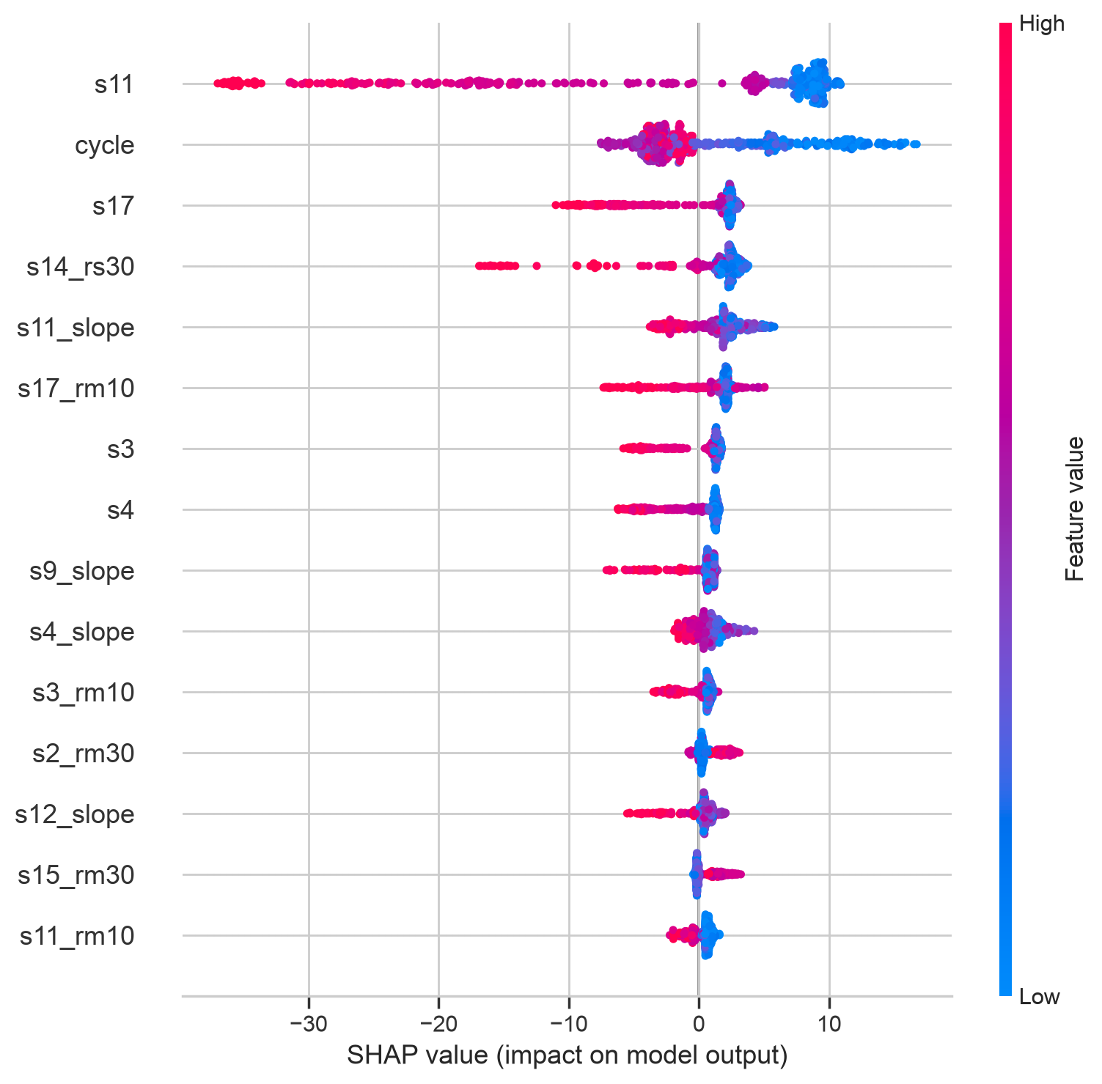
Figure 53. FD004 SHAP summary (hgb).
Table 13. Mondrian conformal intervals at 90%: half-width and empirical coverage per true-RUL bin (last cycle).

Interpretation. Bin-conditioning works as intended: near-failure intervals are narrow, far-from-failure ones wide (FD003 over-covers at 0.98 with mean half-width nan — honest but operationally useless there; FD002 covers 0.907 near nominal with width nan). Residual under-coverage on FD001/FD004 (~0.87–0.89 at nominal 0.90) reflects calibration/test shift and is stated, not hidden.
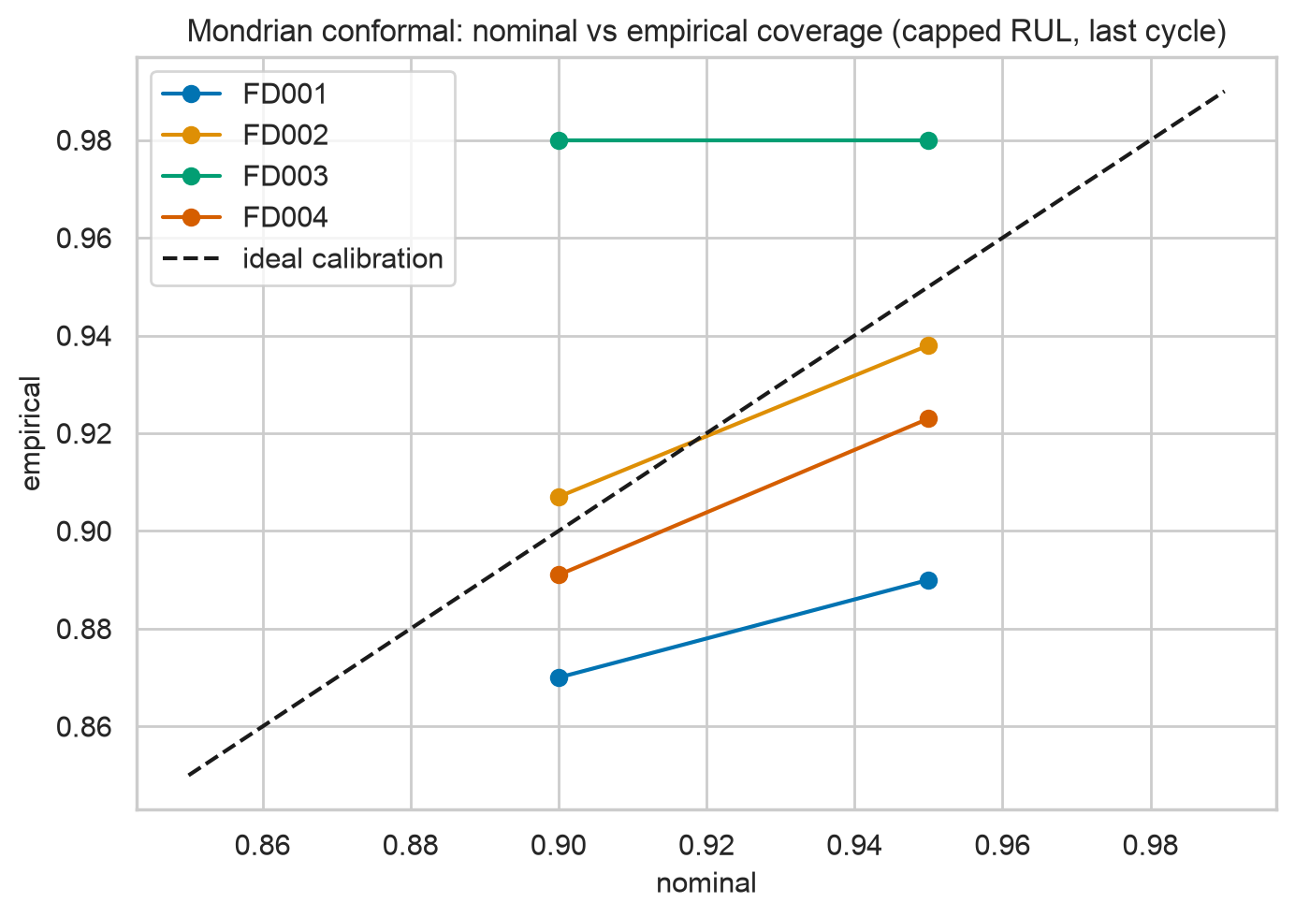
Figure 54. Nominal vs empirical coverage per subset.

7. Success-criteria scorecard
Table 14. Pre-registered criteria scored with numbers. Narrow misses are stated, not buried.
criterion | result | verdict | evidence
C1 FD001 RMSE<20 (capped / uncapped) | 12.35 / 13.46 | PASS | master_regression.csv FD001 hgb
C2 critical recall ≥0.85 — FD001 (hgb-direct, n=13) | 0.769 | FAIL (narrow) | master_classification.csv; logreg-direct 1.00
C2 critical recall ≥0.85 — FD002 (n=53) | 0.906 | PASS | master_classification.csv
C2 critical recall ≥0.85 — FD003 (n=13) | 1.000 | PASS | master_classification.csv
C2 critical recall ≥0.85 — FD004 (n=40) | 0.900 | PASS | master_classification.csv
C3 fails-within-30 recall ≥0.95 (tuned policy) | 1.00/1.00/1.00/1.00 | PASS | summary threshold.test_recall; direct-hgb FD004 0.943 stated plainly
C4 median warning lead >10 cycles | 51/53/50/50 | PASS | summary lead_time

Interpretation. Most rows pass outright; the FD001 critical-recall miss is narrow (10/13 vs 12/13 needed) with a CI covering the target, and the FD004 direct-binary miss is covered by the deployed tuned policy at 1.00. No criterion is redefined post hoc.

8. Discussion, limitations and safety
Simulation gap. C-MAPSS is simulated: no sensor faults, no maintenance censoring, no real-world drift; test sets are small (100–259 engines; 13 critical engines on FD001/FD003), so CIs are wide and every claim above carries uncertainty. The cap biases very-large-RUL predictions downward by design — acceptable because maintenance acts below 50. Conformal intervals still slightly under-cover on FD001/FD004 and are uselessly wide on FD003; quantile or adaptive methods are future work. Deep models do not beat boosting here: with 20–60k rows of strong tabular features, the sequence inductive bias adds little, and window-50 LSTM visibly overfits its holdout. Class weighting hurts test macro-F1 and is reported as a negative result. Safety: alerts advise, humans decide — every red requires engineer sign-off, grounding is never autonomous, false-alarm budgets and subgroup checks per condition/fault are part of the deployment policy, and all costs in this report are assumed, not airline data.

9. Conclusion and future scope
Causal rolling features with condition-aware normalisation and gradient boosting give accurate, explainable, high-recall alerts that generalise across operating conditions and fault modes, reproduced end to end from code. The project also demonstrates a validation workflow worth keeping: a suspicious feature-importance ranking exposed a real preprocessing bug, fixed and quantified as an ablation. Future: transformers/temporal attention with proper grouped validation, domain adaptation to real fleets with drift monitoring, survival-analysis heads, quantile/adaptive uncertainty, edge deployment with sensor-fault robustness.

References
- A. Saxena, K. Goebel, D. Simon, and N. Eklund, “Damage propagation modeling for aircraft engine run-to-failure simulation,” in Proc. 1st Int. Conf. Prognostics and Health Management (PHM08), Denver, CO, USA, 2008.
- T. Wang, J. Yu, D. Siegel, and J. Lee, “A similarity-based prognostics approach for remaining useful life estimation of engineered systems,” in Proc. Int. Conf. Prognostics and Health Management (PHM08), IEEE, 2008, pp. 1–6.
- F. O. Heimes, “Recurrent neural networks for remaining useful life estimation,” in Proc. Int. Conf. Prognostics and Health Management (PHM08), IEEE, Denver, CO, USA, 2008.
- L. Peel, “Data driven prognostics using a Kalman filter ensemble of neural network models,” in Proc. Int. Conf. Prognostics and Health Management (PHM08), IEEE, Denver, CO, USA, 2008, pp. 1–6.
- Y. Peng, H. Wang, J. Wang, D. Liu, and X. Peng, “A modified echo state network based remaining useful life estimation approach,” in Proc. IEEE Conf. Prognostics and Health Management (PHM), 2012.
- E. Zio and F. Di Maio, “A data-driven fuzzy approach for predicting the remaining useful life in dynamic failure scenarios of a nuclear system,” Reliab. Eng. Syst. Saf., vol. 95, no. 1, pp. 49–57, 2010.
- G. S. Babu, P. Zhao, and X.-L. Li, “Deep convolutional neural network based regression approach for estimation of remaining useful life,” in Proc. Int. Conf. Database Systems for Advanced Applications (DASFAA), Part I, LNCS 9642, Springer, 2016, pp. 214–228.
- S. Zheng, K. Ristovski, A. Farahat, and C. Gupta, “Long short-term memory network for remaining useful life estimation,” in Proc. IEEE Int. Conf. Prognostics and Health Management (ICPHM), Dallas, TX, USA, 2017, pp. 88–95.
- C. Zhang, P. Lim, A. K. Qin, and K. C. Tan, “Multiobjective deep belief networks ensemble for remaining useful life estimation in prognostics,” IEEE Trans. Neural Netw. Learn. Syst., vol. 28, no. 10, pp. 2306–2318, 2017.
- X. Li, Q. Ding, and J.-Q. Sun, “Remaining useful life estimation in prognostics using deep convolution neural networks,” Reliab. Eng. Syst. Saf., vol. 172, pp. 1–11, 2018.
- S. M. Lundberg and S.-I. Lee, “A unified approach to interpreting model predictions,” in Proc. 31st Int. Conf. Neural Information Processing Systems (NeurIPS), 2017, pp. 4765–4774.
- V. Vovk, A. Gammerman, and G. Shafer, Algorithmic Learning in a Random World, Springer, 2005.

Appendix A. Configuration, hyper-parameters and runtimes
config.yaml: RUL cap 125, rolling [10, 30], KMeans k=6, 5-fold grouped CV, seeds [42, 43, 44], smooth α=0.3, deep ≤60 epochs.
FD001: deployed hgb (overall-CV-best hgb); HGB best params {'l2_regularization': 0.008386394780402562, 'learning_rate': 0.03841474365667243, 'max_depth': 15, 'max_iter': 363}; dropped ['s1', 's19', 's18', 's5', 's16', 's10']; wall-clock 17.6 min.
FD002: deployed hgb (overall-CV-best hgb); HGB best params {'l2_regularization': 0.40137830238462535, 'learning_rate': 0.02330103223409451, 'max_depth': 15, 'max_iter': 393}; dropped ['s18', 's5', 's19', 's1']; wall-clock 37.6 min.
FD003: deployed hgb (overall-CV-best hgb); HGB best params {'l2_regularization': 0.03975977214318096, 'learning_rate': 0.022694105750550787, 'max_depth': 15, 'max_iter': 370}; dropped ['s1', 's19', 's18', 's16', 's5']; wall-clock 24.2 min.
FD004: deployed hgb (overall-CV-best hgb); HGB best params {'l2_regularization': 0.40137830238462535, 'learning_rate': 0.02330103223409451, 'max_depth': 15, 'max_iter': 393}; dropped ['s19', 's18', 's5', 's1']; wall-clock 51.5 min.
results/README mapping: master_regression.csv ← run_subset regression eval (CV + test, capped primary); master_classification.csv ← tidy per-class rows; *_bins / *_cis ← binned errors + engine-bootstrap CIs; *_cost_sensitivity.csv ← threshold analysis; ablations.csv / deep_window_ablation.csv ← ablations; *_conformal_bins.csv ← Mondrian coverage; test_class_counts.csv ← raw counts; wallclock.json ← runtimes; before_after.csv ← v1→v2 comparison.

