I. Project Introduction
This project is a mobile-based smart attendance management system designed mainly for classroom attendance scenarios. It uses location services to support on-site check-in and attendance verification. The system provides essential functions including user authentication, real-time location check-in, and attendance history review, offering a straightforward and practical user experience.
The overall design focuses on simplifying the attendance process and reducing proxy check-ins. Compared with traditional paper-based attendance methods, the system utilizes mobile location capabilities to improve both efficiency and reliability, making classroom attendance management more convenient and accurate.

II. Requirements Analysis
- Develop a basic login module that allows users to access the system homepage after entering a valid account and password.
- Implement a real-time location-based check-in feature that automatically detects the user’s current position and determines whether it falls within the designated attendance area.
- Store attendance information after successful check-in and display related details clearly, including course information, location, and timestamp.
- Provide an attendance history module that allows users to review previous attendance records at any time.
- Design a clean and user-friendly interface with clear functional divisions and intuitive operation buttons to improve usability.
- Add attendance status notifications to inform users about location loading progress and check-in results in real time.

III. System Implementation
The development process started with building the login interface, including account and password input components and navigation logic. After successful authentication, users are redirected to the main page.
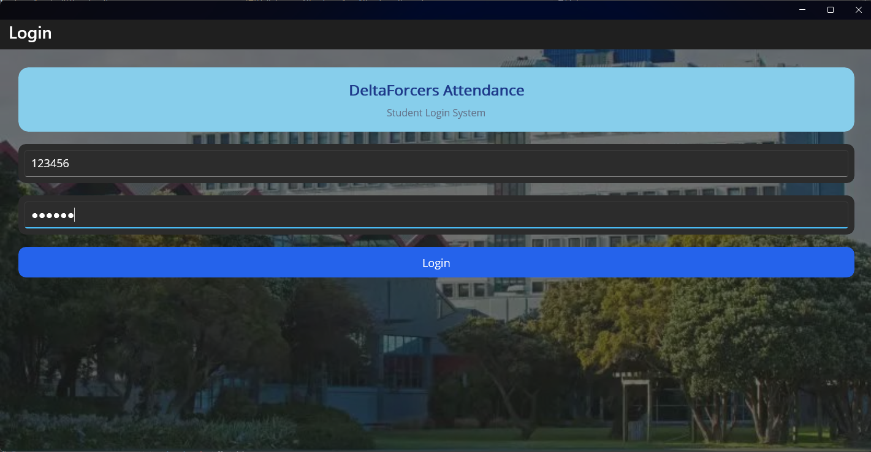
The homepage integrates two major functional sections: online attendance and attendance history. A location status indicator is also displayed to provide feedback on location acquisition progress.
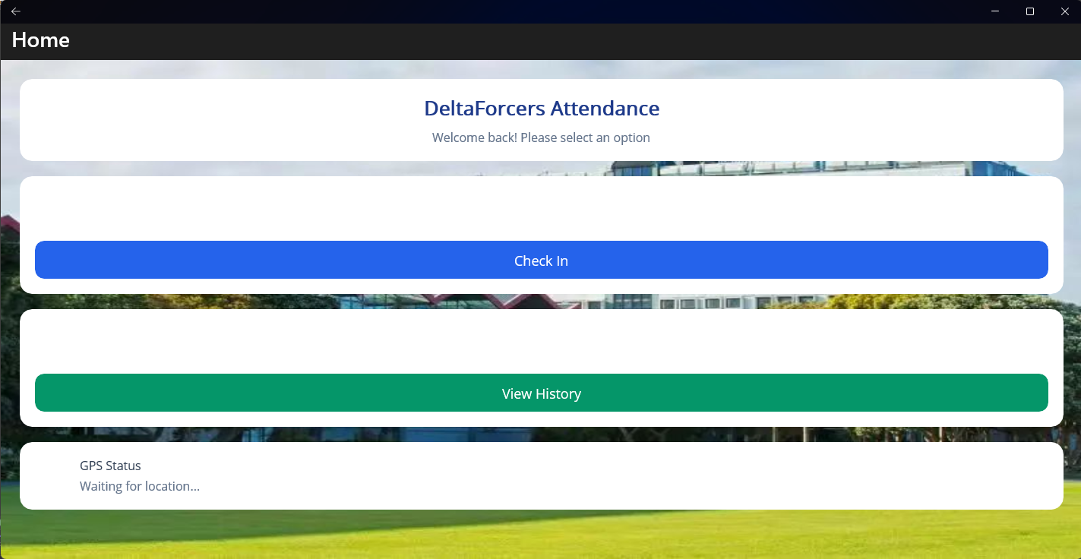
For the core attendance feature, the application requests location permissions automatically once users enter the check-in page. The system retrieves geographic information and compares it with predefined attendance boundaries to determine eligibility. When the location meets the requirements, users can complete attendance by pressing the confirmation button, and the corresponding data is stored automatically.
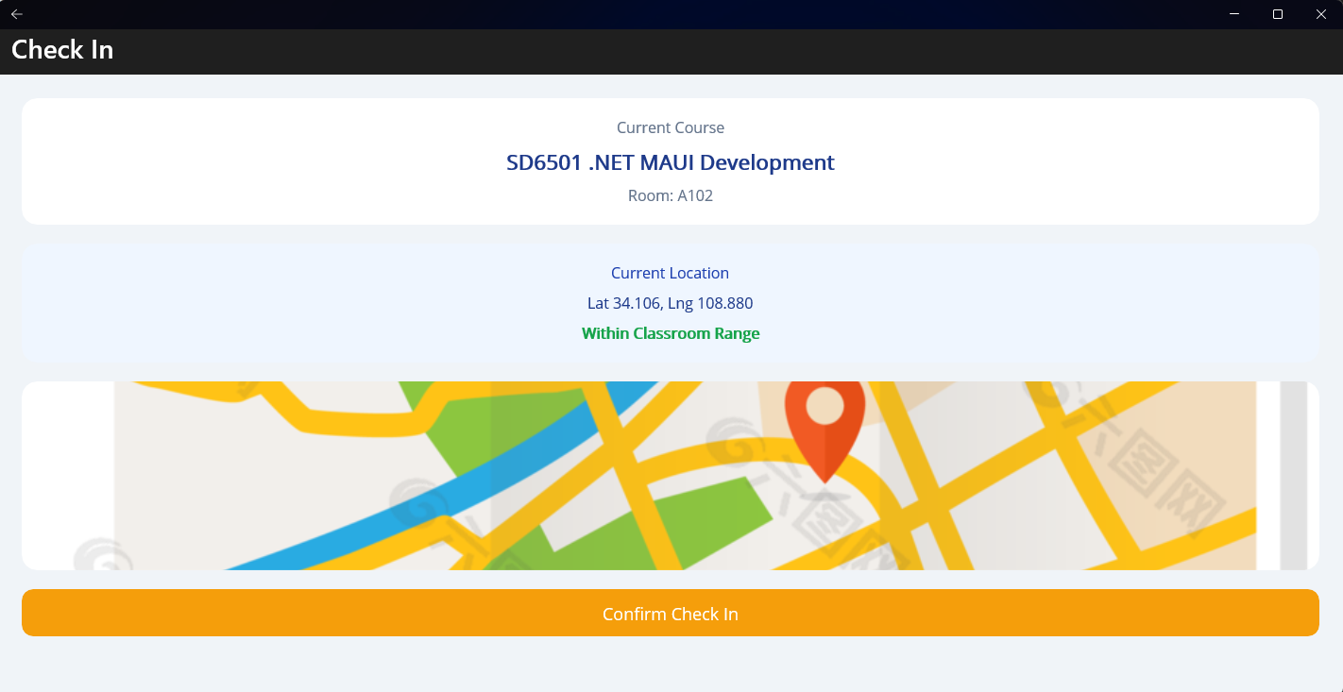

Finally, an attendance record page was developed to organize all completed check-ins in chronological order. Each record displays detailed information including course name, attendance time, check-in location, and attendance result for future reference.
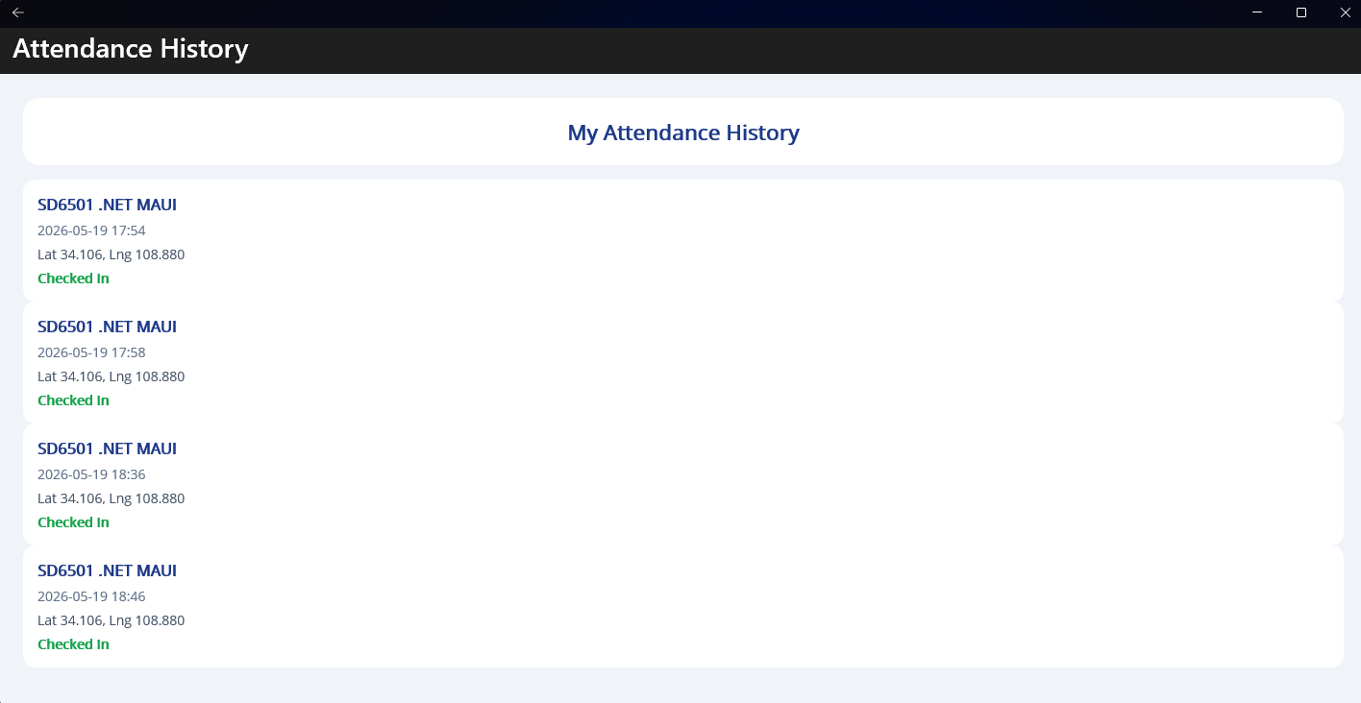

IV. Challenges Encountered and Solutions
One of the earliest issues encountered was unstable location retrieval. Slow loading times and occasional failures to obtain location data directly affected attendance functionality.
To solve this issue, the location request process was optimized by adjusting permission settings and improving loading logic. Additional buffering mechanisms were introduced to increase stability and reduce location failures.
Another challenge involved inaccurate attendance boundary detection. Some users located within the allowed area were incorrectly denied check-in access.
This issue was addressed by adjusting distance thresholds and introducing a reasonable location tolerance range. Multiple rounds of testing were conducted to refine the judgment parameters and improve positioning accuracy.
Screen adaptation was also problematic during development. Different devices displayed inconsistent layouts, causing misplaced buttons and interface distortion.
To improve compatibility, responsive layout techniques were applied and component sizes and spacing were standardized across different screen resolutions.
Additionally, there were situations where attendance data was not stored successfully after check-in. The data submission process was redesigned and confirmation feedback was added to ensure records were reliably saved.

V. Remaining Limitations and Reasons
At present, the system does not support multi-user administrative management. Features such as centralized student management and attendance task publishing are not available and only front-end self-check-in is supported.
The main reason is that backend server deployment and management module development require additional time and resources, which exceeded the scope of this project.
Offline attendance is also unavailable. Users cannot complete location verification or upload attendance information without network access.
This limitation remains because implementing offline storage and synchronization mechanisms would require additional database and caching design, making the development process significantly more complex.
Another unfinished feature is attendance exception notifications and message reminders. Users currently do not receive alerts for failed or missed attendance.
Since this functionality depends on integrating third-party notification services, it was excluded from the current project scope.

VI. Differences from Assignment 1 Prototype and Reasons for Changes
The first major modification involved redesigning the overall interface. Compared with the initial prototype, improvements were made to page colors, button styles, and layout organization.
These changes were introduced to improve visual quality and make the interface easier to navigate.
The second change was adding real-time location status feedback. The original prototype did not display location loading information.
This enhancement helps users understand system progress and reduces confusion during location acquisition.
The third modification expanded the content displayed on the attendance page. Instead of showing only a check-in button, additional information such as course details and location information was added.
This improvement makes the attendance process more informative and structured.
The fourth change involved improving attendance history records. Additional fields were included to provide more comprehensive attendance information.
Lastly, unnecessary navigation steps from the original prototype were removed to simplify operation flow and improve overall efficiency.

