ADVANCED CHALLENGE 1

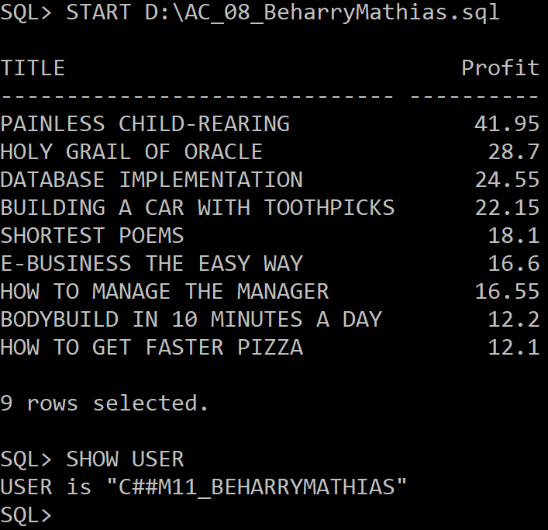

ADVANCED CHALLENGE 2

