THE UNIVERSITY OF DA NANG
VNUK INSTITUTE FOR RESEARCH AND EXECUTIVE EDUCATION


Final Report
M5 Retail Demand Forecasting & Supply Chain Decision Support System
An Enterprise End-to-End Pipeline Integrating MySQL, KNIME, and Power BI
Group Name: | Khá Bí
Members & Student IDs: | Bùi Đình Hiếu — 24040006  Huỳnh Nguyễn Nhật Linh — 24040001  Phạm Ngọc Thiên Ân — 24040005  Ngô Tuấn Minh — 24040007
Course: | BigData
Academic Year: | Term 2 – AY 2026-2027
Project Title: | M5 Retail Demand Forecasting & Inventory Optimization
Instructor: | TS. Trần Thế Vũ
Đà Nẵng, Tháng 11, 2026
(Da Nang, November 2026)

ACADEMIC INTEGRITY STATEMENT
VNUK Big Data Analytics Final Project
By signing below, each member certifies that the submitted assignment is the group's own work and that external sources and assistance are acknowledged in accordance with VNUK academic integrity requirements.
Student name | Student ID | Signature | Date
Bùi Đình Hiếu | 24040006
Huỳnh Nguyễn Nhật Linh | 24040001
Phạm Ngọc Thiên Ân | 24040005
Ngô Tuấn Minh | 24040007
AI Tool Disclosure
OpenAI ChatGPT (Codex) assisted with report organization, English wording, and cross-checking selected data counts and forecast metrics. The team must verify the final text and figures against the project files before signing.
Other AI tools and their use, if applicable: ___________________________________________
M5 Retail Demand Forecasting & Supply Chain Decision Support System
Bùi Đình Hiếu, Huỳnh Nguyễn Nhật Linh, Phạm Ngọc Thiên Ân, Ngô Tuấn Minh
Group Khá Bí— Department of Computer Science & Data Science
VNUK Institute for Research and Executive Education, The University of Danang, Vietnam
Abstract— This study examines weekly retail sales forecasts for 10 Walmart stores in California, Texas, and Wisconsin using the M5 dataset. The project links MySQL, KNIME Linear Regression, and Power BI. The exported forecast file contained 39,496 records. After duplicate records were removed, 19,748 unique item–store–day records matched a selling price and were aggregated into 110 store-week rows. On the 100 store-week observations with seven observed days, unit-sales MAE was 12.59 units and MAPE was 14.43%. Revenue MAE was USD 65.07 and MAPE was 17.73%. Actual unit sales exceeded forecasts in all ten assessed weeks at CA_1 and CA_3, and CA_3 had the highest revenue MAE, at USD 128.73 per week. Regional revenue bias was −20.20% in California, +4.76% in Texas, and +3.27% in Wisconsin. The results support inventory review, investigation of revenue forecast errors, and testing of local forecast adjustments.
Keywords— Retail demand forecasting, M5 Competition, KNIME Analytics, MySQL data warehouse, Linear regression, Power BI, Supply chain optimization, Inventory reorder point, Regional bias calibration, MAE/MAPE metrics.

I. INTRODUCTION AND PROBLEM DEFINITION
Retail replenishment and merchandising managers use sales forecasts to plan stock and review expected revenue. A persistent gap between actual sales and forecasts can help them identify stores and products for review. Decisions about order quantities also require inventory and lead-time information.
Retail supercenters are inherently defined by hierarchical aggregation levels—spanning stock-keeping units (SKUs), product categories, stores, and geographical regions. This empirical investigation focuses on 10 Walmart supercenters situated across three economically diverse U.S. states:
• California (CA): Four stores, CA_1 through CA_4.
• Texas (TX): Three stores, TX_1 through TX_3.
• Wisconsin (WI): Three stores, WI_1 through WI_3.
The study uses weekly sales and revenue comparisons to address three decision questions.
1) Store-Level Inventory Stockout Mitigation:
Which stores repeatedly sell more or less than forecast, and where should managers review available stock and order quantities first?
2) Revenue Error Prioritization & Capital Protection:
Which store has the highest revenue MAE, and which categories and SKUs contribute most to its forecast error?
3) Macro-Level Regional Forecast Calibration:
Which states show positive or negative forecast bias, and would an adjustment improve results at both state and store level?
A. Related Work
Contemporary demand forecasting literature spans three primary methodological paradigms:
1) Classical Statistical Models: Univariate methods such as ARIMA, SARIMA, and Exponential Smoothing (ETS) maintain solid foundational utility [1]. However, they struggle to ingest high-dimensional exogenous feature matrices (calendar flags, price shifts) across tens of thousands of parallel SKUs in unified enterprise pipelines.
2) Nonlinear models: Gradient-boosted trees such as XGBoost and LightGBM can capture nonlinear relationships and interactions [2], [3].
3) Linear Regression: The project uses KNIME [4] to forecast unit sales. A linear model provides a straightforward baseline and coefficients that can be inspected.
• Interpretability: Regression coefficients show how predictors relate to the forecast under the model assumptions.
• Implementation: KNIME integrates the model into the data preparation workflow.
• Evaluation: Model suitability depends on results for a later period held out from training.
II. DATASET DESCRIPTION
The M5 Forecasting Competition (2020), organized by Prof. Spyros Makridakis and the Institute for the Future at the University of Nicosia, constitutes a recognized gold standard in hierarchical retail time-series benchmarking [5]. Unlike its predecessors (M1–M4), M5 provided authentic Walmart point-of-sale data across 1,941 consecutive daily observations. The dataset encapsulates deep hierarchical cross-sections from total enterprise sales down to individual SKU-store daily units, integrated with exogenous promotional indicators, federal food stamp cycles (SNAP), cultural calendar events, and weekly dynamic pricing tables.
Source data is extracted from three core warehouse entities: sales_history (daily unit sales per SKU and store), calendar (calendar attributes, day-of-week, financial week wm_yr_wk, SNAP flags, holiday identifiers), and sell_prices (weekly SKU unit pricing).
The project covers ten M5 stores and uses the exported item–store–day predictions for weekly analysis. See the M5 source for access and use conditions. The relevant fields include the item and store identifiers, forecast day, actual and predicted units, and the matched weekly selling price.
III. DATA QUALITY ASSESSMENT
The forecast export and the retained detail records were checked before weekly aggregation.
TABLE I. FORECAST EXPORT BEFORE AND AFTER CLEANING
Check | Before cleaning | After cleaning
Record count | 39,496 | 19,748
Duplicate rows | 19,748 | 0
Missing actual or forecast units | 0 | 0
Negative actual or forecast units | 0 | 0
Calendar and price matches | Join not yet applied | 19,748 of 19,748
• Coverage: In the ten complete weeks, 3,095 source rows with actual sales above two units were absent from the forecast export for the same 315 item–store pairs. The exact workflow step responsible requires confirmation.
IV. SYSTEM ARCHITECTURE AND DATA PIPELINE
A. End-to-End Enterprise Data Pipeline
The project workflow links the MySQL source tables, KNIME processing and Linear Regression, MySQL result staging, and Power BI reporting (Fig. 1).

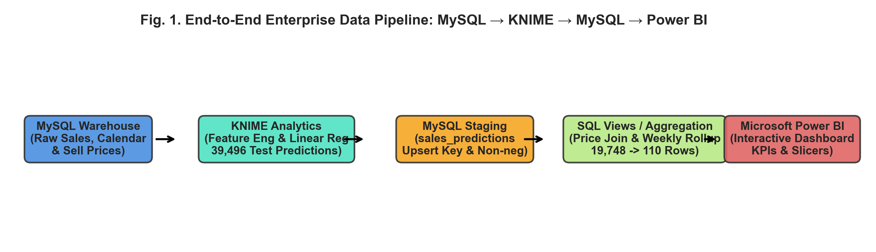
Fig. 1. End-to-end enterprise data pipeline: MySQL → KNIME → MySQL → Power BI.
B. MySQL Write-Back and Result Tables
The project stages predictions in sales_predictions and uses bigdataprj.dashboard_sales_store_period for the weekly and monthly summaries. Verify KNIME write-back and the duplicate checks during the end-to-end demonstration.
C. Revenue Calculation and Weekly Aggregation
Crucially, revenue is computed strictly at the atomic SKU–store–day level before any temporal or spatial aggregation:
$${\text{ActualRevenue}}_{ijt}={\text{ActualUnits}}_{ijt}×{\text{SellPrice}}_{ijt}$$
$${\text{PredictedRevenue}}_{ijt}={\text{PredictedUnits}}_{ijt}×{\text{SellPrice}}_{ijt}$$
Here, i denotes the product, j the store, and t the date. The calendar maps each date to wm_yr_wk. Match the selling price by product, store, and M5 week, then calculate revenue before aggregation.
The aggregation has three stages.
• Stage 1: The exported forecast file contains 39,496 records, including identical repeated observations.
• Stage 2: Keep one record per item, store, and forecast day. All 19,748 retained records match a selling price.
• Stage 3: Aggregate by store and reporting week to produce 110 weekly rows. The same table also contains 30 monthly rows. Select period_type = weekly for the weekly view.
• Evaluation coverage: The week starting March 7 contains observations for March 11–13. The primary weekly metrics use the 100 store-week rows with seven observed days, from March 14 through May 22.

INSERT KNIME WORKFLOW SCREENSHOT
Capture the actual workflow with readable node names and statuses. Show MySQL input, cleaning, Linear Regression, Predictor, and DB Writer where present.
Fig. 2. KNIME workflow and node execution status.
INSERT MYSQL WORKBENCH SCREENSHOT
Show the schema or the query and result grid for bigdataprj.dashboard_sales_store_period. If available, include verification of KNIME write-back.
Fig. 3. MySQL schema and query or write-back verification.

V. EXPLORATORY DATA ANALYSIS
The retained item–store–day sample contained 13,170 observations with zero actual sales, 4,422 with one unit, and 2,156 with two units. These counts describe the exported sample. The coverage check above shows why the distribution should not be generalized to all M5 sales.
In the ten complete weeks, actual unit sales in the evaluated sample totaled 3,275 units in California, 2,348 in Texas, and 2,739 in Wisconsin. These totals reflect four stores in California and three each in Texas and Wisconsin.
VI. MACHINE LEARNING AND EVALUATION
A. Model and Evaluation Window
The prediction target is daily unit sales for each item and store. The Week 3 workflow used calendar-derived information such as the holiday flag in data preparation. Verify the final feature list against the exported modeling workflow before reporting the exact predictors.
The evaluation uses forecast observations dated March 11–May 22, 2016. The main weekly comparison uses March 14–May 22. The planned training history is about one year. The exact training dates and Rule-based Row Splitter settings require confirmation from the modeling workflow.
The workflow may use a nonnegative constraint on predicted units. The exported file contained no negative values. Verify the Math Formula node before attributing this to clipping.
$$ŷ = max(0, ŷ_raw)$$
B. Evaluation Metrics
To evaluate model performance simultaneously through operational and financial dimensions, Mean Absolute Error (MAE) and Mean Absolute Percentage Error (MAPE) are established as standard metrics:
1) Mean Absolute Error (MAE): Formulated as:
MAE = $\frac{1}{n} ∑ |yᵢ − ŷᵢ|$
MAE measures the average absolute gap between actual and forecast values. It retains the original unit, such as items or USD per store-week.
2) Mean Absolute Percentage Error (MAPE): Formulated as:
MAPE = $\frac{1}{n}\sum_{i=1}^{n}{\left|\frac{y_{i}-{\hat{y}}_{i}}{y_{i}}\right|}×100\%$
MAPE averages absolute percentage errors. Rows with zero actual values are excluded from MAPE. Small actual values can produce large percentages.
C. KNIME Scoring and Export Check
The Week 3 Numeric Scorer displayed a warning. The team should retain the scorer output and the corresponding test data to establish model-level performance. On the 18,955 unique exported item–store–day observations within the ten main evaluation weeks, a separate calculation gives MAE 0.563 units, RMSE 0.675 units, and R² 0.016.
D. Weekly Forecast Performance
Across the benchmark set of 100 complete 7-day store-weeks, the enterprise recorded total actual volume of 8,362.00 units versus forecasted volume of 7,510.01 units (-10.19% net volume variance). Financially, total actual revenue reached $37,030.74 USD versus forecasted revenue of $34,392.47 USD (-7.12% variance).
The resulting enterprise-wide error metrics are:
• Unit Volume Error: MAE = 12.59 units/week; MAPE = 14.43%.
• Dollar Revenue Error: MAE = $65.07 USD/week; MAPE = 17.73%.
Across all 110 store-week rows, including the partial week, unit-sales MAE is 12.29 units (MAPE 15.39%) and revenue MAE is USD 62.81 (MAPE 18.47%). These values describe the sensitivity of the reported metrics to including the partial week.
VII. DASHBOARD AND INSIGHTS
The Power BI walkthrough uses weekly results from the MySQL summary table. The intended views compare actual and forecast units and revenue by state, store, and week. Verify the MySQL refresh and the CA to CA_3 filter during the demonstration.

INSERT POWER BI DASHBOARD SCREENSHOT
Show actual and forecast KPIs and the state, store, and week filters. For the demo example, select CA, CA_3, and March 14–20, 2016.
Fig. 4. Power BI dashboard with interactive filters and the CA_3 comparison.

A. Store-Level Results
Table II provides the comprehensive breakdown of actual versus forecasted units, revenues, and error metrics across all 10 Walmart supercenters.

TABLE II. STORE-LEVEL RESULTS ACROSS 100 COMPLETE STORE-WEEK OBSERVATIONS
Store ID | Actual Units | Forecast Units | Units MAE | Units MAPE | Actual Rev ($) | Forecast Rev ($) | Revenue MAE ($) | Under-Fcst Weeks
CA_1 | 897.0 | 721.1 | 17.59 | 18.83% | 4,107.60 | 3,035.25 | 107.24 | 10 / 10
CA_2 | 760.0 | 616.1 | 14.96 | 19.26% | 4,703.17 | 3,787.07 | 91.61 | 9 / 10
CA_3 | 910.0 | 642.8 | 26.72 | 28.18% | 4,511.90 | 3,224.63 | 128.73 | 10 / 10
CA_4 | 708.0 | 728.8 | 3.81 | 5.58% | 3,738.46 | 3,568.17 | 29.43 | 4 / 10
TX_1 | 764.0 | 826.8 | 6.58 | 9.31% | 3,703.66 | 3,539.64 | 27.90 | 1 / 10
TX_2 | 710.0 | 642.5 | 9.75 | 14.03% | 2,946.57 | 2,926.09 | 27.11 | 9 / 10
TX_3 | 874.0 | 887.8 | 4.93 | 5.87% | 3,770.24 | 4,450.36 | 70.32 | 6 / 10
WI_1 | 1,155.0 | 978.8 | 17.62 | 14.29% | 4,594.10 | 4,290.75 | 55.43 | 10 / 10
WI_2 | 819.0 | 667.1 | 15.19 | 17.32% | 2,563.02 | 2,401.95 | 28.04 | 10 / 10
WI_3 | 765.0 | 798.3 | 8.75 | 11.57% | 2,392.02 | 3,168.56 | 84.89 | 3 / 10
Enterprise Total | 8,362.0 | 7,510.0 | 12.59 | 14.43% | 37,030.74 | 34,392.47 | 65.07 | 72 / 100

Table II shows how the forecast errors differ by store.
1) Lower unit-sales errors: CA_4 had a unit-sales MAPE of 5.58% and TX_3 had a unit-sales MAPE of 5.87%. CA_4 also had a revenue MAE of USD 29.43 per week.
2) Severe Under-Forecasting Cluster (CA_1, CA_3): In both locations, actual demand exceeded predictions across all 10 out of 10 evaluation weeks. CA_3 suffered an extreme volume MAE of 26.72 units (MAPE = 28.18%) and an enterprise-peak revenue MAE of $128.73 USD/week (MAPE = 26.97%).
3) Wisconsin stores: Actual unit sales exceeded forecasts in all ten assessed weeks at WI_1 and WI_2. WI_2 had a revenue MAE of USD 28.04 per week.

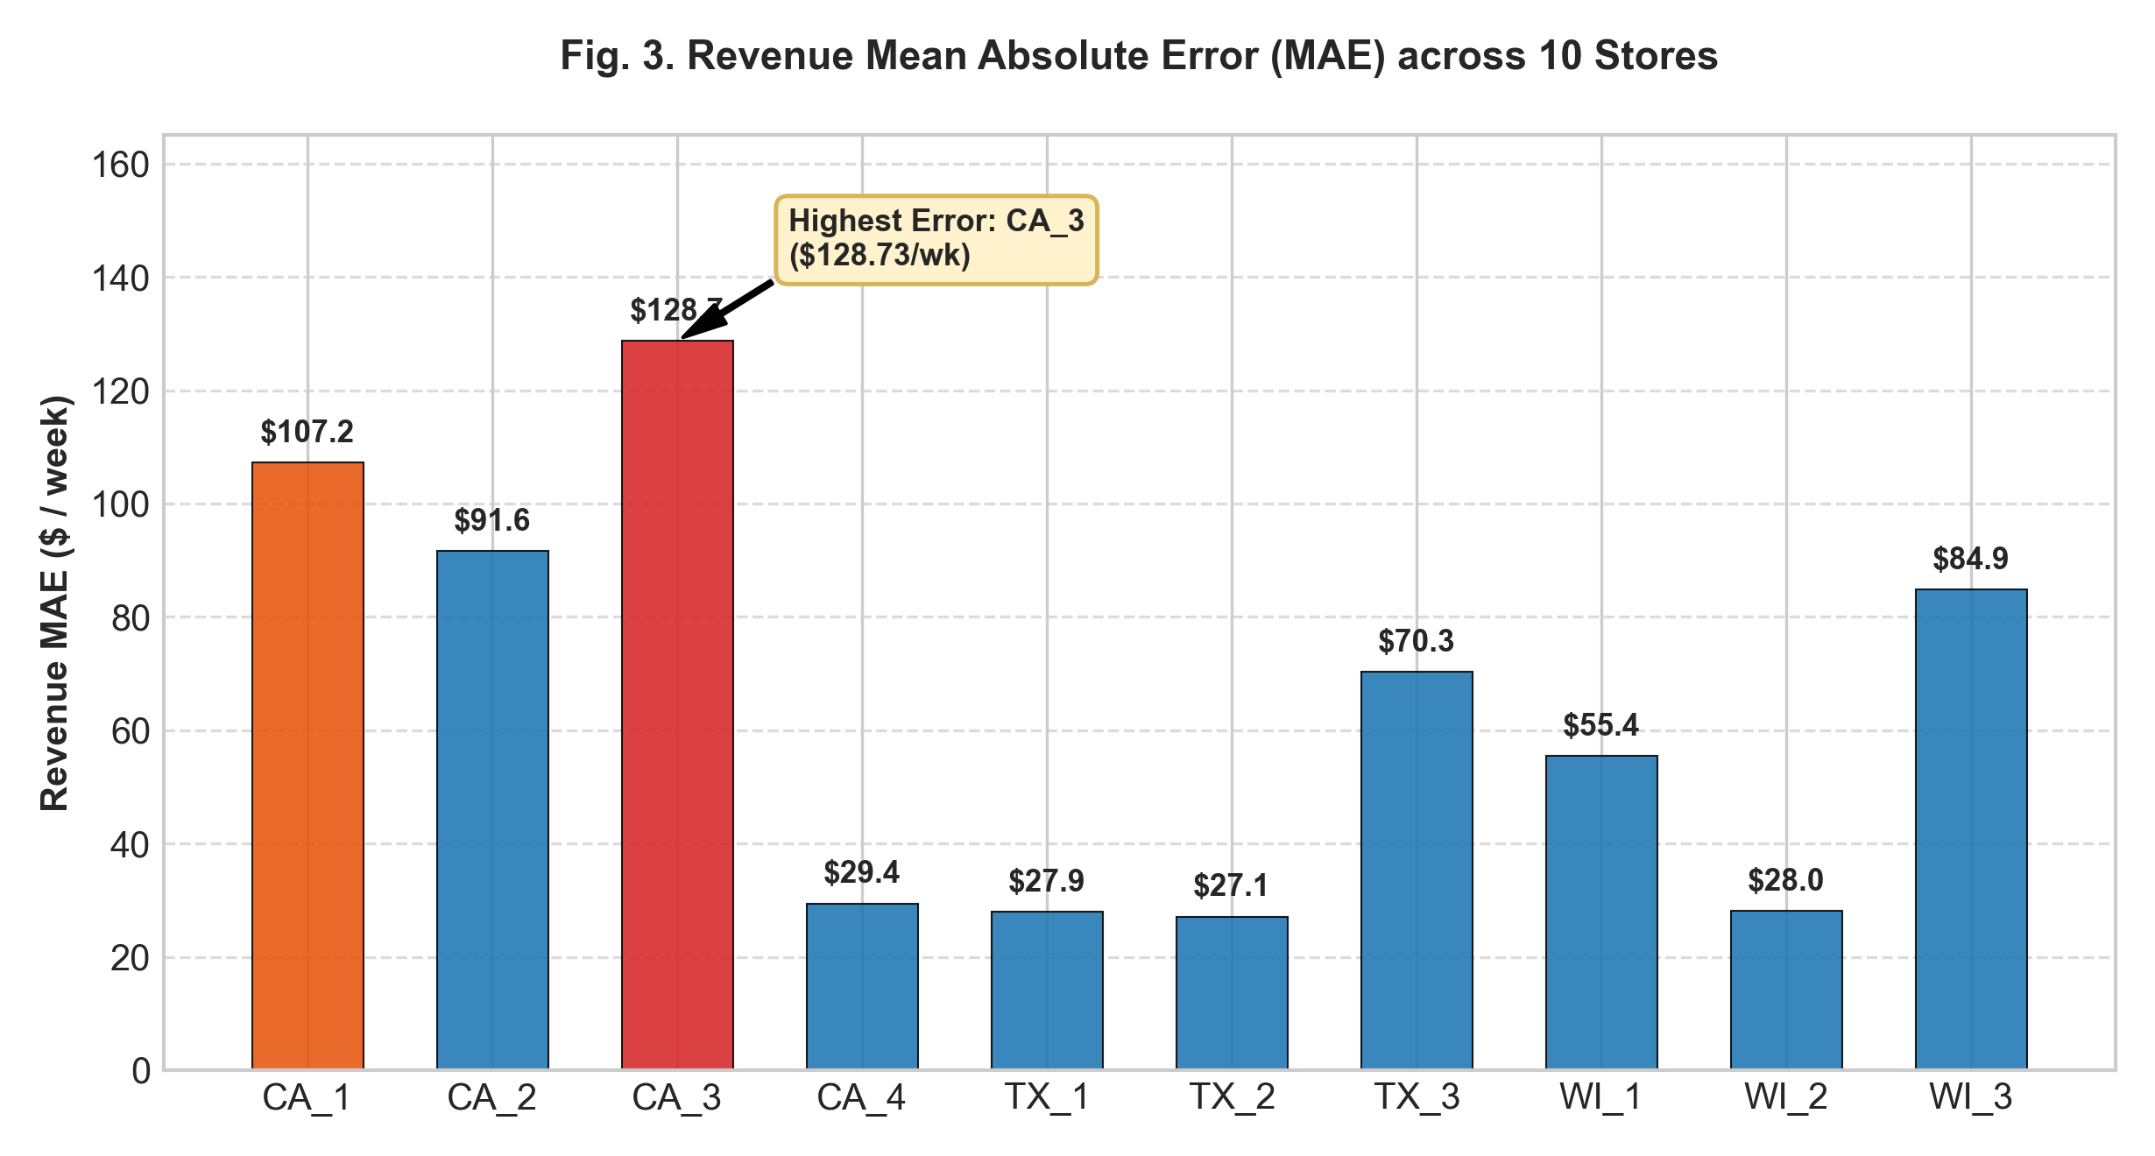
Fig. 5. Store-level revenue Mean Absolute Error (MAE) across 10 supercenters (CA_3 incurs highest error at $128.73/wk).
B. State-Level Forecast Bias
When aggregated to state level, the empirical results unveil strong geographic divergence (Table III, Fig. 6, Fig. 7):
TABLE III. REGIONAL DEMAND & REVENUE BIAS SUMMARY
State | Actual Rev ($) | Forecast Rev ($) | Rev Bias (%) | Volume Bias (%)
CA | 17,061.13 | 13,615.12 | -20.20% | -17.29%
TX | 10,420.47 | 10,916.09 | +4.76% | +0.38%
WI | 9,549.14 | 9,861.27 | +3.27% | -10.76%
• California: Forecast revenue was USD 3,446.01 below actual revenue (−20.20%). Forecast unit sales were 566.22 units below actual sales (−17.29%).
• Texas: Total forecast unit sales were 9.00 units above actual sales (+0.38%). Revenue was overforecast by USD 495.62 (+4.76%). Store-level errors can offset one another in the state total.
• Wisconsin: Unit sales were underforecast by 10.76%, while revenue was overforecast by 3.27% (USD 312.13). Differences in item prices and opposite store-level revenue errors can contribute to this pattern.

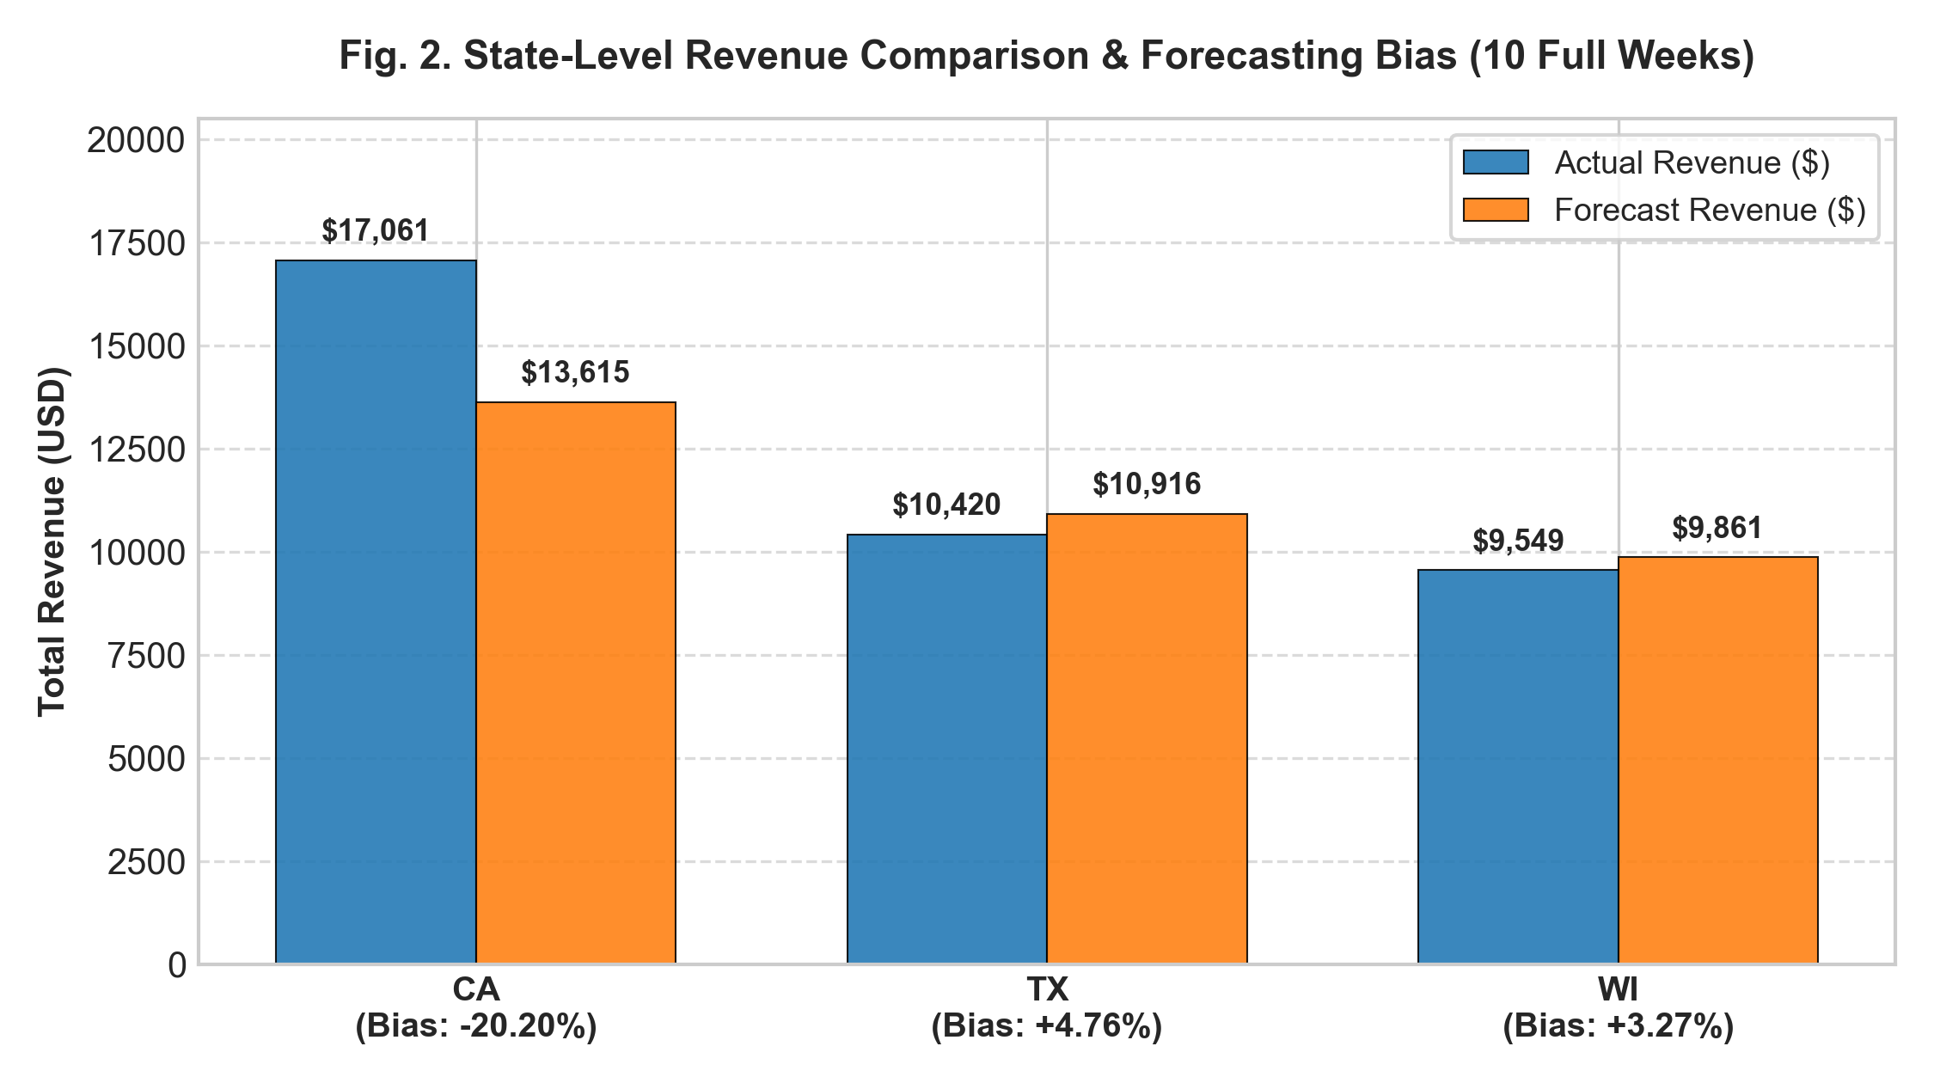
Fig. 6. State-level actual vs. forecast revenue and percentage bias.

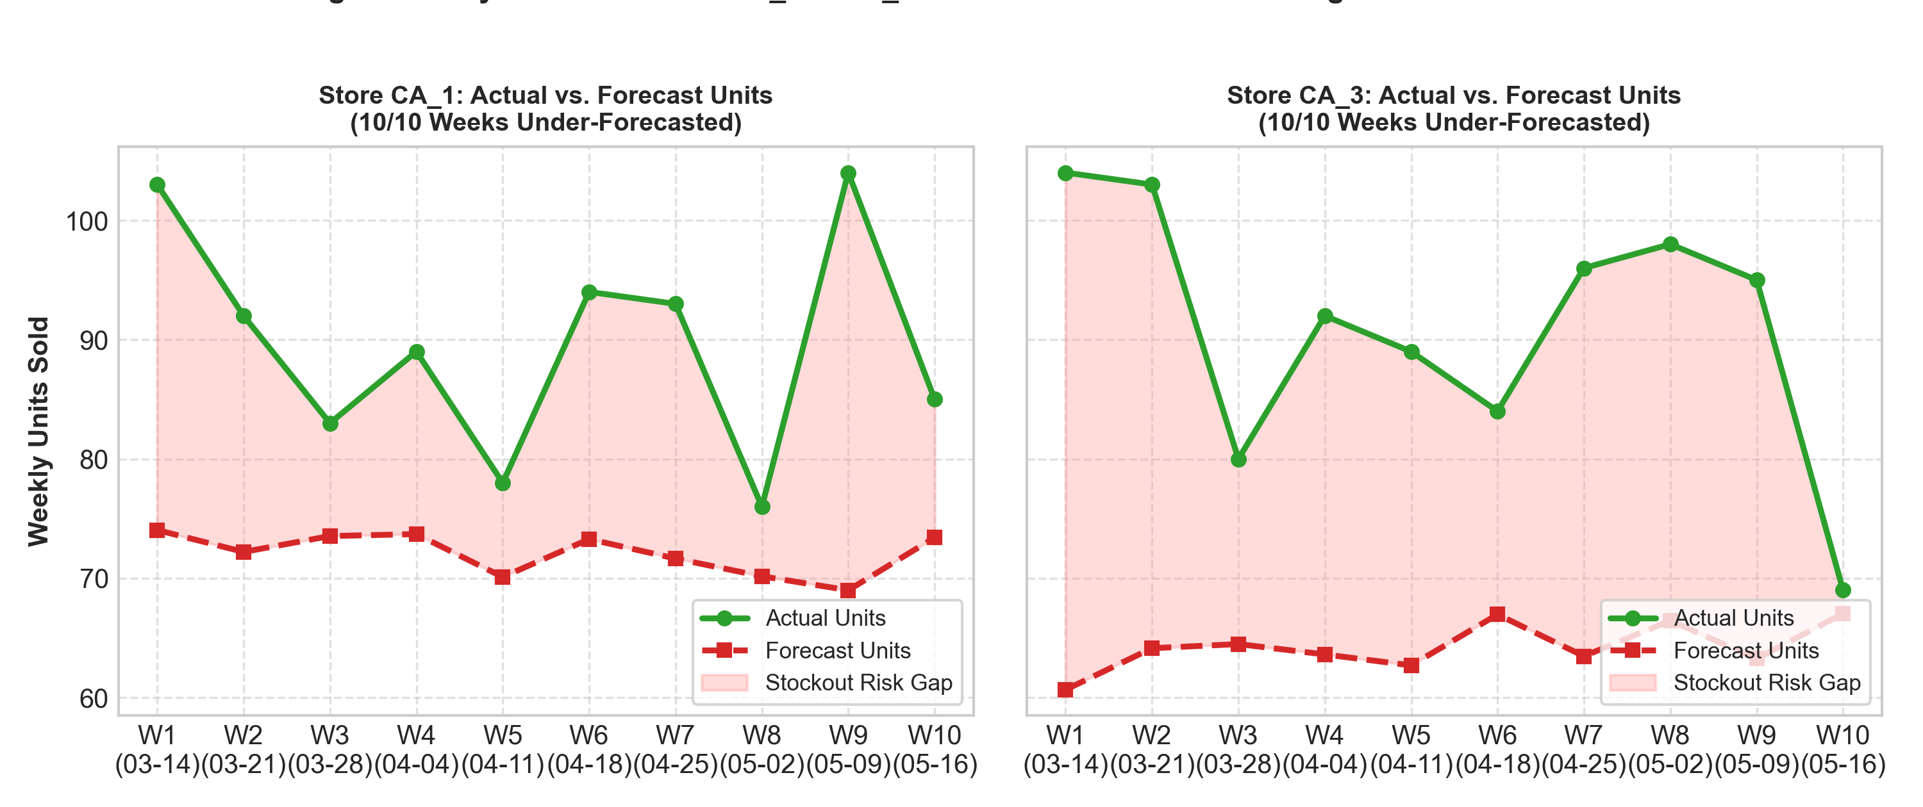
Fig. 7. Weekly sales tracking for CA_1 and CA_3 (red area highlights persistent 10/10 weeks under-forecasting).
VIII. DECISION RECOMMENDATIONS
Converting statistical variance into measurable supply chain interventions represents the ultimate objective of enterprise analytics. Based on empirical findings, three strategic decisions are formulated:
1) Recommendation 1: Stockout Prevention in CA_1 and CA_3:
• Empirical Grounding: Actual unit sales exceeded forecasts across 10 out of 10 evaluation weeks at both CA_1 (+24.4% demand surplus) and CA_3 (+41.6% surplus) (Fig. 7). This chronic volume deficit presents an immediate risk of shelf stockouts and lost revenue.
• Action: Replenishment managers should review the affected categories and SKUs, check available stock and lead times, and consider updating reorder points if the evidence supports a change [6].
• Trade-off and KPI: Extra stock may increase holding costs. Track stockout rate and days of inventory during any pilot.
2) Recommendation 2: Dollar-Error Prioritization for CA_3:
• Evidence: CA_3 has the highest revenue MAE at USD 128.73 per week. Forecast revenue was USD 1,287.27 below actual revenue over ten weeks (Table II).
• Action: Review Foods, Household, and Hobbies first, then inspect the SKUs contributing most to the error.
• Trade-off and KPI: Prioritizing CA_3 may shift attention away from other stores. Track CA_3 revenue MAE on later weeks.
3) Recommendation 3: Regional Forecast Calibration Multipliers:
• Empirical Grounding: Systematic macroeconomic polarization: California is under-projected by -20.20% in revenue, while Texas and Wisconsin are over-projected by +4.76% and +3.27% respectively (Table III).
• Action: Inspect each store before testing a state-level revenue calibration. A candidate adjustment can be expressed as follows.
$${\hat{y}}_{\text{adjusted}}=α_{\text{State}}×{\hat{y}}_{\text{base}}$$
The candidate adjustment should reduce signed bias on a later validation period without worsening store-level MAE. Estimate the factor from earlier observations and validate it on separate weeks.
• Trade-off and KPI: One factor can improve the state total while worsening an individual store. Monitor signed bias and MAE at both levels.
IX. CONCLUSION AND LIMITATIONS
The project produced weekly unit-sales and revenue summaries for ten M5 stores. The evaluated sample identifies CA_1 and CA_3 for inventory review, CA_3 for revenue-error investigation, and differing forecast bias across the three states. Verification of the complete KNIME-to-Power BI rerun remains part of the demonstration.
1) Training history: The plan describes about one year of history. If confirmed, this provides about one annual cycle and limits the assessment of recurring seasonal patterns.
2) Evaluation coverage: The CSV covers March 11–May 22, 2016. The first reporting week has only three observed days. The primary metrics use 100 observations from ten stores across ten weeks with seven observed days.
3) Product-level coverage: Seven observed days per store-week do not ensure that every item–store–day record is present. The weekly metrics apply to the exported sample described in the quality assessment.
Future enhancements include: (1) integrating Gradient Boosted Trees (LightGBM/CatBoost) with SHAP value interpretability; (2) incorporating localized weather data and SNAP disbursement schedules; and (3) deploying automated MLOps webhook alerts directly from Power BI into ERP replenishment modules.
REFERENCES
[1] R. J. Hyndman and G. Athanasopoulos, Forecasting: Principles and Practice, 3rd ed. Melbourne, Australia: OTexts, 2021.
[2] T. Chen and C. Guestrin, "XGBoost: A scalable tree boosting system," in Proc. 22nd ACM SIGKDD Int. Conf. Knowl. Discovery Data Mining, 2016, pp. 785-794.
[3] G. Ke et al., "LightGBM: A highly efficient gradient boosting decision tree," in Advances in Neural Information Processing Systems (NeurIPS), vol. 30, 2017, pp. 3146-3154.
[4] M. R. Berthold et al., "KNIME: The Konstanz Information Miner," ACM SIGKDD Explorations Newsletter, vol. 11, no. 1, pp. 26-31, 2009.
[5] S. Makridakis, E. Spiliotis, and V. Assimakopoulos, "The M5 accuracy competition: Results, findings, and conclusions," International Journal of Forecasting, vol. 38, no. 4, pp. 1346-1364, 2022.
[6] E. A. Silver, D. F. Pyke, and R. Peterson, Inventory Management and Production Planning and Scheduling, 3rd ed. New York: John Wiley & Sons, 1998.
[7] A. de Myttenaere, B. Golden, B. Le Grand, and F. Rossi, "Mean Absolute Percentage Error for Regression Models," Neurocomputing, vol. 192, pp. 38-48, 2016.

APPENDICES
Appendix A. MySQL Schema and Sample Queries
INSERT SQL SCRIPT OR QUERY SCREENSHOT
Add the table definition or a runnable query showing the keys, price join, weekly aggregation, or validation counts. Keep the SQL and result legible.
Appendix B. KNIME Configuration and Scoring
INSERT KNIME NODE SETTINGS OR SCORER SCREENSHOT
Show the actual train/test rule, predictor inputs, Numeric Scorer output, or DB Writer settings. Use separate images if one screenshot cannot show the settings clearly.

