Source and sinks:
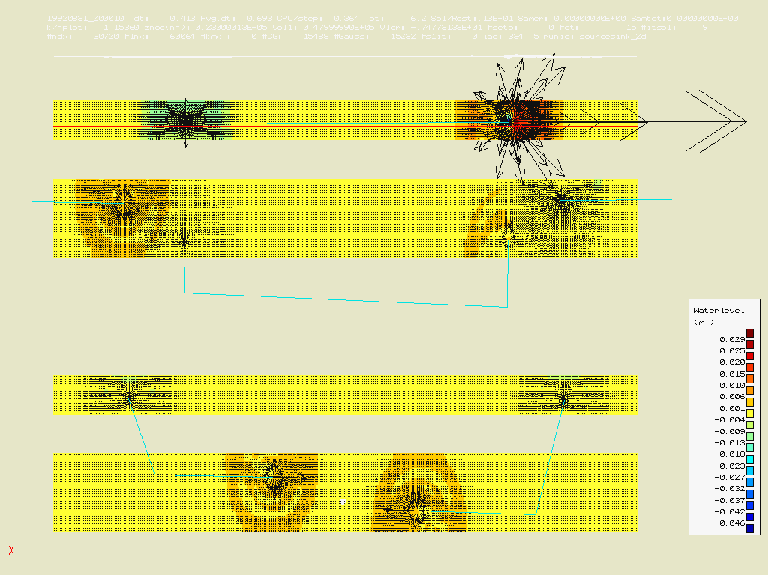
Notice how one of the source points in the above model has zero area for the pipe’s cross section (and as such does not receive momentum). All the others receive momentum too.

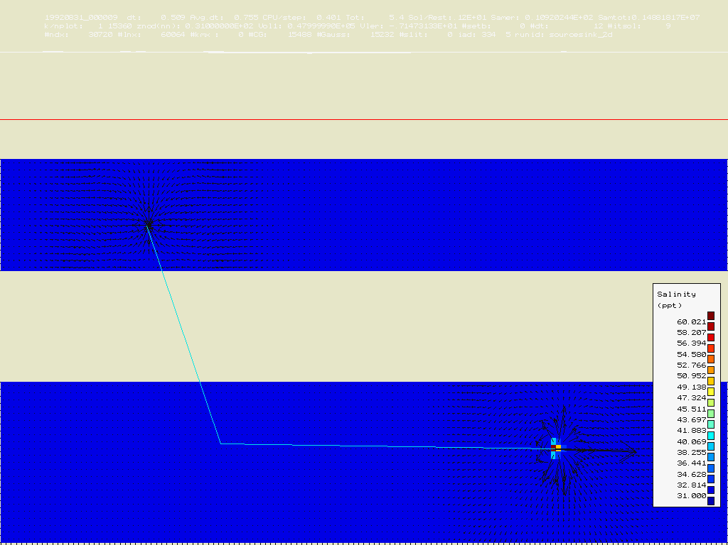
Notice how the sink of an intake-outfall relation has no change in salinity concentration, whereas the source cell does have change in salinity concentration.

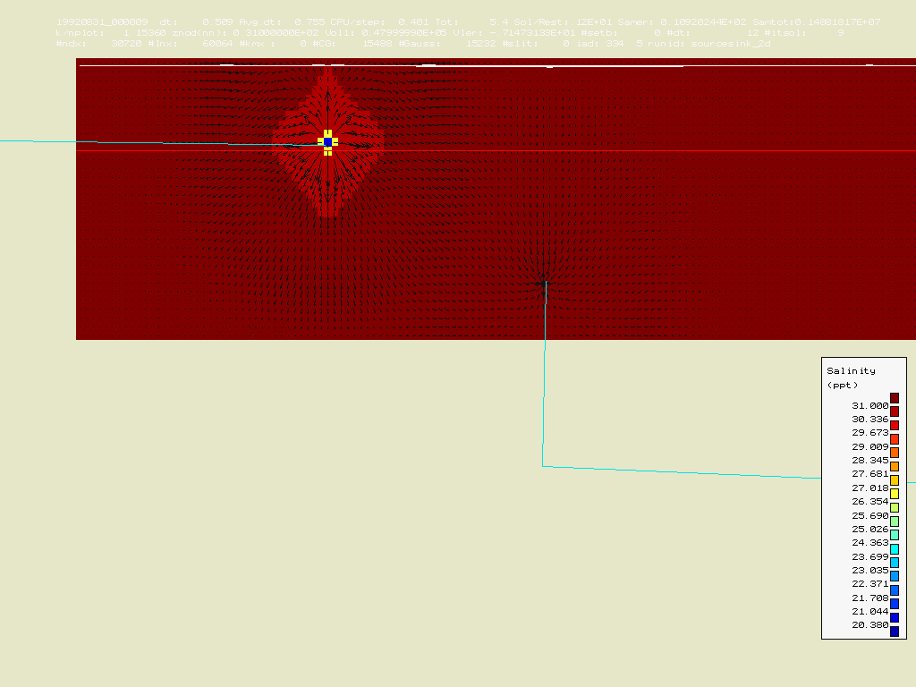
For completeness: this change in salinity concentration can also be a decrease, if the intake-outfall relation prescribes less saline values than what’s currently in the model.

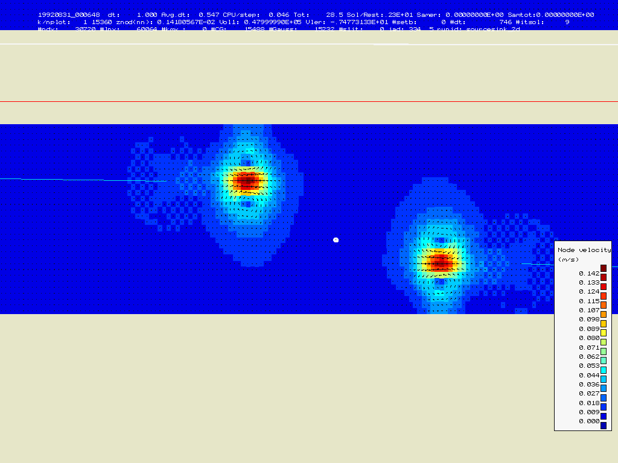
After one minute, the time series for all sources and sinks decrease to zero. Notice how the jet that originated from the source cells have now travelled ahead, and the surroundings are becoming ‘quiet’ again.

