|  |
| --- |
| Game Design Document |
| Module 4 – Infinite Scrolling Fighter |

|  |
| --- |
| Armin Raad  [Date] |

# Game overview

|  |  |
| --- | --- |
|  |  |
| Title | Righteous Fury |
| Platform | PC |
| Genre | Endless side scrolling fighter |
| Target Audience | Casual players |
| Release Date | January 2024 |

# Story

Righteous Fury is a mashup of 2D fighting games and infinite runners such as Subway Surfers. The game is based in a future where demons have invaded the human world and the player must kill them to survive, the player can do this in many ways depending on what character they are playing. Killing enemies and running to the right will give the player points which will be added to their score. A high score will be recorded per character and displayed on the character select screen.

The player will occasionally face off against a boss character.

# High-Level concept

Righteous Fury places the player in a hypothetical world where they must defeat demons in order to survive. Demons spawn in front of the player and there is no going back, the only choice is to destroy the demons and progress further using your character’s abilities.

# Unique Selling Points

* Satisfying kill effects
* Powerful character abilities
* Interesting character design
* Responsive player movement
* Impactful sound effects
* Multiplatform

# Platform Minimum Requirements

[figure this out eventually, though I’m confident I can make it perform very well]

# Objectives

1. Main Menu
   1. Display buttons.
      1. Play
      2. Settings
      3. Quit
   2. Buttons will be clickable to go to other scenes.
   3. Buttons will have interesting hover effects.
   4. Buttons will have interesting on click effects.
   5. Going to new scene must have a transition.
2. Character Select
   1. 4 characters.
      1. Gunblade
      2. Fighter
      3. Gunslinger
      4. Destroyer
   2. On hover, the quadrant should become animated (use character’s idle animation).
   3. On click, character’s voice line should play.
   4. On click a transition should appear.
   5. Player should be moved to gameplay scene.
3. Gameplay scene
   1. HUD
      1. Health
      2. Character specific UI elements
      3. Score
   2. Should start “paused”, where the game waits for the player to press something before it starts spawning enemies.
   3. Enemies should be spawned off screen.
   4. Allow player movement.
      1. Jump
      2. Run left/right
      3. Double jump
      4. Air dash
      5. Movement must be responsive and fast.
   5. Allow player attacks.
      1. Character specific special moves.
      2. Character specific normal moves.
      3. Attacks should combo and juggle depending on the move.
      4. Some attacks should end in a launch that will throw enemies ghost out of the screen.
   6. Camera must follow player past ¼ of the screen when going right but cannot go left.
   7. Buildings should be procedurally generated with fixed width between buildings with varying heights (not too varied to allow player to jump between them easily.
   8. Player should be able to fall off and die.
4. Settings Menu
   1. Volume
   2. Controls
      1. Inputs must be able to be rebound individually.
      2. 1 move can have 2 inputs, but 2 moves can’t have the same input.
5. Game Over Menu
   1. Score
   2. High Score
      1. Change text to new high score if score is new high score.
   3. Restart button
   4. Main Menu Button
6. Missions Menu
   1. Have 3 active missions.
   2. Get random mission when mission is completed.
   3. When player opens this menu, check if mission has been completed. If completed it will play a little animation that it has been finished.
7. Pause Menu
   1. Quit
   2. Resume
   3. Settings
   4. Show active missions.

# Further Objectives

These will be worked on if there is extra time:

1. Powerups
2. Bosses
3. Multiplayer
4. Upgrades
5. Level editor
6. Achievements
7. Challenges
8. Time based events
9. Character customization – alternate colour outfits.

# Game States

|  |  |
| --- | --- |
| State | Description |
| 1 | Main Menu |
| 2 | Character Select |
| 3 | Actual game |
| 4 | Pause menu |
| 5 | Game over screen |
| 6 | Settings menu |
| 7 | Settings menu (paused) |

# Gameplay

## Universal Controls

|  |  |
| --- | --- |
| Button | Function |
| W / Space | Jump |
| A | Move left |
| D | Move right |
| Escape | Pause |

These can be changed anytime in the settings. Attack controls will be character specific.

## Game Camera

TODO show camera angle somehow

## Player Objectives

* Kill enemies and run further to gain score. The further they are the more score they get from killing enemies.
* Complete missions to unlock higher score multiplier.
* Complete missions to unlock new characters.

# Player

## Characters

There will be multiple playable characters, all of which will have unique moves. As unique as they will be, they will share some attributes such as:

* Having health.
* Ability to move.
* Able to take damage.

## Gunblade

|  |  |
| --- | --- |
| Statistic | Value |
| Health | 1000 |
| Movement Speed | 95% |

### Description

Figure 1 Gunblade Concept

Gunblade has a unique weapon that allows him to slash and shoot giving him access to strong abilities in short to mid-range.

### Lore

Gunblade's real name is Daniel Cross, a former soldier who fought in the army of his nation. After a terrible battle, he was left stranded behind enemy lines, injured and alone. As he lay there dying, he saw a vision of a demon, beckoning him to make a deal. The demon promised to save his life and give him the power to fight his enemies, but in return, Daniel would have to offer his soul.

Desperate to survive, Daniel agreed to the deal, and the demon infused his body with demonic power, turning him 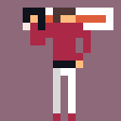into a hybrid creature with superhuman strength and speed. He also gave him a unique weapon, a gunblade, a sword with a gun built into the hilt.

With his newfound power and weapon, Daniel was able to fight his way back to his own lines, where he was hailed as a hero. However, his victory came at a great cost, as he soon realized that the demon's power was slowly corrupting him, and he was losing control of his own body.

Determined to regain his humanity, Daniel set out on a quest to rid the world of the demon menace that had invaded his land, hoping to find a way to break the demon's hold on him in the process. Now, as the gunblade, he fights to protect his people and redeem his soul, wielding his hybrid sword gun weapon with deadly precision against the demons that threaten his world.

Figure 2 Gunblade Sprite

### Specials

Demon Slayer’s Roar – a dragon punch style move that goes more vertically than fighter’s but less horizontally.

Shadow Assault – a move that propels Gunblade forwards and ends in a slash that launches enemies into the air, can be chained into a gunshot that will deal heavy damage and knock back.

Infernal Blade Takedown – a move that can only be done in the air, dives downwards and deals huge damage to any enemy it hits. Launches enemies outside of damage area.

### Unique Mechanic

He has super abilities that are on cooldowns.

### Iron Flame

Launches nearby enemies into the air and hits them with a powerful strike from his gunblade.

### Infernal Cataclysm

Gunblade launches himself with the gunblade and obliterates any enemies in his path.

### Controls – incomplete

|  |  |
| --- | --- |
| Button | Function |
|  | Demon Slayer’s Roar |
|  | Shadow Assault |
|  | Infernal Blade Takedown |
|  | Iron Flame |
|  | Infernal Cataclysm |

## Fighter

|  |  |
| --- | --- |
| Statistic | Value |
| Health | 1000 |
| Movement Speed | 100% |

[Images are placeholder, character will end up somewhat like image shown]d

### Description

The initially unlocked character. He will have access to common shoto[1] abilities.

### Lore

The fighter is half demon but chooses his human form because he’s too powerful and relates more to humans than to demons as he was raised in the human world. The fighter spent his pre-invasion days travelling the world in search of worthy opponents to train his fighting abilities.

### Specials

He will have a tatsu[2], fireball and dragon punch[3].

### Unique Mechanic

Pressure meter, a resource that fills up from dealing/taking damage used to unleash powerful attacks.

He may spend pressure for a critical move.

### Demon Install

Uses all of fighter’s pressure meter to boost fighter’s abilities for a moderate time, he will be in his demon form and all his attacks will be faster, more powerful and have bigger hitboxes.

### Pressure Burst

Uses half of fighter’s pressure meter to unleash a radial shockwave that will damage and pushback enemies, returns 10% of pressure meter for every enemy hit.

## Gunslinger

|  |  |
| --- | --- |
| Statistic | Value |
| Health | 900 |
| Movement Speed | 120% |

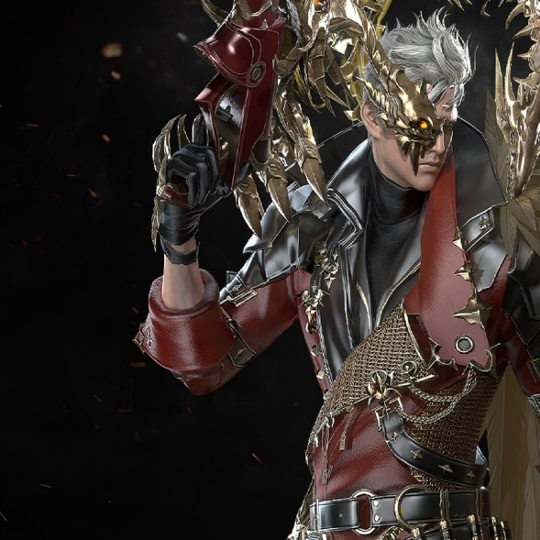

[Placeholder image as always]

### Description

The gunslinger is a ranged character that excels in mid-range encounters. Heavily reliant on mouse position.

### Lore

TODO come up with lore for this guy.

### Specials

Rapid Fire – shoots a flurry of projectiles at cursor.

Stun Grenade – throws a stun grenade which will incapacitate enemies for a short time and pull them in slightly. Medium radius and short cooldown.

Shotgun Spazz – rapidly fires a cone shaped area in front of him 3 times.

### BFG

Shoots a rifle that will obliterate anything in the large cone in front of it.

Note to self: it should materialize and dissolve after shooting.

## Destroyer

|  |  |
| --- | --- |
| Statistic | Value |
| Health | 2000 |
| Movement Speed | 80% |

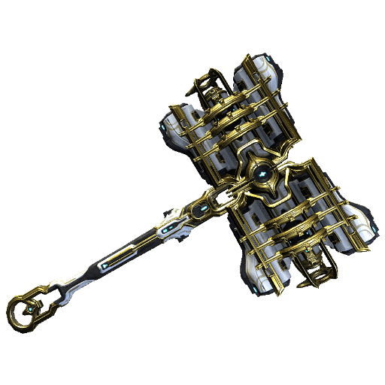

[Images are placeholders]

### Description

A heavy hammer wielding character. Uses large and slow swings to heavily damage enemies and knock them back.

### A picture containing text, athletic game Description automatically generatedUnique Mechanic

Figure 3

Enemies drop ammo for his ultimate ability: BFG.

### Lore

Hammer

### Specials

Swing – does a massive swing in front of him that deals heavy damage and knocks enemies back.

Smash – smashes the ground in front of him and deals damage to grounded enemies, also incapacitates them.

Uppercut – swings hammer upwards like a dragon punch, deals heavy damage and knocks enemies back.

### Unique Mechanic

Rage meter fills up by taking damage, when full allows him to become extremely fast for a short time.

## Pyromaniac

TODO if I have extra time.

## Cloak

TODO if I have extra time.

# Enemies

The enemies will be quite generic and not much variety, just flying and grounded enemies. They all have scaling health depending on how far the player has travelled but caps at 1,000,000% of initial health.

## Flyer

|  |  |
| --- | --- |
|  |  |
| Health | 1,000 |
| Behavior | Slowly flies towards the player and deals contact damage. |
| Score from killing | 100 * (1 + distance travelled / 100) |
| Spawn frequency (relative to other enemies) | 2 |

## Walker

|  |  |
| --- | --- |
|  |  |
| Health | 2,000 |
| Behavior | Walks towards player |
| Score from killing | 200 * (1 + distance travelled / 100) |
| Spawn frequency (relative to other enemies) | 1 |

## Spawning

Enemies will spawn off screen and make their way towards the player. If an enemy is off screen for more than 5 seconds they will be automatically deleted and no score will be given.

Enemy spawn rates will increase over time but there is a cap of 10 enemies spawned at a time.

## Killing

Enemies will die when their health reaches 0, this will result in a sound effect, score being added, death animation and small screen shake.

The score counter will always be increasing if the player is moving but when score is added from enemies it should momentarily increase in size to convey it has been substantially increased.

The death animation will consist of the enemy turning into particles and a “ghost” of them being launched and faded out.

# Wireframes

## Main Menu

The lights on the buildings will randomly turn on/off.

The moon will slowly more right, disappear for a while and then teleport to the left and start moving right again.

There will be shining stars randomly generated upon launching the game.

## Character Select

TODO add the classes artwork onto each quadrant

# Art

TODO

# Audio

TODO

# Minimum Viable Product

* One playable character (gunblade)
* Built for PC

# Wishlist

* Server with database for highest scores worldwide to give a sense of multiplayer without there really being one. I have the necessary database and python knowledge to do this but no knowledge of setting up the server and API.

# References

Infil, n.d. *Fighting Game Glossary.* [Online]   
Available at: https://glossary.infil.net  
[Accessed 14 3 2023].

1. An archetype in the Street Fighter series for a character that has a fireball, a shoryuken, and a tatsu (Infil, n.d.).
2. The name of a shoto special move where the character travels forward with their foot extended, usually spinning like a top while doing so (Infil, n.d.).
3. A powerful rising uppercut attack that is great for anti-air and is usually invincible, making it great for reversal attacks (Infil, n.d.).