|  |
| --- |
| Game Design Document |
| Module 4 – Infinite Scrolling Fighter |

|  |
| --- |
| Armin Raad  [Date] |

# Game overview

|  |  |
| --- | --- |
|  |  |
| Title | Not decided yet |
| Platform | PC + iOS & Android |
| Genre | Endless sidescrolling fighter |
| Target Audience | Casual players |
| Release Date | January 2024 |

[Insert name here] is a mashup of 2D fighting games and infinite runners such as Subway Surfers. The game is based in a future where demons have invaded the human world and the player must kill them to survive, the player can do this in many ways depending on what character they are playing. Killing enemies and running to the right will give the player points which will be added to their score. A high score will be recorded per character and displayed on the character select screen.

The player will occasionally face off against a boss character.

# High-Level concept

[Insert name here] places the player in a hypothetical world where they must defeat demons in order to survive. Demons spawn in front of the player and there is no going back, the only choice is to destroy the demons and progress further using your character’s abilities.

# Unique Selling Points

* Satisfying kill effects
* Powerful character abilities
* Interesting character design
* Responsive player movement
* Impactful sound effects
* Multiplatform

# Platform Minimum Requirements

[figure this out eventually, though I’m confident I can make it perform very well]

# Competence Title

[Not sure what this means, ask Aidan]

# Synopsis

The demons have invaded your world and all but is lost, you have one choice: survive.

# Game Objectives

The objective of the game is to get the highest score through distance travelled and killing enemies. You can also unlock new characters and level up your score multiplier through completing missions.

# Game Rules

* The player can move forward, backwards, up and down. The player can jump, double jump and air dash (depending on their chosen character). The player can perform special moves (character dependent). The player can perform basic attacks that will do less damage than special moves.
* The player can move right, once the player is further than the middle of the screen the camera will start following them to the right, though the camera can never go left. The player cannot leave the camera’s view.
* The player can double jump by jumping while already in the air, this double jump is replenished when they next touch the ground.
* The player can move downwards by not doing anything and allowing themselves to fall.
* The enemies are all generic and simply do contact damage, they have bigger hitboxes[1] than hurtboxes[2]. The enemies are spawned procedurally off screen and will make their way towards the player.
* More rooftops are procedurally generated as the player moves to the right.
* The player can fall off the roof and die (this will not be easy to do as parkour isn’t a focal point).
* The player can die from taking too much damage from enemies.

# Game States

|  |  |
| --- | --- |
| State | Description |
| 1 | Main Menu |
| 2 | Character Select |
| 3 | Actual game |
| 4 | Pause menu |
| 5 | Game over screen |
| 6 | Settings menu |
| 7 | Settings menu (paused) |

# Gameplay

## Universal Controls

|  |  |
| --- | --- |
| Button | Function |
| W / Space | Jump |
| A | Move left |
| D | Move right |
| Escape | Pause |

These can be changed anytime in the settings. Attack controls will be character specific.

## Game Camera

TODO show camera angle somehow

## HUD

TODO design HUD

# Player

## Characters

There will be multiple playable characters, all of which will have unique moves. As unique as they will be, they will share some attributes such as:

* Having health.
* Ability to move.
* Able to take damage.

## Fighter

|  |  |
| --- | --- |
| Statistic | Value |
| Health | 1000 |
| Movement Speed | 100% |

[Images are placeholder, character will end up somewhat like image shown]

### Description

The initially unlocked character. He will have access to common shoto[3] abilities.

### Lore

The fighter is half demon but chooses his human form because he’s too powerful and relates more to humans than to demons as he was raised in the human world. The fighter spent his pre-invasion days travelling the world in search of worthy opponents to train his fighting abilities.

### Specials

He will have a tatsu[4], fireball and dragon punch[5].

### Unique Mechanic

Pressure meter, a resource that fills up from dealing/taking damage used to unleash powerful attacks.

He may spend pressure for a critical move.

### Demon Install

Uses all of fighter’s pressure meter to boost fighter’s abilities for a moderate time, he will be in his demon form and all his attacks will be faster, more powerful and have bigger hitboxes.

### Pressure Burst

Uses half of fighter’s pressure meter to unleash a radial shockwave that will damage and pushback enemies, returns 10% of pressure meter for every enemy hit.

## Gunslinger

|  |  |
| --- | --- |
| Statistic | Value |
| Health | 900 |
| Movement Speed | 120% |

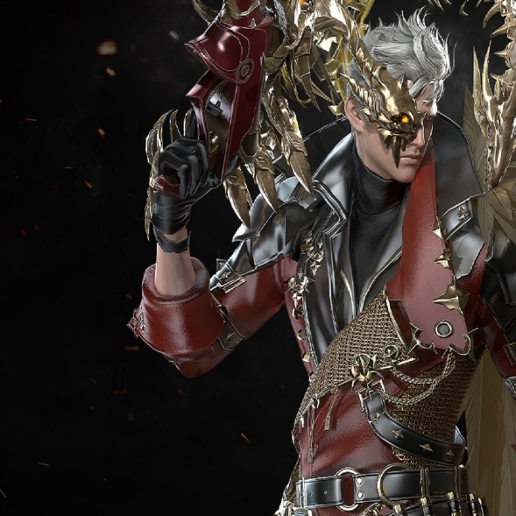

[Placeholder image as always]

### Description

The gunslinger is a ranged character that excels in mid-range encounters. Heavily reliant on mouse position.

### Lore

TODO come up with lore for this guy.

### Specials

Rapid Fire – shoots a flurry of projectiles at cursor.

Stun Grenade – throws a stun grenade which will incapacitate enemies for a short time and pull them in slightly. Medium radius and short cooldown.

Shotgun Spazz – rapidly fires a cone shaped area in front of him 3 times.

### BFG

Shoots a rifle that will obliterate anything in the large cone in front of it (figure 1).

## Destroyer

|  |  |
| --- | --- |
| Statistic | Value |
| Health | 2000 |
| Movement Speed | 80% |

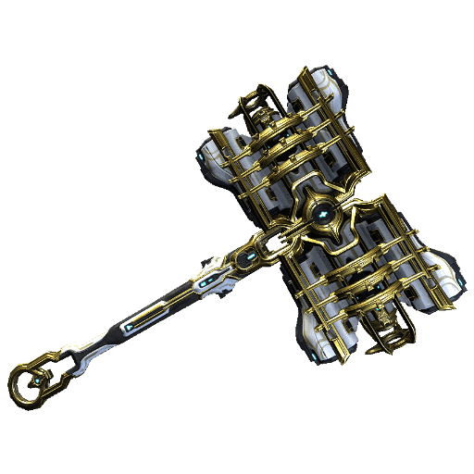

[Images are placeholders]

### Description

A heavy hammer wielding character. Uses large and slow swings to heavily damage enemies and knock them back.

### A picture containing text, athletic game Description automatically generatedUnique Mechanic

Figure 1

Enemies drop ammo for his ultimate ability: BFG.

### Lore

Hammer

### Specials

Swing – does a massive swing in front of him that deals heavy damage and knocks enemies back.

Smash – smashes the ground in front of him and deals damage to grounded enemies, also incapacitates them.

Uppercut – swings hammer upwards like a dragon punch, deals heavy damage and knocks enemies back.

### Unique Mechanic

Rage meter fills up by taking damage, when full allows him to become extremely fast for a short time.

## Gunblade

|  |  |
| --- | --- |
| Statistic | Value |
| Health | 1000 |
| Movement Speed | 95% |

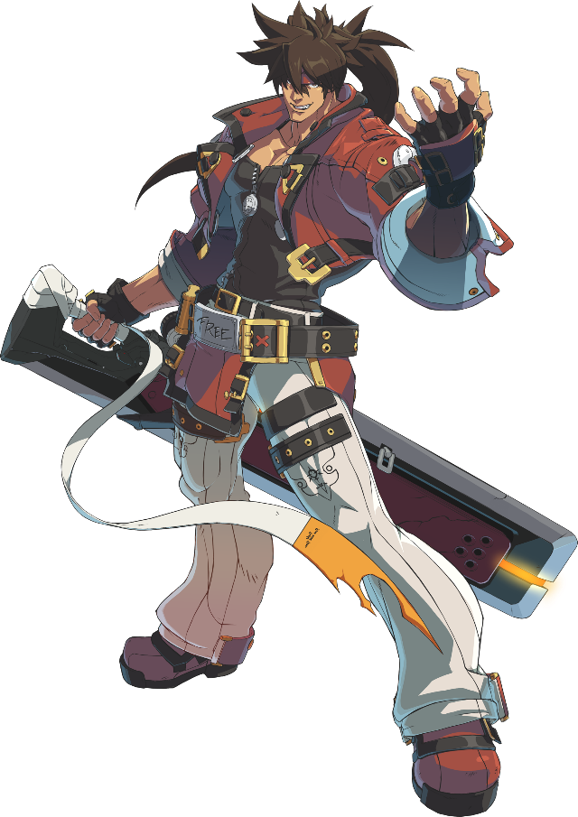

[images are placeholder]

### Description

Gunblade has a unique weapon that allows him to slash and shoot. He has access to strong abilities in short to mid-range.

### Lore

TODO come up with lore for this guy.

### Specials

Rising Slash – a dragon punch style move that goes more vertically than fighter’s.

Advancing Slash – a move that propels Gunblade forwards and ends in a slash that launches enemies into the air, can be chained into a gunshot that will deal heavy damage and knock back.

Diving Slash – a move that can only be done in the air, dives downwards and deals huge damage to any enemy it hits. Launches enemies outside of damage area.

### Unique Mechanic

He has super abilities that are on cooldowns.

### Iron Flame

Launches nearby enemies into the air and hits them with a powerful strike from his gunblade.

### Obliterate

Gunblade launches himself with the gunblade and obliterates any enemies in his path.

# Enemies

The enemies will be quite generic and not much variety, just flying and grounded enemies. They all have scaling health depending on how far the player has travelled but caps at 1,000,000% of initial health.

## Flyer

|  |  |
| --- | --- |
|  |  |
| Health | 1,000 |
| Behavior | Slowly flies towards the player and deals contact damage. |
| Score from killing | 100 * (1 + distance travelled / 100) |
| Spawn frequency (relative to other enemies) | 2 |

## Walker

|  |  |
| --- | --- |
|  |  |
| Health | 2,000 |
| Behavior | Walks towards player |
| Score from killing | 200 * (1 + distance travelled / 100) |
| Spawn frequency (relative to other enemies) | 1 |

## Spawning

Enemies will spawn off screen and make their way towards the player. If an enemy is off screen for more than 5 seconds they will be automatically deleted and no score will be given.

Enemy spawn rates will increase over time but there is a cap of 10 enemies spawned at a time.

## Killing

Enemies will die when their health reaches 0, this will result in a sound effect, score being added, death animation and small screen shake.

The score counter will always be increasing if the player is moving but when score is added from enemies it should momentarily increase in size to convey it has been substantially increased.

The death animation will consist of the enemy turning into particles and a “ghost” of them being launched and faded out.

# Minimum Viable Product

* One playable character (fighter)
* Built for PC

# Wishlist

* Server with database for highest scores worldwide to give a sense of multiplayer without there really being one. I have the necessary database and python knowledge to do this but no knowledge of setting up the server and API.

# References

Infil, n.d. *Fighting Game Glossary.* [Online]   
Available at: https://glossary.infil.net  
[Accessed 14 3 2023].

1. A box that will deal damage to a hurtbox when they collide
2. A box that will take damage from a hitbox when they collide
3. An archetype in the Street Fighter series for a character that has a fireball, a shoryuken, and a tatsu (Infil, n.d.).
4. The name of a shoto special move where the character travels forward with their foot extended, usually spinning like a top while doing so (Infil, n.d.).
5. A powerful rising uppercut attack that is great for anti-air and is usually invincible, making it great for reversal attacks (Infil, n.d.).