PHYSICS CLASS X

Science paper I

(2 hours)

(You will not be allowed to write during first 15 minutes. This time to spent in reading question paper. The time given at head of paper is the time allowed for writing the answers)

**Section I (40 marks)**

(Attempt all questions from this section)

**Question 1**

1. Draw a ray diagram to illustrate how a Ray of light incident obliquely on one face of a rectangular glass slab and emerge out [2]
2. State the condition required for total internal reflection of light to take place [2]
3. A converging lens is used to obtain image of an object placed in front on it. The inverted image is formed between F2 and 2F2. Draw a ray diagram to illustrate it [2]
4. Mention two factors on which resistance of a wire depends [2]
5. Explain critical angle using diagram [2]

**Question 2**

1. Define specific resistance of a material, state its SI unit [2]
2. Calculate the potential difference required across a conductor of resistance 5 ohm to pass a current of 1.5 ampere through it [2]
3. 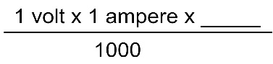Complete the following [2]
4. 1KWh =
5. 1 KWh =-----------J
6. Why we connect switch on live wire? [2]
7. For earthing an electric appliance, one has to remove the paint from metallic body of appliance were electric contact is made. why? [2]

**Question 3**

1. In cold countries water in lakes and Ponds does not freeze at all once why? [2]
2. What do you understand by the term latent heat? [2]
3. Why should a radioactive substance not be touched by hand? [2]
4. What do you mean by heat capacity? Write the equation to show the relation between heat capacity and specific heat capacity [2]
5. An iron ball required 500 J heat energy to raise its temperature by 100 C. Calculate the heat capacity of iron ball [2]

**Question 4**

1. A water pond appears 2.7 m deep. If refractive index of water is 4 / 3 find actual depth of pond [2]
2. Complete the diagram [2]

6o 0

1. Complete the ray diagram to show the path of incident ray AB after refraction through lens [2]

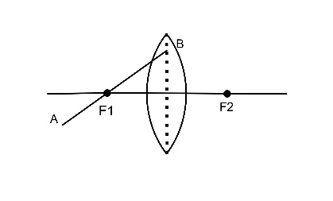ii)

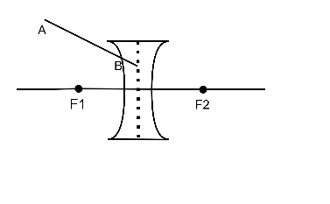

i)

1. Is it possible to burn a piece of paper using convex lens in daylight without maths box? If yes support your answer [2]
2. What is background radiation? [2]

**Section II (40 marks)**

(attempt any four questions)

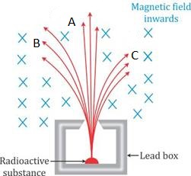**Question 5**

1. Name the radiation A B and C
2. Explain the diagram to arrive the answer above [4]

(b) Write any three difference between heat and specific heat capacity [3]

c) Why the base of Cooking Pan made thick [3]

**Question 6**

1. Explain the working of fuse with neat diagram [4]
2. How heating effect of current depend on I R and T [3]
3. Give the statement for ohms law and List the factors on which resistance of conductor depends [3]

**Question 7**

1. Explain heating curve of water with suitable experiment [4]
2. Define power of lens, write its unit [3]
3. Write any two use of radioactive isotope in industrial field [3]

**Question 8**

1. A lens form the image of an object placed at a distance of 45 cm from it on a screen placed at a distance 90 cm on other side of it i) name the kind of lens ii) find focal length of lens and magnification of image [4]
2. What change happen with in nucleus during Alpha emission [3]
3. Answer the following [3]
4. Name three wires of cables
5. To which wire should be fuse and switch connected?
6. To which wire should be metallic case of a geyser connected?

**Question 9**

1. Write any four properties of Beta particles [4]
2. i) For which colour of white light is the refractive index of transparent medium least and most ii) Which colour of light travel fastest in any medium except air? [3]
3. State two difference between EMF and terminal voltage [3]

**Question 10**

1. i) Write lens formula

ii) An object is placed at a distance of 10cm in front of a concave lens of focal length 10cm find the position of image formed [4]

1. Write any two disadvantages while connect appliance in series [3]
2. i) State Snell’s Law of refraction of light ii) Speed of light in air is 3 x10 8 m/s calculate speed of light in glass. (refractive index of glass is 1.5) [3]

`````````````````````````````````````````````````````````````````````````````````````````````````````

PHYSICS CLASS IX

Science paper I

(2 hours)

( You will not be allowed to write during first 15 minutes. This time to spent in reading question paper. The time given at head of paper is the time allowed for writing the answers)

**Section I (40 marks)**

(Attempt all questions from this section)

**Question 1**

1. What do you mean my lunar month? [2]
2. i) 1 nm= ------------Ao

ii) Write the derived unit of acceleration [2]

1. Write any two distinction between real and virtual image [2]
2. How concave mirror is act as a shaving mirror [2]
3. The radius of curvature of a convex mirror is 40 cm find focal length [2]

**Question 2**

1. When a body said to be rest [2]
2. If a stone and pencil are dropped simultaneously in vacuum from top of a tower. Which of the two will reach first. why? [2]
3. State Archimedes principle [2]
4. Relative density of silver is 10.5 what is the density of silver in SI unit? [relative density of water 103 kgm-3] [2]
5. Explain why egg sink freshwater but floating salt water [2]

**Question 3**

a ) Give one example in each case, contact force and non-contact force [2]

1. Two equal and opposite force acts on a stationary body will the body move? Give reason to your answer [2]
2. What do you mean by Anomalous expansion of water? [2]
3. Draw a graph to show variation in density of water with temperature range from 00c to 100c [2]
4. What result in the increase of carbon dioxide content of earth’s atmosphere? [2]

**Question 4**

1. How fish can float as well as sink in water? [2]
2. Flash of lightning reaches earlier than sound of thunder why? [2]
3. A bat that can hear sound of frequency up to 120 KHz determine the minimum wavelength of sound which it can hear. Take speed of sound in air 334 m/s [2]
4. Write any two factors affecting speed of sound in gas. How they are affecting? [2]
5. How i) mass ii) volume iii)density of a metallic piece affected with increase in temperature? [2]

**SECTION II (40 mark)**

(Attempt any four questions)

**Question 5**

1. Write any four difference between primary cell and secondary cell [4]
2. What do you understand by the term electric current? [3]
3. You are given two identical bars, one which is magnetised. How will you select magnetised bar? [3]

**Question 6**

1. Write any four properties of magnetic field line [4]
2. Explain induced magnetism with suitable example [3]
3. What do you mean by electrical resistance? what is the cause of electrical resistance [3]

**Question 7**

1. What are the conditions for body float or sink in a fluid? [4]
2. An object is placed i) asymmetrically ii) symmetrically between two plane mirrors inclined in an angle of 50 0. Find number of images formed [3]
3. Compare speed of sound with the speed of light [3]

**Question 8**

1. Write symbols and state functions of each of following i) Cell ii) Rheostat iii) ammeter[4]
2. State three evidence of existence of earth magnetic field [3]
3. i) Define heat ii) 1 J = -----erg [3]

1 Cal =-----J

**Question 9**

1. When an object is placed at centre of curvature of a concave mirror ,draw the ray diagram of image formation .Write the features of image [4]
2. Write any three uses of plane mirror [3]
3. Write any three application of ultrasound [3]

**Question 10**

1. What do you mean by open circuit and closed circuit? [3]
2. Write a short note about greenhouse effect [4]
3. Explain two kind of inertia with example [4]