**1**. **Repository** : <https://github.com/DemaSilviu/msa>

**2. User requirements**:

a). The system will allow you to broadcast any music you want by just using your Raspberry Pi.Just upload the music on raspberry and play it !

b). You can choose the desired channel on wich you want to broadcast

c).You can listen to both mp3 and wav files on your own channel

**3. System overview**

Raspberry Pi Radio

**ffmpeg**

libraries

Ffmpeg libraries: Our radio use the ffmpeg libraries to convert the mp3 file and stream it to the transmitter for broadcasting.

Raspberry pi Radio: Allows you to play any file(mp3/wav) on a desired channel( between 87.1 and 108.1).

**4. Circuit design**

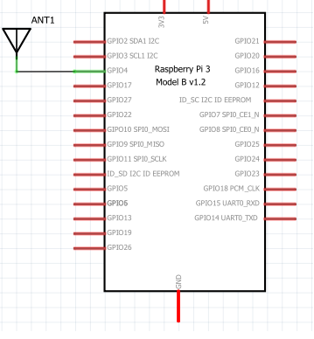

-The piece of wire attached on GPIO4 works as an antenna for our radio.

**5.Software design**

**5.1 Python modules**

**PiStation.py:** The PiStation allows you to use the code in a more simple way.Just load your music into your Pi, and play. Also don’t forget to select the frequencies you want to broadcast.

**5.2 CPP modules**

**error_reporter.h &.cpp:** reports if it’s any error broadcasting a specific file on the desire frequency.

**main.cpp:** the code limits the frequencies to 87.1 and 108.1. There is also majorly restricted frequencies in there like, 121.5 and 243.0 (military aircraft). Also format the WAV file wich must be in this format: 16 bit (mono or stereo) 22050 hz.

**6. Results and further work**

The current version of the project support the following functionalities:

-Broadcast on any desire channel between a certain range

-Play mp3 and wav files

-Store the files only on raspberry

The following list of extensions and improvements was identified to be supported in the future:

-Broadcast music from internet(eg. Youtube)

-Mobile application interacting with raspberry via Bluetooth