**1**. **Repository** : <https://github.com/DemaSilviu/msa>

**2. User requirements**:

a). The system will allow you to broadcast any music you want by just using your Raspberry Pi.Just upload the music on raspberry and play it !

b). You can choose the desired channel on wich you want to broadcast

c).You can listen to both mp3 and wav files on your own channel

**3. System overview**

Raspberry Pi Radio

**ffmpeg**

libraries

Ffmpeg libraries: Our radio use the ffmpeg libraries to convert the mp3 file and stream it to the transmitter for broadcasting.

Raspberry pi Radio: Allows you to play any file(mp3/wav) on a desired channel( between 87.1 and 108.1).

**4. Circuit design**

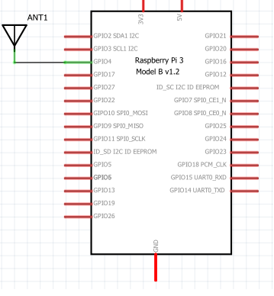

-The piece of wire attached on GPIO4 works as an antenna for our radio.

**6. Results and further work**

The current version of the project support the following functionalities:

-Broadcast on any desire channel between a certain range

-Play mp3 and wav files

-Store the files only on raspberry

The following list of extensions and improvements was identified to be supported in the future:

-Broadcast music from internet(eg. Youtube)

-Mobile application interacting with raspberry via Bluetooth