What Is a Financial Market?
Concept
A financial market is a system where buyers and sellers interact to exchange assets at agreed prices.
Price is formed through the continuous interaction of buying and selling orders, not through prediction or external control.

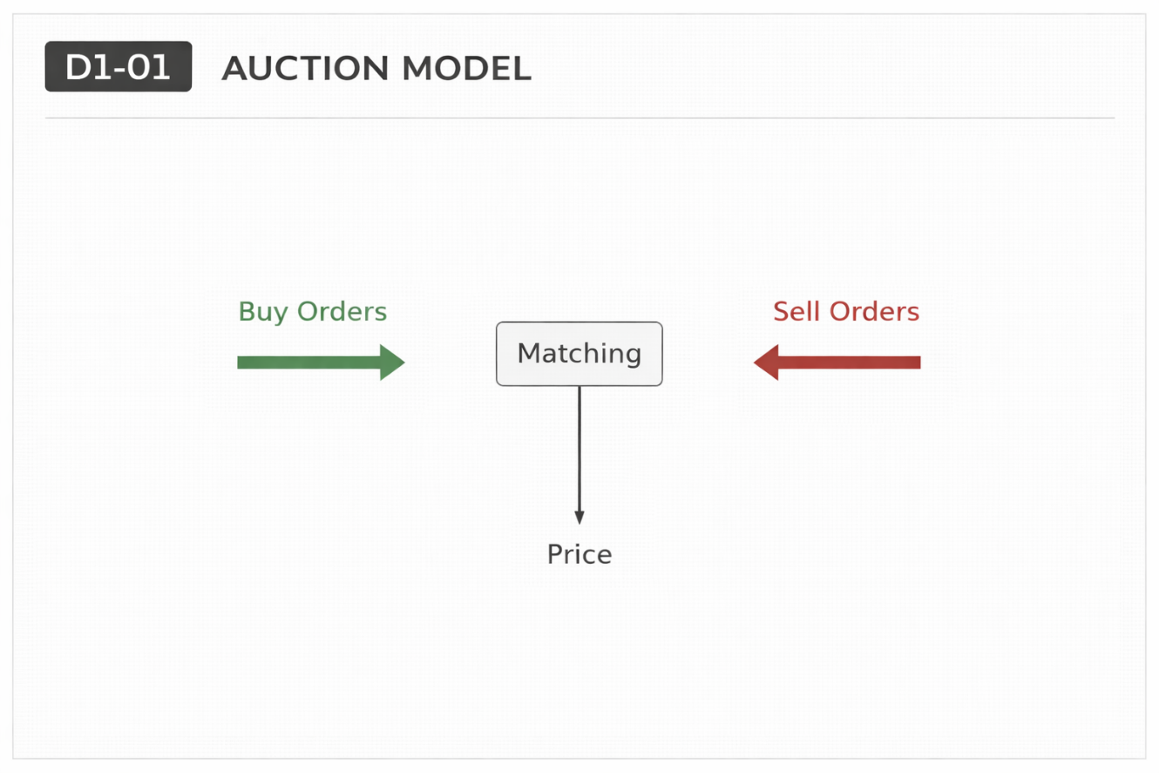
Why It Matters
Understanding that price is created through order interaction removes the idea that markets move randomly or by intention.
It establishes that every price movement is the result of transactions between participants.

Professional Perspective
Markets operate as matching engines.
Orders from participants are continuously matched based on availability, creating price movement.
There is no need to assume intent—only interaction between supply and demand.

Practical Insight
Price does not move because it “wants to go somewhere.”
It moves because orders are being matched.
Understanding this prevents assigning meaning or prediction to normal market behaviour.

