Market Participants (Banks, Funds, Retail)
Concept
Financial markets are composed of different types of participants, each with varying levels of capital, influence, and purpose.
The primary groups include institutional participants (banks and funds) and retail participants.

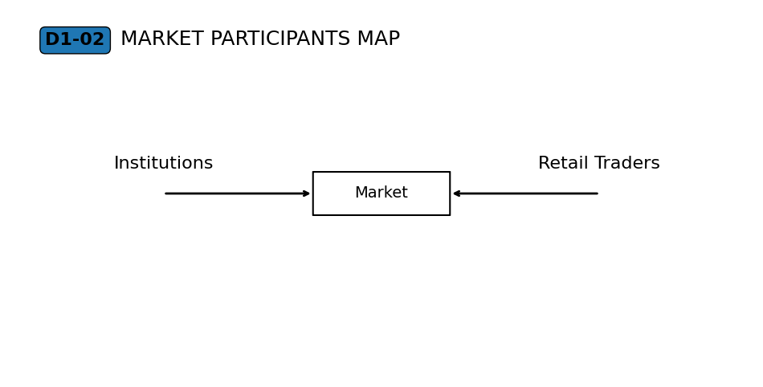
Why It Matters
Not all participants influence the market equally.
Understanding who participates—and how—helps explain differences in order size, behavior, and impact on price movement.

Professional Perspective
Institutional participants, such as banks and large funds, provide significant liquidity and execute large-volume transactions.
Retail participants contribute smaller orders and operate within the conditions created by larger participants.
Market behaviour reflects the combined interaction of all participants, not any single group acting alone.

Practical Insight
Retail traders do not control the market, but they are still part of it.
Different participants operate with different objectives and constraints.
Understanding this prevents oversimplified assumptions about how and why price moves.

