Brokers, Liquidity Providers & Execution Path
Concept
When a trader places an order, it does not go directly into the market.
The order is routed through a broker, which may connect to liquidity providers or internal systems to execute the trade.
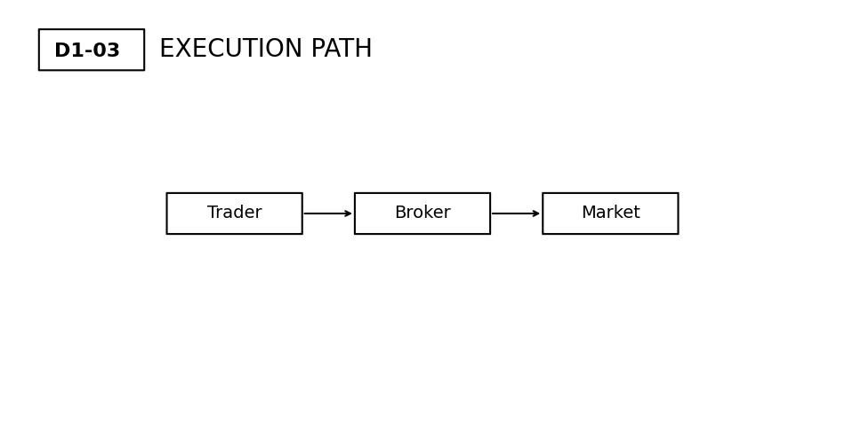Why It Matters
Understanding the execution path explains why prices may differ slightly from expectations.
It also clarifies the role of intermediaries in facilitating trade execution.
Professional Perspective
Brokers act as intermediaries between traders and the broader market.
They may route orders to liquidity providers (such as banks or institutions) or match orders internally depending on their model.
Execution depends on available liquidity, pricing, and system conditions—not instant or guaranteed outcomes.
Practical Insight
Execution is a process, not a single action.
Delays, price differences, and variations can occur due to how orders are routed and filled.
Understanding this prevents unrealistic expectations about precision and control.

