Market Microstructure Limitations
Concept
Market microstructure limitations refer to the real-world constraints that affect how trades are executed.
These include spread, slippage, and latency, which can cause differences between expected and actual execution.
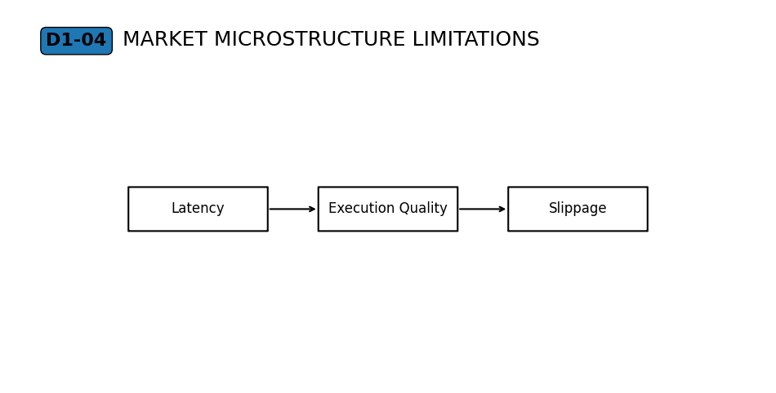
Why It Matters
Trading does not occur in a perfect environment.
Even if analysis is correct, execution may differ due to market conditions and system limitations.
Understanding this prevents unrealistic expectations about precision.

Professional Perspective
Markets operate through systems that process orders under varying conditions.
Spread reflects the difference between buying and selling prices.
Slippage occurs when orders are filled at different prices due to liquidity availability.
Latency introduces delays between order placement and execution.

Practical Insight
Execution is influenced by market conditions, not controlled by the trader.
Price differences are normal and expected.
Understanding these limitations helps traders avoid frustration and incorrect assumptions.

