Liquidity & Order Flow Basics
Concept
Liquidity refers to the availability of buy and sell orders in the market.
Order flow is the process of these orders interacting, where buying and selling pressure determines how price moves.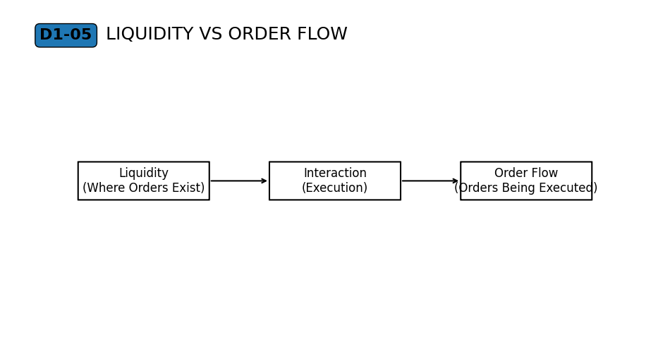
Why It Matters
Price does not move on its own—it moves when there is an imbalance between buying and selling orders.
Understanding this explains why price accelerates, slows down, or changes direction.

Professional Perspective
Markets function through continuous order matching.
When buy orders exceed available sell orders, price moves upward.
When sell orders exceed available buy orders, price moves downward.
Liquidity provides the capacity for orders to be filled, while order flow determines directional pressure.
Practical Insight
Price movement reflects the interaction of orders, not intention or prediction.
Strong movement often indicates imbalance, while slow movement suggests more balanced interaction.
Understanding this removes the need to guess and focuses attention on observable behavior.

