Asset Classes Overview (FX, Gold, Oil, Indices)
Concept
An asset class is a category of financial instruments that share similar characteristics.
Common asset classes include foreign exchange (FX), commodities such as gold and oil, and indices representing groups of stocks. 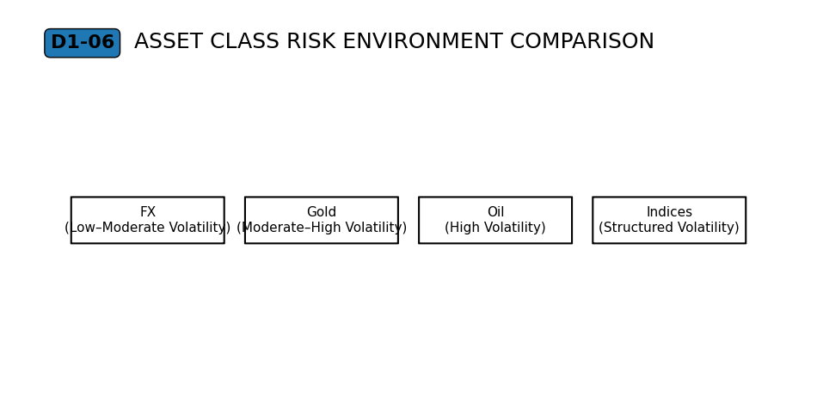
Why It Matters
Different asset classes may appear unique, but they all operate through the same underlying mechanisms of order interaction, liquidity, and execution.
Understanding this prevents treating each market as fundamentally different.

Professional Perspective
Each asset class has its own participants, trading hours, and liquidity conditions.
However, all markets function through the same principles:
orders interact, liquidity is required, and price reflects transactions.
Differences are contextual—not structural.

Practical Insight
Changing asset classes does not change how markets function.
It only changes context, such as volatility or liquidity conditions.
Understanding this allows traders to apply consistent reasoning across markets.

