CANDLESTICK ANATOMY
Concept
A candlestick represents the movement of price over a specific period, showing four key data points: open, high, low, and close.
It is a visual representation of how price moved during that interval—not an indicator of future direction.

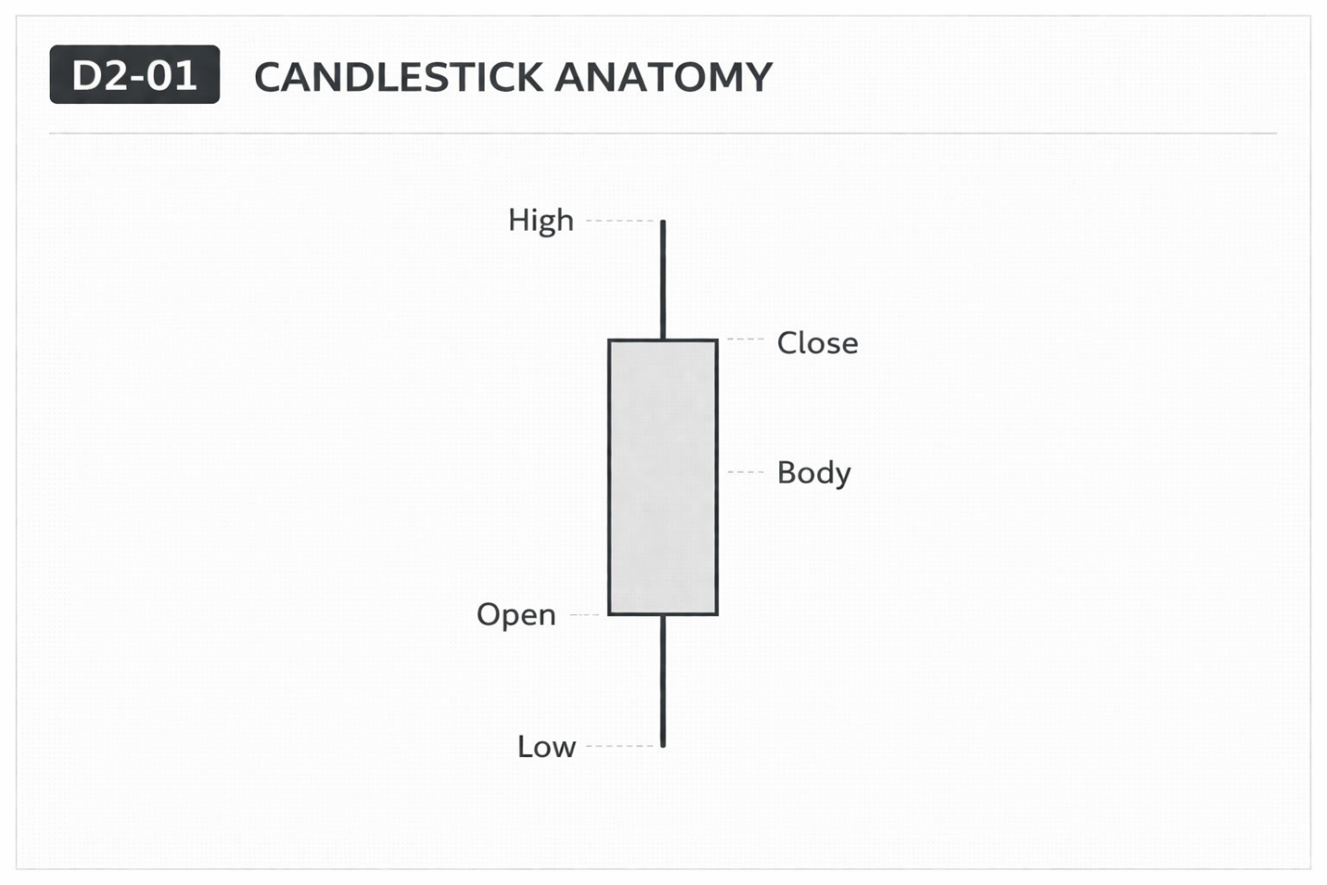

Why It Matters
Candlesticks provide a structured way to observe how price behaves within a defined time period.
They allow traders to see how price opened, where it moved, and where it closed.
Professional Perspective
A candlestick is a record of completed price activity.
It reflects interaction between buyers and sellers during that time interval.
It does not predict what price will do next—it only shows what has already occurred.

Practical Insight
The shape of a candlestick reflects past movement, not future outcome.
Interpreting candlesticks as signals leads to incorrect assumptions.
They should be used to observe behavior, not to predict direction.

