OHLC Mechanics
Concept
OHLC stands for Open, High, Low, and Close.
These four data points define how price moves within a specific time interval and form the foundation of all chart representations.

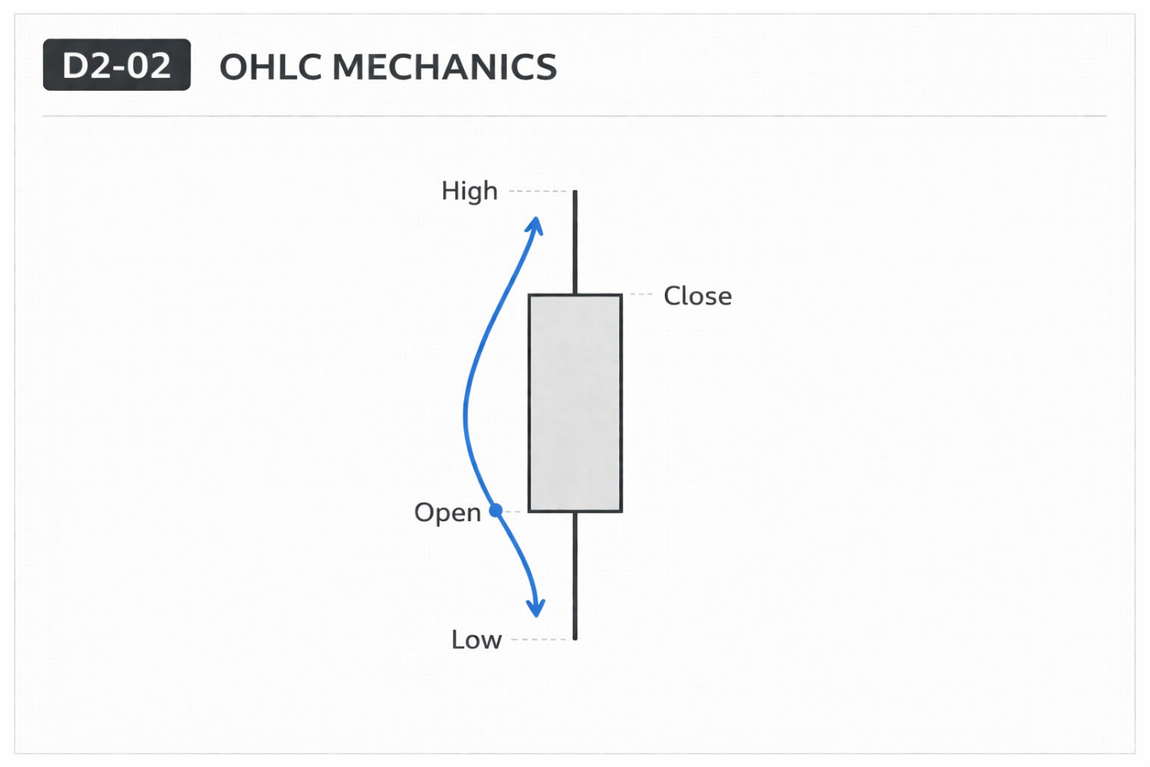

Why It Matters
All chart types—candlesticks, bars, and line charts—are built from OHLC data.
Understanding OHLC removes dependence on visual interpretation and builds precise understanding of price behavior.

Professional Perspective
Charts are simply visual representations of underlying OHLC data.
Each time interval records where price started (open), where it reached (high/low), and where it finished (close).
Professional analysis begins with understanding this data—not relying on visual assumptions.

Practical Insight
A candlestick is not the source of information—the OHLC data is.
Misunderstanding OHLC leads to misinterpreting charts.
Clarity at the data level prevents errors at the visual level.

