Timeframes Explained
Concept
A timeframe defines the duration of each price interval on a chart.
Each candlestick or data point represents price movement over that specific period.
Different timeframes display the same market data at different levels of detail.

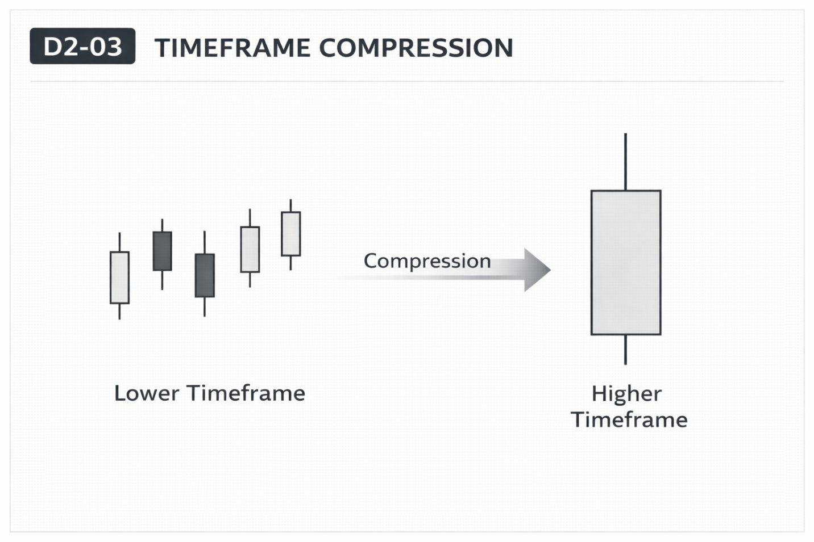

Why It Matters
The same market can appear different depending on the timeframe used.
Shorter timeframes show more detailed movement, while higher timeframes show broader structure.

Professional Perspective
Timeframes do not change the market—they change how price data is aggregated.
Lower timeframes provide granular detail, while higher timeframes compress multiple intervals into a simplified view.
Both represent the same underlying price activity.

Practical Insight
No timeframe is inherently more “correct” than another.
Misunderstanding timeframes leads to confusion and inconsistent analysis.
Clarity comes from understanding that all timeframes reflect the same data at different resolutions.

