Market Noise vs Structural Signal
Concept

Market noise refers to short-term price fluctuations that do not clearly reflect broader structural behavior.
Structural signal refers to price movement that contributes to observable patterns of market organization over time.

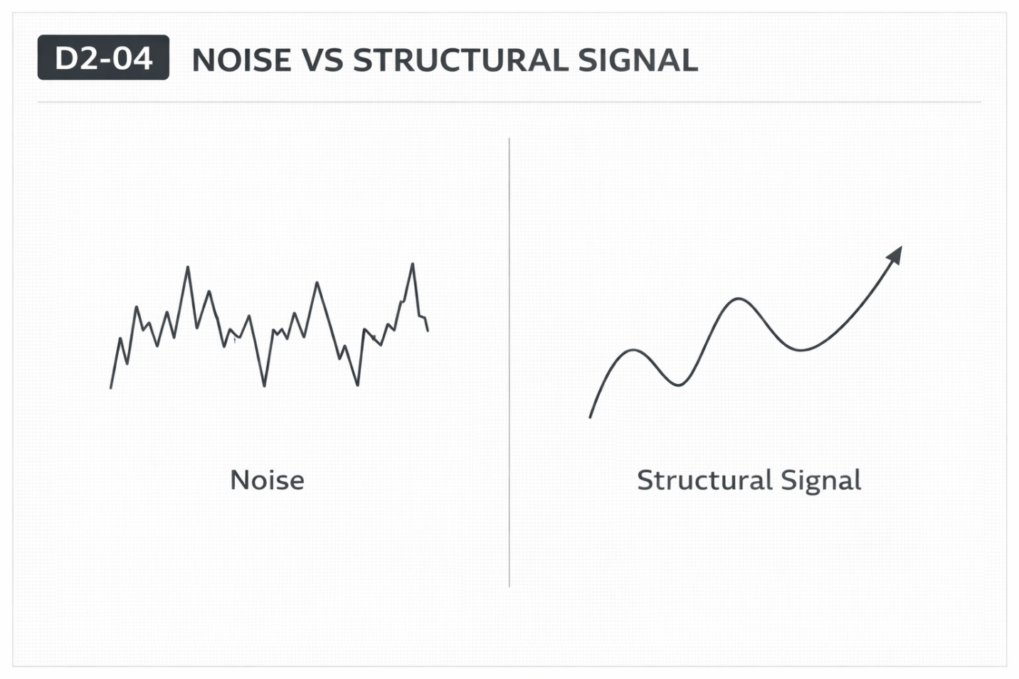

Why It Matters
Price moves continuously, but not all movement carries the same analytical relevance.
Distinguishing between short-term fluctuation and broader structural movement helps maintain clarity in observation.

Professional Perspective

Noise and structure are not fixed categories—they depend on the timeframe and context being analyzed.
What appears as noise on a higher timeframe may be structured movement on a lower timeframe.
Professional analysis avoids labeling movement prematurely and instead evaluates it within context.

Practical Insight
Calling something “noise” without context leads to ignoring valid information.
Calling everything “structure” leads to overinterpretation.
Clarity comes from understanding the relationship between movement and timeframe.

